**The Oman Animal and Plant Genetic Resources Center’s (OAPGRC) Science Café: A Success Story**

Dr. Nadiya Abubakr Al Saadi *

Dr. Hameed Ch. Ali AL-khafaji**

Rasha Hilal Al Saifi***

*Executive Director, Oman Animal & Plant Genetic Resources Center

** Expert of Plant Genetic Resources, Policies & Data Analysis, Oman Animal & Plant Genetic Resources Center

***Marketing Specialist, Oman Animal & Plant Genetic Resources Center

**ABSTRACT**

Science Cafés are held in many towns and cities across the world for the promotion of scientific culture and the understanding of our daily lives which we live in. They provide a platform for interaction and dialogue between scientists, researchers, businesses and the community on trends towards current scientific issues the extent of their impact on culture and society.

The OAPGRC Science Cafe is a forum for the discussion of important and interesting scientific topics and issues. Since May 2013 to December 2015, OAPGRC has held a series of science café sessions on topics related to biodiversity, food security, climate change, pollution and sustainable use. Reviewing the data on the outcomes and performance of these sessions indicates that the session attendance and active participation was 51% by men and 49% women. This is an exceptional case where the interest is almost equal between the genders. As for the age group, the highest percentage 49% was of a class of young people aged between 18-25 years. The OAPGRC science café is the first in Oman to be put on the international map of scientific cafes around the world.

**Key words*:*** *Scientific, Café, OAPGRC, Success, Story*

**INTRODUCTION**

A science café is usually held in countries that support the scientific culture in everyday life. Where scientists, researches and community all gather to share a two-way dialogue on the latest relevant scientific issues and their impact on culture and community. The issues discussed at Science Cafés are important topics that require awareness. The issues discussed are important and play a major, role in food, agriculture, and industrial security., through supporting an entire global biodiversity. The purpose of Science Café is to address the major scientific and social issues that are related to genetic resources, as well as discussing the means of maintaining them in order to serve the community and future generations.

The first Science Café was organized by Duncan Dallas in Leeds, UK in 1998. Dallas, was the founder of [Café Scientifique](http://www.cafescientifique.org/) (4) whose worldwide success has helped introduce science to millions of people. Dallas based the Science Cafe on the Café Philosophic movement developed by the French philosopher Marc Sautet.

In France, science cafes were established by scientists who thought they ought to inform the public on the current scientific topics of concern. In the UK it was started by members of the public who wanted to know more about science. In both countries they began within an academic structure and spread to more popular locations, and thereby attracted audiences.

It started at a time in the UK where COPUS, the [Committee on the Public Understanding of Science](https://en.wikipedia.org/wiki/Committee_on_the_Public_Understanding_of_Science) (organized by the [Royal Society](https://en.wikipedia.org/wiki/Royal_Society) and the [British Association for the Advancement of Science](https://en.wikipedia.org/wiki/British_Association_for_the_Advancement_of_Science)), considered that a better understand of science was needed by the public. Newspapers considered it odd that people should go to a café, drink wine and discuss science rather than just gossip (1).

However, the public were becoming more concerned about topics like Mad Cow Disease, GM crops, cloning, etc.

Individual Cafes have many different names and often don’t require funding, only payment for the speaker’s travelling expenses, usually made through donations given by the audience. The Cafes provide the opportunity for individuals and groups to explore and discuss science through many different form, such as street science, comedy, music, theatrical readings, and demonstrations.

Public science initiatives are currently running in more than 40 towns across the [United Kingdom](https://en.wikipedia.org/wiki/United_Kingdom) and in many other countries around the world. At least twelve cafés outside the UK are organized by the [British Council](https://en.wikipedia.org/wiki/British_Council) alone.”[1] A science café chain organized at schools called Junior Café Scientifique. (3)

Today, Science Cafes are organized in towns and cities across the world – including Oman. (Diagram 1)

**What is the OAPGRC Science Café?**

The OAPGRC Science Cafe is a forum for the discussion of important and interesting scientific issues. We meet on a monthly basis and the sessions are informal, relaxed, fun and accessible. It's an opportunity to get together with old and new friends in a relaxed atmosphere and discuss cool scientific topics.

Our audience consist of people who are interested in science but generally never have the opportunity to discuss their views with, and ask questions of, someone in the know. No scientific knowledge is assumed by the Science Café panelists, so anyone can come along and participate

**Science Café Objectives**

OAPGRC is determined to create awareness of the importance of genetic diversity in animals, plants, and microorganisms in Oman, as they are all considered as natural traditional resources. The Center’s goal is to achieve excellence in the various fields related to genetic resources, ranging from education and scientific research to innovation and investment. (5) The main objectives of the science café are to Create dialogue and communication between scientists, experts, and the community, to raise awareness on animal and plant genetic resources, microorganisms and marine life through experts in the fields of genetic resources, to initiate discussions about the challenges and opportunities of genetic resources and establish networks for knowledge exchange and top scientific practices in order to maintain genetic resources.

The Science café is one of the main achievements on awareness of the center. In 2013, the first Science café was launched together with The Research Council, in order to pursue the goals of the center, the first sessions focused on establishing a platform for mutual learning and dissemination of knowledge and science in Oman. To our knowledge, this is the first example of a science café in Oman.

Main operated sessions from 2013-2015 as per the schedule below:

|  |  |  |  |  |
| --- | --- | --- | --- | --- |
|  | | | | |
|  | **Topic** | **Date** | **Venue** | **Center help session** |
|
| 1 | Biodiversity and Genetic Erosion: A Game of Consequences | 28-May-2013 | Bait Al B aranda Museum | 1.Pro.Othman Mahgoub,2.Dr.Ali Al-Lawati, 3. Michel Claereoudt |
| 2 | Global Warming and Genetic Resources: Are We Ready for the Change? | 27-Sep-2013 | Al Bustan Palace Hotel | 1.Dr.Salim K. Nadaf,2. Dr. Antoly V Chernyshev, 3. Dr. ……. |
| 3 | Renewable Energy and Biodiversity | 13-Nov-2013 | Café' Barbera(Bait Al Reem) | 1. Dr. Amar Al.Obidani, 2.Dr. Antoly V Chernyshev |
| 4 | Mammals Genetic Diversity: Horses, Camels | 24-Feb-2014 | Café' Barbera(Bait Al Reem) | 1. Dr. Albano, 2. Ihab Shatt |
| 5 | You are what you eat? Food for thought | 1-Apr-2014 | Al Mouj Golf Restaurant | 1.Dr. Ahmed Al. Shukaili,2. Mr. Yahya Al. Mukhaini,3. Dr.Mohammed Essa |
| 6 | Millennials and the future of food | 24-Sep-2014 | Oman Tel | 1.Dr.Nejib Guizani,2.Mr.Robert MacLean (NHI), 3. Sami Al-Shaikh. |
| 7 | Microbial Genetic Resources (The best things Come in Small Packages) | 3-Dec-2014 | Moka and More coffee Shop | 1.Dr. Saif Al- Bahri,2.Dr.Siva kumar, 3.Mr. Nelesh Bakal |
| 8 | Oman's Marine Life: Plenty More Fish in the Sea? | 28-Jan-2015 | Moka and More coffee Shop | 1.Dr.Shekar Bose,2. Abdesslam Fahfouhi |
| 9 | Buy Local Supporting Communities and Protecting the Environment | 27-05-2015 | Lulu Hyber Market | 1. Malik Al.Ghahdami,2. Dr. Hameedichalloob, 3.Assad …..Al.Kindi |
| 10 | Solving Our Problems Through STEM | 28-10-2015 | Moka and More coffee Shop | 1. Mohammed Al.Magiri,2. Basel Dhyani |
| 11 | Planting for the Future: Native Plants in Our Gardens | 30-12-2015 | SQU | 1. Dr.AbulAraheem Al-Ismaili,2. Abdullbaqi Al.Raisi,3. Dr. Abdullah Al-Jafari |

Schedule (1) English language sessions:

**Results and discussions**

Table (1) shows the analysis of 11 sessions of Science Café during the period from 28 May 2013 to 30 December 2015. The results indicated that the Science Café introduces important topics to the community such as the marine life, and another tropic about the honey which highlights the benefits of honey. Another successful topic was the importance of medical plants, and traditional medicines. An exceptional attendance was achieved, with a great diversity of audience with 51% of men and 49% for women participating.

Table 1: The data of Science Café collected during the period from 28 May 2013 to 30 December 2015

|  |  |  |  |  |  |  |  |  |  |  |  |  |  |  |  |
| --- | --- | --- | --- | --- | --- | --- | --- | --- | --- | --- | --- | --- | --- | --- | --- |
| **Session No** | **Title of Session** | **Attendees Number** | **Women** | **Men** | **Age Group** | | | **How did you hear about Science Café?** | | | | | **Occupation** | | |
| **18-25** | **26-35** | <35 | **Email** | **Word of Mouth** | **Social Media** | **SMS** | **Others** | **Government Sector** | **Private sector** | **Student\Seeker** |
| 1 | Microbial Genetic Resources | 29 | 12 | 17 | 13 | 7 | 8 | 2 | 9 | 13 | 3 | 1 | 8 | 1 | 12 |
| 3 | Oman's Marine Life Plenty More Fish in the Sea | 25 | 7 | 18 | 3 | 10 | 12 | 9 | 7 | 5 | 4 | / | 6 | 7 | 6 |
| 7 | Buy Local Supporting Communities and Protecting the Environment | 15 | 9 | 6 | 6 | 5 | 4 | 1 | 2 | 3 | 7 | / | 4 | 1 | 3 |
| Total | | 69 | 28 | 41 | 22 | 22 | 24 | 12 | 18 | 21 | 14 | 1 | 18 | 9 | 21 |

As for the age group, the youth (18-25 years) attendance was highest with 49%. Followed by the age group (26-35 years) which was 30%. The lowest percentage was 21% for the age group of above 35 years.

Regarding the question, how did you hear about Science café? the options were through email, scientific speakers, social medias MS, and other. The top percentage of 44% was through speakers, followed by social media with 31%, then 22% for email, 19% from SMS, and other 18%.

The science cafés audience’s occupation was also monitored, with the highest percentage being job seekers and students with 52%. This statistic shows the usefulness in providing the latest information for their related studies. While for the public sector the attendance percentage was 34%, and 14% of private sector.

Science Café of Oman Animal Plant Genetic Resource Center has been successful in maintaining and developing the various genetic resources. The center was recently established by Sultan Qaboos’s order, under the umbrella of TRC in 2012. The center’s activities were highly recognized in spreading awareness in Oman’s community, especially in sustainable development of genetic resources to support the food security. Furthermore, the opportunity for the usage of resources in medical plant investment by producing medical drugs and pharmaceuticals.

During the Science Café’s successful sessions, a number of scientific Omani ideas were successfully translated into investment projects, in which it can be seen in the results from the young age group (18-25).

The Sultanate of Oman was labeled on the map of science cafés around the world (2) as well as OAPGRC as a registered scientific institution that organizes the Science café every month and presents advanced scientific programs that provide the community needs, and spreads media awareness of animal plant genetic resources together with other species.

Diagram (1) The location map of science cafes around the world, and recently the Sultanate of Oman was added.

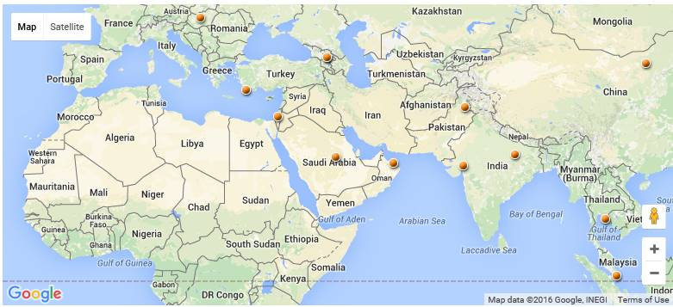

Number of sessions organized by Science Café, in diagrams 2,3

Diagram 2: shows events posters of Science Café

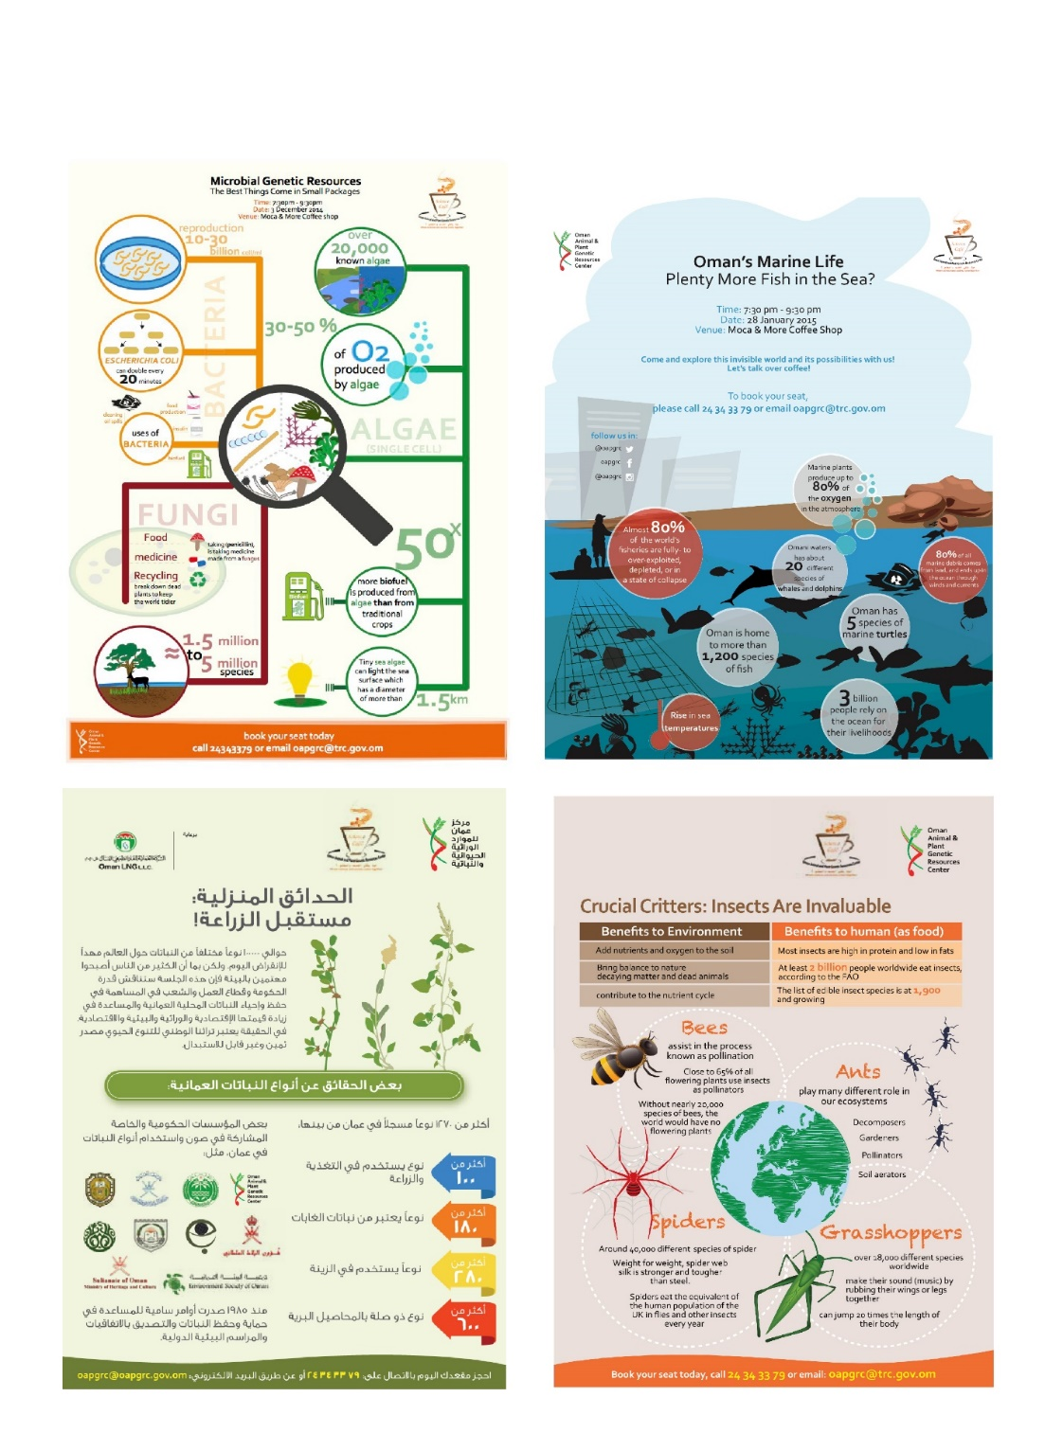

Diagram 3: participants and discussions of Science Cafe

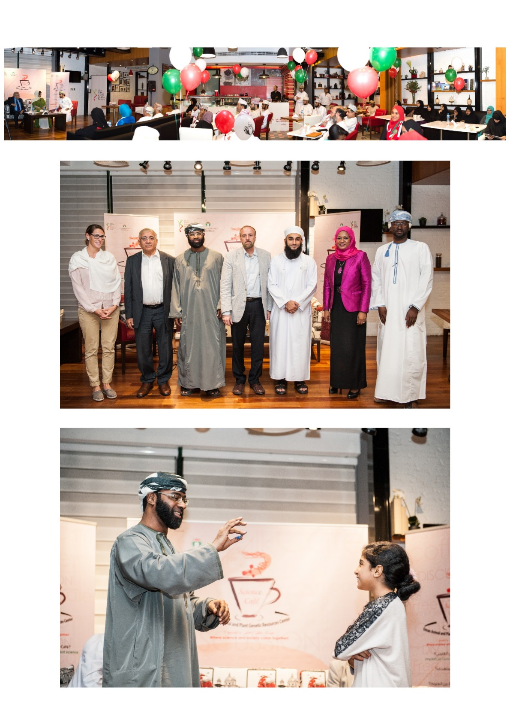

**References**

1. http://www.cafescientifique.org/index.php?option=com_content&view=article&id=91&Itemid=435
2. **Find a Café near you!**

<http://sciencecafes.org/find/>

1. **Junior Cafe Scientifique Scheme, Durham University (2016)**

<https://www.dur.ac.uk/science.outreach/outreachschemes/juniorcafescientifiquescheme/>

[www.juniorcafesci.org.uk](http://www.juniorcafesci.org.uk/)

1. Duncan Dallas Obituary 2014 (Science), People in Science.

<https://www.theguardian.com/science/2014/apr/24/duncan-dallas>

1. **Oman Animal & Plant Genetic Resources Center (2016)**

<https://oapgrc.gov.om/Pages/default.aspx>

<https://en.wikipedia.org/wiki/Caf%C3%A9_Scientifique>

<http://sciencecafes.org/>

1. https://en.wikipedia.org/wiki/Caf%C3%A9_Scientifique