**List of Figures**

Figure 1: Import/export operations.

Figure 2: Transshipment operations.

Figure 3: MCT layout.

Figure 4: Container flows at MCT.

Figure 5: YT deployment strategies: FA and RR.

Figure 6: YT deployment strategies: RV, SD, and SQ.

Figure 7: Procedure for estimating size of YT and GC gangs.

Figure 8: Vessel service makespan.

Figure 9: YT states.

Figure 10: Variability in states between YTs in a gang.

Figure 11: Total YT travel distance.

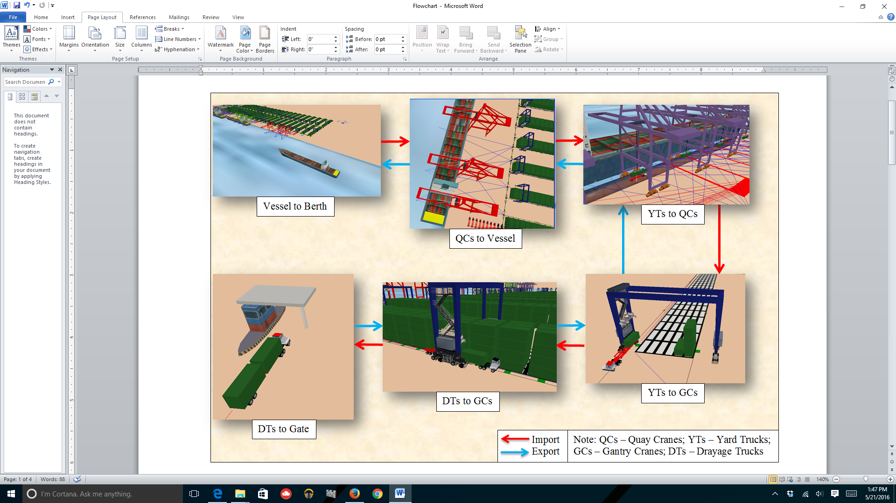

Figure 1: Import/export operations.

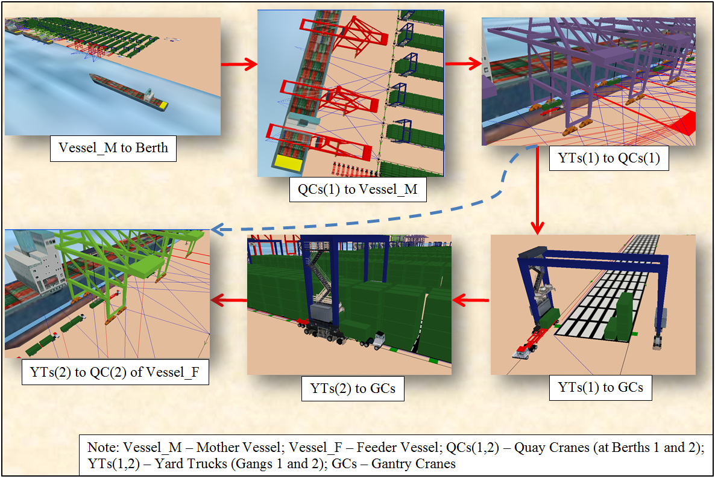

Figure 2: Transshipment operations.



Figure 3: MCT layout.



Figure 4: Container flows at MCT.





Figure 5: YT deployment strategies: FA and RR.







Figure 6: YT deployment strategies: RV, SD, and SQ.

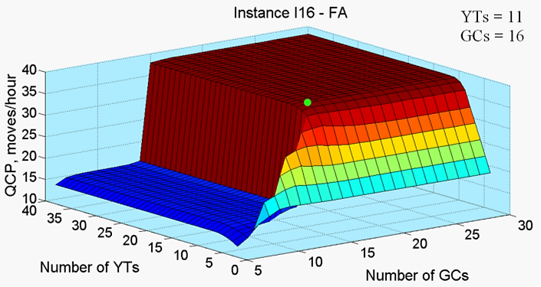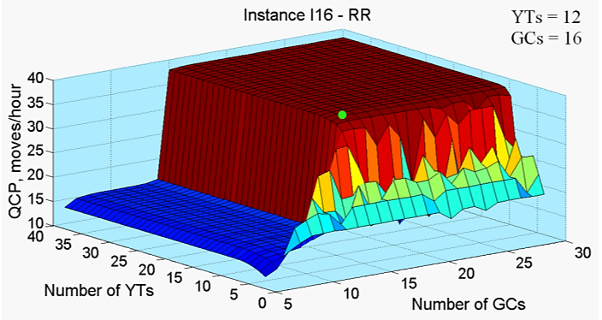

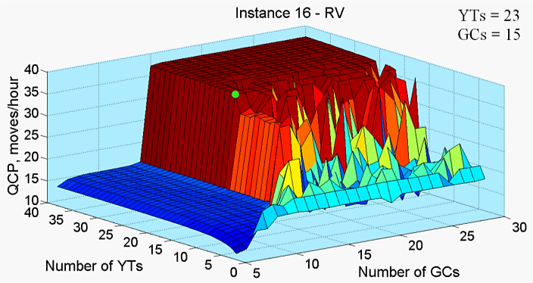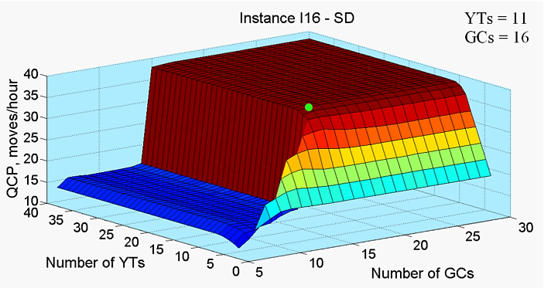

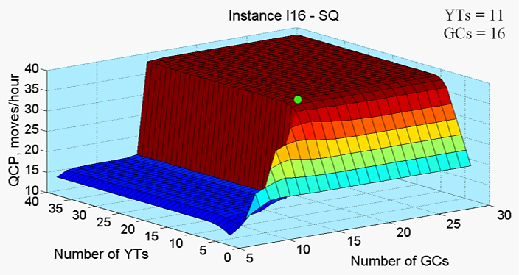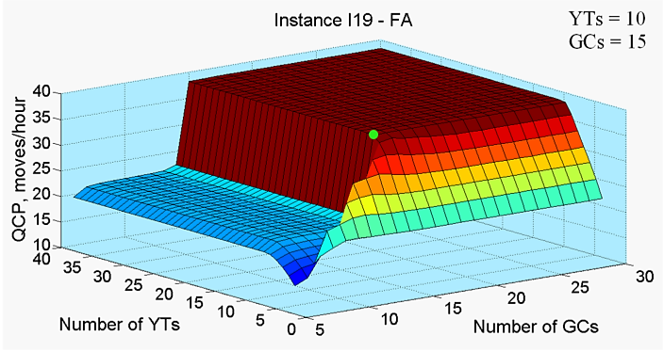

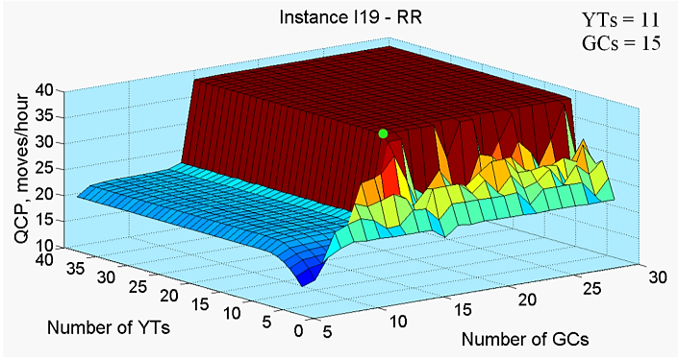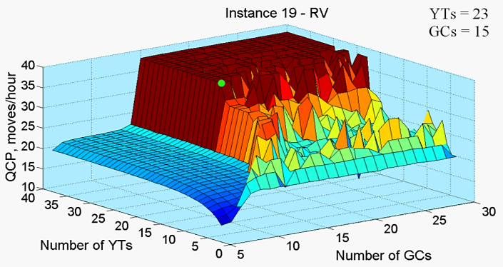

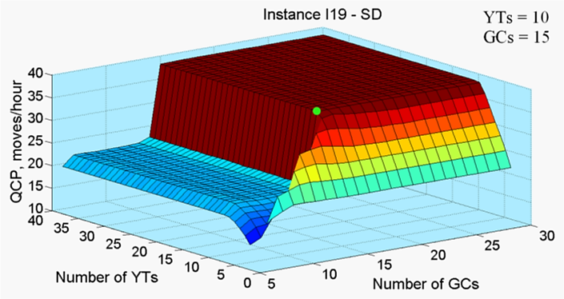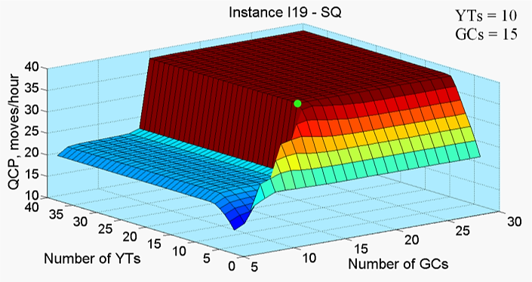

Figure 7: Procedure for estimating size of YT and GC gangs.

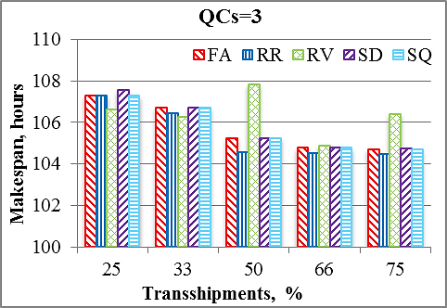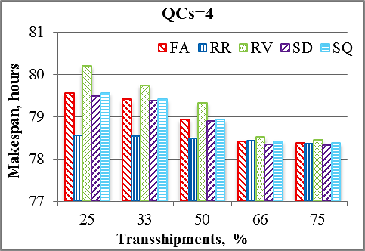

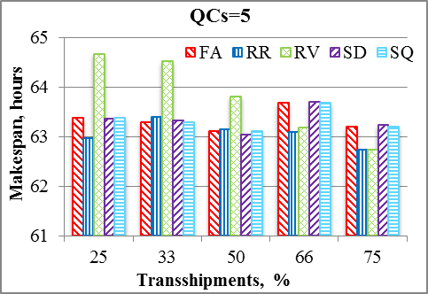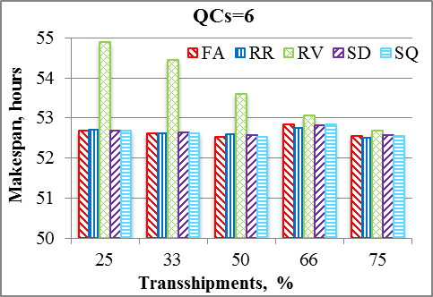

Figure 8: Vessel service makespan.

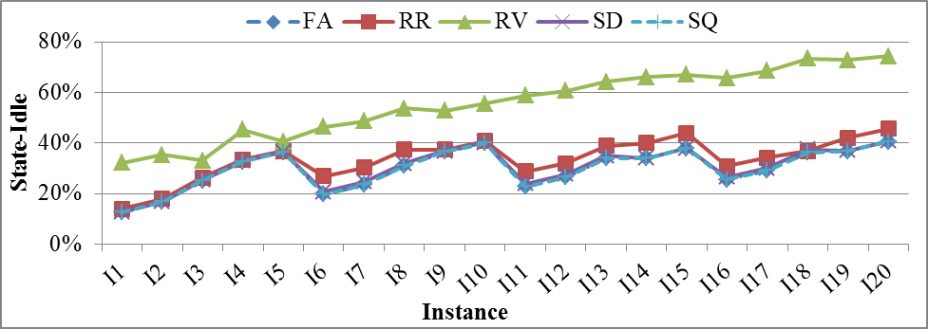

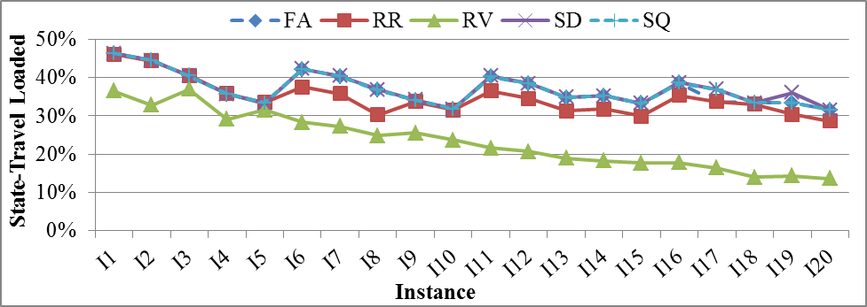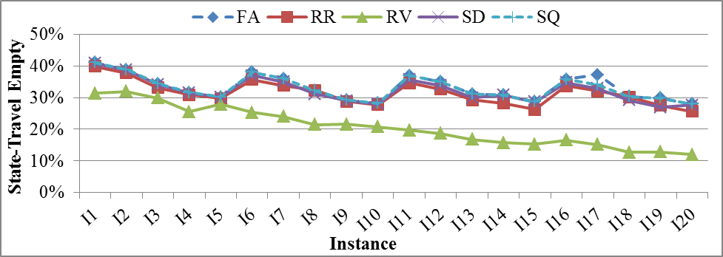

Figure 9: YT states.

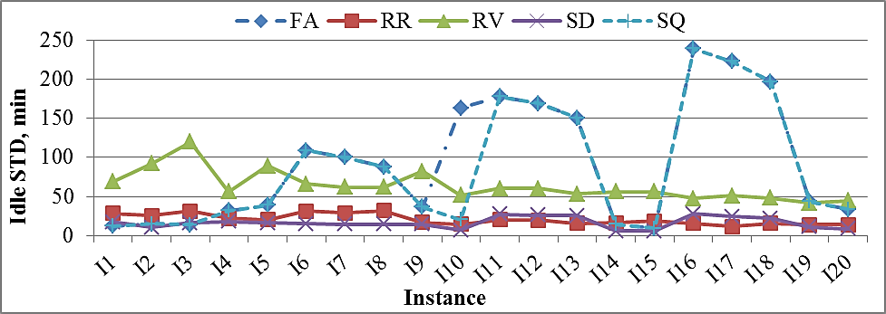

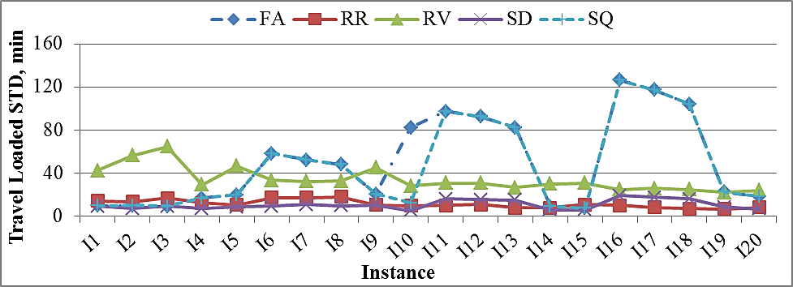

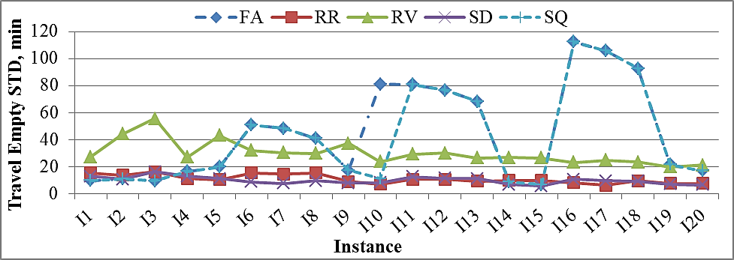

Figure 10: Variability in states between YTs in a gang.

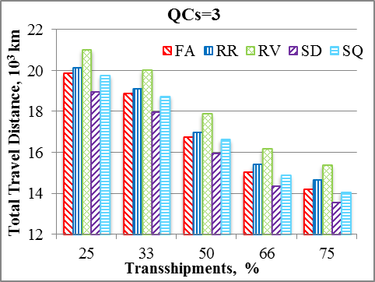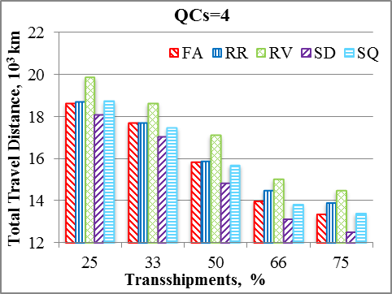

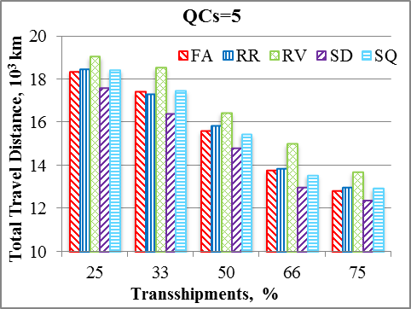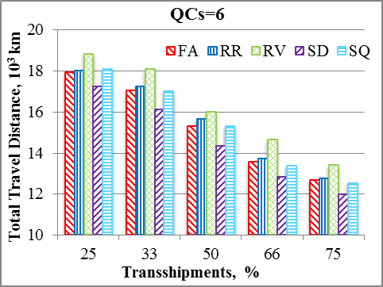

Figure 11: Total YT travel distance.