**Figure 1** **-** Map of the location of the collection area in the estuary of the São Paulo River, Candeias - Bahia, Brazil

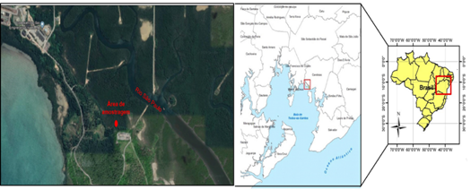

Source: Adapted from Google and Conder[26].

**Figure 2** **-**  Microorganisms encapsulated based on two natural substrates

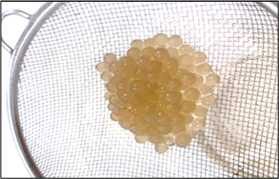

Source: LIMA, 2014.

**Figure 3 -** Description of the movement of rising and lowering of the tide in the experiment of bioremediation of mangrove sediment with oil

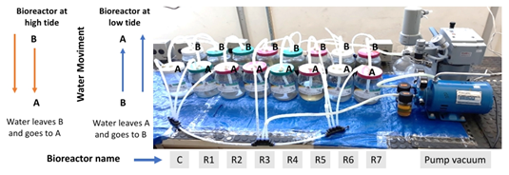

Source: Author, 2020.

**Figure 4 -** Growth of the microbial intercropping during the bioremediation experiment

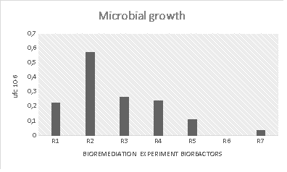

Source: Author, 2020.

**Figure 5 -** Variation of physicochemical parameters during the bioremediation experiment

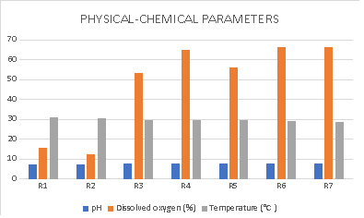

Source: Author, 2020.

**Figure 6 -** Effect Plot (a) and Pareto (b) for percentage ratio of consortium and time

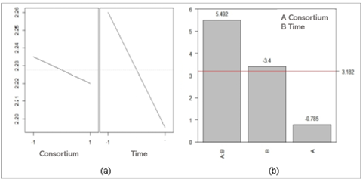

Source: Author, 2020.