Pictures:

Picture 1: Map of Brazil: study areas and mentioned areas (Made by author)

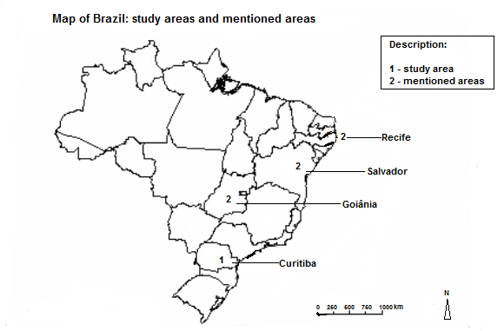

Picture 2: Façade and badge. (Source: author)

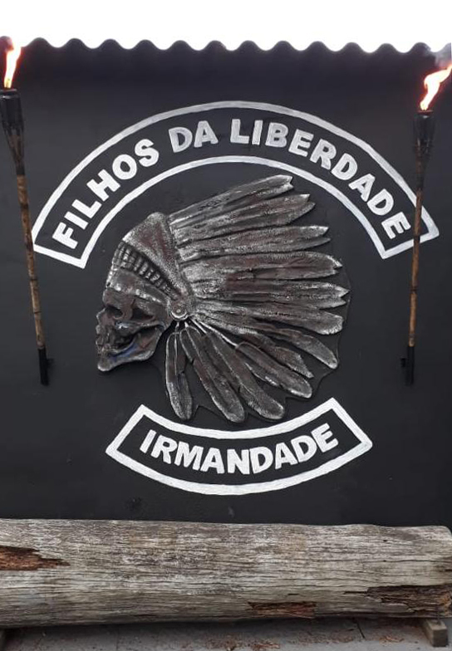

Picture 3: The entrance corridor and the greater symbols, the badge evolution and the words that symbolize the maxims of the group: “road”, “friends” and “family” (Source: author).

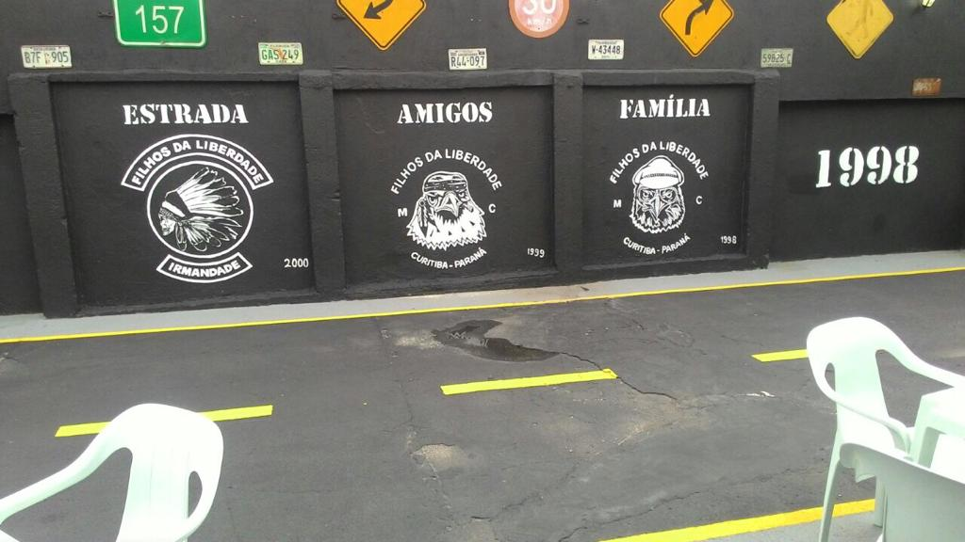

Picture 4: Main hall, bar, pool table and member’s photographs: fun, fraternization and memories (Source: author)

