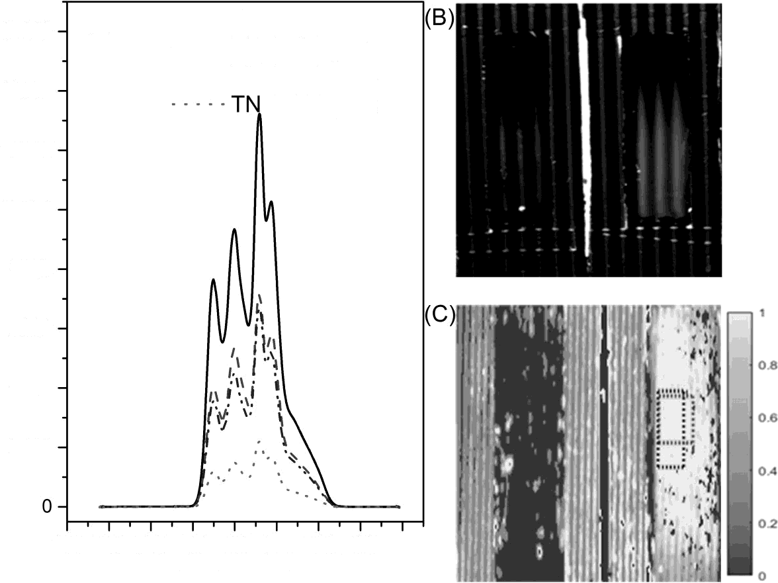

16000

(A)

Before the mask

- - - TNT - 1 layer

14000 -

- TNT - 2 layers

T - 3 layers

12000

10000

8000

6000

4000

2000

100 200 300 400 500 600 700 800 900

Wavelength (nm)

Intensity (arb. unitis)