US Inflation Results

Linear Regression

Model Summary

Model R R² Adjusted R² RMSE Durbin-Watson

1 0.622 0.387 0.381 0.246 1.272

|  |  |  |  |  |  |  |
| --- | --- | --- | --- | --- | --- | --- |
| **ANOVA** |  | | | | | |
| **Model** |  | **Sum of Squares** | **df** | **Mean Square** | **F** | **p** |
| 1 | Regression | 27.63 | 7 | 3.947 | 65.42 | < .001 |
|  | Residual | 43.74 | 725 | 0.060 |  |  |
|  | Total | 71.37 | 732 |  |  |  |

Coefficients

Collinearity Statistics

Model Unstandardized Standard Error Standardized t p Tolerance VIF

|  |  |  |  |  |  |  |  |  |
| --- | --- | --- | --- | --- | --- | --- | --- | --- |
| 1 | (Intercept) | 0.500 | 0.140 |  | 3.580 | < .001 |  | |
|  | M2 Trillions | -0.008 | 0.006 | -0.108 | -1.397 | 0.163 | 0.140 | 7.130 |
|  | M2 % Change | -0.100 | 0.027 | -0.117 | -3.679 | < .001 | 0.834 | 1.198 |
|  | Personal Spending Month over Month % Change | 0.062 | 0.016 | 0.120 | 3.869 | < .001 | 0.886 | 1.129 |
|  | Personal Savings Rate | 0.013 | 0.006 | 0.113 | 2.094 | 0.037 | 0.292 | 3.425 |
|  | Government Spending to GDP&GDI | -0.030 | 0.005 | -0.494 | -5.629 | < .001 | 0.110 | 9.107 |
|  | Highest Historical Marginal Income Tax Rates | 0.006 | 8.524e -4 | 0.363 | 6.509 | < .001 | 0.271 | 3.686 |
|  | Federal Funds Rate | 0.041 | 0.004 | 0.476 | 10.743 | < .001 | 0.430 | 2.323 |

|  |  |  |  |  |
| --- | --- | --- | --- | --- |
| **Descriptives** |  | | | |
|  | **N** | **Mean** | **SD** | **SE** |
| Inflation % MoM | 733 | 0.297 | 0.312 | 0.012 |
| M2 Trillions | 733 | 4.259 | 4.061 | 0.150 |
| M2 % Change | 733 | 0.550 | 0.366 | 0.014 |
| Personal Spending Month over Month % Change | 733 | 0.522 | 0.607 | 0.022 |
| Personal Savings Rate | 733 | 8.819 | 2.811 | 0.104 |

|  |  |  |  |  |
| --- | --- | --- | --- | --- |
| Government Spending to GDP&GDI | 733 | 24.951 | 5.115 | 0.189 |
| Highest Historical Marginal Income Tax Rates | 733 | 53.209 | 20.450 | 0.755 |
| Federal Funds Rate | 733 | 4.958 | 3.646 | 0.135 |

Coefficients Covariance Matrix

|  |  |  |  |  |  |  |
| --- | --- | --- | --- | --- | --- | --- |
| **Model USE M2**  **Trillions** | **USE M2 %**  **Change** | **USE Personal Spending Month over Month %** | **USE Personal Savings Rate** | **USE Government Spending to** | **USE Highest Historical Marginal Income Tax** | **USE Federal Funds Rate** |
|  |  | **Change** |  | **GDP&GDI** | **Rates** |  |

|  |  |  |  |  |  |  |  |  |
| --- | --- | --- | --- | --- | --- | --- | --- | --- |
| 1 | M2 Trillions | 3.563e -5 | 2.544e -5 | 1.467e -5 | -1.115e -5 | 2.541e -5 | -1.871e -7 | 1.512e -5 |
|  | M2 % Change |  | 7.392e -4 | 6.566e -5 | -4.026e -5 | 3.585e -5 | -4.069e -6 | 1.330e -5 |

Personal Spending Month over Month % Change

2.528e -4 4.269e -7 1.056e -5 -1.882e -6 -2.251e -6

Personal Savings Rate 3.572e -5 -1.375e -5 -1.755e -6 -1.006e -5

Government Spending to GDP&GDI

2.869e -5 -1.732e -6 1.049e -5

|  |  |  |
| --- | --- | --- |
| Highest Historical Marginal Income Tax Rates | 7.265e -7 | 1.815e -7 |
| Federal Funds Rate |  | 1.441e -5 |

Collinearity Diagnostics

Variance Proportions

|  |  |  |  |  |  |  |  |  |
| --- | --- | --- | --- | --- | --- | --- | --- | --- |
| **Model Dimension Eigenvalue Condition** | **intercept** | **M2** | **M2 %** | **Personal** | **Personal** | **Government** | **Highest** | **Federal** |
| **Index** |  | **Trillions** | **Change** | **Spending Month over Month %**  **Change** | **Savings Rate** | **Spending to GDP&GDI** | **Historical Marginal Income Tax**  **Rates** | **Funds Rate** |

|  |  |  |  |  |  |  |  |  |  |  |  |
| --- | --- | --- | --- | --- | --- | --- | --- | --- | --- | --- | --- |
| 1 | 1 | 6.238 | 1.000 | 0.000 | 0.001 | 0.005 | 0.007 | 0.001 | 0.000 | 0.001 | 0.003 |
|  | 2 | 0.776 | 2.836 | 0.000 | 0.057 | 0.005 | 0.112 | 0.000 | 0.000 | 0.001 | 0.024 |
|  | 3 | 0.493 | 3.557 | 0.000 | 0.017 | 0.057 | 0.698 | 0.001 | 0.000 | 0.002 | 0.011 |
|  | 4 | 0.251 | 4.985 | 0.000 | 0.011 | 0.521 | 0.122 | 0.000 | 0.000 | 0.001 | 0.213 |
|  | 5 | 0.187 | 5.768 | 0.000 | 0.010 | 0.324 | 0.025 | 0.008 | 0.003 | 0.035 | 0.280 |
|  | 6 | 0.031 | 14.230 | 0.041 | 0.110 | 0.019 | 0.004 | 0.165 | 0.036 | 0.224 | 0.030 |

|  |  |  |  |  |  |  |  |  |  |  |
| --- | --- | --- | --- | --- | --- | --- | --- | --- | --- | --- |
| 7 | 0.022 | 16.740 | 0.000 | 0.012 | 0.002 | 0.010 | 0.676 | 0.001 | 0.656 | 0.092 |
| 8 | 0.002 | 53.932 | 0.958 | 0.782 | 0.067 | 0.023 | 0.148 | 0.960 | 0.081 | 0.348 |

|  |  |  |  |  |  |
| --- | --- | --- | --- | --- | --- |
| **Residuals Statistics** |  | | | | |
|  | **Minimum** | **Maximum** | **Mean** | **SD** | **N** |
| Predicted Value | -0.532 | 1.125 | 0.297 | 0.194 | 733 |
| Residual | -1.734 | 1.202 | 1.024e -17 | 0.244 | 733 |
| Std. Predicted Value | -4.271 | 4.258 | 1.628e -17 | 1.000 | 733 |
| Std. Residual | -7.117 | 4.920 | 2.002e -4 | 1.001 | 733 |

**Residuals vs. Dependent**

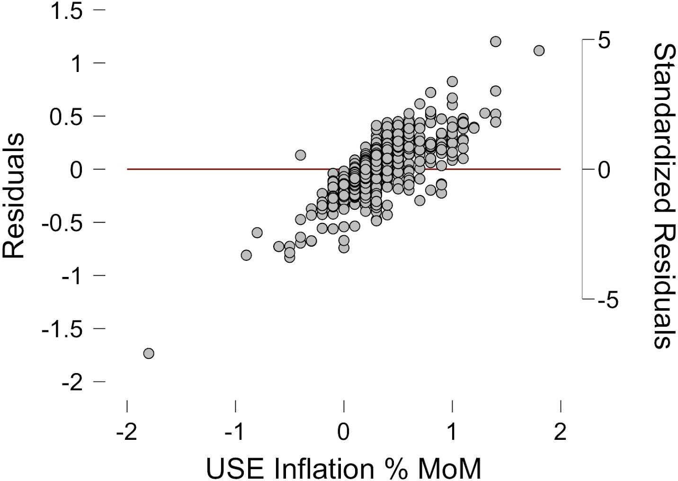

**Residuals vs. Predicted**

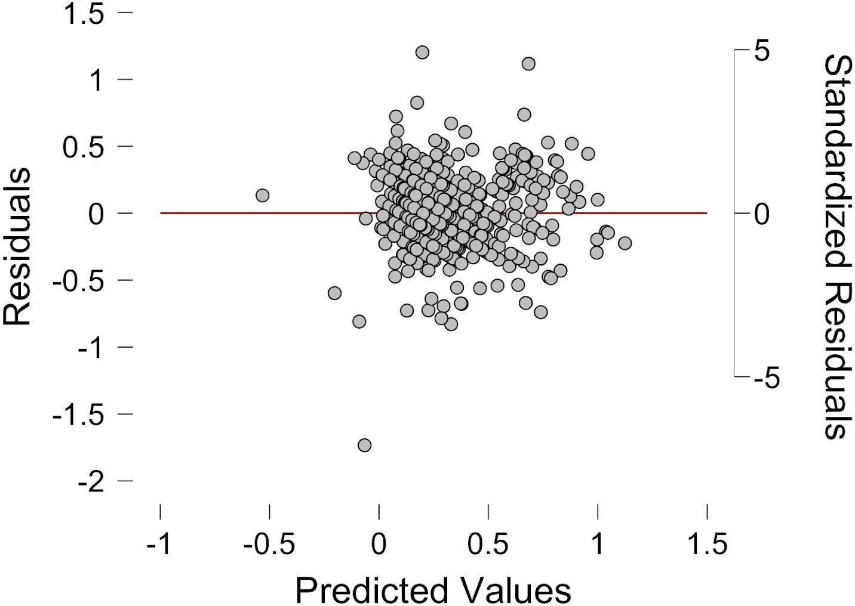

**Standardized Residuals Histogram**

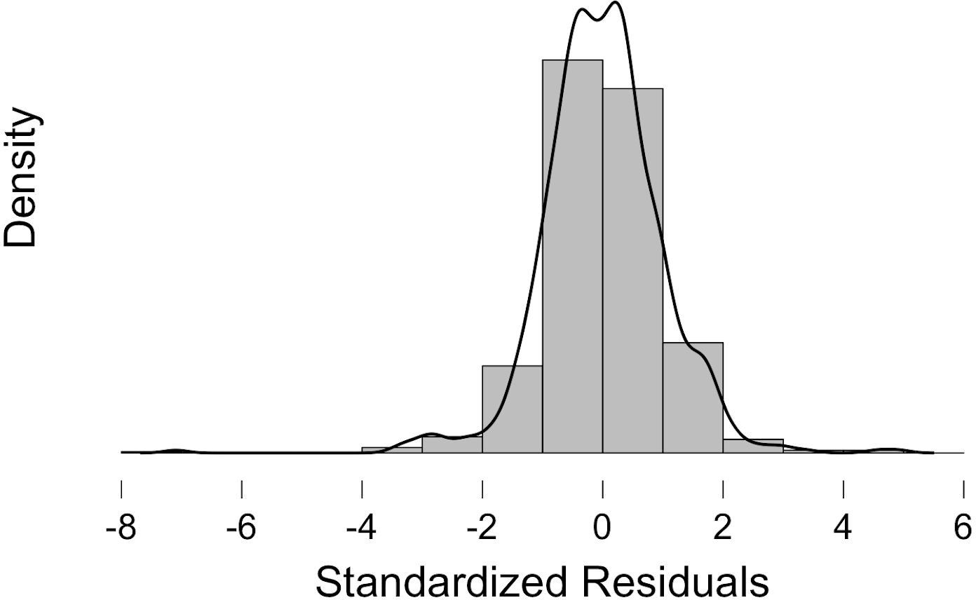

**Q-Q Plot Standardized Residuals**

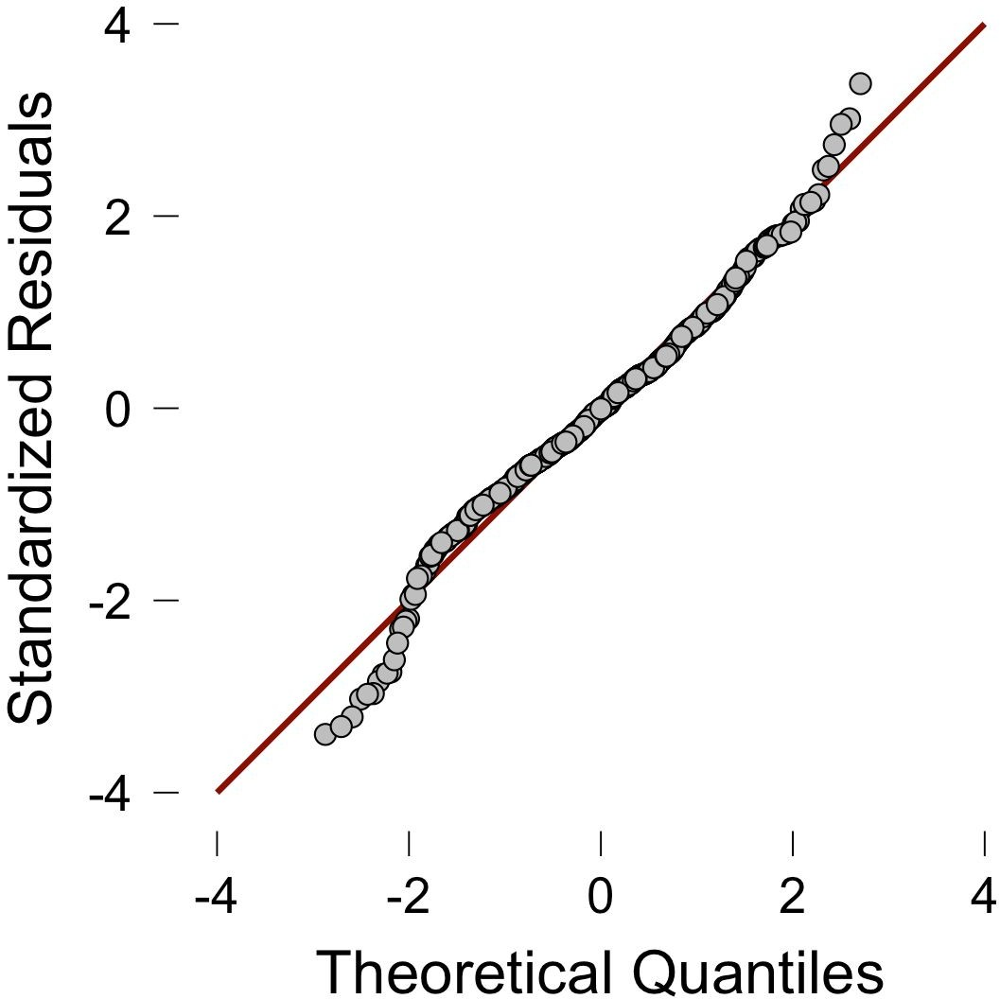

Germany Inflation Results

Linear Regression

Model Summary

Model R R² Adjusted R² RMSE Durbin-Watson

1 0.213 0.045 0.026 0.354 2.403

|  |  |  |  |  |  |  |
| --- | --- | --- | --- | --- | --- | --- |
| **ANOVA** |  | | | | | |
| **Model** |  | **Sum of Squares** | **df** | **Mean Square** | **F** | **p** |
| 1 | Regression | 2.037 | 7 | 0.291 | 2.317 | 0.025 |
|  | Residual | 42.942 | 342 | 0.126 |  |  |
|  | Total | 44.979 | 349 |  |  |  |

Coefficients

Collinearity Statistics

Model Unstandardized Standard Error Standardized t p Tolerance VIF

|  |  |  |  |  |  |  |  |  |
| --- | --- | --- | --- | --- | --- | --- | --- | --- |
| 1 | (Intercept) | -0.065 | 1.549 |  | -0.042 | 0.967 |  | |
|  | M2 Trillions | 0.104 | 0.313 | 0.212 | 0.333 | 0.739 | 0.007 | 145.387 |
|  | M2% Change | 8.003e -4 | 0.007 | 0.007 | 0.121 | 0.904 | 0.943 | 1.060 |
|  | Consumer Spending in Trillions | 0.077 | 12.314 | 0.002 | 0.006 | 0.995 | 0.025 | 40.628 |
|  | Personal Savings Rate | 0.017 | 0.033 | 0.045 | 0.515 | 0.607 | 0.369 | 2.710 |
|  | Government Spending to GDP&GDI Growth | -1.064e -5 | 1.577e -5 | -0.036 | -0.675 | 0.500 | 0.983 | 1.017 |
|  | 90-day Rates and Yields | 0.036 | 0.020 | 0.264 | 1.822 | 0.069 | 0.133 | 7.529 |
|  | Government Monthly Spending Trillions | -6.121 | 38.070 | -0.102 | -0.161 | 0.872 | 0.007 | 144.600 |

|  |  |  |  |  |
| --- | --- | --- | --- | --- |
| **Descriptives** |  | | | |
|  | **N** | **Mean** | **SD** | **SE** |
| Inflation Rate | 350 | 0.142 | 0.359 | 0.019 |
| M2 Trillions | 350 | 1.660 | 0.730 | 0.039 |
| M2% Change | 350 | 0.579 | 2.958 | 0.158 |
| Consumer Spending in Trillions | 350 | 0.123 | 0.010 | 5.248e -4 |
| Personal Savings Rate | 350 | 10.643 | 0.934 | 0.050 |
| Government Spending to GDP&GDI Growth | 350 | -128.857 | 1212.846 | 64.829 |

|  |  |  |  |  |
| --- | --- | --- | --- | --- |
| 90-day Rates and Yields | 350 | 2.809 | 2.653 | 0.142 |
| Government Monthly Spending Trillions | 350 | 0.043 | 0.006 | 3.202e -4 |

Collinearity Diagnostics

Variance Proportions

|  |  |  |  |  |  |  |  |  |
| --- | --- | --- | --- | --- | --- | --- | --- | --- |
| **Model Dimension Eigenvalue Condition** | **intercept** | **M2** | **M2%** | **Consumer** | **Personal** | **Government** | **90-day** | **Government** |
| **Index** |  | **Trillions** | **Change** | **Spending in Trillions** | **Savings Rate** | **Spending to GDP&GDI**  **Growth** | **Rates and**  **Yields** | **Monthly Spending**  **Trillions** |

|  |  |  |  |  |  |  |  |  |  |  |  |
| --- | --- | --- | --- | --- | --- | --- | --- | --- | --- | --- | --- |
| 1 | 1 | 5.412 | 1.000 | 0.000 | 0.000 | 0.002 | 0.000 | 0.000 | 0.001 | 0.001 | 0.000 |
|  | 2 | 0.993 | 2.335 | 0.000 | 0.000 | 0.132 | 0.000 | 0.000 | 0.826 | 0.000 | 0.000 |
|  | 3 | 0.957 | 2.378 | 0.000 | 0.000 | 0.780 | 0.000 | 0.000 | 0.156 | 0.001 | 0.000 |
|  | 4 | 0.619 | 2.958 | 0.000 | 0.000 | 0.035 | 0.000 | 0.000 | 0.000 | 0.073 | 0.000 |
|  | 5 | 0.017 | 18.034 | 0.002 | 0.036 | 0.001 | 0.000 | 0.011 | 0.003 | 0.573 | 0.000 |
|  | 6 | 0.003 | 42.997 | 0.005 | 0.001 | 0.004 | 0.007 | 0.707 | 0.008 | 0.260 | 0.001 |
|  | 7 | 1.109e -4 | 220.882 | 0.009 | 0.160 | 0.005 | 0.561 | 0.215 | 0.007 | 0.088 | 0.681 |
|  | 8 | 7.999e -5 | 260.105 | 0.985 | 0.802 | 0.042 | 0.432 | 0.068 | 0.000 | 0.004 | 0.318 |

|  |  |  |  |  |  |
| --- | --- | --- | --- | --- | --- |
| **Residuals Statistics** |  | | | | |
|  | **Minimum** | **Maximum** | **Mean** | **SD** | **N** |
| Predicted Value | 0.032 | 0.375 | 0.142 | 0.076 | 350 |
| Residual | -1.072 | 1.427 | 5.145e -18 | 0.351 | 350 |
| Std. Predicted Value | -1.433 | 3.050 | 1.481e -17 | 1.000 | 350 |
| Std. Residual | -3.038 | 4.086 | 0.004 | 1.004 | 350 |

Residuals vs. Dependent

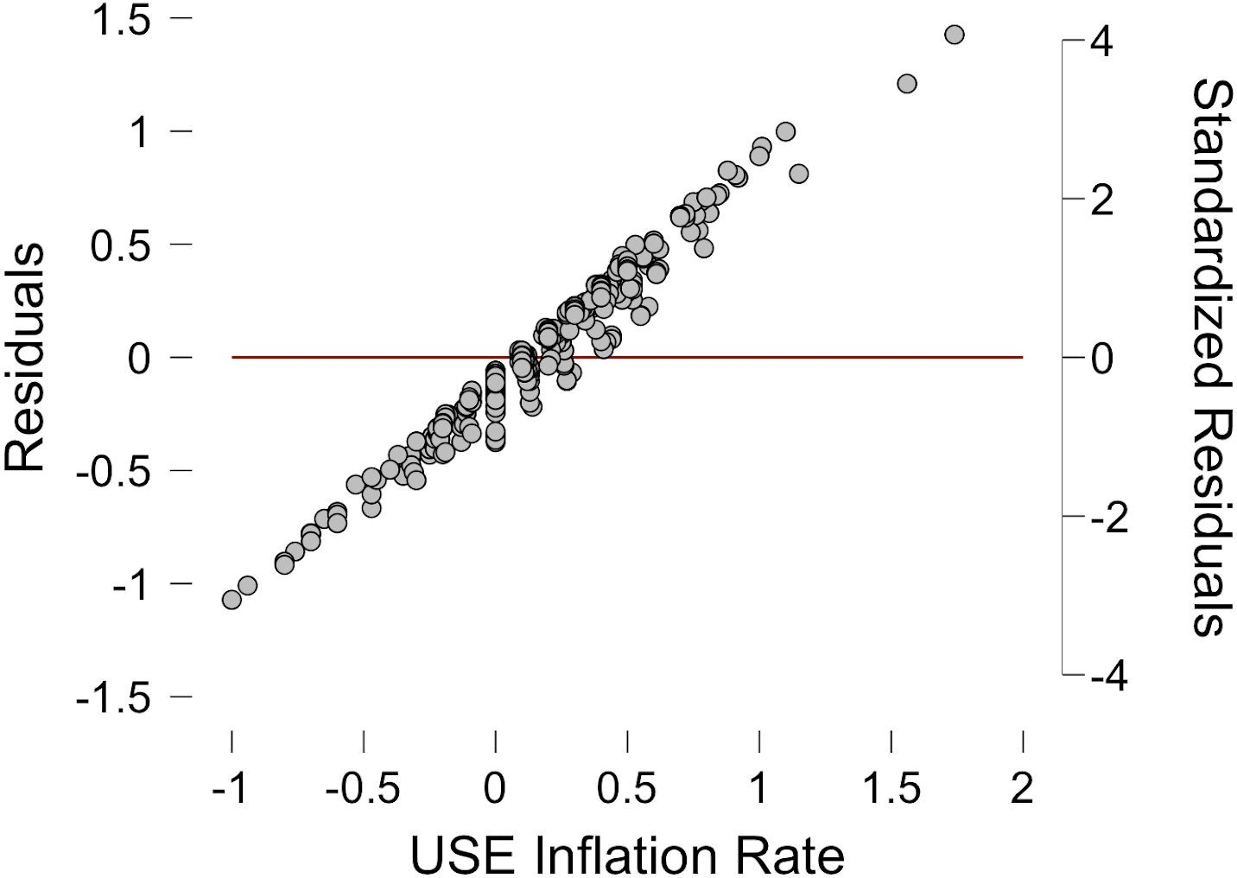

Residuals vs. Predicted

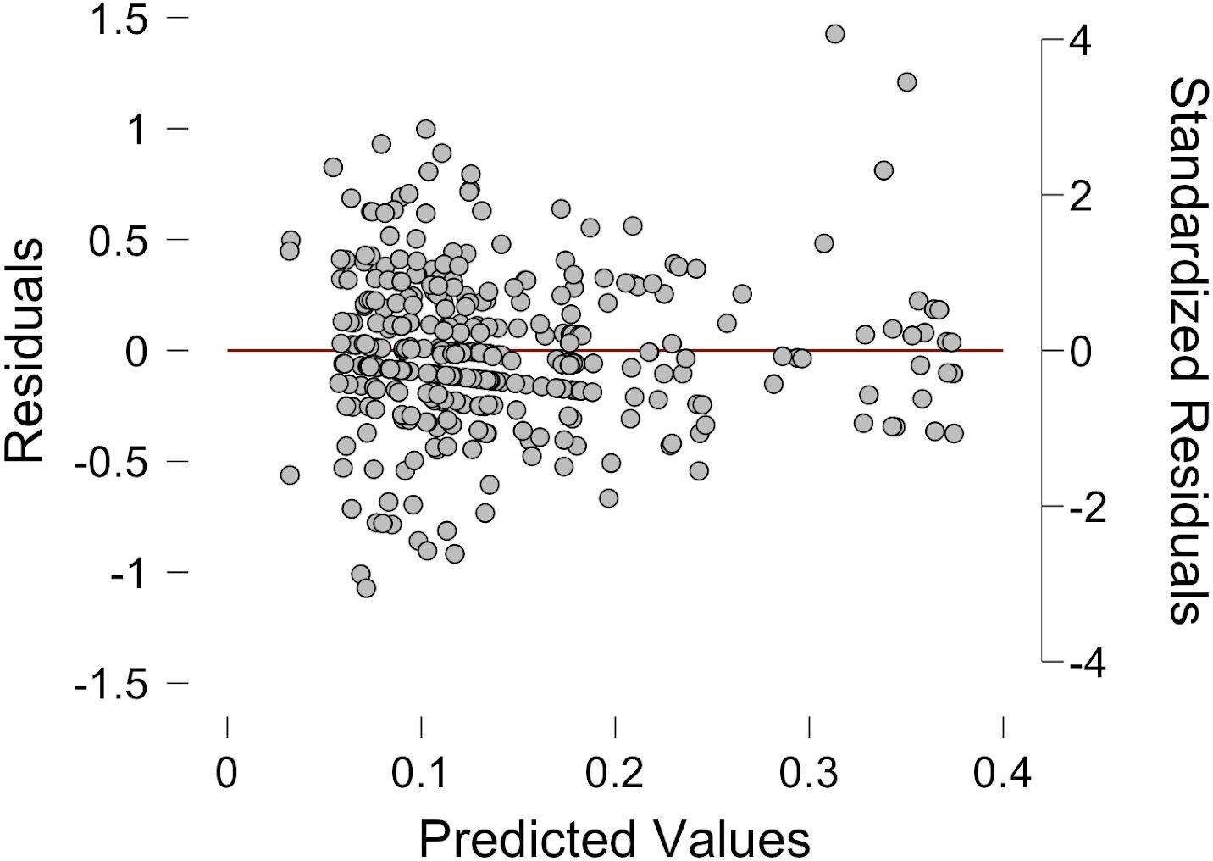

Standardized Residuals Histogram

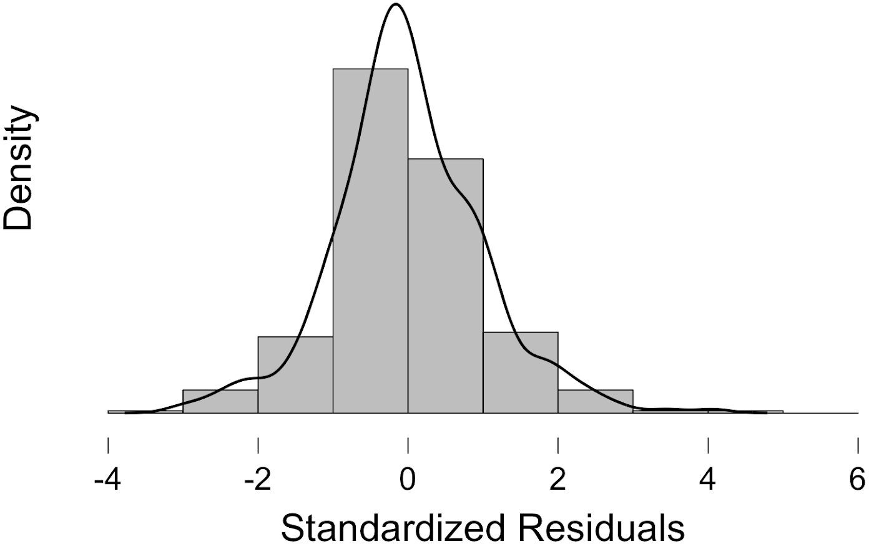

Q-Q Plot Standardized Residuals

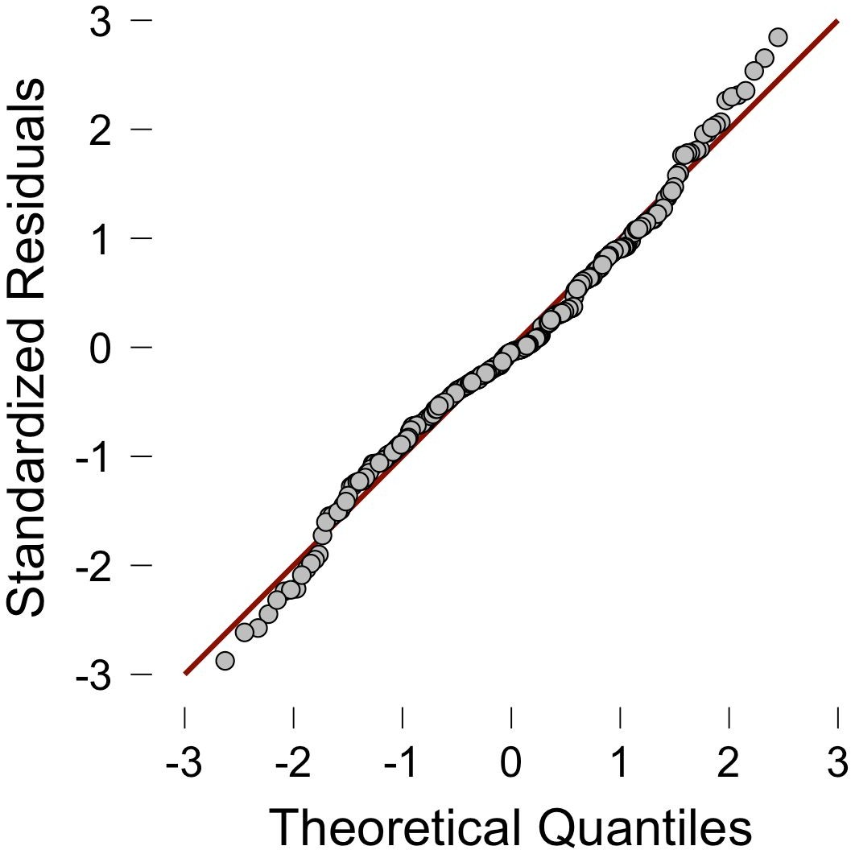

Germany Inflation Results

Linear Regression

Model Summary

Model R R² Adjusted R² RMSE Durbin-Watson

1 0.213 0.045 0.026 0.354 2.403

|  |  |  |  |  |  |  |
| --- | --- | --- | --- | --- | --- | --- |
| **ANOVA** |  | | | | | |
| **Model** |  | **Sum of Squares** | **df** | **Mean Square** | **F** | **p** |
| 1 | Regression | 2.037 | 7 | 0.291 | 2.317 | 0.025 |
|  | Residual | 42.942 | 342 | 0.126 |  |  |
|  | Total | 44.979 | 349 |  |  |  |

Coefficients

Collinearity Statistics

Model Unstandardized Standard Error Standardized t p Tolerance VIF

|  |  |  |  |  |  |  |  |  |
| --- | --- | --- | --- | --- | --- | --- | --- | --- |
| 1 | (Intercept) | -0.065 | 1.549 |  | -0.042 | 0.967 |  | |
|  | M2 Trillions | 0.104 | 0.313 | 0.212 | 0.333 | 0.739 | 0.007 | 145.387 |
|  | M2% Change | 8.003e -4 | 0.007 | 0.007 | 0.121 | 0.904 | 0.943 | 1.060 |
|  | Consumer Spending in Trillions | 0.077 | 12.314 | 0.002 | 0.006 | 0.995 | 0.025 | 40.628 |
|  | Personal Savings Rate | 0.017 | 0.033 | 0.045 | 0.515 | 0.607 | 0.369 | 2.710 |
|  | Government Spending to GDP&GDI Growth | -1.064e -5 | 1.577e -5 | -0.036 | -0.675 | 0.500 | 0.983 | 1.017 |
|  | 90-day Rates and Yields | 0.036 | 0.020 | 0.264 | 1.822 | 0.069 | 0.133 | 7.529 |
|  | Government Monthly Spending Trillions | -6.121 | 38.070 | -0.102 | -0.161 | 0.872 | 0.007 | 144.600 |

|  |  |  |  |  |
| --- | --- | --- | --- | --- |
| **Descriptives** |  | | | |
|  | **N** | **Mean** | **SD** | **SE** |
| Inflation Rate | 350 | 0.142 | 0.359 | 0.019 |
| M2 Trillions | 350 | 1.660 | 0.730 | 0.039 |
| M2% Change | 350 | 0.579 | 2.958 | 0.158 |
| Consumer Spending in Trillions | 350 | 0.123 | 0.010 | 5.248e -4 |
| Personal Savings Rate | 350 | 10.643 | 0.934 | 0.050 |
| Government Spending to GDP&GDI Growth | 350 | -128.857 | 1212.846 | 64.829 |

|  |  |  |  |  |
| --- | --- | --- | --- | --- |
| 90-day Rates and Yields | 350 | 2.809 | 2.653 | 0.142 |
| Government Monthly Spending Trillions | 350 | 0.043 | 0.006 | 3.202e -4 |

Collinearity Diagnostics

Variance Proportions

|  |  |  |  |  |  |  |  |  |
| --- | --- | --- | --- | --- | --- | --- | --- | --- |
| **Model Dimension Eigenvalue Condition** | **intercept** | **M2** | **M2%** | **Consumer** | **Personal** | **Government** | **90-day** | **Government** |
| **Index** |  | **Trillions** | **Change** | **Spending in Trillions** | **Savings Rate** | **Spending to GDP&GDI**  **Growth** | **Rates and**  **Yields** | **Monthly Spending**  **Trillions** |

|  |  |  |  |  |  |  |  |  |  |  |  |
| --- | --- | --- | --- | --- | --- | --- | --- | --- | --- | --- | --- |
| 1 | 1 | 5.412 | 1.000 | 0.000 | 0.000 | 0.002 | 0.000 | 0.000 | 0.001 | 0.001 | 0.000 |
|  | 2 | 0.993 | 2.335 | 0.000 | 0.000 | 0.132 | 0.000 | 0.000 | 0.826 | 0.000 | 0.000 |
|  | 3 | 0.957 | 2.378 | 0.000 | 0.000 | 0.780 | 0.000 | 0.000 | 0.156 | 0.001 | 0.000 |
|  | 4 | 0.619 | 2.958 | 0.000 | 0.000 | 0.035 | 0.000 | 0.000 | 0.000 | 0.073 | 0.000 |
|  | 5 | 0.017 | 18.034 | 0.002 | 0.036 | 0.001 | 0.000 | 0.011 | 0.003 | 0.573 | 0.000 |
|  | 6 | 0.003 | 42.997 | 0.005 | 0.001 | 0.004 | 0.007 | 0.707 | 0.008 | 0.260 | 0.001 |
|  | 7 | 1.109e -4 | 220.882 | 0.009 | 0.160 | 0.005 | 0.561 | 0.215 | 0.007 | 0.088 | 0.681 |
|  | 8 | 7.999e -5 | 260.105 | 0.985 | 0.802 | 0.042 | 0.432 | 0.068 | 0.000 | 0.004 | 0.318 |

|  |  |  |  |  |  |
| --- | --- | --- | --- | --- | --- |
| **Residuals Statistics** |  | | | | |
|  | **Minimum** | **Maximum** | **Mean** | **SD** | **N** |
| Predicted Value | 0.032 | 0.375 | 0.142 | 0.076 | 350 |
| Residual | -1.072 | 1.427 | 5.145e -18 | 0.351 | 350 |
| Std. Predicted Value | -1.433 | 3.050 | 1.481e -17 | 1.000 | 350 |
| Std. Residual | -3.038 | 4.086 | 0.004 | 1.004 | 350 |

Residuals vs. Dependent



Residuals vs. Predicted



Standardized Residuals Histogram



Q-Q Plot Standardized Residuals



China Inflation Results

Linear Regression

Model Summary

Model R R² Adjusted R² RMSE Durbin-Watson

1 0.177 0.031 0.003 0.764 1.392

|  |  |  |  |  |  |  |
| --- | --- | --- | --- | --- | --- | --- |
| **ANOVA** |  | | | | | |
| **Model** |  | **Sum of Squares** | **df** | **Mean Square** | **F** | **p** |
| 1 | Regression | 4.569 | 7 | 0.653 | 1.118 | 0.352 |
|  | Residual | 141.839 | 243 | 0.584 |  |  |
|  | Total | 146.407 | 250 |  |  |  |

Coefficients

Collinearity Statistics

Model Unstandardized Standard Error Standardized t p Tolerance VIF

|  |  |  |  |  |  |  |  |  |
| --- | --- | --- | --- | --- | --- | --- | --- | --- |
| 1 | (Intercept) | -0.142 | 1.252 |  | -0.113 | 0.910 |  | |
|  | M2 Trillions | -0.004 | 0.017 | -0.251 | -0.255 | 0.799 | 0.004 | 241.846 |
|  | M2 % Change | 0.025 | 0.039 | 0.041 | 0.642 | 0.522 | 0.963 | 1.039 |
|  | China Household Savings Rate | 0.011 | 0.025 | 0.055 | 0.438 | 0.662 | 0.249 | 4.020 |
|  | Consumer Spending in Trillions | 0.382 | 2.197 | 0.338 | 0.174 | 0.862 | 0.001 | 946.967 |
|  | Government Spending in Trillions | -0.104 | 2.845 | -0.065 | -0.036 | 0.971 | 0.001 | 806.090 |
|  | Trillions of Gov Dollars Per Share of GDP | -0.068 | 0.397 | -0.017 | -0.172 | 0.864 | 0.415 | 2.411 |
|  | China Real Interest Rate | -0.037 | 0.024 | -0.135 | -1.565 | 0.119 | 0.534 | 1.873 |

|  |  |  |  |  |
| --- | --- | --- | --- | --- |
| **Descriptives** |  | | | |
|  | **N** | **Mean** | **SD** | **SE** |
| Inflation MoM % | 251 | 0.150 | 0.765 | 0.048 |
| M2 Trillions | 251 | 50.852 | 43.808 | 2.765 |
| M2 % Change | 251 | 1.323 | 1.256 | 0.079 |
| China Household Savings Rate | 251 | 33.845 | 3.919 | 0.247 |
| Consumer Spending in Trillions | 251 | 0.984 | 0.677 | 0.043 |
| Government Spending in Trillions | 251 | 0.555 | 0.482 | 0.030 |

|  |  |  |  |  |
| --- | --- | --- | --- | --- |
| Trillions of Gov Dollars Per Share of GDP | 251 | 1.387 | 0.189 | 0.012 |
| China Real Interest Rate | 251 | 2.962 | 2.800 | 0.177 |

Collinearity Diagnostics

Variance Proportions

|  |  |  |  |  |  |  |  |  |
| --- | --- | --- | --- | --- | --- | --- | --- | --- |
| **Model Dimension Eigenvalue Condition** | **intercept** | **M2** | **M2 %** | **China** | **Consumer** | **Government** | **Trillions of** | **China Real** |
| **Index** |  | **Trillions** | **Change** | **Household** | **Spending in** | **Spending in** | **Gov Dollars** | **Interest** |
|  |  |  |  | **Savings Rate** | **Trillions** | **Trillions** | **Per Share** | **Rate** |
|  |  |  |  |  |  |  | **of GDP** |  |

|  |  |  |  |  |  |  |  |  |  |  |  |
| --- | --- | --- | --- | --- | --- | --- | --- | --- | --- | --- | --- |
| 1 | 1 | 6.359 | 1.000 | 0.000 | 0.000 | 0.006 | 0.000 | 0.000 | 0.000 | 0.000 | 0.003 |
|  | 2 | 0.888 | 2.677 | 0.000 | 0.000 | 0.115 | 0.000 | 0.000 | 0.000 | 0.000 | 0.058 |
|  | 3 | 0.480 | 3.641 | 0.000 | 0.000 | 0.428 | 0.000 | 0.000 | 0.000 | 0.000 | 0.286 |
|  | 4 | 0.260 | 4.942 | 0.001 | 0.000 | 0.425 | 0.002 | 0.000 | 0.000 | 0.005 | 0.161 |
|  | 5 | 0.010 | 25.059 | 0.003 | 0.001 | 0.014 | 0.132 | 0.000 | 0.000 | 0.421 | 0.011 |
|  | 6 | 0.002 | 64.122 | 0.361 | 0.286 | 0.000 | 0.284 | 0.000 | 0.054 | 0.379 | 0.279 |
|  | 7 | 9.971e -4 | 79.859 | 0.285 | 0.649 | 0.001 | 0.503 | 0.046 | 0.067 | 0.183 | 0.034 |
|  | 8 | 2.097e -4 | 174.160 | 0.351 | 0.063 | 0.011 | 0.079 | 0.953 | 0.878 | 0.012 | 0.167 |

|  |  |  |  |  |  |
| --- | --- | --- | --- | --- | --- |
| **Residuals Statistics** |  | | | | |
|  | **Minimum** | **Maximum** | **Mean** | **SD** | **N** |
| Predicted Value | -0.094 | 0.482 | 0.150 | 0.135 | 251 |
| Residual | -1.756 | 2.197 | -4.572e -18 | 0.753 | 251 |
| Std. Predicted Value | -1.808 | 2.456 | -1.020e -16 | 1.000 | 251 |
| Std. Residual | -2.328 | 2.927 | 0.002 | 1.004 | 251 |

Residuals vs. Dependent

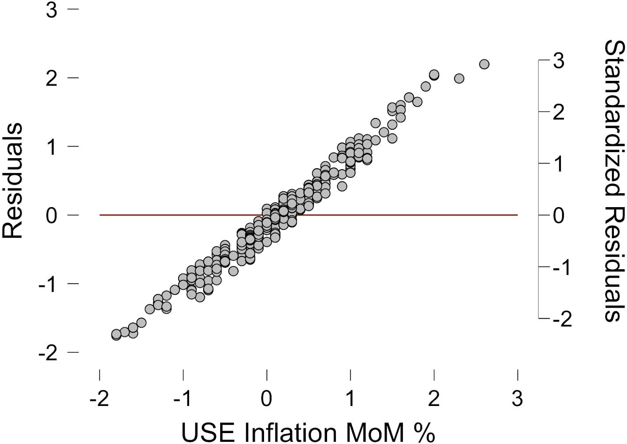

Residuals vs. Predicted

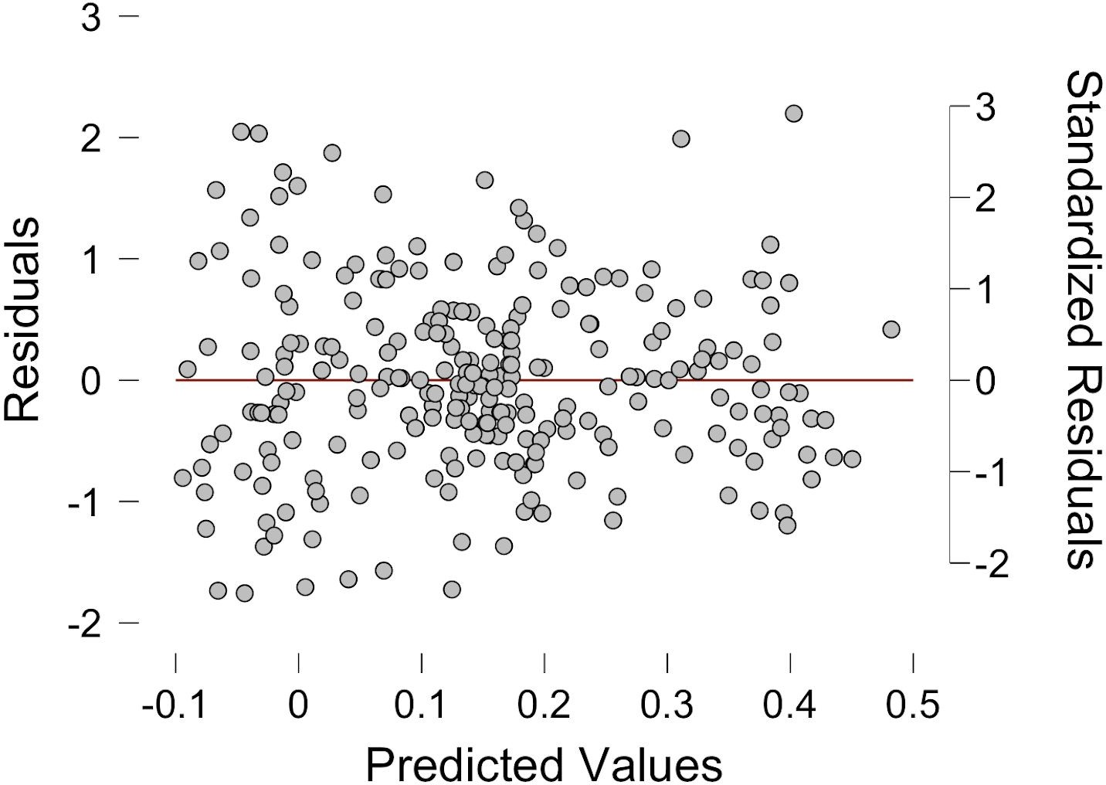

Standardized Residuals Histogram

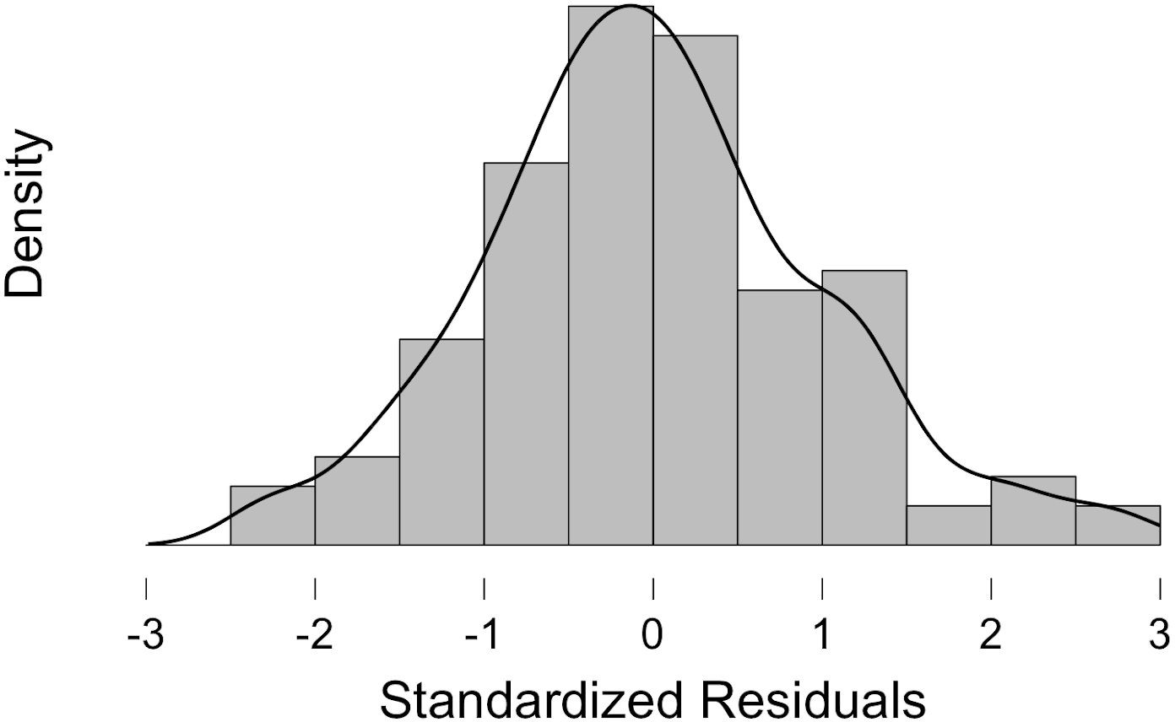

Q-Q Plot Standardized Residuals

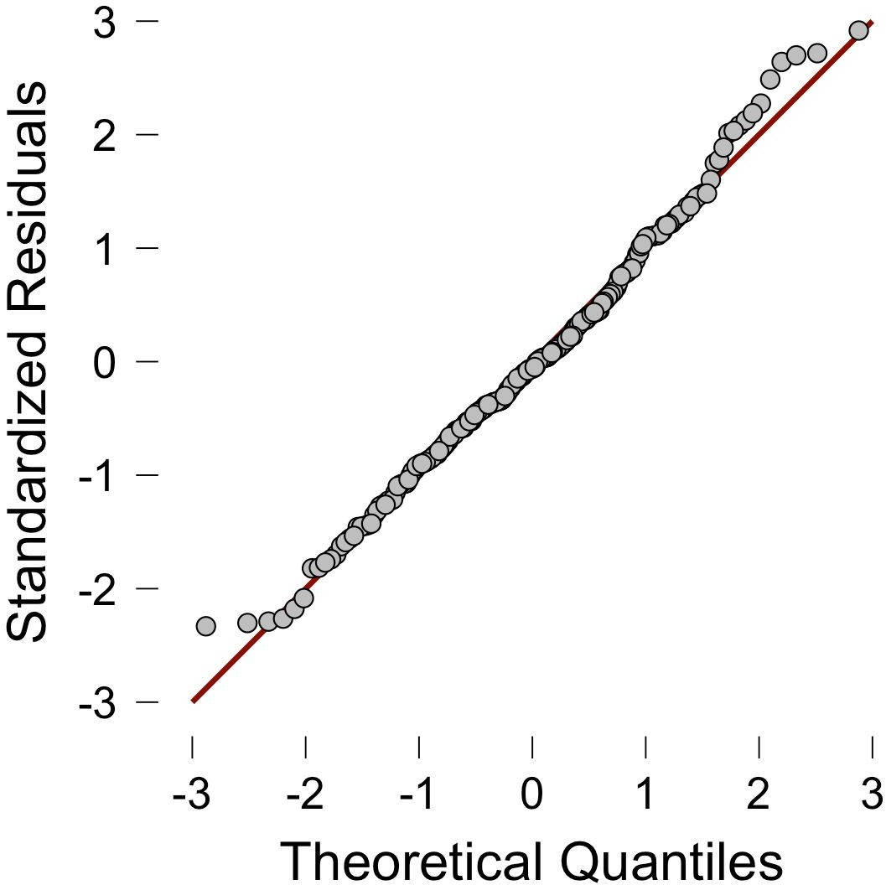

|  |  |  |  |  |  |  |  |  |  |  |  |
| --- | --- | --- | --- | --- | --- | --- | --- | --- | --- | --- | --- |
| **US Inflation** | | | | | | | | |  |  |  |
| **Date** | **M2 Trillions** | **M2 % Change** | **Inflation % MoM**  0.0000  0.2000 | **Personal Spending Month over**  **Month % Change**  -0.2000  1.3000 | **Personal Savings Rate**  11.2000  10.6000 | **Government Spending to GDP&GDI**  **Growth**  13.887705  13.887705 | **Highest Historical Marginal Income Tax Rates**  91  91 | **Federal Funds Rate**  2.960000  2.900000 |  |  |  |
| 1959-04-01 | 0.2901 | 0.3112 |
| 1959-05-01 | 0.2922 | 0.7239 |
| 1959-06-01 | 0.2941 | 0.6502 | 0.2000 | 0.7000 | 10.5000 | 13.887705 | 91 | 3.390000 |  |  |  |
| 1959-07-01 | 0.2952 | 0.3740 | 0.1000 | -0.1000 | 10.7000 | -90.67715094 | 91 | 3.470000 |  |  |  |
| 1959-08-01 | 0.2964 | 0.4065 | 0.1000 | 0.7000 | 9.6000 | -90.67715094 | 91 | 3.500000 |
| 1959-09-01 | 0.2967 | 0.1012 | 0.2000 | 1.3000 | 8.7000 | -90.67715094 | 91 | 3.760000 |
| 1959-10-01 | 0.2965 | -0.0674 | 0.3000 | -0.4000 | 9.4000 | 70.13932511 | 91 | 3.980000 |  |  |  |
| 1959-11-01 | 0.2971 | 0.20236 | 0.0000 | 0.0000 | 10.1000 | 70.13932511 | 91 | 4.000000 |  |  |  |
| 1959-12-01 | 0.2978 | 0.23561 | 0.2000 | 0.0000 | 11.0000 | 70.13932511 | 91 | 3.990000 |
| 1960-01-01 | 0.2982 | 0.13432 | -0.1000 | 0.2000 | 10.9000 | 14.83879213 | 91 | 3.990000 |
| 1960-02-01 | 0.2985 | 0.10060 | 0.1000 | 0.5000 | 10.6000 | 14.83879213 | 91 | 3.970000 |
| 1960-03-01 | 0.2994 | 0.30151 | 0.0000 | 1.5000 | 9.4000 | 14.83879213 | 91 | 3.840000 |  |  |  |
| 1960-04-01 | 0.3001 | 0.23380 | 0.4000 | 1.9000 | 8.4000 | -117.8523475 | 91 | 3.920000 |  |  |  |
| 1960-05-01 | 0.3009 | 0.26658 | 0.1000 | -1.9000 | 10.4000 | -117.8523475 | 91 | 3.850000 |
| 1960-06-01 | 0.3023 | 0.46527 | 0.1000 | 0.0000 | 10.4000 | -117.8523475 | 91 | 3.320000 |
| 1960-07-01 | 0.3041 | 0.59543 | -0.2000 | 0.4000 | 10.4000 | 137.0799601 | 91 | 3.230000 |  |  |  |
| 1960-08-01 | 0.3069 | 0.92075 | 0.2000 | 0.1000 | 10.3000 | 137.0799601 | 91 | 2.980000 |  |  |  |
| 1960-09-01 | 0.3084 | 0.48876 | 0.0000 | 0.5000 | 10.0000 | 137.0799601 | 91 | 2.600000 |
| 1960-10-01 | 0.3095 | 0.35668 | 0.5000 | 0.6000 | 9.8000 | -37.07627714 | 91 | 2.470000 |
| 1960-11-01 | 0.3109 | 0.45234 | 0.1000 | 0.0000 | 9.8000 | -37.07627714 | 91 | 2.440000 |
| 1960-12-01 | 0.3124 | 0.48247 | 0.1000 | -1.2000 | 10.4000 | -37.07627714 | 91 | 1.980000 |  |  |  |
| 1961-01-01 | 0.3141 | 0.54417 | 0.1000 | 0.3000 | 11.1000 | 79.0763552 | 91 | 1.450000 |  |  |  |
| 1961-02-01 | 0.3165 | 0.76409 | 0.0000 | 0.5000 | 11.1000 | 79.0763552 | 91 | 2.540000 |
| 1961-03-01 | 0.3183 | 0.56872 | 0.0000 | 1.2000 | 10.4000 | 79.0763552 | 91 | 2.020000 |
| 1961-04-01 | 0.3199 | 0.50267 | -0.1000 | 0.0000 | 10.6000 | 20.44827711 | 91 | 1.490000 |  |  |  |
| 1961-05-01 | 0.3222 | 0.71897 | 0.1000 | 0.7000 | 10.8000 | 20.44827711 | 91 | 1.980000 |  |  |  |
| 1961-06-01 | 0.3243 | 0.65177 | 0.0000 | 0.3000 | 11.5000 | 20.44827711 | 91 | 1.730000 |
| 1961-07-01 | 0.3256 | 0.40086 | 0.3000 | -0.1000 | 12.0000 | 19.68917232 | 91 | 1.170000 |
| 1961-08-01 | 0.3276 | 0.61425 | 0.1000 | 0.4000 | 11.7000 | 19.68917232 | 91 | 2.000000 |  |  |  |
| 1961-09-01 | 0.3295 | 0.57998 | 0.1000 | 0.7000 | 11.3000 | 19.68917232 | 91 | 1.880000 |  |  |  |
| 1961-10-01 | 0.3311 | 0.48558 | 0.0000 | 0.6000 | 11.7000 | 16.12320697 | 91 | 2.260000 |
| 1961-11-01 | 0.3334 | 0.69465 | 0.0000 | 1.0000 | 11.6000 | 16.12320697 | 91 | 2.610000 |
| 1961-12-01 | 0.3355 | 0.62987 | 0.1000 | 0.7000 | 11.6000 | 16.12320697 | 91 | 2.330000 |
| 1962-01-01 | 0.3375 | 0.59613 | 0.1000 | 0.2000 | 11.3000 | 23.25988909 | 91 | 2.150000 |  |  |  |
| 1962-02-01 | 0.3401 | 0.77037 | 0.2000 | 0.2000 | 11.8000 | 23.25988909 | 91 | 2.370000 |  |  |  |
| 1962-03-01 | 0.3431 | 0.88209 | 0.2000 | 1.0000 | 11.6000 | 23.25988909 | 91 | 2.850000 |
| 1962-04-01 | 0.3455 | 0.69950 | 0.1000 | 0.5000 | 11.7000 | 34.24078387 | 91 | 2.780000 |
| 1962-05-01 | 0.3475 | 0.57887 | 0.1000 | 0.8000 | 11.1000 | 34.24078387 | 91 | 2.360000 |  |  |  |
| 1962-06-01 | 0.3493 | 0.51799 | -0.1000 | -0.4000 | 11.5000 | 34.24078387 | 91 | 2.680000 |  |  |  |
| 1962-07-01 | 0.3508 | 0.42943 | 0.0000 | 0.3000 | 11.6000 | 31.18550263 | 91 | 2.710000 |
| 1962-08-01 | 0.3528 | 0.57013 | 0.2000 | 0.4000 | 11.4000 | 31.18550263 | 91 | 2.930000 |
| 1962-09-01 | 0.3549 | 0.59524 | 0.5000 | 1.6000 | 10.4000 | 31.18550263 | 91 | 2.900000 |
| 1962-10-01 | 0.3572 | 0.64807 | -0.1000 | -0.6000 | 11.3000 | 46.39579364 | 91 | 2.900000 |  |  |  |
| 1962-11-01 | 0.3598 | 0.72788 | 0.0000 | 1.4000 | 10.4000 | 46.39579364 | 91 | 2.940000 |  |  |  |
| 1962-12-01 | 0.3627 | 0.80600 | 0.0000 | 0.5000 | 10.3000 | 46.39579364 | 91 | 2.930000 |
| 1963-01-01 | 0.3652 | 0.68927 | 0.2000 | 0.2000 | 10.9000 | 34.80655151 | 91 | 2.920000 |
| 1963-02-01 | 0.3679 | 0.73932 | 0.1000 | -0.3000 | 10.7000 | 34.80655151 | 91 | 3.000000 |  |  |  |
| 1963-03-01 | 0.3707 | 0.76108 | 0.1000 | 0.4000 | 10.6000 | 34.80655151 | 91 | 2.980000 |  |  |  |
| 1963-04-01 | 0.3733 | 0.70138 | -0.1000 | 0.4000 | 10.7000 | 26.18134449 | 91 | 2.900000 |
| 1963-05-01 | 0.3761 | 0.75007 | 0.1000 | 0.2000 | 10.9000 | 26.18134449 | 91 | 3.000000 |

|  |  |  |  |  |  |  |  |  |  |  |  |
| --- | --- | --- | --- | --- | --- | --- | --- | --- | --- | --- | --- |
| 1963-06-01 | 0.3784 | 0.61154 | 0.3000  0.3000 | 1.2000  0.7000 | 10.5000  10.1000 | 26.18134449  19.63046944 | 91  91 | 2.990000  3.020000 |  |  |  |
| 1963-07-01 | 0.3811 | 0.71353 |
| 1963-08-01 | 0.3836 | 0.65600 | 0.2000 | 0.5000 | 10.2000 | 19.63046944 | 91 | 3.490000 |  |  |  |
| 1963-09-01 | 0.386 | 0.62565 | -0.1000 | -0.2000 | 11.0000 | 19.63046944 | 91 | 3.480000 |  |  |  |
| 1963-10-01 | 0.3883 | 0.59585 | 0.1000 | 0.1000 | 11.5000 | 44.4182908 | 91 | 3.500000 |
| 1963-11-01 | 0.3915 | 0.82411 | 0.1000 | 0.9000 | 11.0000 | 44.4182908 | 91 | 3.480000 |
| 1963-12-01 | 0.3932 | 0.43423 | 0.3000 | 1.3000 | 10.7000 | 44.4182908 | 91 | 3.380000 |  |  |  |
| 1964-01-01 | 0.3952 | 0.50865 | 0.2000 | 0.5000 | 10.7000 | 17.85553948 | 77 | 3.480000 |  |  |  |
| 1964-02-01 | 0.3976 | 0.60729 | -0.1000 | 0.9000 | 10.4000 | 17.85553948 | 77 | 3.480000 |
| 1964-03-01 | 0.3998 | 0.55332 | 0.1000 | 0.4000 | 12.1000 | 17.85553948 | 77 | 3.430000 |
| 1964-04-01 | 0.4017 | 0.47524 | 0.0000 | 0.3000 | 12.4000 | 25.99537872 | 77 | 3.470000 |  |  |  |
| 1964-05-01 | 0.4042 | 0.62235 | 0.1000 | 1.4000 | 11.7000 | 25.99537872 | 77 | 3.500000 |  |  |  |
| 1964-06-01 | 0.4071 | 0.71747 | 0.1000 | 0.7000 | 11.5000 | 25.99537872 | 77 | 3.500000 |
| 1964-07-01 | 0.4101 | 0.73692 | 0.0000 | 0.9000 | 11.2000 | 22.13423085 | 77 | 3.420000 |
| 1964-08-01 | 0.4134 | 0.80468 | 0.1000 | 0.7000 | 11.1000 | 22.13423085 | 77 | 3.500000 |
| 1964-09-01 | 0.4169 | 0.84664 | 0.1000 | -0.3000 | 11.8000 | 22.13423085 | 77 | 3.450000 |  |  |  |
| 1964-10-01 | 0.4191 | 0.52770 | 0.1000 | 0.7000 | 11.2000 | 51.17655502 | 77 | 3.360000 |  |  |  |
| 1964-11-01 | 0.422 | 0.69196 | 0.3000 | -0.8000 | 12.5000 | 51.17655502 | 77 | 3.520000 |
| 1964-12-01 | 0.4247 | 0.63981 | 0.1000 | 1.1000 | 12.5000 | 51.17655502 | 77 | 3.850000 |
| 1965-01-01 | 0.4275 | 0.65929 | 0.1000 | 0.8000 | 12.1000 | 13.86594058 | 70 | 3.900000 |  |  |  |
| 1965-02-01 | 0.4304 | 0.67836 | 0.0000 | 1.6000 | 10.7000 | 13.86594058 | 70 | 3.980000 |  |  |  |
| 1965-03-01 | 0.4332 | 0.65056 | 0.1000 | 0.4000 | 10.8000 | 13.86594058 | 70 | 4.050000 |
| 1965-04-01 | 0.4354 | 0.50785 | 0.2000 | 0.9000 | 10.2000 | 25.11514037 | 70 | 4.090000 |
| 1965-05-01 | 0.4371 | 0.39045 | 0.3000 | 0.1000 | 11.2000 | 25.11514037 | 70 | 4.100000 |
| 1965-06-01 | 0.4401 | 0.68634 | 0.4000 | -0.5000 | 12.1000 | 25.11514037 | 70 | 4.050000 |  |  |  |
| 1965-07-01 | 0.4429 | 0.63622 | -0.1000 | 1.3000 | 11.9000 | 17.90659487 | 70 | 4.090000 |  |  |  |
| 1965-08-01 | 0.4458 | 0.65478 | -0.1000 | 0.8000 | 11.7000 | 17.90659487 | 70 | 4.120000 |
| 1965-09-01 | 0.4495 | 0.82997 | 0.2000 | 1.7000 | 12.5000 | 17.90659487 | 70 | 4.020000 |
| 1965-10-01 | 0.4526 | 0.68966 | 0.1000 | 1.4000 | 10.9000 | 14.49249708 | 70 | 4.080000 |  |  |  |
| 1965-11-01 | 0.4557 | 0.68493 | 0.3000 | 0.1000 | 11.5000 | 14.49249708 | 70 | 4.100000 |  |  |  |
| 1965-12-01 | 0.4592 | 0.76805 | 0.3000 | 0.6000 | 11.7000 | 14.49249708 | 70 | 4.320000 |
| 1966-01-01 | 0.462 | 0.60976 | 0.1000 | 0.8000 | 11.2000 | 14.01773532 | 70 | 4.420000 |
| 1966-02-01 | 0.4646 | 0.56277 | 0.6000 | 1.1000 | 11.0000 | 14.01773532 | 70 | 4.600000 |  |  |  |
| 1966-03-01 | 0.4672 | 0.55962 | 0.3000 | 1.0000 | 10.7000 | 14.01773532 | 70 | 4.660000 |  |  |  |
| 1966-04-01 | 0.4693 | 0.44949 | 0.3000 | 0.4000 | 10.3000 | 64.16006518 | 70 | 4.670000 |
| 1966-05-01 | 0.4701 | 0.17047 | 0.2000 | -0.8000 | 11.2000 | 64.16006518 | 70 | 4.900000 |
| 1966-06-01 | 0.4712 | 0.23399 | 0.1000 | 0.5000 | 11.4000 | 64.16006518 | 70 | 5.170000 |
| 1966-07-01 | 0.4709 | -0.06367 | 0.2000 | 1.1000 | 10.9000 | 42.96724311 | 70 | 5.300000 |  |  |  |
| 1966-08-01 | 0.4726 | 0.36101 | 0.6000 | 0.5000 | 11.2000 | 42.96724311 | 70 | 5.530000 |  |  |  |
| 1966-09-01 | 0.4754 | 0.59247 | 0.3000 | 1.2000 | 11.0000 | 42.96724311 | 70 | 5.400000 |
| 1966-10-01 | 0.4757 | 0.06310 | 0.3000 | -0.2000 | 11.6000 | 39.08190406 | 70 | 5.530000 |
| 1966-11-01 | 0.4773 | 0.33635 | 0.1000 | 0.4000 | 11.8000 | 39.08190406 | 70 | 5.760000 |  |  |  |
| 1966-12-01 | 0.4802 | 0.60758 | 0.1000 | 0.4000 | 11.6000 | 39.08190406 | 70 | 5.400000 |  |  |  |
| 1967-01-01 | 0.4816 | 0.29155 | -0.1000 | 0.5000 | 12.1000 | 46.85422041 | 70 | 4.940000 |
| 1967-02-01 | 0.4851 | 0.72674 | 0.3000 | -0.3000 | 12.6000 | 46.85422041 | 70 | 5.000000 |
| 1967-03-01 | 0.4897 | 0.94826 | 0.0000 | 0.6000 | 12.8000 | 46.85422041 | 70 | 4.530000 |
| 1967-04-01 | 0.4921 | 0.49010 | 0.3000 | 1.1000 | 11.9000 | 111.7223837 | 70 | 4.050000 |  |  |  |
| 1967-05-01 | 0.4972 | 1.03637 | 0.0000 | 0.2000 | 12.0000 | 111.7223837 | 70 | 3.940000 |  |  |  |
| 1967-06-01 | 0.502 | 0.96541 | 0.6000 | 0.9000 | 11.9000 | 111.7223837 | 70 | 3.980000 |
| 1967-07-01 | 0.5063 | 0.85657 | 0.3000 | 0.0000 | 12.6000 | 34.37001658 | 70 | 3.790000 |
| 1967-08-01 | 0.5108 | 0.88880 | 0.3000 | 0.6000 | 12.6000 | 34.37001658 | 70 | 3.900000 |  |  |  |
| 1967-09-01 | 0.5147 | 0.76351 | 0.3000 | 1.1000 | 11.9000 | 34.37001658 | 70 | 3.990000 |  |  |  |
| 1967-10-01 | 0.5182 | 0.68001 | 0.3000 | -0.7000 | 12.9000 | 38.85180591 | 70 | 3.880000 |
| 1967-11-01 | 0.5212 | 0.57893 | 0.6000 | 1.0000 | 12.8000 | 38.85180591 | 70 | 4.130000 |

|  |  |  |  |  |  |  |  |  |  |  |  |
| --- | --- | --- | --- | --- | --- | --- | --- | --- | --- | --- | --- |
| 1967-12-01 | 0.5248 | 0.69071 | 0.3000  0.3000 | 1.5000  1.1000 | 11.8000  11.7000 | 38.85180591  19.6085903 | 70  75.25 | 4.510000  4.610000 |  |  |  |
| 1968-01-01 | 0.5274 | 0.49543 |
| 1968-02-01 | 0.5304 | 0.56883 | 0.3000 | 0.5000 | 12.3000 | 19.6085903 | 75.25 | 4.710000 |  |  |  |
| 1968-03-01 | 0.5332 | 0.52790 | 0.3000 | 2.0000 | 11.7000 | 19.6085903 | 75.25 | 5.050000 |  |  |  |
| 1968-04-01 | 0.5357 | 0.46887 | 0.3000 | -0.1000 | 12.3000 | 21.45892924 | 75.25 | 5.760000 |
| 1968-05-01 | 0.5389 | 0.59735 | 0.3000 | 1.1000 | 12.0000 | 21.45892924 | 75.25 | 6.120000 |
| 1968-06-01 | 0.5426 | 0.68658 | 0.6000 | 1.2000 | 11.7000 | 21.45892924 | 75.25 | 6.070000 |  |  |  |
| 1968-07-01 | 0.5456 | 0.55289 | 0.6000 | 1.2000 | 10.7000 | 31.63039713 | 75.25 | 6.030000 |  |  |  |
| 1968-08-01 | 0.5494 | 0.69648 | 0.3000 | 0.7000 | 10.5000 | 31.63039713 | 75.25 | 6.030000 |
| 1968-09-01 | 0.5536 | 0.76447 | 0.3000 | 0.2000 | 10.6000 | 31.63039713 | 75.25 | 5.780000 |
| 1968-10-01 | 0.5576 | 0.72254 | 0.6000 | 0.6000 | 10.8000 | 62.35130421 | 75.25 | 5.910000 |  |  |  |
| 1968-11-01 | 0.5624 | 0.86083 | 0.3000 | 0.9000 | 10.6000 | 62.35130421 | 75.25 | 5.820000 |  |  |  |
| 1968-12-01 | 0.5668 | 0.78236 | 0.6000 | 0.0000 | 11.1000 | 62.35130421 | 75.25 | 6.020000 |
| 1969-01-01 | 0.5693 | 0.44107 | 0.3000 | 1.2000 | 10.3000 | 26.20124151 | 77 | 6.300000 |
| 1969-02-01 | 0.5719 | 0.45670 | 0.3000 | 0.9000 | 9.7000 | 26.20124151 | 77 | 6.610000 |
| 1969-03-01 | 0.5744 | 0.43714 | 0.8000 | 0.0000 | 10.2000 | 26.20124151 | 77 | 6.790000 |  |  |  |
| 1969-04-01 | 0.5757 | 0.22632 | 0.6000 | 0.9000 | 9.7000 | 71.79489012 | 77 | 7.410000 |  |  |  |
| 1969-05-01 | 0.5765 | 0.13896 | 0.3000 | 1.1000 | 10.1000 | 71.79489012 | 77 | 8.670000 |
| 1969-06-01 | 0.5785 | 0.34692 | 0.5000 | 0.1000 | 11.1000 | 71.79489012 | 77 | 8.900000 |
| 1969-07-01 | 0.5795 | 0.17286 | 0.5000 | 0.3000 | 11.8000 | 48.87282658 | 77 | 8.610000 |  |  |  |
| 1969-08-01 | 0.5801 | 0.10354 | 0.3000 | 1.2000 | 11.5000 | 48.87282658 | 77 | 9.190000 |  |  |  |
| 1969-09-01 | 0.5821 | 0.34477 | 0.5000 | 0.5000 | 11.6000 | 48.87282658 | 77 | 9.150000 |
| 1969-10-01 | 0.5834 | 0.22333 | 0.5000 | 0.9000 | 11.4000 | -91.83020285 | 77 | 9.000000 |
| 1969-11-01 | 0.5854 | 0.34282 | 0.5000 | 0.3000 | 11.6000 | -91.83020285 | 77 | 8.850000 |
| 1969-12-01 | 0.5879 | 0.42706 | 0.5000 | 0.4000 | 11.8000 | -91.83020285 | 77 | 8.970000 |  |  |  |
| 1970-01-01 | 0.5896 | 0.28916 | 0.5000 | 1.0000 | 11.8000 | -77.6287187 | 71.75 | 8.980000 |  |  |  |
| 1970-02-01 | 0.5863 | -0.55970 | 0.5000 | 0.8000 | 11.7000 | -77.6287187 | 71.75 | 8.980000 |
| 1970-03-01 | 0.5873 | 0.17056 | 0.5000 | -0.3000 | 12.4000 | -77.6287187 | 71.75 | 7.760000 |
| 1970-04-01 | 0.5884 | 0.18730 | 0.5000 | 0.6000 | 13.3000 | 396.2761156 | 71.75 | 8.100000 |  |  |  |
| 1970-05-01 | 0.5915 | 0.52685 | 0.3000 | 1.0000 | 12.4000 | 396.2761156 | 71.75 | 7.950000 |  |  |  |
| 1970-06-01 | 0.5952 | 0.62553 | 0.5000 | 0.6000 | 12.3000 | 396.2761156 | 71.75 | 7.610000 |
| 1970-07-01 | 0.5991 | 0.65524 | 0.3000 | 0.3000 | 13.5000 | 36.314646 | 71.75 | 7.210000 |
| 1970-08-01 | 0.6049 | 0.96812 | 0.3000 | 0.7000 | 13.4000 | 36.314646 | 71.75 | 6.620000 |  |  |  |
| 1970-09-01 | 0.6112 | 1.04149 | 0.5000 | 0.9000 | 12.9000 | 36.314646 | 71.75 | 6.290000 |  |  |  |
| 1970-10-01 | 0.6164 | 0.85079 | 0.5000 | -0.1000 | 13.1000 | -31.39307063 | 71.75 | 6.200000 |
| 1970-11-01 | 0.6211 | 0.76249 | 0.5000 | -0.3000 | 13.6000 | -31.39307063 | 71.75 | 5.600000 |
| 1970-12-01 | 0.6265 | 0.86943 | 0.5000 | 1.4000 | 13.2000 | -31.39307063 | 71.75 | 4.900000 |
| 1971-01-01 | 0.6329 | 1.02155 | 0.3000 | 1.6000 | 13.3000 | 13.33866379 | 77 | 4.140000 |  |  |  |
| 1971-02-01 | 0.641 | 1.27982 | 0.0000 | 0.5000 | 13.3000 | 13.33866379 | 77 | 3.720000 |  |  |  |
| 1971-03-01 | 0.6499 | 1.38846 | 0.3000 | 0.4000 | 13.5000 | 13.33866379 | 77 | 3.710000 |
| 1971-04-01 | 0.6584 | 1.30789 | 0.2000 | 1.0000 | 13.2000 | 51.30034561 | 77 | 4.160000 |
| 1971-05-01 | 0.6667 | 1.26063 | 0.5000 | 0.3000 | 13.6000 | 51.30034561 | 77 | 4.630000 |  |  |  |
| 1971-06-01 | 0.673 | 0.94495 | 0.5000 | 1.3000 | 14.7000 | 51.30034561 | 77 | 4.910000 |  |  |  |
| 1971-07-01 | 0.6796 | 0.98068 | 0.2000 | -0.1000 | 13.8000 | 36.44389069 | 77 | 5.310000 |
| 1971-08-01 | 0.6855 | 0.86816 | 0.2000 | 0.9000 | 13.6000 | 36.44389069 | 77 | 5.570000 |
| 1971-09-01 | 0.6925 | 1.02115 | 0.2000 | 1.1000 | 13.3000 | 36.44389069 | 77 | 5.550000 |
| 1971-10-01 | 0.6984 | 0.85199 | 0.2000 | 0.4000 | 13.3000 | 40.0826989 | 77 | 5.200000 |  |  |  |
| 1971-11-01 | 0.7046 | 0.88774 | 0.2000 | 0.7000 | 13.1000 | 40.0826989 | 77 | 4.910000 |  |  |  |
| 1971-12-01 | 0.7103 | 0.80897 | 0.2000 | 1.0000 | 13.0000 | 40.0826989 | 77 | 4.140000 |
| 1972-01-01 | 0.7177 | 1.04181 | 0.2000 | 0.4000 | 12.5000 | 18.19034124 | 77 | 3.510000 |
| 1972-02-01 | 0.7257 | 1.11467 | 0.5000 | 0.6000 | 12.8000 | 18.19034124 | 77 | 3.300000 |  |  |  |
| 1972-03-01 | 0.7335 | 1.07482 | 0.0000 | 1.8000 | 11.8000 | 18.19034124 | 77 | 3.830000 |  |  |  |
| 1972-04-01 | 0.7384 | 0.66803 | 0.2000 | 0.4000 | 11.5000 | 16.62410524 | 77 | 4.170000 |
| 1972-05-01 | 0.7433 | 0.66360 | 0.2000 | 0.7000 | 11.7000 | 16.62410524 | 77 | 4.270000 |

|  |  |  |  |  |  |  |  |  |  |  |  |
| --- | --- | --- | --- | --- | --- | --- | --- | --- | --- | --- | --- |
| 1972-06-01 | 0.7497 | 0.86103 | 0.2000  0.2000 | 0.5000  1.1000 | 11.7000  11.7000 | 16.62410524  22.09914358 | 77  77 | 4.460000  4.550000 |  |  |  |
| 1972-07-01 | 0.7595 | 1.30719 |
| 1972-08-01 | 0.7687 | 1.21132 | 0.2000 | 0.8000 | 12.0000 | 22.09914358 | 77 | 4.810000 |  |  |  |
| 1972-09-01 | 0.7783 | 1.24886 | 0.5000 | 0.6000 | 12.2000 | 22.09914358 | 77 | 4.870000 |  |  |  |
| 1972-10-01 | 0.7869 | 1.10497 | 0.2000 | 1.8000 | 13.0000 | 13.35471481 | 77 | 5.050000 |
| 1972-11-01 | 0.7939 | 0.88957 | 0.5000 | 0.7000 | 13.6000 | 13.35471481 | 77 | 5.060000 |
| 1972-12-01 | 0.8023 | 1.05807 | 0.2000 | 0.7000 | 13.7000 | 13.35471481 | 77 | 5.330000 |  |  |  |
| 1973-01-01 | 0.8103 | 0.99713 | 0.5000 | 1.3000 | 12.4000 | 13.14483963 | 77 | 5.940000 |  |  |  |
| 1973-02-01 | 0.8141 | 0.46896 | 0.7000 | 1.1000 | 12.5000 | 13.14483963 | 77 | 6.580000 |
| 1973-03-01 | 0.8153 | 0.14740 | 0.9000 | 0.8000 | 12.7000 | 13.14483963 | 77 | 7.090000 |
| 1973-04-01 | 0.8197 | 0.53968 | 0.7000 | 0.4000 | 13.2000 | 33.24077931 | 77 | 7.120000 |  |  |  |
| 1973-05-01 | 0.8268 | 0.86617 | 0.5000 | 0.7000 | 13.2000 | 33.24077931 | 77 | 7.840000 |  |  |  |
| 1973-06-01 | 0.8333 | 0.78616 | 0.7000 | 0.3000 | 13.6000 | 33.24077931 | 77 | 8.490000 |
| 1973-07-01 | 0.8365 | 0.38402 | 0.0000 | 1.2000 | 13.2000 | -256.4113463 | 77 | 10.400000 |
| 1973-08-01 | 0.8388 | 0.27496 | 1.8000 | -0.1000 | 13.9000 | -256.4113463 | 77 | 10.500000 |
| 1973-09-01 | 0.8393 | 0.05961 | 0.4000 | 1.9000 | 13.1000 | -256.4113463 | 77 | 10.780000 |  |  |  |
| 1973-10-01 | 0.8426 | 0.39318 | 0.9000 | -0.1000 | 14.4000 | 26.89569449 | 77 | 10.010000 |  |  |  |
| 1973-11-01 | 0.8489 | 0.74769 | 0.7000 | 1.0000 | 14.4000 | 26.89569449 | 77 | 10.030000 |
| 1973-12-01 | 0.8555 | 0.77748 | 0.9000 | 0.0000 | 14.8000 | 26.89569449 | 77 | 9.950000 |
| 1974-01-01 | 0.8597 | 0.49094 | 1.1000 | 0.9000 | 14.3000 | -32.8224068 | 77 | 9.650000 |  |  |  |
| 1974-02-01 | 0.8642 | 0.52344 | 1.1000 | 0.6000 | 14.2000 | -32.8224068 | 77 | 8.970000 |  |  |  |
| 1974-03-01 | 0.8701 | 0.68271 | 1.1000 | 1.3000 | 13.4000 | -32.8224068 | 77 | 9.350000 |
| 1974-04-01 | 0.8729 | 0.32180 | 0.6000 | 1.0000 | 13.1000 | -353.9240363 | 77 | 10.510000 |
| 1974-05-01 | 0.8746 | 0.19475 | 1.0000 | 1.3000 | 12.8000 | -353.9240363 | 77 | 11.310000 |
| 1974-06-01 | 0.8778 | 0.36588 | 0.8000 | 0.6000 | 12.8000 | -353.9240363 | 77 | 11.930000 |  |  |  |
| 1974-07-01 | 0.8814 | 0.41012 | 0.6000 | 1.1000 | 12.8000 | -37.0394098 | 77 | 12.920000 |  |  |  |
| 1974-08-01 | 0.8841 | 0.30633 | 1.2000 | 1.8000 | 12.1000 | -37.0394098 | 77 | 12.010000 |
| 1974-09-01 | 0.8879 | 0.42982 | 1.4000 | 0.0000 | 12.9000 | -37.0394098 | 77 | 11.340000 |
| 1974-10-01 | 0.8933 | 0.60818 | 0.8000 | 0.4000 | 13.4000 | -35.35785163 | 77 | 10.060000 |  |  |  |
| 1974-11-01 | 0.8986 | 0.59331 | 1.0000 | -0.3000 | 13.8000 | -35.35785163 | 77 | 9.450000 |  |  |  |
| 1974-12-01 | 0.9021 | 0.38949 | 0.8000 | 0.6000 | 14.0000 | -35.35785163 | 77 | 8.530000 |
| 1975-01-01 | 0.9063 | 0.46558 | 0.8000 | 1.4000 | 13.2000 | -24.14754348 | 77 | 7.130000 |
| 1975-02-01 | 0.9141 | 0.86064 | 0.6000 | 1.4000 | 12.5000 | -24.14754348 | 77 | 6.240000 |  |  |  |
| 1975-03-01 | 0.925 | 1.19243 | 0.4000 | 0.1000 | 12.7000 | -24.14754348 | 77 | 5.540000 |  |  |  |
| 1975-04-01 | 0.9351 | 1.09189 | 0.4000 | 0.5000 | 14.2000 | 36.98713162 | 77 | 5.490000 |
| 1975-05-01 | 0.9479 | 1.36884 | 0.2000 | 2.4000 | 17.3000 | 36.98713162 | 77 | 5.220000 |
| 1975-06-01 | 0.963 | 1.59300 | 0.8000 | 0.8000 | 14.3000 | 36.98713162 | 77 | 5.550000 |
| 1975-07-01 | 0.9751 | 1.25649 | 0.9000 | 1.3000 | 12.6000 | 15.40468327 | 77 | 6.100000 |  |  |  |
| 1975-08-01 | 0.9831 | 0.82043 | 0.4000 | 0.7000 | 13.0000 | 15.40468327 | 77 | 6.140000 |  |  |  |
| 1975-09-01 | 0.9915 | 0.85444 | 0.7000 | 0.8000 | 13.0000 | 15.40468327 | 77 | 6.240000 |
| 1975-10-01 | 0.9978 | 0.63540 | 0.5000 | 0.6000 | 13.4000 | 24.24182243 | 77 | 5.820000 |
| 1975-11-01 | 1.0069 | 0.91201 | 0.7000 | 1.4000 | 12.7000 | 24.24182243 | 77 | 5.220000 |  |  |  |
| 1975-12-01 | 1.0162 | 0.92363 | 0.5000 | 1.5000 | 12.0000 | 24.24182243 | 77 | 5.200000 |  |  |  |
| 1976-01-01 | 1.0266 | 1.02342 | 0.4000 | 1.4000 | 11.7000 | 13.070305 | 77 | 4.870000 |
| 1976-02-01 | 1.0403 | 1.33450 | 0.2000 | 0.0000 | 12.3000 | 13.070305 | 77 | 4.770000 |
| 1976-03-01 | 1.05 | 0.93242 | 0.2000 | 0.6000 | 12.2000 | 13.070305 | 77 | 4.840000 |
| 1976-04-01 | 1.0608 | 1.02857 | 0.2000 | 0.9000 | 11.7000 | 40.1624953 | 77 | 4.820000 |  |  |  |
| 1976-05-01 | 1.0721 | 1.06523 | 0.5000 | -0.2000 | 12.3000 | 40.1624953 | 77 | 5.290000 |  |  |  |
| 1976-06-01 | 1.0776 | 0.51301 | 0.5000 | 1.6000 | 11.4000 | 40.1624953 | 77 | 5.480000 |
| 1976-07-01 | 1.0863 | 0.80735 | 0.5000 | 0.8000 | 11.7000 | 41.38668082 | 77 | 5.310000 |
| 1976-08-01 | 1.0987 | 1.14149 | 0.5000 | 0.7000 | 11.7000 | 41.38668082 | 77 | 5.290000 |  |  |  |
| 1976-09-01 | 1.1108 | 1.10130 | 0.5000 | 0.9000 | 11.4000 | 41.38668082 | 77 | 5.250000 |  |  |  |
| 1976-10-01 | 1.125 | 1.27836 | 0.5000 | 0.7000 | 11.1000 | 51.73311095 | 77 | 5.020000 |
| 1976-11-01 | 1.1382 | 1.17333 | 0.3000 | 1.0000 | 11.4000 | 51.73311095 | 77 | 4.950000 |

|  |  |  |  |  |  |  |  |  |  |  |  |
| --- | --- | --- | --- | --- | --- | --- | --- | --- | --- | --- | --- |
| 1976-12-01 | 1.152 | 1.21244 | 0.5000  0.5000 | 1.9000  0.3000 | 10.6000  10.6000 | 51.73311095  23.55323255 | 77  77 | 4.650000  4.610000 |  |  |  |
| 1977-01-01 | 1.1652 | 1.14583 |
| 1977-02-01 | 1.1776 | 1.06419 | 1.0000 | 1.3000 | 9.3000 | 23.55323255 | 77 | 4.680000 |  |  |  |
| 1977-03-01 | 1.1885 | 0.92561 | 0.5000 | 0.6000 | 10.5000 | 23.55323255 | 77 | 4.690000 |  |  |  |
| 1977-04-01 | 1.1996 | 0.93395 | 0.7000 | 0.7000 | 10.5000 | 12.56411762 | 77 | 4.730000 |
| 1977-05-01 | 1.209 | 0.78359 | 0.3000 | 0.8000 | 10.3000 | 12.56411762 | 77 | 5.350000 |
| 1977-06-01 | 1.2178 | 0.72787 | 0.5000 | 0.5000 | 10.6000 | 12.56411762 | 77 | 5.390000 |  |  |  |
| 1977-07-01 | 1.2267 | 0.73083 | 0.5000 | 1.3000 | 10.5000 | 14.52889288 | 77 | 5.420000 |  |  |  |
| 1977-08-01 | 1.237 | 0.83965 | 0.5000 | 0.4000 | 10.9000 | 14.52889288 | 77 | 5.900000 |
| 1977-09-01 | 1.2462 | 0.74373 | 0.3000 | 0.7000 | 11.1000 | 14.52889288 | 77 | 6.140000 |
| 1977-10-01 | 1.254 | 0.62590 | 0.5000 | 1.3000 | 11.0000 | 90.02487837 | 77 | 6.470000 |  |  |  |
| 1977-11-01 | 1.2624 | 0.66986 | 0.6000 | 1.2000 | 11.2000 | 90.02487837 | 77 | 6.510000 |  |  |  |
| 1977-12-01 | 1.2703 | 0.62579 | 0.5000 | 0.7000 | 11.4000 | 90.02487837 | 77 | 6.560000 |
| 1978-01-01 | 1.2797 | 0.73998 | 0.6000 | -0.5000 | 11.9000 | 56.42771523 | 77 | 6.700000 |
| 1978-02-01 | 1.2855 | 0.45323 | 0.5000 | 1.9000 | 11.1000 | 56.42771523 | 77 | 6.780000 |
| 1978-03-01 | 1.2922 | 0.52120 | 0.6000 | 1.7000 | 11.0000 | 56.42771523 | 77 | 6.790000 |  |  |  |
| 1978-04-01 | 1.3004 | 0.63458 | 0.8000 | 1.4000 | 10.8000 | 7.675605103 | 77 | 6.890000 |  |  |  |
| 1978-05-01 | 1.3105 | 0.77668 | 0.9000 | 1.1000 | 10.3000 | 7.675605103 | 77 | 7.360000 |
| 1978-06-01 | 1.3185 | 0.61045 | 0.8000 | 1.0000 | 10.0000 | 7.675605103 | 77 | 7.600000 |
| 1978-07-01 | 1.3241 | 0.42473 | 0.8000 | 0.1000 | 10.9000 | 29.7110112 | 77 | 7.810000 |  |  |  |
| 1978-08-01 | 1.3335 | 0.70992 | 0.6000 | 1.4000 | 10.5000 | 29.7110112 | 77 | 8.040000 |  |  |  |
| 1978-09-01 | 1.345 | 0.86239 | 0.9000 | 0.4000 | 10.6000 | 29.7110112 | 77 | 8.450000 |
| 1978-10-01 | 1.3523 | 0.54275 | 0.9000 | 1.0000 | 10.7000 | 22.25691508 | 77 | 8.960000 |
| 1978-11-01 | 1.3591 | 0.50285 | 0.6000 | 0.9000 | 10.5000 | 22.25691508 | 77 | 9.760000 |
| 1978-12-01 | 1.366 | 0.50769 | 0.6000 | 1.1000 | 10.4000 | 22.25691508 | 77 | 10.030000 |  |  |  |
| 1979-01-01 | 1.3716 | 0.40996 | 0.9000 | 0.4000 | 11.1000 | 52.27194535 | 77 | 10.070000 |  |  |  |
| 1979-02-01 | 1.3778 | 0.45203 | 1.0000 | 1.0000 | 11.1000 | 52.27194535 | 77 | 10.060000 |
| 1979-03-01 | 1.3878 | 0.72579 | 1.0000 | 0.9000 | 11.2000 | 52.27194535 | 77 | 10.090000 |
| 1979-04-01 | 1.4021 | 1.03041 | 1.0000 | 0.5000 | 11.0000 | -131.0780382 | 77 | 10.010000 |  |  |  |
| 1979-05-01 | 1.4102 | 0.57770 | 1.1000 | 1.3000 | 10.3000 | -131.0780382 | 77 | 10.240000 |  |  |  |
| 1979-06-01 | 1.423 | 0.90767 | 1.1000 | 1.1000 | 9.9000 | -131.0780382 | 77 | 10.290000 |
| 1979-07-01 | 1.4348 | 0.82923 | 1.1000 | 0.7000 | 10.6000 | 58.56355204 | 77 | 10.470000 |
| 1979-08-01 | 1.4466 | 0.82241 | 1.0000 | 1.9000 | 9.7000 | 58.56355204 | 77 | 10.940000 |  |  |  |
| 1979-09-01 | 1.4541 | 0.51846 | 0.9000 | 1.1000 | 9.4000 | 58.56355204 | 77 | 11.430000 |  |  |  |
| 1979-10-01 | 1.4604 | 0.43326 | 1.1000 | 0.5000 | 9.7000 | 79.73297091 | 77 | 13.770000 |
| 1979-11-01 | 1.4659 | 0.37661 | 1.1000 | 1.0000 | 9.7000 | 79.73297091 | 77 | 13.180000 |
| 1979-12-01 | 1.4737 | 0.53210 | 1.2000 | 0.5000 | 10.1000 | 79.73297091 | 77 | 13.780000 |
| 1980-01-01 | 1.4827 | 0.61071 | 1.4000 | 1.9000 | 9.9000 | 220.7122576 | 77 | 13.820000 |  |  |  |
| 1980-02-01 | 1.4946 | 0.80259 | 1.3000 | 0.2000 | 10.1000 | 220.7122576 | 77 | 14.130000 |  |  |  |
| 1980-03-01 | 1.4998 | 0.34792 | 1.4000 | 0.4000 | 10.2000 | 220.7122576 | 77 | 17.190000 |
| 1980-04-01 | 1.5022 | 0.16002 | 1.0000 | -0.8000 | 11.3000 | -14.02451004 | 77 | 17.610000 |
| 1980-05-01 | 1.5123 | 0.67235 | 1.0000 | 0.3000 | 11.4000 | -14.02451004 | 77 | 10.980000 |  |  |  |
| 1980-06-01 | 1.5292 | 1.11750 | 1.0000 | 1.1000 | 11.2000 | -14.02451004 | 77 | 9.470000 |  |  |  |
| 1980-07-01 | 1.5455 | 1.06592 | 0.1000 | 1.6000 | 11.3000 | 83.3313641 | 77 | 9.030000 |
| 1980-08-01 | 1.5615 | 1.03526 | 0.7000 | 1.0000 | 11.3000 | 83.3313641 | 77 | 9.610000 |
| 1980-09-01 | 1.574 | 0.80051 | 0.8000 | 0.9000 | 11.7000 | 83.3313641 | 77 | 10.870000 |
| 1980-10-01 | 1.5848 | 0.68615 | 1.0000 | 2.1000 | 11.3000 | 12.35243818 | 77 | 12.810000 |  |  |  |
| 1980-11-01 | 1.5958 | 0.69409 | 1.1000 | 0.5000 | 11.6000 | 12.35243818 | 77 | 15.850000 |  |  |  |
| 1980-12-01 | 1.5998 | 0.25066 | 0.9000 | 1.4000 | 11.4000 | 12.35243818 | 77 | 18.900000 |
| 1981-01-01 | 1.6069 | 0.44381 | 0.9000 | 1.0000 | 10.9000 | 19.14303125 | 69.13 | 19.080000 |
| 1981-02-01 | 1.6187 | 0.73433 | 0.9000 | 0.8000 | 10.8000 | 19.14303125 | 69.13 | 15.930000 |  |  |  |
| 1981-03-01 | 1.6366 | 1.10583 | 0.7000 | 1.0000 | 10.8000 | 19.14303125 | 69.13 | 14.700000 |  |  |  |
| 1981-04-01 | 1.6592 | 1.38091 | 0.6000 | 0.1000 | 10.9000 | -71.81340185 | 69.13 | 15.720000 |
| 1981-05-01 | 1.6642 | 0.30135 | 0.7000 | 0.5000 | 11.0000 | -71.81340185 | 69.13 | 18.520000 |

|  |  |  |  |  |  |  |  |  |  |  |  |
| --- | --- | --- | --- | --- | --- | --- | --- | --- | --- | --- | --- |
| 1981-06-01 | 1.6703 | 0.36654 | 0.9000  1.1000 | 1.1000  0.4000 | 10.8000  12.3000 | -71.81340185  19.29961974 | 69.13  69.13 | 19.100000  19.040000 |  |  |  |
| 1981-07-01 | 1.6819 | 0.69449 |
| 1981-08-01 | 1.6943 | 0.73726 | 0.8000 | 1.3000 | 12.0000 | 19.29961974 | 69.13 | 17.820000 |  |  |  |
| 1981-09-01 | 1.706 | 0.69055 | 1.0000 | -0.1000 | 12.4000 | 19.29961974 | 69.13 | 15.870000 |  |  |  |
| 1981-10-01 | 1.7218 | 0.92614 | 0.3000 | -0.1000 | 13.0000 | -23.997754 | 69.13 | 15.080000 |
| 1981-11-01 | 1.7361 | 0.83053 | 0.4000 | 0.3000 | 13.2000 | -23.997754 | 69.13 | 13.310000 |
| 1981-12-01 | 1.7555 | 1.11745 | 0.3000 | 0.9000 | 12.5000 | -23.997754 | 69.13 | 12.370000 |  |  |  |
| 1982-01-01 | 1.7704 | 0.84876 | 0.3000 | 0.4000 | 12.7000 | -21.82624593 | 50 | 13.220000 |  |  |  |
| 1982-02-01 | 1.7745 | 0.23159 | 0.3000 | 1.2000 | 12.1000 | -21.82624593 | 50 | 14.780000 |
| 1982-03-01 | 1.7865 | 0.67625 | 0.0000 | 0.1000 | 12.2000 | -21.82624593 | 50 | 14.680000 |
| 1982-04-01 | 1.8039 | 0.97397 | 0.3000 | 0.1000 | 12.9000 | 63.58175671 | 50 | 14.940000 |  |  |  |
| 1982-05-01 | 1.8154 | 0.63751 | 0.9000 | 0.9000 | 12.3000 | 63.58175671 | 50 | 14.450000 |  |  |  |
| 1982-06-01 | 1.826 | 0.58389 | 1.1000 | 0.2000 | 12.3000 | 63.58175671 | 50 | 14.150000 |
| 1982-07-01 | 1.8315 | 0.30120 | 0.5000 | 1.2000 | 12.5000 | -67.78271455 | 50 | 12.590000 |
| 1982-08-01 | 1.8452 | 0.74802 | 0.2000 | 0.4000 | 12.6000 | -67.78271455 | 50 | 10.120000 |
| 1982-09-01 | 1.8584 | 0.71537 | 0.0000 | 1.2000 | 11.8000 | -67.78271455 | 50 | 10.310000 |  |  |  |
| 1982-10-01 | 1.8697 | 0.60805 | 0.4000 | 1.0000 | 11.3000 | -133.7973822 | 50 | 9.710000 |  |  |  |
| 1982-11-01 | 1.8837 | 0.74878 | -0.1000 | 1.1000 | 10.9000 | -133.7973822 | 50 | 9.200000 |
| 1982-12-01 | 1.9059 | 1.17853 | -0.3000 | 0.6000 | 10.9000 | -133.7973822 | 50 | 8.950000 |
| 1983-01-01 | 1.9594 | 2.80707 | 0.2000 | 0.6000 | 11.1000 | 22.50916148 | 50 | 8.680000 |  |  |  |
| 1983-02-01 | 1.9968 | 1.90875 | 0.1000 | 0.1000 | 11.1000 | 22.50916148 | 50 | 8.510000 |  |  |  |
| 1983-03-01 | 2.0152 | 0.92147 | 0.1000 | 1.2000 | 10.6000 | 22.50916148 | 50 | 8.770000 |
| 1983-04-01 | 2.0286 | 0.66495 | 0.7000 | 1.1000 | 10.3000 | 13.55997055 | 50 | 8.800000 |
| 1983-05-01 | 2.0431 | 0.71478 | 0.4000 | 0.9000 | 9.9000 | 13.55997055 | 50 | 8.630000 |
| 1983-06-01 | 2.0535 | 0.50903 | 0.2000 | 1.3000 | 9.1000 | 13.55997055 | 50 | 8.980000 |  |  |  |
| 1983-07-01 | 2.0648 | 0.55028 | 0.4000 | 1.2000 | 9.6000 | 15.79634595 | 50 | 9.370000 |  |  |  |
| 1983-08-01 | 2.074 | 0.44556 | 0.3000 | 0.7000 | 9.2000 | 15.79634595 | 50 | 9.560000 |
| 1983-09-01 | 2.0832 | 0.44359 | 0.3000 | 0.6000 | 9.6000 | 15.79634595 | 50 | 9.450000 |
| 1983-10-01 | 2.0993 | 0.77285 | 0.4000 | 1.0000 | 9.7000 | 11.74060512 | 50 | 9.480000 |  |  |  |
| 1983-11-01 | 2.1123 | 0.61925 | 0.3000 | 0.4000 | 10.3000 | 11.74060512 | 50 | 9.340000 |  |  |  |
| 1983-12-01 | 2.1235 | 0.53023 | 0.3000 | 1.2000 | 10.1000 | 11.74060512 | 50 | 9.470000 |
| 1984-01-01 | 2.1382 | 0.69225 | 0.7000 | 1.1000 | 10.0000 | 10.9573382 | 50 | 9.560000 |
| 1984-02-01 | 2.1582 | 0.93537 | 0.5000 | -0.7000 | 11.7000 | 10.9573382 | 50 | 9.590000 |  |  |  |
| 1984-03-01 | 2.1752 | 0.78769 | 0.3000 | 1.2000 | 11.5000 | 10.9573382 | 50 | 9.910000 |  |  |  |
| 1984-04-01 | 2.1917 | 0.75855 | 0.4000 | 1.1000 | 11.5000 | 15.22359508 | 50 | 10.290000 |
| 1984-05-01 | 2.2041 | 0.56577 | 0.2000 | 0.7000 | 11.1000 | 15.22359508 | 50 | 10.320000 |
| 1984-06-01 | 2.2151 | 0.49907 | 0.2000 | 0.9000 | 11.1000 | 15.22359508 | 50 | 11.060000 |
| 1984-07-01 | 2.2235 | 0.37922 | 0.4000 | 0.0000 | 11.6000 | 25.12424556 | 50 | 11.230000 |  |  |  |
| 1984-08-01 | 2.2304 | 0.31032 | 0.3000 | 0.7000 | 11.8000 | 25.12424556 | 50 | 11.640000 |  |  |  |
| 1984-09-01 | 2.2444 | 0.62769 | 0.3000 | 0.9000 | 11.8000 | 25.12424556 | 50 | 11.300000 |
| 1984-10-01 | 2.2589 | 0.64605 | 0.4000 | -0.1000 | 11.7000 | 26.7274203 | 50 | 9.990000 |
| 1984-11-01 | 2.2814 | 0.99606 | 0.2000 | 1.6000 | 10.9000 | 26.7274203 | 50 | 9.430000 |  |  |  |
| 1984-12-01 | 2.3064 | 1.09582 | 0.2000 | 0.4000 | 11.2000 | 26.7274203 | 50 | 8.380000 |  |  |  |
| 1985-01-01 | 2.3324 | 1.12730 | 0.2000 | 1.4000 | 10.3000 | 28.20547692 | 50 | 8.350000 |
| 1985-02-01 | 2.3541 | 0.93037 | 0.6000 | 0.8000 | 9.1000 | 28.20547692 | 50 | 8.500000 |
| 1985-03-01 | 2.3662 | 0.51400 | 0.5000 | 0.3000 | 8.7000 | 28.20547692 | 50 | 8.580000 |
| 1985-04-01 | 2.3754 | 0.38881 | 0.2000 | 0.4000 | 9.9000 | 32.63118704 | 50 | 8.270000 |  |  |  |
| 1985-05-01 | 2.3895 | 0.59358 | 0.2000 | 1.4000 | 11.1000 | 32.63118704 | 50 | 7.970000 |  |  |  |
| 1985-06-01 | 2.4126 | 0.96673 | 0.3000 | -0.3000 | 9.6000 | 32.63118704 | 50 | 7.530000 |
| 1985-07-01 | 2.4295 | 0.70049 | 0.2000 | 1.0000 | 9.1000 | 19.24575491 | 50 | 7.880000 |
| 1985-08-01 | 2.444 | 0.59683 | 0.2000 | 1.3000 | 8.2000 | 19.24575491 | 50 | 7.900000 |  |  |  |
| 1985-09-01 | 2.4564 | 0.50736 | 0.2000 | 1.5000 | 7.3000 | 19.24575491 | 50 | 7.920000 |  |  |  |
| 1985-10-01 | 2.468 | 0.47224 | 0.4000 | -1.4000 | 9.1000 | 40.06480018 | 50 | 7.990000 |
| 1985-11-01 | 2.4778 | 0.39708 | 0.5000 | 0.6000 | 9.0000 | 40.06480018 | 50 | 8.050000 |

|  |  |  |  |  |  |  |  |  |  |  |  |
| --- | --- | --- | --- | --- | --- | --- | --- | --- | --- | --- | --- |
| 1985-12-01 | 2.4921 | 0.57712 | 0.5000  0.4000 | 1.4000  0.6000 | 8.6000  8.6000 | 40.06480018  27.23789657 | 50  50 | 8.270000  8.140000 |  |  |  |
| 1986-01-01 | 2.5021 | 0.40127 |
| 1986-02-01 | 2.5129 | 0.43164 | -0.2000 | -0.2000 | 9.3000 | 27.23789657 | 50 | 7.860000 |  |  |  |
| 1986-03-01 | 2.5331 | 0.80385 | -0.5000 | 0.1000 | 9.9000 | 27.23789657 | 50 | 7.480000 |  |  |  |
| 1986-04-01 | 2.5578 | 0.97509 | -0.4000 | 0.4000 | 9.7000 | 72.36738491 | 50 | 6.990000 |
| 1986-05-01 | 2.5848 | 1.05559 | 0.3000 | 0.8000 | 9.3000 | 72.36738491 | 50 | 6.850000 |
| 1986-06-01 | 2.605 | 0.78149 | 0.4000 | 0.1000 | 9.4000 | 72.36738491 | 50 | 6.920000 |  |  |  |
| 1986-07-01 | 2.6266 | 0.82917 | 0.1000 | 0.7000 | 9.3000 | 33.93718659 | 50 | 6.560000 |  |  |  |
| 1986-08-01 | 2.6465 | 0.75763 | 0.1000 | 0.6000 | 9.0000 | 33.93718659 | 50 | 6.170000 |
| 1986-09-01 | 2.6678 | 0.80484 | 0.4000 | 2.5000 | 7.2000 | 33.93718659 | 50 | 5.890000 |
| 1986-10-01 | 2.6874 | 0.73469 | 0.2000 | -1.3000 | 8.4000 | 40.18763153 | 50 | 5.850000 |  |  |  |
| 1986-11-01 | 2.7013 | 0.51723 | 0.2000 | -0.2000 | 8.8000 | 40.18763153 | 50 | 6.040000 |  |  |  |
| 1986-12-01 | 2.728 | 0.98841 | 0.4000 | 2.3000 | 7.0000 | 40.18763153 | 50 | 6.910000 |
| 1987-01-01 | 2.7439 | 0.58284 | 0.5000 | -2.1000 | 9.7000 | 29.92008034 | 38.5 | 6.430000 |
| 1987-02-01 | 2.7475 | 0.13120 | 0.4000 | 2.3000 | 8.5000 | 29.92008034 | 38.5 | 6.100000 |
| 1987-03-01 | 2.7537 | 0.22566 | 0.4000 | 0.4000 | 8.5000 | 29.92008034 | 38.5 | 6.130000 |  |  |  |
| 1987-04-01 | 2.7677 | 0.50841 | 0.4000 | 0.8000 | 4.5000 | 19.89280627 | 38.5 | 6.370000 |  |  |  |
| 1987-05-01 | 2.7729 | 0.18788 | 0.3000 | 0.3000 | 8.2000 | 19.89280627 | 38.5 | 6.850000 |
| 1987-06-01 | 2.7746 | 0.06131 | 0.4000 | 0.8000 | 7.7000 | 19.89280627 | 38.5 | 6.730000 |
| 1987-07-01 | 2.779 | 0.15858 | 0.3000 | 0.7000 | 7.5000 | 22.61933628 | 38.5 | 6.580000 |  |  |  |
| 1987-08-01 | 2.7882 | 0.33105 | 0.4000 | 1.2000 | 7.2000 | 22.61933628 | 38.5 | 6.730000 |  |  |  |
| 1987-09-01 | 2.7995 | 0.40528 | 0.3000 | -0.1000 | 7.6000 | 22.61933628 | 38.5 | 7.220000 |
| 1987-10-01 | 2.8148 | 0.54653 | 0.3000 | 0.3000 | 8.3000 | 17.23442508 | 38.5 | 7.290000 |
| 1987-11-01 | 2.8189 | 0.14566 | 0.3000 | 0.3000 | 8.5000 | 17.23442508 | 38.5 | 6.690000 |
| 1987-12-01 | 2.8264 | 0.26606 | 0.2000 | 1.0000 | 8.7000 | 17.23442508 | 38.5 | 6.770000 |  |  |  |
| 1988-01-01 | 2.8474 | 0.74299 | 0.3000 | 1.2000 | 8.1000 | 30.1177108 | 28 | 6.830000 |  |  |  |
| 1988-02-01 | 2.8704 | 0.80775 | 0.2000 | 0.2000 | 8.6000 | 30.1177108 | 28 | 6.580000 |
| 1988-03-01 | 2.8907 | 0.70722 | 0.3000 | 1.2000 | 8.2000 | 30.1177108 | 28 | 6.580000 |
| 1988-04-01 | 2.9107 | 0.69187 | 0.6000 | 0.1000 | 8.8000 | 20.7472369 | 28 | 6.870000 |  |  |  |
| 1988-05-01 | 2.926 | 0.52565 | 0.3000 | 0.9000 | 8.4000 | 20.7472369 | 28 | 7.090000 |  |  |  |
| 1988-06-01 | 2.9384 | 0.42379 | 0.4000 | 0.8000 | 8.4000 | 20.7472369 | 28 | 7.510000 |
| 1988-07-01 | 2.9472 | 0.29948 | 0.4000 | 0.7000 | 8.6000 | 33.90606567 | 28 | 7.750000 |
| 1988-08-01 | 2.952 | 0.16287 | 0.4000 | 0.8000 | 8.4000 | 33.90606567 | 28 | 8.010000 |  |  |  |
| 1988-09-01 | 2.9569 | 0.16599 | 0.4000 | 0.2000 | 8.9000 | 33.90606567 | 28 | 8.190000 |  |  |  |
| 1988-10-01 | 2.9653 | 0.28408 | 0.3000 | 1.1000 | 8.6000 | 18.97196285 | 28 | 8.300000 |
| 1988-11-01 | 2.9802 | 0.50248 | 0.3000 | 0.5000 | 8.4000 | 18.97196285 | 28 | 8.350000 |
| 1988-12-01 | 2.9882 | 0.26844 | 0.3000 | 0.9000 | 8.3000 | 18.97196285 | 28 | 8.760000 |
| 1989-01-01 | 2.9917 | 0.11713 | 0.4000 | 0.7000 | 8.5000 | 30.82865742 | 28 | 9.120000 |  |  |  |
| 1989-02-01 | 2.9922 | 0.01671 | 0.3000 | 0.1000 | 9.0000 | 30.82865742 | 28 | 9.360000 |  |  |  |
| 1989-03-01 | 2.9997 | 0.25065 | 0.5000 | 0.3000 | 9.5000 | 30.82865742 | 28 | 9.850000 |
| 1989-04-01 | 3.006 | 0.21002 | 0.7000 | 1.3000 | 8.4000 | 85.82364363 | 28 | 9.840000 |
| 1989-05-01 | 3.0116 | 0.18629 | 0.5000 | 0.2000 | 8.1000 | 85.82364363 | 28 | 9.810000 |  |  |  |
| 1989-06-01 | 3.0279 | 0.54124 | 0.3000 | 0.4000 | 8.2000 | 85.82364363 | 28 | 9.530000 |  |  |  |
| 1989-07-01 | 3.0524 | 0.80914 | 0.3000 | 0.5000 | 8.2000 | 43.98941578 | 28 | 9.240000 |
| 1989-08-01 | 3.0744 | 0.72074 | 0.0000 | 1.0000 | 7.6000 | 43.98941578 | 28 | 8.990000 |
| 1989-09-01 | 3.0925 | 0.58873 | 0.2000 | 0.0000 | 8.1000 | 43.98941578 | 28 | 9.020000 |
| 1989-10-01 | 3.1141 | 0.69846 | 0.5000 | 0.3000 | 8.5000 | 164.7060278 | 28 | 8.840000 |  |  |  |
| 1989-11-01 | 3.1333 | 0.61655 | 0.4000 | 0.3000 | 8.6000 | 164.7060278 | 28 | 8.550000 |  |  |  |
| 1989-12-01 | 3.1525 | 0.61277 | 0.3000 | 1.1000 | 7.8000 | 164.7060278 | 28 | 8.450000 |
| 1990-01-01 | 3.1668 | 0.45361 | 1.0000 | 1.3000 | 8.0000 | 25.16605382 | 28 | 8.230000 |
| 1990-02-01 | 3.1792 | 0.39156 | 0.4000 | -0.1000 | 8.6000 | 25.16605382 | 28 | 8.240000 |  |  |  |
| 1990-03-01 | 3.1901 | 0.34285 | 0.5000 | 0.7000 | 8.3000 | 25.16605382 | 28 | 8.280000 |  |  |  |
| 1990-04-01 | 3.2016 | 0.36049 | 0.2000 | 0.4000 | 8.8000 | 55.8073837 | 28 | 8.260000 |
| 1990-05-01 | 3.2006 | -0.03123 | 0.2000 | 0.2000 | 8.7000 | 55.8073837 | 28 | 8.180000 |

|  |  |  |  |  |  |  |  |  |  |  |  |
| --- | --- | --- | --- | --- | --- | --- | --- | --- | --- | --- | --- |
| 1990-06-01 | 3.2137 | 0.40930 | 0.6000  0.5000 | 0.8000  0.5000 | 8.6000  8.7000 | 55.8073837  -9207.484496 | 28  28 | 8.290000  8.150000 |  |  |  |
| 1990-07-01 | 3.2245 | 0.33606 |
| 1990-08-01 | 3.242 | 0.54272 | 0.8000 | 0.7000 | 8.1000 | -9207.484496 | 28 | 8.130000 |  |  |  |
| 1990-09-01 | 3.2546 | 0.38865 | 0.7000 | 0.6000 | 8.1000 | -9207.484496 | 28 | 8.200000 |  |  |  |
| 1990-10-01 | 3.2593 | 0.14441 | 0.7000 | 0.0000 | 7.8000 | -37.20134406 | 28 | 8.110000 |
| 1990-11-01 | 3.2626 | 0.10125 | 0.2000 | 0.0000 | 7.9000 | -37.20134406 | 28 | 7.810000 |
| 1990-12-01 | 3.2718 | 0.28198 | 0.4000 | -0.3000 | 8.8000 | -37.20134406 | 28 | 7.310000 |  |  |  |
| 1991-01-01 | 3.2877 | 0.48597 | 0.4000 | -0.5000 | 9.3000 | -76.79486688 | 31 | 6.910000 |  |  |  |
| 1991-02-01 | 3.3045 | 0.51100 | 0.1000 | 0.7000 | 8.8000 | -76.79486688 | 31 | 6.250000 |
| 1991-03-01 | 3.3219 | 0.52655 | 0.0000 | 1.2000 | 8.0000 | -76.79486688 | 31 | 6.120000 |
| 1991-04-01 | 3.3324 | 0.31608 | 0.2000 | -0.2000 | 8.6000 | 48.73713202 | 31 | 5.910000 |  |  |  |
| 1991-05-01 | 3.343 | 0.31809 | 0.4000 | 0.7000 | 8.4000 | 48.73713202 | 31 | 5.780000 |  |  |  |
| 1991-06-01 | 3.3519 | 0.26623 | 0.3000 | 0.2000 | 8.9000 | 48.73713202 | 31 | 5.900000 |
| 1991-07-01 | 3.3561 | 0.12530 | 0.1000 | 0.6000 | 8.2000 | 66.16385112 | 31 | 5.820000 |
| 1991-08-01 | 3.355 | -0.03278 | 0.3000 | 0.1000 | 8.6000 | 66.16385112 | 31 | 5.660000 |
| 1991-09-01 | 3.3549 | -0.00298 | 0.3000 | 0.4000 | 8.8000 | 66.16385112 | 31 | 5.450000 |  |  |  |
| 1991-10-01 | 3.3601 | 0.15500 | 0.1000 | -0.2000 | 9.3000 | 73.72336817 | 31 | 5.210000 |  |  |  |
| 1991-11-01 | 3.3655 | 0.16071 | 0.4000 | 0.7000 | 9.0000 | 73.72336817 | 31 | 4.810000 |
| 1991-12-01 | 3.3722 | 0.19908 | 0.3000 | 0.4000 | 9.7000 | 73.72336817 | 31 | 4.430000 |
| 1992-01-01 | 3.3812 | 0.26689 | 0.1000 | 1.6000 | 9.4000 | 17.77302801 | 31 | 4.030000 |  |  |  |
| 1992-02-01 | 3.4 | 0.55602 | 0.2000 | 0.4000 | 9.8000 | 17.77302801 | 31 | 4.060000 |  |  |  |
| 1992-03-01 | 3.4039 | 0.11471 | 0.4000 | 0.4000 | 9.7000 | 17.77302801 | 31 | 3.980000 |
| 1992-04-01 | 3.3997 | -0.12339 | 0.2000 | 0.4000 | 9.9000 | 26.47689482 | 31 | 3.730000 |
| 1992-05-01 | 3.3986 | -0.03236 | 0.2000 | 0.6000 | 9.9000 | 26.47689482 | 31 | 3.820000 |
| 1992-06-01 | 3.3934 | -0.15300 | 0.3000 | 0.4000 | 10.1000 | 26.47689482 | 31 | 3.760000 |  |  |  |
| 1992-07-01 | 3.3939 | 0.01473 | 0.3000 | 0.7000 | 9.6000 | 38.65991735 | 31 | 3.250000 |  |  |  |
| 1992-08-01 | 3.3988 | 0.14438 | 0.2000 | 0.4000 | 9.7000 | 38.65991735 | 31 | 3.300000 |
| 1992-09-01 | 3.4103 | 0.33835 | 0.2000 | 0.8000 | 8.7000 | 38.65991735 | 31 | 3.220000 |
| 1992-10-01 | 3.4238 | 0.39586 | 0.4000 | 0.7000 | 8.0000 | 25.33678805 | 31 | 3.100000 |  |  |  |
| 1992-11-01 | 3.4265 | 0.07886 | 0.3000 | 0.4000 | 8.0000 | 25.33678805 | 31 | 3.090000 |  |  |  |
| 1992-12-01 | 3.4247 | -0.05253 | 0.1000 | 0.8000 | 10.6000 | 25.33678805 | 31 | 2.920000 |
| 1993-01-01 | 3.4191 | -0.16352 | 0.4000 | 0.1000 | 8.6000 | -283.7857905 | 39.6 | 3.020000 |
| 1993-02-01 | 3.4145 | -0.13454 | 0.2000 | 0.3000 | 8.9000 | -283.7857905 | 39.6 | 3.030000 |  |  |  |
| 1993-03-01 | 3.4117 | -0.08200 | 0.1000 | -0.1000 | 8.9000 | -283.7857905 | 39.6 | 3.070000 |  |  |  |
| 1993-04-01 | 3.4113 | -0.01172 | 0.3000 | 0.9000 | 8.7000 | 27.68529082 | 39.6 | 2.960000 |
| 1993-05-01 | 3.4369 | 0.75045 | 0.3000 | 0.7000 | 8.3000 | 27.68529082 | 39.6 | 3.000000 |
| 1993-06-01 | 3.4424 | 0.16003 | 0.1000 | 0.4000 | 7.8000 | 27.68529082 | 39.6 | 3.040000 |
| 1993-07-01 | 3.442 | -0.01162 | 0.1000 | 0.7000 | 7.6000 | 71.81819272 | 39.6 | 3.060000 |  |  |  |
| 1993-08-01 | 3.4457 | 0.10750 | 0.2000 | 0.3000 | 7.7000 | 71.81819272 | 39.6 | 3.030000 |  |  |  |
| 1993-09-01 | 3.4522 | 0.18864 | 0.1000 | 0.7000 | 6.9000 | 71.81819272 | 39.6 | 3.090000 |
| 1993-10-01 | 3.4567 | 0.13035 | 0.4000 | 0.5000 | 6.3000 | 14.84000864 | 39.6 | 2.990000 |
| 1993-11-01 | 3.4701 | 0.38765 | 0.3000 | 0.5000 | 6.3000 | 14.84000864 | 39.6 | 3.020000 |  |  |  |
| 1993-12-01 | 3.4745 | 0.12680 | 0.2000 | 0.4000 | 9.1000 | 14.84000864 | 39.6 | 2.960000 |  |  |  |
| 1994-01-01 | 3.4749 | 0.01151 | 0.0000 | 0.3000 | 7.1000 | 31.09881231 | 39.6 | 3.050000 |
| 1994-02-01 | 3.4757 | 0.02302 | 0.3000 | 1.0000 | 6.5000 | 31.09881231 | 39.6 | 3.250000 |
| 1994-03-01 | 3.4801 | 0.12659 | 0.3000 | 0.3000 | 6.8000 | 31.09881231 | 39.6 | 3.340000 |
| 1994-04-01 | 3.4813 | 0.03448 | 0.1000 | 0.5000 | 6.4000 | 16.3071168 | 39.6 | 3.560000 |  |  |  |
| 1994-05-01 | 3.4908 | 0.27289 | 0.2000 | 0.0000 | 7.6000 | 16.3071168 | 39.6 | 4.010000 |  |  |  |
| 1994-06-01 | 3.4795 | -0.32371 | 0.3000 | 0.8000 | 6.9000 | 16.3071168 | 39.6 | 4.250000 |
| 1994-07-01 | 3.4882 | 0.25004 | 0.3000 | 0.2000 | 7.0000 | 31.45457255 | 39.6 | 4.260000 |
| 1994-08-01 | 3.4857 | -0.07167 | 0.4000 | 0.9000 | 6.5000 | 31.45457255 | 39.6 | 4.470000 |  |  |  |
| 1994-09-01 | 3.4861 | 0.01148 | 0.2000 | 0.3000 | 6.8000 | 31.45457255 | 39.6 | 4.730000 |  |  |  |
| 1994-10-01 | 3.4843 | -0.05163 | 0.1000 | 0.8000 | 7.1000 | 19.9586275 | 39.6 | 4.760000 |
| 1994-11-01 | 3.4872 | 0.08323 | 0.3000 | 0.3000 | 7.0000 | 19.9586275 | 39.6 | 5.290000 |

|  |  |  |  |  |  |  |  |  |  |  |  |
| --- | --- | --- | --- | --- | --- | --- | --- | --- | --- | --- | --- |
| 1994-12-01 | 3.4864 | -0.02294 | 0.2000  0.3000 | 0.3000  0.2000 | 7.2000  7.5000 | 19.9586275  59.96842864 | 39.6  39.6 | 5.450000  5.530000 |  |  |  |
| 1995-01-01 | 3.4924 | 0.17210 |
| 1995-02-01 | 3.4899 | -0.07158 | 0.3000 | 0.0000 | 7.8000 | 59.96842864 | 39.6 | 5.920000 |  |  |  |
| 1995-03-01 | 3.4911 | 0.03438 | 0.2000 | 0.7000 | 7.5000 | 59.96842864 | 39.6 | 5.980000 |  |  |  |
| 1995-04-01 | 3.4992 | 0.23202 | 0.4000 | 0.1000 | 6.9000 | 52.73366714 | 39.6 | 6.050000 |
| 1995-05-01 | 3.5242 | 0.71445 | 0.2000 | 0.9000 | 7.1000 | 52.73366714 | 39.6 | 6.010000 |
| 1995-06-01 | 3.5489 | 0.70087 | 0.2000 | 0.9000 | 6.7000 | 52.73366714 | 39.6 | 6.000000 |  |  |  |
| 1995-07-01 | 3.5674 | 0.52129 | 0.1000 | -0.1000 | 7.1000 | 22.10701377 | 39.6 | 5.850000 |  |  |  |
| 1995-08-01 | 3.589 | 0.60548 | 0.2000 | 0.7000 | 6.7000 | 22.10701377 | 39.6 | 5.740000 |
| 1995-09-01 | 3.6021 | 0.36500 | 0.1000 | 0.3000 | 6.8000 | 22.10701377 | 39.6 | 5.800000 |
| 1995-10-01 | 3.6134 | 0.31371 | 0.3000 | -0.1000 | 7.1000 | 33.83558367 | 39.6 | 5.760000 |  |  |  |
| 1995-11-01 | 3.6199 | 0.17989 | 0.1000 | 0.8000 | 6.6000 | 33.83558367 | 39.6 | 5.800000 |  |  |  |
| 1995-12-01 | 3.6295 | 0.26520 | 0.1000 | 0.8000 | 6.1000 | 33.83558367 | 39.6 | 5.600000 |
| 1996-01-01 | 3.6479 | 0.50696 | 0.5000 | -0.2000 | 6.7000 | 24.19034982 | 39.6 | 5.560000 |
| 1996-02-01 | 3.6618 | 0.38104 | 0.2000 | 0.9000 | 6.7000 | 24.19034982 | 39.6 | 5.220000 |
| 1996-03-01 | 3.687 | 0.68819 | 0.3000 | 0.8000 | 6.6000 | 24.19034982 | 39.6 | 5.310000 |  |  |  |
| 1996-04-01 | 3.6978 | 0.29292 | 0.4000 | 0.7000 | 5.7000 | 14.46844937 | 39.6 | 5.220000 |  |  |  |
| 1996-05-01 | 3.7096 | 0.31911 | 0.2000 | 0.3000 | 6.7000 | 14.46844937 | 39.6 | 5.240000 |
| 1996-06-01 | 3.7225 | 0.34775 | 0.2000 | 0.1000 | 7.1000 | 14.46844937 | 39.6 | 5.270000 |
| 1996-07-01 | 3.7372 | 0.39490 | 0.2000 | 0.4000 | 6.7000 | 24.45313943 | 39.6 | 5.400000 |  |  |  |
| 1996-08-01 | 3.7441 | 0.18463 | 0.1000 | 0.4000 | 6.6000 | 24.45313943 | 39.6 | 5.220000 |  |  |  |
| 1996-09-01 | 3.7535 | 0.25106 | 0.3000 | 0.4000 | 6.7000 | 24.45313943 | 39.6 | 5.300000 |
| 1996-10-01 | 3.7709 | 0.46357 | 0.3000 | 0.6000 | 6.4000 | 19.5249033 | 39.6 | 5.240000 |
| 1996-11-01 | 3.79 | 0.50651 | 0.3000 | 0.4000 | 6.4000 | 19.5249033 | 39.6 | 5.310000 |
| 1996-12-01 | 3.8104 | 0.53826 | 0.3000 | 0.5000 | 6.4000 | 19.5249033 | 39.6 | 5.290000 |  |  |  |
| 1997-01-01 | 3.8246 | 0.37266 | 0.2000 | 0.6000 | 6.2000 | 24.96982719 | 39.6 | 5.250000 |  |  |  |
| 1997-02-01 | 3.8363 | 0.30591 | 0.2000 | 0.4000 | 6.2000 | 24.96982719 | 39.6 | 5.190000 |
| 1997-03-01 | 3.8512 | 0.38840 | 0.1000 | 0.4000 | 6.4000 | 24.96982719 | 39.6 | 5.390000 |
| 1997-04-01 | 3.8672 | 0.41545 | 0.1000 | 0.1000 | 6.5000 | 14.83560279 | 39.6 | 5.510000 |  |  |  |
| 1997-05-01 | 3.8791 | 0.30772 | 0.0000 | 0.0000 | 6.8000 | 14.83560279 | 39.6 | 5.500000 |  |  |  |
| 1997-06-01 | 3.8958 | 0.43051 | 0.2000 | 0.6000 | 6.6000 | 14.83560279 | 39.6 | 5.560000 |
| 1997-07-01 | 3.9138 | 0.46204 | 0.1000 | 1.0000 | 6.1000 | 15.23975087 | 39.6 | 5.520000 |
| 1997-08-01 | 3.9473 | 0.85595 | 0.2000 | 0.7000 | 6.0000 | 15.23975087 | 39.6 | 5.540000 |  |  |  |
| 1997-09-01 | 3.963 | 0.39774 | 0.2000 | 0.3000 | 6.2000 | 15.23975087 | 39.6 | 5.540000 |  |  |  |
| 1997-10-01 | 3.9821 | 0.48196 | 0.2000 | 0.6000 | 6.2000 | 19.4382705 | 39.6 | 5.500000 |
| 1997-11-01 | 4.0046 | 0.56503 | 0.1000 | 0.4000 | 6.4000 | 19.4382705 | 39.6 | 5.520000 |
| 1997-12-01 | 4.0228 | 0.45448 | 0.1000 | 0.5000 | 6.4000 | 19.4382705 | 39.6 | 5.500000 |
| 1998-01-01 | 4.0461 | 0.57920 | 0.1000 | 0.0000 | 7.4000 | 20.74656946 | 39.6 | 5.560000 |  |  |  |
| 1998-02-01 | 4.0788 | 0.80819 | 0.0000 | 0.6000 | 7.4000 | 20.74656946 | 39.6 | 5.510000 |  |  |  |
| 1998-03-01 | 4.1043 | 0.62518 | 0.0000 | 0.5000 | 7.5000 | 20.74656946 | 39.6 | 5.490000 |
| 1998-04-01 | 4.1301 | 0.62861 | 0.1000 | 0.7000 | 7.2000 | 18.27614199 | 39.6 | 5.450000 |
| 1998-05-01 | 4.154 | 0.57868 | 0.2000 | 0.9000 | 6.9000 | 18.27614199 | 39.6 | 5.490000 |  |  |  |
| 1998-06-01 | 4.1738 | 0.47665 | 0.1000 | 0.6000 | 6.8000 | 18.27614199 | 39.6 | 5.560000 |  |  |  |
| 1998-07-01 | 4.1935 | 0.47199 | 0.2000 | 0.3000 | 6.9000 | 16.2146205 | 39.6 | 5.540000 |
| 1998-08-01 | 4.2185 | 0.59616 | 0.1000 | 0.6000 | 6.8000 | 16.2146205 | 39.6 | 5.550000 |
| 1998-09-01 | 4.2574 | 0.92213 | 0.1000 | 0.7000 | 6.4000 | 16.2146205 | 39.6 | 5.510000 |
| 1998-10-01 | 4.2975 | 0.94189 | 0.2000 | 0.6000 | 6.2000 | 16.41374301 | 39.6 | 5.070000 |  |  |  |
| 1998-11-01 | 4.3361 | 0.89820 | 0.1000 | 0.3000 | 6.3000 | 16.41374301 | 39.6 | 4.830000 |  |  |  |
| 1998-12-01 | 4.365 | 0.66650 | 0.2000 | 0.9000 | 5.8000 | 16.41374301 | 39.6 | 4.680000 |
| 1999-01-01 | 4.3924 | 0.62772 | 0.2000 | 0.0000 | 6.4000 | 18.49876419 | 39.6 | 4.630000 |
| 1999-02-01 | 4.4152 | 0.51908 | 0.0000 | 0.5000 | 6.2000 | 18.49876419 | 39.6 | 4.760000 |  |  |  |
| 1999-03-01 | 4.422 | 0.15401 | 0.1000 | 0.5000 | 5.9000 | 18.49876419 | 39.6 | 4.810000 |  |  |  |
| 1999-04-01 | 4.4506 | 0.64677 | 0.7000 | 1.0000 | 5.2000 | 30.37601669 | 39.6 | 4.740000 |
| 1999-05-01 | 4.4749 | 0.54599 | 0.1000 | 0.5000 | 4.9000 | 30.37601669 | 39.6 | 4.740000 |

|  |  |  |  |  |  |  |  |  |  |  |  |
| --- | --- | --- | --- | --- | --- | --- | --- | --- | --- | --- | --- |
| 1999-06-01 | 4.4967 | 0.48716 | 0.0000  0.4000 | 0.5000  0.4000 | 4.8000  4.8000 | 30.37601669  18.42698894 | 39.6  39.6 | 4.760000  4.990000 |  |  |  |
| 1999-07-01 | 4.5239 | 0.60489 |
| 1999-08-01 | 4.5412 | 0.38241 | 0.2000 | 0.7000 | 4.7000 | 18.42698894 | 39.6 | 5.070000 |  |  |  |
| 1999-09-01 | 4.5572 | 0.35233 | 0.4000 | 0.8000 | 4.2000 | 18.42698894 | 39.6 | 5.220000 |  |  |  |
| 1999-10-01 | 4.5809 | 0.52006 | 0.2000 | 0.4000 | 4.6000 | 12.78252546 | 39.6 | 5.200000 |
| 1999-11-01 | 4.5999 | 0.41477 | 0.2000 | 0.6000 | 4.8000 | 12.78252546 | 39.6 | 5.420000 |
| 1999-12-01 | 4.6274 | 0.59784 | 0.2000 | 1.6000 | 4.4000 | 12.78252546 | 39.6 | 5.300000 |  |  |  |
| 2000-01-01 | 4.6557 | 0.61157 | 0.3000 | -0.1000 | 5.4000 | 16.78719286 | 39.6 | 5.450000 |  |  |  |
| 2000-02-01 | 4.669 | 0.28567 | 0.4000 | 1.3000 | 4.8000 | 16.78719286 | 39.6 | 5.730000 |
| 2000-03-01 | 4.6998 | 0.65967 | 0.6000 | 1.0000 | 4.5000 | 16.78719286 | 39.6 | 5.850000 |
| 2000-04-01 | 4.7556 | 1.18728 | -0.1000 | -0.2000 | 5.0000 | 17.27647493 | 39.6 | 6.020000 |  |  |  |
| 2000-05-01 | 4.7431 | -0.26285 | 0.2000 | 0.5000 | 4.9000 | 17.27647493 | 39.6 | 6.270000 |  |  |  |
| 2000-06-01 | 4.7609 | 0.37528 | 0.6000 | 0.5000 | 4.9000 | 17.27647493 | 39.6 | 6.530000 |
| 2000-07-01 | 4.7784 | 0.36758 | 0.3000 | 0.3000 | 5.2000 | 43.07185425 | 39.6 | 6.540000 |
| 2000-08-01 | 4.8066 | 0.59016 | 0.0000 | 0.5000 | 5.2000 | 43.07185425 | 39.6 | 6.500000 |
| 2000-09-01 | 4.8422 | 0.74065 | 0.5000 | 1.2000 | 4.5000 | 43.07185425 | 39.6 | 6.520000 |  |  |  |
| 2000-10-01 | 4.8582 | 0.33043 | 0.2000 | 0.1000 | 4.6000 | 90.20007416 | 39.6 | 6.510000 |  |  |  |
| 2000-11-01 | 4.869 | 0.22230 | 0.2000 | 0.2000 | 4.5000 | 90.20007416 | 39.6 | 6.510000 |
| 2000-12-01 | 4.9137 | 0.91805 | 0.2000 | 0.6000 | 4.2000 | 90.20007416 | 39.6 | 6.400000 |
| 2001-01-01 | 4.9643 | 1.02977 | 0.6000 | 0.5000 | 4.8000 | 45.26747867 | 39.1 | 5.980000 |  |  |  |
| 2001-02-01 | 5.0026 | 0.77151 | 0.2000 | 0.3000 | 4.9000 | 45.26747867 | 39.1 | 5.490000 |  |  |  |
| 2001-03-01 | 5.0604 | 1.15540 | 0.1000 | -0.1000 | 5.3000 | 45.26747867 | 39.1 | 5.310000 |
| 2001-04-01 | 5.1244 | 1.26472 | 0.2000 | 0.2000 | 5.0000 | 93.85368918 | 39.1 | 4.800000 |
| 2001-05-01 | 5.1211 | -0.06440 | 0.5000 | 0.7000 | 4.5000 | 93.85368918 | 39.1 | 4.210000 |
| 2001-06-01 | 5.1613 | 0.78499 | 0.2000 | 0.2000 | 4.5000 | 93.85368918 | 39.1 | 3.970000 |  |  |  |
| 2001-07-01 | 5.1913 | 0.58125 | -0.2000 | 0.2000 | 5.6000 | -46.9514223 | 39.1 | 3.770000 |  |  |  |
| 2001-08-01 | 5.2252 | 0.65302 | 0.0000 | 0.5000 | 6.8000 | -46.9514223 | 39.1 | 3.650000 |
| 2001-09-01 | 5.3363 | 2.12623 | 0.4000 | -1.4000 | 7.0000 | -46.9514223 | 39.1 | 3.070000 |
| 2001-10-01 | 5.3249 | -0.21363 | -0.3000 | 2.8000 | 3.4000 | -164.5051281 | 39.1 | 2.490000 |  |  |  |
| 2001-11-01 | 5.3685 | 0.81879 | -0.1000 | -0.6000 | 4.1000 | -164.5051281 | 39.1 | 2.090000 |  |  |  |
| 2001-12-01 | 5.4216 | 0.98910 | -0.1000 | -0.3000 | 4.5000 | -164.5051281 | 39.1 | 1.820000 |
| 2002-01-01 | 5.442 | 0.37627 | 0.2000 | 0.4000 | 6.1000 | 21.4322738 | 38.6 | 1.730000 |
| 2002-02-01 | 5.4714 | 0.54024 | 0.2000 | 0.6000 | 5.8000 | 21.4322738 | 38.6 | 1.740000 |  |  |  |
| 2002-03-01 | 5.4834 | 0.21932 | 0.3000 | 0.3000 | 5.9000 | 21.4322738 | 38.6 | 1.730000 |  |  |  |
| 2002-04-01 | 5.4835 | 0.00182 | 0.4000 | 0.9000 | 5.8000 | 29.53359335 | 38.6 | 1.750000 |
| 2002-05-01 | 5.5094 | 0.47233 | 0.1000 | -0.3000 | 6.5000 | 29.53359335 | 38.6 | 1.750000 |
| 2002-06-01 | 5.5343 | 0.45195 | 0.1000 | 0.5000 | 6.4000 | 29.53359335 | 38.6 | 1.750000 |
| 2002-07-01 | 5.5769 | 0.76975 | 0.2000 | 0.8000 | 5.5000 | 76.35598902 | 38.6 | 1.730000 |  |  |  |
| 2002-08-01 | 5.6194 | 0.76207 | 0.3000 | 0.3000 | 5.4000 | 76.35598902 | 38.6 | 1.740000 |  |  |  |
| 2002-09-01 | 5.6437 | 0.43243 | 0.2000 | -0.1000 | 5.7000 | 76.35598902 | 38.6 | 1.750000 |
| 2002-10-01 | 5.6883 | 0.79026 | 0.2000 | 0.5000 | 5.7000 | 51.0003674 | 38.6 | 1.750000 |
| 2002-11-01 | 5.7384 | 0.88076 | 0.2000 | 0.4000 | 5.7000 | 51.0003674 | 38.6 | 1.340000 |  |  |  |
| 2002-12-01 | 5.7597 | 0.37118 | 0.2000 | 0.7000 | 5.5000 | 51.0003674 | 38.6 | 1.240000 |  |  |  |
| 2003-01-01 | 5.7923 | 0.56600 | 0.4000 | 0.3000 | 5.5000 | 60.56306288 | 35 | 1.240000 |
| 2003-02-01 | 5.8285 | 0.62497 | 0.5000 | 0.0000 | 5.6000 | 60.56306288 | 35 | 1.260000 |
| 2003-03-01 | 5.8493 | 0.35687 | 0.2000 | 0.8000 | 5.3000 | 60.56306288 | 35 | 1.250000 |
| 2003-04-01 | 5.8865 | 0.63597 | -0.4000 | 0.3000 | 5.3000 | 24.97431485 | 35 | 1.260000 |  |  |  |
| 2003-05-01 | 5.9466 | 1.02098 | -0.2000 | 0.1000 | 5.8000 | 24.97431485 | 35 | 1.260000 |  |  |  |
| 2003-06-01 | 5.9833 | 0.61716 | 0.1000 | 0.7000 | 5.6000 | 24.97431485 | 35 | 1.220000 |
| 2003-07-01 | 6.03 | 0.78051 | 0.3000 | 0.8000 | 6.3000 | 15.82669747 | 35 | 1.010000 |
| 2003-08-01 | 6.0882 | 0.96517 | 0.4000 | 1.2000 | 6.0000 | 15.82669747 | 35 | 1.030000 |  |  |  |
| 2003-09-01 | 6.0601 | -0.46155 | 0.3000 | 0.0000 | 5.2000 | 15.82669747 | 35 | 1.010000 |  |  |  |
| 2003-10-01 | 6.0509 | -0.15181 | -0.1000 | 0.1000 | 5.3000 | 22.10861493 | 35 | 1.010000 |
| 2003-11-01 | 6.0561 | 0.08594 | 0.1000 | 0.7000 | 5.4000 | 22.10861493 | 35 | 1.000000 |

|  |  |  |  |  |  |  |  |  |  |  |  |
| --- | --- | --- | --- | --- | --- | --- | --- | --- | --- | --- | --- |
| 2003-12-01 | 6.0542 | -0.03137 | 0.3000  0.4000 | 0.4000  0.7000 | 5.4000  5.0000 | 22.10861493  30.33902957 | 35  35 | 0.980000  1.000000 |  |  |  |
| 2004-01-01 | 6.0627 | 0.14040 |
| 2004-02-01 | 6.1016 | 0.64163 | 0.2000 | 0.4000 | 5.0000 | 30.33902957 | 35 | 1.010000 |  |  |  |
| 2004-03-01 | 6.1374 | 0.58673 | 0.2000 | 0.7000 | 4.9000 | 30.33902957 | 35 | 1.000000 |  |  |  |
| 2004-04-01 | 6.1784 | 0.66804 | 0.2000 | 0.2000 | 5.3000 | 20.99742478 | 35 | 1.000000 |
| 2004-05-01 | 6.255 | 1.23980 | 0.4000 | 0.9000 | 5.3000 | 20.99742478 | 35 | 1.000000 |
| 2004-06-01 | 6.2573 | 0.03677 | 0.4000 | -0.2000 | 5.8000 | 20.99742478 | 35 | 1.030000 |  |  |  |
| 2004-07-01 | 6.271 | 0.21894 | 0.1000 | 0.9000 | 5.3000 | 19.94265719 | 35 | 1.260000 |  |  |  |
| 2004-08-01 | 6.2971 | 0.41620 | 0.1000 | 0.4000 | 5.2000 | 19.94265719 | 35 | 1.430000 |
| 2004-09-01 | 6.3317 | 0.54946 | 0.3000 | 0.8000 | 4.6000 | 19.94265719 | 35 | 1.610000 |
| 2004-10-01 | 6.3599 | 0.44538 | 0.5000 | 0.6000 | 4.5000 | 26.95646424 | 35 | 1.760000 |  |  |  |
| 2004-11-01 | 6.3864 | 0.41667 | 0.5000 | 0.5000 | 4.1000 | 26.95646424 | 35 | 1.930000 |  |  |  |
| 2004-12-01 | 6.405 | 0.29124 | 0.0000 | 0.7000 | 6.9000 | 26.95646424 | 35 | 2.160000 |
| 2005-01-01 | 6.4112 | 0.09680 | -0.1000 | -0.1000 | 3.7000 | 19.19637643 | 35 | 2.280000 |
| 2005-02-01 | 6.4196 | 0.13102 | 0.4000 | 0.7000 | 3.4000 | 19.19637643 | 35 | 2.500000 |
| 2005-03-01 | 6.4286 | 0.14020 | 0.4000 | 0.5000 | 3.6000 | 19.19637643 | 35 | 2.630000 |  |  |  |
| 2005-04-01 | 6.4426 | 0.21778 | 0.3000 | 0.9000 | 3.1000 | 31.71263883 | 35 | 2.790000 |  |  |  |
| 2005-05-01 | 6.4599 | 0.26853 | -0.1000 | 0.0000 | 3.5000 | 31.71263883 | 35 | 3.000000 |
| 2005-06-01 | 6.4923 | 0.50156 | 0.1000 | 0.9000 | 2.9000 | 31.71263883 | 35 | 3.040000 |
| 2005-07-01 | 6.5239 | 0.48673 | 0.6000 | 1.2000 | 2.2000 | 24.91803522 | 35 | 3.260000 |  |  |  |
| 2005-08-01 | 6.5566 | 0.50123 | 0.6000 | 0.0000 | 2.7000 | 24.91803522 | 35 | 3.500000 |  |  |  |
| 2005-09-01 | 6.5907 | 0.52009 | 1.4000 | 0.6000 | 2.7000 | 24.91803522 | 35 | 3.620000 |
| 2005-10-01 | 6.6247 | 0.51588 | 0.2000 | 0.5000 | 3.1000 | 18.13480327 | 35 | 3.780000 |
| 2005-11-01 | 6.6412 | 0.24907 | -0.5000 | 0.1000 | 3.5000 | 18.13480327 | 35 | 4.000000 |
| 2005-12-01 | 6.668 | 0.40354 | 0.0000 | 0.3000 | 3.7000 | 18.13480327 | 35 | 4.160000 |  |  |  |
| 2006-01-01 | 6.7105 | 0.63737 | 0.6000 | 1.0000 | 4.2000 | 13.27647694 | 35 | 4.290000 |  |  |  |
| 2006-02-01 | 6.7348 | 0.36212 | 0.1000 | 0.3000 | 4.2000 | 13.27647694 | 35 | 4.490000 |
| 2006-03-01 | 6.7493 | 0.21530 | 0.2000 | 0.4000 | 4.2000 | 13.27647694 | 35 | 4.590000 |
| 2006-04-01 | 6.7864 | 0.54969 | 0.5000 | 0.6000 | 4.0000 | 95.57091534 | 35 | 4.790000 |  |  |  |
| 2006-05-01 | 6.793 | 0.09725 | 0.3000 | 0.4000 | 3.8000 | 95.57091534 | 35 | 4.940000 |  |  |  |
| 2006-06-01 | 6.831 | 0.55940 | 0.2000 | 0.3000 | 4.0000 | 95.57091534 | 35 | 4.990000 |
| 2006-07-01 | 6.8725 | 0.60752 | 0.5000 | 0.9000 | 3.4000 | 66.05052973 | 35 | 5.240000 |
| 2006-08-01 | 6.9033 | 0.44816 | 0.4000 | 0.0000 | 3.6000 | 66.05052973 | 35 | 5.250000 |  |  |  |
| 2006-09-01 | 6.9305 | 0.39401 | -0.5000 | 0.4000 | 3.6000 | 66.05052973 | 35 | 5.250000 |  |  |  |
| 2006-10-01 | 6.9795 | 0.70702 | -0.4000 | 0.2000 | 3.6000 | 33.46318409 | 35 | 5.250000 |
| 2006-11-01 | 7.0143 | 0.49860 | 0.0000 | 0.1000 | 3.9000 | 33.46318409 | 35 | 5.250000 |
| 2006-12-01 | 7.0575 | 0.61588 | 0.5000 | 0.9000 | 3.7000 | 33.46318409 | 35 | 5.240000 |
| 2007-01-01 | 7.0955 | 0.53843 | 0.2000 | 0.5000 | 3.7000 | 216.2860248 | 35 | 5.250000 |  |  |  |
| 2007-02-01 | 7.1113 | 0.22268 | 0.4000 | 0.3000 | 4.1000 | 216.2860248 | 35 | 5.260000 |  |  |  |
| 2007-03-01 | 7.1451 | 0.47530 | 0.5000 | 0.4000 | 4.4000 | 216.2860248 | 35 | 5.260000 |
| 2007-04-01 | 7.2174 | 1.01188 | 0.3000 | 0.3000 | 4.2000 | 48.05113163 | 35 | 5.250000 |
| 2007-05-01 | 7.231 | 0.18843 | 0.4000 | 0.4000 | 4.0000 | 48.05113163 | 35 | 5.250000 |  |  |  |
| 2007-06-01 | 7.2642 | 0.45913 | 0.2000 | 0.2000 | 3.8000 | 48.05113163 | 35 | 5.250000 |  |  |  |
| 2007-07-01 | 7.2945 | 0.41711 | 0.2000 | 0.4000 | 3.7000 | -166.6512446 | 35 | 5.260000 |
| 2007-08-01 | 7.3709 | 1.04736 | 0.0000 | 0.5000 | 3.4000 | -166.6512446 | 35 | 5.020000 |
| 2007-09-01 | 7.3892 | 0.24827 | 0.4000 | 0.5000 | 3.5000 | -166.6512446 | 35 | 4.940000 |
| 2007-10-01 | 7.4028 | 0.18405 | 0.3000 | 0.3000 | 3.4000 | 82.18164271 | 35 | 4.760000 |  |  |  |
| 2007-11-01 | 7.4278 | 0.33771 | 0.8000 | 0.7000 | 3.1000 | 82.18164271 | 35 | 4.490000 |  |  |  |
| 2007-12-01 | 7.458 | 0.40658 | 0.3000 | 0.1000 | 3.6000 | 82.18164271 | 35 | 4.240000 |
| 2008-01-01 | 7.4918 | 0.45320 | 0.3000 | 0.2000 | 3.7000 | -73.5872387 | 35 | 3.940000 |
| 2008-02-01 | 7.5765 | 1.13057 | 0.2000 | -0.2000 | 4.1000 | -73.5872387 | 35 | 2.980000 |  |  |  |
| 2008-03-01 | 7.6425 | 0.87111 | 0.4000 | 0.5000 | 4.0000 | -73.5872387 | 35 | 2.610000 |  |  |  |
| 2008-04-01 | 7.6852 | 0.55872 | 0.2000 | 0.4000 | 3.4000 | 132.3198571 | 35 | 2.280000 |
| 2008-05-01 | 7.6971 | 0.15484 | 0.6000 | 0.6000 | 7.8000 | 132.3198571 | 35 | 1.980000 |

|  |  |  |  |  |  |  |  |  |  |  |  |
| --- | --- | --- | --- | --- | --- | --- | --- | --- | --- | --- | --- |
| 2008-06-01 | 7.7146 | 0.22736 | 1.0000  0.7000 | 0.5000  0.0000 | 5.5000  4.4000 | 132.3198571  -43.45956669 | 35  35 | 2.000000  2.010000 |  |  |  |
| 2008-07-01 | 7.761 | 0.60146 |
| 2008-08-01 | 7.776 | 0.19327 | -0.1000 | -0.1000 | 3.8000 | -43.45956669 | 35 | 2.000000 |  |  |  |
| 2008-09-01 | 7.8459 | 0.89892 | 0.1000 | -0.5000 | 4.7000 | -43.45956669 | 35 | 1.810000 |  |  |  |
| 2008-10-01 | 7.954 | 1.37779 | -0.9000 | -0.8000 | 5.5000 | -9.744309647 | 35 | 0.970000 |
| 2008-11-01 | 8.0046 | 0.63616 | -1.8000 | -1.4000 | 6.4000 | -9.744309647 | 35 | 0.390000 |
| 2008-12-01 | 8.181 | 2.20373 | -0.8000 | -0.9000 | 6.4000 | -9.744309647 | 35 | 0.160000 |  |  |  |
| 2009-01-01 | 8.2624 | 0.99499 | 0.3000 | 0.5000 | 6.2000 | -15.55537193 | 35 | 0.150000 |  |  |  |
| 2009-02-01 | 8.2916 | 0.35341 | 0.4000 | -0.2000 | 5.5000 | -15.55537193 | 35 | 0.220000 |
| 2009-03-01 | 8.3576 | 0.79599 | -0.1000 | -0.5000 | 5.9000 | -15.55537193 | 35 | 0.180000 |
| 2009-04-01 | 8.3607 | 0.03709 | 0.1000 | 0.1000 | 6.8000 | 158.6538333 | 35 | 0.150000 |  |  |  |
| 2009-05-01 | 8.4182 | 0.68774 | 0.1000 | 0.2000 | 8.2000 | 158.6538333 | 35 | 0.180000 |  |  |  |
| 2009-06-01 | 8.4278 | 0.11404 | 0.8000 | 0.6000 | 6.7000 | 158.6538333 | 35 | 0.210000 |
| 2009-07-01 | 8.4325 | 0.05577 | 0.0000 | 0.4000 | 6.0000 | 58.03656662 | 35 | 0.160000 |
| 2009-08-01 | 8.4322 | -0.00356 | 0.3000 | 1.2000 | 4.9000 | 58.03656662 | 35 | 0.160000 |
| 2009-09-01 | 8.4315 | -0.00830 | 0.2000 | -0.8000 | 5.9000 | 58.03656662 | 35 | 0.150000 |  |  |  |
| 2009-10-01 | 8.4583 | 0.31786 | 0.3000 | 0.5000 | 5.4000 | 18.43568097 | 35 | 0.120000 |  |  |  |
| 2009-11-01 | 8.4884 | 0.35586 | 0.3000 | 0.1000 | 5.9000 | 18.43568097 | 35 | 0.120000 |
| 2009-12-01 | 8.4834 | -0.05890 | 0.1000 | 0.6000 | 5.9000 | 18.43568097 | 35 | 0.120000 |
| 2010-01-01 | 8.4457 | -0.44440 | 0.1000 | 0.0000 | 6.1000 | 49.89864387 | 35 | 0.110000 |  |  |  |
| 2010-02-01 | 8.4953 | 0.58728 | -0.1000 | 0.3000 | 5.8000 | 49.89864387 | 35 | 0.130000 |  |  |  |
| 2010-03-01 | 8.4924 | -0.03414 | 0.0000 | 0.6000 | 5.7000 | 49.89864387 | 35 | 0.160000 |
| 2010-04-01 | 8.5228 | 0.35797 | 0.0000 | 0.2000 | 6.4000 | 20.91220328 | 35 | 0.200000 |
| 2010-05-01 | 8.5775 | 0.64181 | -0.1000 | 0.2000 | 7.0000 | 20.91220328 | 35 | 0.200000 |
| 2010-06-01 | 8.5966 | 0.22268 | 0.0000 | 0.2000 | 6.9000 | 20.91220328 | 35 | 0.180000 |  |  |  |
| 2010-07-01 | 8.6062 | 0.11167 | 0.2000 | 0.3000 | 6.8000 | 18.48382332 | 35 | 0.180000 |  |  |  |
| 2010-08-01 | 8.6565 | 0.58446 | 0.1000 | 0.4000 | 6.9000 | 18.48382332 | 35 | 0.190000 |
| 2010-09-01 | 8.6877 | 0.36042 | 0.2000 | 0.2000 | 6.7000 | 18.48382332 | 35 | 0.190000 |
| 2010-10-01 | 8.7367 | 0.56402 | 0.3000 | 0.5000 | 6.6000 | 55.29518164 | 35 | 0.190000 |  |  |  |
| 2010-11-01 | 8.7574 | 0.23693 | 0.3000 | 0.5000 | 6.6000 | 55.29518164 | 35 | 0.190000 |  |  |  |
| 2010-12-01 | 8.7893 | 0.36426 | 0.4000 | 0.4000 | 7.1000 | 55.29518164 | 35 | 0.180000 |
| 2011-01-01 | 8.8259 | 0.41642 | 0.3000 | 0.4000 | 7.4000 | -223.6249052 | 35 | 0.170000 |
| 2011-02-01 | 8.8714 | 0.51553 | 0.3000 | 0.3000 | 7.6000 | -223.6249052 | 35 | 0.160000 |  |  |  |
| 2011-03-01 | 8.9157 | 0.49936 | 0.5000 | 0.8000 | 7.0000 | -223.6249052 | 35 | 0.140000 |  |  |  |
| 2011-04-01 | 8.9779 | 0.69765 | 0.5000 | 0.4000 | 6.9000 | 27.87733979 | 35 | 0.100000 |
| 2011-05-01 | 9.0292 | 0.57140 | 0.3000 | 0.2000 | 6.9000 | 27.87733979 | 35 | 0.090000 |
| 2011-06-01 | 9.1134 | 0.93253 | 0.0000 | 0.2000 | 7.2000 | 27.87733979 | 35 | 0.090000 |
| 2011-07-01 | 9.3014 | 2.06290 | 0.3000 | 0.4000 | 7.3000 | 111.5606731 | 35 | 0.070000 |  |  |  |
| 2011-08-01 | 9.5151 | 2.29750 | 0.3000 | 0.2000 | 7.2000 | 111.5606731 | 35 | 0.100000 |  |  |  |
| 2011-09-01 | 9.5397 | 0.25854 | 0.2000 | 0.4000 | 6.8000 | 111.5606731 | 35 | 0.080000 |
| 2011-10-01 | 9.5713 | 0.33125 | 0.1000 | 0.1000 | 6.8000 | 19.4482021 | 35 | 0.070000 |
| 2011-11-01 | 9.6123 | 0.42836 | 0.2000 | 0.1000 | 7.0000 | 19.4482021 | 35 | 0.080000 |  |  |  |
| 2011-12-01 | 9.6511 | 0.40365 | 0.0000 | 0.1000 | 7.8000 | 19.4482021 | 35 | 0.070000 |  |  |  |
| 2012-01-01 | 9.7303 | 0.82063 | 0.3000 | 0.8000 | 8.0000 | 13.66834517 | 35 | 0.080000 |
| 2012-02-01 | 9.7731 | 0.43986 | 0.2000 | 0.8000 | 8.0000 | 13.66834517 | 35 | 0.100000 |
| 2012-03-01 | 9.8178 | 0.45738 | 0.2000 | 0.0000 | 8.5000 | 13.66834517 | 35 | 0.130000 |
| 2012-04-01 | 9.8721 | 0.55308 | 0.2000 | 0.3000 | 8.7000 | 48.24384104 | 35 | 0.140000 |  |  |  |
| 2012-05-01 | 9.9038 | 0.32111 | -0.2000 | -0.1000 | 8.8000 | 48.24384104 | 35 | 0.160000 |  |  |  |
| 2012-06-01 | 9.9736 | 0.70478 | -0.1000 | -0.2000 | 9.1000 | 48.24384104 | 35 | 0.160000 |
| 2012-07-01 | 10.0468 | 0.73394 | 0.0000 | 0.3000 | 8.2000 | -90.38099764 | 35 | 0.160000 |
| 2012-08-01 | 10.1179 | 0.70769 | 0.6000 | 0.2000 | 8.0000 | -90.38099764 | 35 | 0.130000 |  |  |  |
| 2012-09-01 | 10.2002 | 0.81341 | 0.5000 | 0.5000 | 8.2000 | -90.38099764 | 35 | 0.140000 |  |  |  |
| 2012-10-01 | 10.2613 | 0.59901 | 0.3000 | 0.3000 | 8.8000 | 35.61951762 | 35 | 0.160000 |
| 2012-11-01 | 10.3199 | 0.57108 | -0.2000 | 0.3000 | 9.7000 | 35.61951762 | 35 | 0.160000 |

|  |  |  |  |  |  |  |  |  |  |  |  |
| --- | --- | --- | --- | --- | --- | --- | --- | --- | --- | --- | --- |
| 2012-12-01 | 10.4457 | 1.21900 | 0.0000  0.2000 | 0.0000  0.6000 | 12.0000  6.3000 | 35.61951762  38.01014627 | 35  39.6 | 0.160000  0.140000 |  |  |  |
| 2013-01-01 | 10.4712 | 0.24412 |
| 2013-02-01 | 10.4682 | -0.02865 | 0.5000 | 0.3000 | 5.8000 | 38.01014627 | 39.6 | 0.150000 |  |  |  |
| 2013-03-01 | 10.5397 | 0.68302 | -0.3000 | -0.1000 | 5.9000 | 38.01014627 | 39.6 | 0.140000 |  |  |  |
| 2013-04-01 | 10.5751 | 0.33587 | -0.2000 | -0.2000 | 6.4000 | 51.58501426 | 39.6 | 0.150000 |
| 2013-05-01 | 10.6113 | 0.34231 | 0.0000 | 0.4000 | 6.7000 | 51.58501426 | 39.6 | 0.110000 |
| 2013-06-01 | 10.6659 | 0.51455 | 0.2000 | 0.2000 | 6.8000 | 51.58501426 | 39.6 | 0.090000 |  |  |  |
| 2013-07-01 | 10.7219 | 0.52504 | 0.2000 | 0.2000 | 6.6000 | 43.29937262 | 39.6 | 0.090000 |  |  |  |
| 2013-08-01 | 10.7804 | 0.54561 | 0.2000 | 0.3000 | 6.7000 | 43.29937262 | 39.6 | 0.080000 |
| 2013-09-01 | 10.8326 | 0.48421 | 0.0000 | 0.3000 | 6.8000 | 43.29937262 | 39.6 | 0.080000 |
| 2013-10-01 | 10.9452 | 1.03945 | 0.1000 | 0.5000 | 6.3000 | 24.32813365 | 39.6 | 0.090000 |  |  |  |
| 2013-11-01 | 10.953 | 0.07126 | 0.2000 | 0.6000 | 6.2000 | 24.32813365 | 39.6 | 0.080000 |  |  |  |
| 2013-12-01 | 11.015 | 0.56605 | 0.3000 | 0.3000 | 6.4000 | 24.32813365 | 39.6 | 0.090000 |
| 2014-01-01 | 11.0656 | 0.45937 | 0.2000 | -0.1000 | 7.1000 | 152.652888 | 39.6 | 0.070000 |
| 2014-02-01 | 11.1487 | 0.75098 | 0.1000 | 0.6000 | 7.1000 | 152.652888 | 39.6 | 0.070000 |
| 2014-03-01 | 11.1903 | 0.37314 | 0.2000 | 0.6000 | 7.2000 | 152.652888 | 39.6 | 0.080000 |  |  |  |
| 2014-04-01 | 11.2465 | 0.50222 | 0.2000 | 0.5000 | 7.2000 | 12.71834646 | 39.6 | 0.090000 |  |  |  |
| 2014-05-01 | 11.3148 | 0.60730 | 0.2000 | 0.4000 | 7.4000 | 12.71834646 | 39.6 | 0.090000 |
| 2014-06-01 | 11.3671 | 0.46223 | 0.1000 | 0.5000 | 7.5000 | 12.71834646 | 39.6 | 0.100000 |
| 2014-07-01 | 11.4284 | 0.53928 | 0.1000 | 0.4000 | 7.5000 | 14.48916245 | 39.6 | 0.090000 |  |  |  |
| 2014-08-01 | 11.4576 | 0.25550 | 0.0000 | 0.7000 | 7.3000 | 14.48916245 | 39.6 | 0.090000 |  |  |  |
| 2014-09-01 | 11.492 | 0.30024 | 0.0000 | 0.1000 | 7.5000 | 14.48916245 | 39.6 | 0.090000 |
| 2014-10-01 | 11.5514 | 0.51688 | 0.0000 | 0.6000 | 7.3000 | 25.09763077 | 39.6 | 0.090000 |
| 2014-11-01 | 11.5906 | 0.33935 | -0.2000 | 0.3000 | 7.4000 | 25.09763077 | 39.6 | 0.090000 |
| 2014-12-01 | 11.668 | 0.66778 | -0.3000 | 0.1000 | 7.7000 | 25.09763077 | 39.6 | 0.120000 |  |  |  |
| 2015-01-01 | 11.7321 | 0.54937 | -0.6000 | -0.2000 | 7.8000 | 25.14764637 | 39.6 | 0.110000 |  |  |  |
| 2015-02-01 | 11.8525 | 1.02624 | 0.3000 | 0.4000 | 7.9000 | 25.14764637 | 39.6 | 0.110000 |
| 2015-03-01 | 11.8694 | 0.14259 | 0.3000 | 0.5000 | 7.4000 | 25.14764637 | 39.6 | 0.110000 |
| 2015-04-01 | 11.9166 | 0.39766 | 0.1000 | 0.3000 | 7.6000 | 33.42288385 | 39.6 | 0.120000 |  |  |  |
| 2015-05-01 | 11.9493 | 0.27441 | 0.3000 | 0.6000 | 7.6000 | 33.42288385 | 39.6 | 0.120000 |  |  |  |
| 2015-06-01 | 11.9946 | 0.37910 | 0.3000 | 0.3000 | 7.7000 | 33.42288385 | 39.6 | 0.130000 |
| 2015-07-01 | 12.0466 | 0.43353 | 0.2000 | 0.5000 | 7.6000 | 66.95103493 | 39.6 | 0.130000 |
| 2015-08-01 | 12.0976 | 0.42336 | 0.0000 | 0.2000 | 7.6000 | 66.95103493 | 39.6 | 0.140000 |  |  |  |
| 2015-09-01 | 12.1531 | 0.45877 | -0.2000 | 0.0000 | 7.7000 | 66.95103493 | 39.6 | 0.140000 |  |  |  |
| 2015-10-01 | 12.185 | 0.26248 | 0.1000 | 0.0000 | 7.7000 | 173.1792647 | 39.6 | 0.120000 |
| 2015-11-01 | 12.2742 | 0.73205 | 0.1000 | 0.3000 | 7.3000 | 173.1792647 | 39.6 | 0.120000 |
| 2015-12-01 | 12.3301 | 0.45543 | -0.1000 | 0.2000 | 7.4000 | 173.1792647 | 39.6 | 0.240000 |
| 2016-01-01 | 12.458 | 1.03730 | 0.0000 | 0.2000 | 7.6000 | 34.85428334 | 39.6 | 0.340000 |  |  |  |
| 2016-02-01 | 12.5343 | 0.61246 | -0.1000 | 0.6000 | 7.1000 | 34.85428334 | 39.6 | 0.380000 |  |  |  |
| 2016-03-01 | 12.5979 | 0.50741 | 0.2000 | -0.1000 | 7.5000 | 34.85428334 | 39.6 | 0.360000 |
| 2016-04-01 | 12.6872 | 0.70885 | 0.4000 | 0.7000 | 7.1000 | 1416.480361 | 39.6 | 0.370000 |
| 2016-05-01 | 12.756 | 0.54228 | 0.3000 | 0.4000 | 6.7000 | 1416.480361 | 39.6 | 0.370000 |  |  |  |
| 2016-06-01 | 12.8236 | 0.52995 | 0.3000 | 0.7000 | 6.3000 | 1416.480361 | 39.6 | 0.380000 |  |  |  |
| 2016-07-01 | 12.8823 | 0.45775 | 0.0000 | 0.1000 | 6.5000 | 34.21106346 | 39.6 | 0.390000 |
| 2016-08-01 | 12.9697 | 0.67845 | 0.2000 | 0.3000 | 6.5000 | 34.21106346 | 39.6 | 0.400000 |
| 2016-09-01 | 13.0308 | 0.47110 | 0.2000 | 0.5000 | 6.5000 | 34.21106346 | 39.6 | 0.400000 |
| 2016-10-01 | 13.0994 | 0.52645 | 0.2000 | 0.3000 | 6.5000 | 42.22508387 | 39.6 | 0.400000 |  |  |  |
| 2016-11-01 | 13.1697 | 0.53667 | 0.1000 | 0.2000 | 6.5000 | 42.22508387 | 39.6 | 0.410000 |  |  |  |
| 2016-12-01 | 13.1989 | 0.22172 | 0.3000 | 0.6000 | 6.3000 | 42.22508387 | 39.6 | 0.540000 |
| 2017-01-01 | 13.2754 | 0.57959 | 0.4000 | 0.4000 | 6.8000 | 23.39038701 | 39.6 | 0.650000 |
| 2017-02-01 | 13.3411 | 0.49490 | 0.1000 | 0.1000 | 7.1000 | 23.39038701 | 39.6 | 0.660000 |  |  |  |
| 2017-03-01 | 13.4114 | 0.52694 | -0.1000 | 0.4000 | 7.2000 | 23.39038701 | 39.6 | 0.790000 |  |  |  |
| 2017-04-01 | 13.4768 | 0.48764 | 0.1000 | 0.3000 | 7.0000 | 29.7055492 | 39.6 | 0.900000 |
| 2017-05-01 | 13.5305 | 0.39846 | -0.1000 | 0.1000 | 7.2000 | 29.7055492 | 39.6 | 0.910000 |

|  |  |  |  |  |  |  |  |  |  |  |  |
| --- | --- | --- | --- | --- | --- | --- | --- | --- | --- | --- | --- |
| 2017-06-01 | 13.5582 | 0.20472 | 0.1000 | 0.4000 | 6.9000 | 29.7055492 | 39.6 | 1.040000 |  |  |  |
| 2017-07-01 | 13.6182 | 0.44254 | 0.1000 | 0.2000 | 7.0000 | 35.36031128 | 39.6 | 1.150000 |
| 2017-08-01 | 13.6738 | 0.40828 | 0.4000 | 0.3000 | 7.1000 | 35.36031128 | 39.6 | 1.160000 |
| 2017-09-01 | 13.7164 | 0.31154 | 0.5000 | 0.9000 | 6.8000 | 35.36031128 | 39.6 | 1.150000 |
| 2017-10-01 | 13.7689 | 0.38275 | 0.1000 | 0.4000 | 6.9000 | 22.68931728 | 39.6 | 1.150000 |  |  |  |
| 2017-11-01 | 13.794 | 0.18229 | 0.3000 | 0.6000 | 6.7000 | 22.68931728 | 39.6 | 1.160000 |
| 2017-12-01 | 13.8357 | 0.30231 | 0.2000 | 0.6000 | 6.7000 | 22.68931728 | 39.6 | 1.300000 |
| 2018-01-01 | 13.8584 | 0.16407 | 0.4000 | 0.2000 | 7.7000 | 19.68254037 | 37 | 1.410000 |
| 2018-02-01 | 13.8928 | 0.24822 | 0.3000 | 0.1000 | 8.0000 | 19.68254037 | 37 | 1.420000 |  |  |  |
| 2018-03-01 | 13.9527 | 0.43116 | 0.0000 | 0.5000 | 8.0000 | 19.68254037 | 37 | 1.510000 |  |  |  |
| 2018-04-01 | 13.9892 | 0.26160 | 0.2000 | 0.6000 | 7.7000 | 33.40571174 | 37 | 1.690000 |
| 2018-05-01 | 14.0549 | 0.46965 | 0.3000 | 0.7000 | 7.5000 | 33.40571174 | 37 | 1.700000 |
| 2018-06-01 | 14.12 | 0.46318 | 0.2000 | 0.4000 | 7.6000 | 33.40571174 | 37 | 1.820000 |  |  |  |
| 2018-07-01 | 14.153 | 0.23371 | 0.1000 | 0.5000 | 7.5000 | 22.72546708 | 37 | 1.910000 |  |  |  |
| 2018-08-01 | 14.197 | 0.31089 | 0.2000 | 0.4000 | 7.5000 | 22.72546708 | 37 | 1.910000 |
| 2018-09-01 | 14.2285 | 0.22188 | 0.1000 | 0.1000 | 7.5000 | 22.72546708 | 37 | 1.950000 |
| 2018-10-01 | 14.2354 | 0.04849 | 0.2000 | 0.6000 | 7.3000 | 74.27775992 | 37 | 2.190000 |
| 2018-11-01 | 14.2454 | 0.07025 | 0.0000 | 0.3000 | 7.2000 | 74.27775992 | 37 | 2.200000 |  |  |  |
| 2018-12-01 | 14.3517 | 0.74621 | 0.0000 | -0.8000 | 8.8000 | 74.27775992 | 37 | 2.270000 |  |  |  |
| 2019-01-01 | 14.4346 | 0.57763 | 0.0000 | 0.6000 | 8.3000 | 22.17057254 | 37 | 2.400000 |
| 2019-02-01 | 14.4643 | 0.20576 | 0.2000 | -0.1000 | 8.8000 | 22.17057254 | 37 | 2.400000 |
| 2019-03-01 | 14.5118 | 0.32839 | 0.4000 | 1.0000 | 8.4000 | 22.17057254 | 37 | 2.410000 |  |  |  |
| 2019-04-01 | 14.5587 | 0.32319 | 0.3000 | 0.7000 | 8.0000 | 48.62813648 | 37 | 2.420000 |  |  |  |
| 2019-05-01 | 14.6543 | 0.65665 | 0.1000 | 0.4000 | 7.8000 | 48.62813648 | 37 | 2.390000 |
| 2019-06-01 | 14.7826 | 0.87551 | 0.1000 | 0.3000 | 7.8000 | 48.62813648 | 37 | 2.380000 |
| 2019-07-01 | 14.8621 | 0.53779 | 0.3000 | 0.5000 | 7.4000 | 42.12362096 | 37 | 2.400000 |
| 2019-08-01 | 14.9333 | 0.47907 | 0.1000 | 0.3000 | 7.7000 | 42.12362096 | 37 | 2.130000 |  |  |  |
| 2019-09-01 | 15.0229 | 0.60000 | 0.1000 | 0.2000 | 7.8000 | 42.12362096 | 37 | 2.040000 |
| 2019-10-01 | 15.1498 | 0.84471 | 0.2000 | 0.3000 | 7.7000 | 26.97933861 | 37 | 1.830000 |
| 2019-11-01 | 15.2512 | 0.66932 | 0.3000 | 0.3000 | 7.9000 | 26.97933861 | 37 | 1.550000 |
| 2019-12-01 | 15.3071 | 0.36653 | 0.2000 | 0.4000 | 7.7000 | 26.97933861 | 37 | 1.550000 |  |  |  |
| 2020-01-01 | 15.4022 | 0.62128 | 0.1000 | 0.4000 | 7.9000 | -14.57446251 | 37 | 1.550000 |  |  |  |
| 2020-02-01 | 15.447 | 0.29087 | 0.1000 | 0.0000 | 8.4000 | -14.57446251 | 37 | 1.580000 |
| 2020-03-01 | 15.9901 | 3.51589 | -0.4000 | -6.6000 | 12.6000 | -14.57446251 | 37 | 0.650000 |
|  |  |  |  |  |  |  |  |  |  |  |  |
|  |  |  |  |  |  |  |  |  |  |  |  |
|  |  |  |  |  |  |  |  |  |  |  |  |
|  |  |  |  |  |  |  |  |  |  |  |  |
|  |  |  |  |  |  |  |  |  |  |  |  |
|  |  |  |  |  |  |  |  |  |  |  |  |
|  |  |  |  |  |  |  |  |  |  |  |  |
|  |  |  |  |  |  |  |  |  |  |  |  |
|  |  |  |  |  |  |  |  |  |  |  |  |

|  |  |  |  |  |  |  |  |  |
| --- | --- | --- | --- | --- | --- | --- | --- | --- |
| **Germany Inflation** | | | | | | | | |
| **Date** | **M2 Trillions** | **M2% Change** | **Consumer Spending in Trillions** | **Personal Savings Rate** | **Government Monthly Spending Trillions** | **Inflation Rate** | **Government Spending to GDP&GDI**  **Growth** | **90-day Rates and Yields** |
| 1991-01-31 | 0.487 |  | 0.1046503 | 12.6000 | 0.0316606 | -1.7200 | 43.97305556 | 9.3500 |
| 1991-02-28  1991-03-31 | 0.4928  0.4946 | 1.190965092  0.3652597403 | 0.1046503  0.1046503 | 12.6000  12.6000 | 0.0316606  0.0316606 | 0.4400  0.0000 | 43.97305556  43.97305556 | 9.0800  9.0900 |
| 1991-04-30  1991-05-31 | 0.4946  0.4998 | 0  1.05135463 | 0.1057584667  0.1057584667 | 13.6000  13.6000 | 0.03209526667  0.03209526667 | 0.4400  0.2900 | 135.6138028  135.6138028 | 9.1800  9.0800 |
| 1991-06-30 | 0.5022 | 0.4801920768 | 0.1057584667 | 13.6000 | 0.03209526667 | 0.5800 | 135.6138028 | 9.0600 |
| 1991-07-31  1991-08-31 | 0.5084  0.5137 | 1.234567901  1.042486231 | 0.1038091333  0.1038091333 | 12.7000  12.7000 | 0.03300903333  0.03300903333 | 1.1500  0.0000 | 241.5295122  241.5295122 | 9.1500  9.3100 |
| 1991-09-30  1991-10-31 | 0.5155  0.5198 | 0.3503990656  0.8341416101 | 0.1038091333  0.1059187 | 12.7000  12.7000 | 0.03300903333  0.03316706667 | 0.0000  1.5600 | 241.5295122  -98.5160396 | 9.2700  9.3800 |
| 1991-11-30  1991-12-31 | 0.526  0.529 | 1.192766449  0.5703422053 | 0.1059187  0.1059187 | 12.7000  12.7000 | 0.03316706667  0.03316706667 | 0.4200  0.1400 | -98.5160396  -98.5160396 | 9.4300  9.5800 |
| 1992-01-31 | 0.5372 | 1.550094518 | 0.1070269667 | 12.9000 | 0.03383753333 | 0.5500 | -725.09 | 9.5300 |
| 1992-02-29  1992-03-31 | 0.5419  0.5468 | 0.8749069248  0.9042258719 | 0.1070269667  0.1070269667 | 12.9000  12.9000 | 0.03383753333  0.03383753333 | 0.5500  0.4100 | -725.09  -725.09 | 9.6100  9.7000 |
| 1992-04-30  1992-05-31 | 0.5541  0.5563 | 1.335040234  0.3970402454 | 0.1069735667  0.1069735667 | 13.0000  13.0000 | 0.0341635  0.0341635 | 0.4100  0.2700 | -732.075  -732.075 | 9.7500  9.7900 |
| 1992-06-30 | 0.5613 | 0.8987956139 | 0.1069735667 | 13.0000 | 0.0341635 | 0.2700 | -732.075 | 9.7500 |
| 1992-07-31 | 0.569 | 1.371815428 | 0.1070803667 | 13.1000 | 0.03462776667 | 0.2700 | -384.752963 | 9.7800 |
| 1992-08-31 | 0.5725 | 0.6151142355 | 0.1070803667 | 13.1000 | 0.03462776667 | 0.0000 | -384.752963 | 9.8800 |
| 1992-09-30  1992-10-31 | 0.5899  0.5905 | 3.03930131  0.1017121546 | 0.1070803667  0.1102447333 | 13.1000  12.5000 | 0.03462776667  0.03458333333 | 0.0000  0.0000 | -384.752963  59.62643678 | 9.5000  8.9400 |
| 1992-11-30  1992-12-31 | 0.5946  0.5898 | 0.6943268417  -0.8072653885 | 0.1102447333  0.1102447333 | 12.5000  12.5000 | 0.03458333333  0.03458333333 | 0.4000  0.1300 | 59.62643678  59.62643678 | 8.9400  9.0400 |
| 1993-01-31 | 0.5881 | -0.2882332994 | 0.1071504667 | 12.4000 | 0.03474506667 | 1.7400 | -70.42918919 | 8.5900 |
| 1993-02-28  1993-03-31 | 0.5917  0.5992 | 0.6121407924  1.267534223 | 0.1071504667  0.1071504667 | 12.4000  12.4000 | 0.03474506667  0.03474506667 | 0.7900  0.2600 | -70.42918919  -70.42918919 | 8.4000  7.9800 |
| 1993-04-30  1993-05-31 | 0.6045  0.6074 | 0.8845126836  0.4797353184 | 0.1072839667  0.1072839667 | 12.9000  12.9000 | 0.03462653333  0.03462653333 | 0.2600  0.1300 | 399.5369231  399.5369231 | 7.9200  7.5100 |
| 1993-06-30 | 0.6148 | 1.21830754 | 0.1072839667 | 12.9000 | 0.03462653333 | 0.2600 | 399.5369231 | 7.6000 |

|  |  |  |  |  |  |  |  |  |
| --- | --- | --- | --- | --- | --- | --- | --- | --- |
| 1993-07-31  1993-08-31 | 0.6212  0.6214 | 1.040988939  0.03219575016 | 0.1082319667  0.1082319667 | 12.0000  12.0000 | 0.0345327  0.0345327 | 0.5200  0.0000 | -199.2271154  -199.2271154 | 7.2400  6.6100 |
| 1993-09-30 | 0.6247 | 0.5310588993 | 0.1082319667 | 12.0000 | 0.0345327 | -0.1300 | -199.2271154 | 6.6300 |
| 1993-10-31 | 0.6286 | 0.6242996638 | 0.1094203 | 12.2000 | 0.0343401 | 0.0000 | 202.0005882 | 6.6400 |
| 1993-11-30 | 0.6378 | 1.463569838 | 0.1094203 | 12.2000 | 0.0343401 | 0.1300 | 202.0005882 | 6.3100 |
| 1993-12-31  1994-01-31 | 0.6501  0.6532 | 1.928504233  0.4768497154 | 0.1094203  0.1090998667 | 12.2000  11.6000 | 0.0343401  0.0354415 | 0.2600  0.5100 | 202.0005882  -279.8013158 | 6.1100  5.8900 |
| 1994-02-28  1994-03-31 | 0.6539  0.662 | 0.1071647275  1.238721517 | 0.1090998667  0.1090998667 | 11.6000  11.6000 | 0.0354415  0.0354415 | 0.7700  0.1300 | -279.8013158  -279.8013158 | 5.9100  5.8400 |
| 1994-04-30 | 0.666 | 0.6042296073 | 0.1084189 | 11.8000 | 0.0356934 | 0.1300 | 892.335 | 5.5900 |
| 1994-05-31  1994-06-30 | 0.6615  0.6645 | -0.6756756757  0.4535147392 | 0.1084189  0.1084189 | 11.8000  11.8000 | 0.0356934  0.0356934 | 0.2500  0.1300 | 892.335  892.335 | 5.2000  5.0700 |
| 1994-07-31  1994-08-31 | 0.6589  0.6549 | -0.8427389014  -0.6070723934 | 0.109674  0.109674 | 11.8000  11.8000 | 0.0357329  0.0357329 | 0.2500  0.2500 | -282.1018421  -282.1018421 | 4.9700  5.0000 |
| 1994-09-30  1994-10-31 | 0.6526  0.6481 | -0.3511986563  -0.6895494943 | 0.109674  0.1105953 | 11.8000  11.8000 | 0.0357329  0.0360243 | -0.2500  -0.1300 | -282.1018421  211.9076471 | 5.0700  5.2200 |
| 1994-11-30 | 0.6427 | -0.8332047524 | 0.1105953 | 11.8000 | 0.0360243 | 0.1300 | 211.9076471 | 5.2100 |
| 1994-12-31  1995-01-31 | 0.6305  0.9739 | -1.898241792  54.46471055 | 0.1105953  0.1101647333 | 11.8000  11.5000 | 0.0360243  0.03565016667 | 0.2500  0.3800 | 211.9076471  -411.3480769 | 5.4000  5.1600 |
| 1995-02-28  1995-03-31 | 0.9726  0.9688 | -0.1334839306  -0.3907053259 | 0.1101647333  0.1101647333 | 11.5000  11.5000 | 0.03565016667  0.03565016667 | 0.5000  0.0000 | -411.3480769  -411.3480769 | 5.1000  5.0700 |
| 1995-04-30 | 0.9704 | 0.1651527663 | 0.1116601 | 11.5000 | 0.03629223333 | 0.1200 | 837.5130769 | 4.6800 |
| 1995-05-31 | 0.9784 | 0.8244023083 | 0.1116601 | 11.5000 | 0.03629223333 | 0.0000 | 837.5130769 | 4.5900 |
| 1995-06-30 | 0.9794 | 0.102207686 | 0.1116601 | 11.5000 | 0.03629223333 | 0.1200 | 837.5130769 | 4.5300 |
| 1995-07-31  1995-08-31 | 0.9831  0.9866 | 0.3777823157  0.3560166819 | 0.1115399333  0.1115399333 | 11.4000  11.4000 | 0.03686023333  0.03686023333 | 0.2500  0.0000 | -221.1614  -221.1614 | 4.5600  4.4600 |
| 1995-09-30  1995-10-31 | 0.9928  0.9998 | 0.6284208392  0.7050765512 | 0.1115399333  0.1117936333 | 11.4000  11.1000 | 0.03686023333  0.0372455 | 0.0000  -0.2500 | -221.1614  223.473 | 4.1900  4.0900 |
| 1995-11-30 | 1.0089 | 0.9101820364 | 0.1117936333 | 11.1000 | 0.0372455 | 0.0000 | 223.473 | 4.0100 |
| 1995-12-31  1996-01-31 | 1.0113  1.0197 | 0.2378828427  0.8306140611 | 0.1117936333  0.1124679 | 11.1000  11.1000 | 0.0372455  0.03694913333 | 0.3700  0.2500 | 223.473  -443.3896 | 3.9400  3.6100 |
| 1996-02-29  1996-03-31 | 1.0279  1.0321 | 0.8041580857  0.4086000584 | 0.1124679  0.1124679 | 11.1000  11.1000 | 0.03694913333  0.03694913333 | 0.6200  0.0000 | -443.3896  -443.3896 | 3.3500  3.3600 |
| 1996-04-30 | 1.0422 | 0.9785873462 | 0.1130687667 | 11.2000 | 0.0373344 | 0.0000 | 933.36 | 3.3300 |

|  |  |  |  |  |  |  |  |  |
| --- | --- | --- | --- | --- | --- | --- | --- | --- |
| 1996-05-31  1996-06-30 | 1.0442  1.0479 | 0.1919017463  0.3543382494 | 0.1130687667  0.1130687667 | 11.2000  11.2000 | 0.0373344  0.0373344 | 0.1200  0.1200 | 933.36  933.36 | 3.2900  3.3900 |
| 1996-07-31 | 1.0549 | 0.668002672 | 0.1131622333 | 10.8000 | 0.0378678 | 0.1200 | -946.695 | 3.3800 |
| 1996-08-31 | 1.0603 | 0.5118968623 | 0.1131622333 | 10.8000 | 0.0378678 | 0.0000 | -946.695 | 3.2900 |
| 1996-09-30 | 1.0681 | 0.7356408564 | 0.1131622333 | 10.8000 | 0.0378678 | 0.0000 | -946.695 | 3.1200 |
| 1996-10-31  1996-11-30 | 1.0725  1.077 | 0.411946447  0.4195804196 | 0.1133625333  0.1133625333 | 10.6000  10.6000 | 0.03779866667  0.03779866667 | 0.0000  -0.1200 | 133.4070588  133.4070588 | 3.1200  3.1900 |
| 1996-12-31  1997-01-31 | 1.084  1.0954 | 0.6499535747  1.051660517 | 0.1133625333  0.1136763 | 10.6000  10.7000 | 0.03779866667  0.03784436667 | 0.3700  0.8500 | 133.4070588  -117.044433 | 3.2300  3.1400 |
| 1997-02-28 | 1.0977 | 0.2099689611 | 0.1136763 | 10.7000 | 0.03784436667 | 0.1200 | -117.044433 | 3.1900 |
| 1997-03-31  1997-04-30 | 1.0995  1.1068 | 0.1639792293  0.6639381537 | 0.1136763  0.1140902 | 10.7000  10.5000 | 0.03784436667  0.0380913 | 0.0000  -0.1200 | -117.044433  119.0353125 | 3.2600  3.2300 |
| 1997-05-31  1997-06-30 | 1.1113  1.113 | 0.4065775208  0.1529739944 | 0.1140902  0.1140902 | 10.5000  10.5000 | 0.0380913  0.0380913 | 0.2400  0.1200 | 119.0353125  119.0353125 | 3.1700  3.1400 |
| 1997-07-31  1997-08-31 | 1.119  1.123 | 0.539083558  0.3574620197 | 0.1135160667  0.1135160667 | 10.6000  10.6000 | 0.03800733333  0.03800733333 | 0.8400  0.1200 | -118.7729167  -118.7729167 | 3.1400  3.2600 |
| 1997-09-30 | 1.1259 | 0.2582368655 | 0.1135160667 | 10.6000 | 0.03800733333 | -0.2400 | -118.7729167 | 3.3100 |
| 1997-10-31  1997-11-30 | 1.1278  1.1322 | 0.1687538858  0.3901400958 | 0.1146910333  0.1146910333 | 10.5000  10.5000 | 0.0373455  0.0373455 | -0.1200  0.0000 | 933.6375  933.6375 | 3.5800  3.7400 |
| 1997-12-31  1998-01-31 | 1.1393  1.1389 | 0.6270976859  -0.03510927763 | 0.1146910333  0.1149180333 | 10.5000  10.8000 | 0.0373455  0.03860866667 | 0.2400  0.0000 | 933.6375  965.2166667 | 3.7400  3.5700 |
| 1998-02-28 | 1.1445 | 0.49170252 | 0.1149180333 | 10.8000 | 0.03860866667 | 0.2400 | 965.2166667 | 3.5100 |
| 1998-03-31 | 1.1506 | 0.5329838357 | 0.1149180333 | 10.8000 | 0.03860866667 | -0.1200 | 965.2166667 | 3.5200 |
| 1998-04-30 | 1.1609 | 0.8951851208 | 0.1146643667 | 10.6000 | 0.0388161 | 0.1200 | 485.20125 | 3.6300 |
| 1998-05-31  1998-06-30 | 1.1605  1.1662 | -0.0344560255  0.4911676002 | 0.1146643667  0.1146643667 | 10.6000  10.6000 | 0.0388161  0.0388161 | 0.1200  0.1200 | 485.20125  485.20125 | 3.6300  3.5600 |
| 1998-07-31  1998-08-31 | 1.1694  1.1813 | 0.2743954725  1.017615871 | 0.1157859  0.1157859 | 10.2000  10.2000 | 0.0388161  0.0388161 | 0.3600  -0.2400 | -242.600625  -242.600625 | 3.5400  3.5000 |
| 1998-09-30 | 1.1847 | 0.287818505 | 0.1157859 | 10.2000 | 0.0388161 | -0.2400 | -242.600625 | 3.4900 |
| 1998-10-31  1998-11-30 | 1.1934  1.2025 | 0.7343631299  0.7625272331 | 0.1167071667  0.1167071667 | 10.0000  10.0000 | 0.03864323333  0.03864323333 | -0.1200  0.0000 | 0  0 | 3.5700  3.6300 |
| 1998-12-31  1999-01-31 | 1.2262  1.2422 | 1.970893971  1.304844234 | 0.1167071667  0.1179422667 | 10.0000  9.7000 | 0.03864323333  0.03937423333 | 0.1200  -0.1200 | 0  196.8711667 | 3.3800  3.1321 |
| 1999-02-28 | 1.2455 | 0.2656577041 | 0.1179422667 | 9.7000 | 0.03937423333 | 0.1200 | 196.8711667 | 3.0934 |

|  |  |  |  |  |  |  |  |  |
| --- | --- | --- | --- | --- | --- | --- | --- | --- |
| 1999-03-31  1999-04-30 | 1.2534  1.2599 | 0.6342834203  0.5185894367 | 0.1179422667  0.1184096 | 9.7000  9.7000 | 0.03937423333  0.03908283333 | 0.0000  0.4800 | 196.8711667  -11724.85 | 3.0467  2.6965 |
| 1999-05-31 | 1.269 | 0.722279546 | 0.1184096 | 9.7000 | 0.03908283333 | 0.0000 | -11724.85 | 2.5790 |
| 1999-06-30 | 1.2795 | 0.8274231678 | 0.1184096 | 9.7000 | 0.03908283333 | 0.1200 | -11724.85 | 2.6267 |
| 1999-07-31 | 1.281 | 0.1172332943 | 0.1181158333 | 9.9000 | 0.03932976667 | 0.4700 | -199.9818644 | 2.6765 |
| 1999-08-31  1999-09-30 | 1.2843  1.2872 | 0.2576112412  0.2258039399 | 0.1181158333  0.1181158333 | 9.9000  9.9000 | 0.03932976667  0.03932976667 | -0.1200  -0.2400 | -199.9818644  -199.9818644 | 2.6950  2.7267 |
| 1999-10-31  1999-11-30 | 1.2914  1.2999 | 0.3262896209  0.6582004027 | 0.1190238  0.1190238 | 10.0000  10.0000 | 0.03902356667  0.03902356667 | -0.1200  0.2400 | 325.1963889  325.1963889 | 3.3757  3.4677 |
| 1999-12-31 | 1.2888 | -0.8539118394 | 0.1190238 | 10.0000 | 0.03902356667 | 0.3500 | 325.1963889 | 3.4460 |
| 2000-01-31  2000-02-29 | 1.2985  1.3014 | 0.752638113  0.2233346169 | 0.1198983667  0.1198983667 | 10.1000  10.1000 | 0.0399805  0.0399805 | 0.2400  0.1200 | -499.75625  -499.75625 | 3.3431  3.5368 |
| 2000-03-31  2000-04-30 | 1.2999  1.3024 | -0.1152604887  0.1923224863 | 0.1198983667  0.1211133667 | 10.1000  9.3000 | 0.0399805  0.039778 | 0.0000  0.0000 | -499.75625  253.9021277 | 3.7470  3.9253 |
| 2000-05-31  2000-06-30 | 1.2945  1.2883 | -0.6065724816  -0.4789494013 | 0.1211133667  0.1211133667 | 9.3000  9.3000 | 0.039778  0.039778 | -0.1200  0.4700 | 253.9021277  253.9021277 | 4.3620  4.5017 |
| 2000-07-31 | 1.282 | -0.4890165334 | 0.1207395333 | 8.9000 | 0.03968416667 | 0.4700 | -201.7838983 | 4.5829 |
| 2000-08-31  2000-09-30 | 1.2794  1.2785 | -0.2028081123  -0.07034547444 | 0.1207395333  0.1207395333 | 8.9000  8.9000 | 0.03968416667  0.03968416667 | -0.2300  0.2300 | -201.7838983  -201.7838983 | 4.7771  4.8528 |
| 2000-10-31  2000-11-30 | 1.2767  1.2791 | -0.1407899883  0.1879846479 | 0.1200586  0.1200586 | 9.1000  9.1000 | 0.0398916  0.0398916 | -0.1200  0.1200 | -520.3252174  -520.3252174 | 5.0413  5.0920 |
| 2000-12-31 | 1.2758 | -0.257993902 | 0.1200586 | 9.1000 | 0.0398916 | 0.8100 | -520.3252174 | 4.9392 |
| 2001-01-31 | 1.2853 | 0.7446308199 | 0.1222683667 | 9.9000 | 0.04007063333 | -0.3500 | 148.4097531 | 4.7707 |
| 2001-02-28 | 1.2966 | 0.8791721777 | 0.1222683667 | 9.9000 | 0.04007063333 | 0.5800 | 148.4097531 | 4.7558 |
| 2001-03-31  2001-04-30 | 1.3047  1.3118 | 0.624710782  0.544186403 | 0.1222683667  0.1218945 | 9.9000  9.9000 | 0.04007063333  0.03997186667 | 0.0000  0.4600 | 148.4097531  -342.616 | 4.7086  4.6820 |
| 2001-05-31  2001-06-30 | 1.3147  1.3275 | 0.2210702851  0.9736061459 | 0.1218945  0.1218945 | 9.9000  9.9000 | 0.03997186667  0.03997186667 | 0.3400  0.1100 | -342.616  -342.616 | 4.6367  4.4536 |
| 2001-07-31 | 1.328 | 0.03766478343 | 0.1219345333 | 10.0000 | 0.0398879 | 0.1100 | -543.9259091 | 4.4671 |
| 2001-08-31  2001-09-30 | 1.3335  1.3468 | 0.4141566265  0.9973753281 | 0.1219345333  0.1219345333 | 10.0000  10.0000 | 0.0398879  0.0398879 | -0.2300  0.0000 | -543.9259091  -543.9259091 | 4.3535  3.9829 |
| 2001-10-31  2001-11-30 | 1.3484  1.3478 | 0.1188001188  -0.04449718185 | 0.1218410667  0.1218410667 | 10.2000  10.2000 | 0.04028796667  0.04028796667 | -0.1100  -0.2300 | 549.3813636  549.3813636 | 3.5999  3.3857 |
| 2001-12-31 | 1.3328 | -1.112924766 | 0.1218410667 | 10.2000 | 0.04028796667 | 0.9200 | 549.3813636 | 3.3449 |

|  |  |  |  |  |  |  |  |  |
| --- | --- | --- | --- | --- | --- | --- | --- | --- |
| 2002-01-31  2002-02-28 | 1.269  1.2663 | -4.786914766  -0.2127659574 | 0.1202889  0.1202889 | 9.8000  9.8000 | 0.04024843333  0.04024843333 | 0.1100  0.3400 | -548.8422727  -548.8422727 | 3.3388  3.3571 |
| 2002-03-31 | 1.2704 | 0.3237779357 | 0.1202889 | 9.8000 | 0.04024843333 | 0.2300 | -548.8422727 | 3.3908 |
| 2002-04-30 | 1.2711 | 0.05510075567 | 0.1195011333 | 10.0000 | 0.0404213 | -0.1100 | 551.1995455 | 3.4069 |
| 2002-05-31 | 1.279 | 0.6215089293 | 0.1195011333 | 10.0000 | 0.0404213 | 0.1100 | 551.1995455 | 3.4671 |
| 2002-06-30  2002-07-31 | 1.2919  1.2953 | 1.008600469  0.2631782646 | 0.1195011333  0.1203823667 | 10.0000  10.3000 | 0.0404213  0.04056946667 | 0.0000  0.1100 | 551.1995455  -553.22 | 3.4640  3.4100 |
| 2002-08-31  2002-09-30 | 1.2954  1.2999 | 0.007720219254  0.3473830477 | 0.1203823667  0.1203823667 | 10.3000  10.3000 | 0.04056946667  0.04056946667 | -0.1100  0.0000 | -553.22  -553.22 | 3.3519  3.3101 |
| 2002-10-31 | 1.3108 | 0.8385260405 | 0.1212102 | 10.2000 | 0.04092016667 | -0.1100 | 1116.004545 | 3.2613 |
| 2002-11-30  2002-12-31 | 1.321  1.3384 | 0.7781507476  1.317183952 | 0.1212102  0.1212102 | 10.2000  10.2000 | 0.04092016667  0.04092016667 | -0.3400  0.9100 | 1116.004545  1116.004545 | 3.1241  2.9410 |
| 2003-01-31  2003-02-28 | 1.3344  1.3466 | -0.2988643156  0.9142685851 | 0.1205659667  0.1205659667 | 10.8000  10.8000 | 0.04057443333  0.04057443333 | 0.0000  0.5600 | -368.8584848  -368.8584848 | 2.8318  2.6875 |
| 2003-03-31  2003-04-30 | 1.3535  1.3586 | 0.512401604  0.3768008866 | 0.1205659667  0.1206060333 | 10.8000  10.5000 | 0.04057443333  0.04063863333 | 0.1100  -0.3300 | -368.8584848  221.6652727 | 2.5300  2.5333 |
| 2003-05-31 | 1.3676 | 0.6624466362 | 0.1206060333 | 10.5000 | 0.04063863333 | -0.2200 | 221.6652727 | 2.4005 |
| 2003-06-30  2003-07-31 | 1.379  1.3728 | 0.8335770693  -0.4496011603 | 0.1206060333  0.1210867 | 10.5000  10.8000 | 0.04063863333  0.041014 | 0.3400  0.2200 | 221.6652727  -559.2818182 | 2.1519  2.1300 |
| 2003-08-31  2003-09-30 | 1.3822  1.3767 | 0.6847319347  -0.3979163652 | 0.1210867  0.1210867 | 10.8000  10.8000 | 0.041014  0.041014 | 0.0000  -0.1100 | -559.2818182  -559.2818182 | 2.1404  2.1473 |
| 2003-10-31 | 1.3786 | 0.1380111862 | 0.1212202 | 10.2000 | 0.0411177 | 0.0000 | 0 | 2.1436 |
| 2003-11-30 | 1.3855 | 0.5005077615 | 0.1212202 | 10.2000 | 0.0411177 | -0.2200 | 0 | 2.1590 |
| 2003-12-31 | 1.3832 | -0.1660050523 | 0.1212202 | 10.2000 | 0.0411177 | 0.7800 | 0 | 2.1463 |
| 2004-01-31  2004-02-29 | 1.3855  1.3914 | 0.1662810873  0.4258390473 | 0.1211534333  0.1211534333 | 10.6000  10.6000 | 0.04058306667  0.04058306667 | 0.0000  0.2200 | 368.9369697  368.9369697 | 2.0895  2.0705 |
| 2004-03-31  2004-04-30 | 1.3963  1.3963 | 0.3521632888  0 | 0.1211534333  0.1211267667 | 10.6000  10.7000 | 0.04058306667  0.04052873333 | 0.3300  0.3300 | 368.9369697  -1105.329091 | 2.0288  2.0488 |
| 2004-05-31 | 1.3984 | 0.1503974791 | 0.1211267667 | 10.7000 | 0.04052873333 | 0.2200 | -1105.329091 | 2.0859 |
| 2004-06-30  2004-07-31 | 1.3955  1.3979 | -0.2073798627  0.1719813687 | 0.1211267667  0.1208196667 | 10.7000  10.8000 | 0.04052873333  0.04078063333 | 0.0000  0.2200 | -1105.329091  -1112.199091 | 2.1127  2.1160 |
| 2004-08-31  2004-09-30 | 1.4027  1.4091 | 0.3433722012  0.4562629215 | 0.1208196667  0.1208196667 | 10.8000  10.8000 | 0.04078063333  0.04078063333 | 0.1100  -0.2200 | -1112.199091  -1112.199091 | 2.1143  2.1186 |
| 2004-10-31 | 1.409 | -0.007096728408 | 0.1217409333 | 10.4000 | 0.04046453333 | 0.1100 | -139.5328736 | 2.1473 |

|  |  |  |  |  |  |  |  |  |
| --- | --- | --- | --- | --- | --- | --- | --- | --- |
| 2004-11-30  2004-12-31 | 1.4114  1.4108 | 0.1703335699  -0.042510982 | 0.1217409333  0.1217409333 | 10.4000  10.4000 | 0.04046453333  0.04046453333 | -0.2200  1.1000 | -139.5328736  -139.5328736 | 2.1703  2.1732 |
| 2005-01-31 | 1.4267 | 1.12702013 | 0.1222483333 | 10.3000 | 0.0404571 | -0.7600 | 224.7616667 | 2.1454 |
| 2005-02-28 | 1.4306 | 0.2733580991 | 0.1222483333 | 10.3000 | 0.0404571 | 0.4400 | 224.7616667 | 2.1383 |
| 2005-03-31 | 1.4277 | -0.2027121487 | 0.1222483333 | 10.3000 | 0.0404571 | 0.4400 | 224.7616667 | 2.1372 |
| 2005-04-30  2005-05-31 | 1.4359  1.4445 | 0.5743503537  0.5989275019 | 0.1221815667  0.1221815667 | 10.2000  10.2000 | 0.0410498  0.0410498 | -0.2200  0.2200 | 189.4606154  189.4606154 | 2.1372  2.1256 |
| 2005-06-30  2005-07-31 | 1.4511  1.4595 | 0.4569055036  0.5788712012 | 0.1221815667  0.1221682 | 10.2000  10.6000 | 0.0410498  0.0409115 | 0.1100  0.4300 | 189.4606154  -383.5453125 | 2.1110  2.1194 |
| 2005-08-31 | 1.4639 | 0.3014731072 | 0.1221682 | 10.6000 | 0.0409115 | 0.1100 | -383.5453125 | 2.1325 |
| 2005-09-30  2005-10-31 | 1.4684  1.4738 | 0.3073980463  0.3677472078 | 0.1221682  0.1226488667 | 10.6000  11.1000 | 0.0409115  0.04093126667 | 0.1100  0.1100 | -383.5453125  -285.5669767 | 2.1391  2.1966 |
| 2005-11-30  2005-12-31 | 1.4723  1.4772 | -0.1017777175  0.3328126061 | 0.1226488667  0.1226488667 | 11.1000  11.1000 | 0.04093126667  0.04093126667 | -0.3200  0.7600 | -285.5669767  -285.5669767 | 2.3609  2.4729 |
| 2006-01-31  2006-02-28 | 1.486  1.4882 | 0.5957216355  0.1480484522 | 0.1231696333  0.1231696333 | 10.3000  10.3000 | 0.04117203333  0.04117203333 | -0.3200  0.4300 | 192.9939063  192.9939063 | 2.5117  2.6004 |
| 2006-03-31 | 1.4986 | 0.6988308023 | 0.1231696333 | 10.3000 | 0.04117203333 | 0.0000 | 192.9939063 | 2.7226 |
| 2006-04-30  2006-05-31 | 1.517  1.505 | 1.227812625  -0.7910349374 | 0.1237170667  0.1237170667 | 10.6000  10.6000 | 0.0411177  0.0411177 | 0.3200  0.0000 | 1121.391818  1121.391818 | 2.7938  2.8890 |
| 2006-06-30  2006-07-31 | 1.5233  1.5208 | 1.215946844  -0.1641173767 | 0.1237170667  0.1237838333 | 10.6000  10.6000 | 0.0411177  0.0413548 | 0.2100  0.4300 | 1121.391818  -387.70125 | 2.9857  3.1022 |
| 2006-08-31 | 1.5209 | 0.006575486586 | 0.1237838333 | 10.6000 | 0.0413548 | -0.2100 | -387.70125 | 3.2265 |
| 2006-09-30 | 1.5259 | 0.3287527122 | 0.1237838333 | 10.6000 | 0.0413548 | -0.3200 | -387.70125 | 3.3354 |
| 2006-10-31 | 1.5233 | -0.1703912445 | 0.1257999333 | 11.0000 | 0.04150296667 | 0.1100 | -1131.899091 | 3.5020 |
| 2006-11-30  2006-12-31 | 1.5361  1.5535 | 0.8402809689  1.132738754 | 0.1257999333  0.1257999333 | 11.0000  11.0000 | 0.04150296667  0.04150296667 | 0.0000  0.7400 | -1131.899091  -1131.899091 | 3.5972  3.6842 |
| 2007-01-31  2007-02-28 | 1.5595  1.5638 | 0.386224654  0.2757294004 | 0.1225554667  0.1225554667 | 10.8000  10.8000 | 0.04180546667  0.04180546667 | 0.0000  0.4200 | 241.1853846  241.1853846 | 3.7519  3.8182 |
| 2007-03-31 | 1.5765 | 0.8121243126 | 0.1225554667 | 10.8000 | 0.04180546667 | 0.2100 | 241.1853846 | 3.8909 |
| 2007-04-30  2007-05-31 | 1.5854  1.5908 | 0.5645417063  0.3406080484 | 0.1240775667  0.1240775667 | 10.6000  10.6000 | 0.04196846667  0.04196846667 | 0.5200  0.0000 | 0  0 | 3.9753  4.0714 |
| 2007-06-30  2007-07-31 | 1.6134  1.6247 | 1.420668846  0.7003842816 | 0.1240775667  0.1243713 | 10.6000  10.5000 | 0.04196846667  0.0419092 | 0.0000  0.5200 | 0  -405.5729032 | 4.1478  4.2162 |
| 2007-08-31 | 1.6403 | 0.9601772635 | 0.1243713 | 10.5000 | 0.0419092 | -0.1000 | -405.5729032 | 4.5436 |

|  |  |  |  |  |  |  |  |  |
| --- | --- | --- | --- | --- | --- | --- | --- | --- |
| 2007-09-30  2007-10-31 | 1.6631  1.6626 | 1.389989636  -0.03006433768 | 0.1243713  0.1243846333 | 10.5000  10.9000 | 0.0419092  0.0422747 | 0.2100  0.2100 | -405.5729032  -243.8925 | 4.7417  4.6874 |
| 2007-11-30 | 1.6856 | 1.383375436 | 0.1243846333 | 10.9000 | 0.0422747 | 0.5200 | -243.8925 | 4.6385 |
| 2007-12-31 | 1.7174 | 1.886568581 | 0.1243846333 | 10.9000 | 0.0422747 | 0.6200 | -243.8925 | 4.8484 |
| 2008-01-31 | 1.7269 | 0.5531617561 | 0.1238105333 | 10.9000 | 0.04296493333 | -0.3100 | 1171.770909 | 4.4815 |
| 2008-02-29  2008-03-31 | 1.7466  1.7587 | 1.140772482  0.6927745334 | 0.1238105333  0.1238105333 | 10.9000  10.9000 | 0.04296493333  0.04296493333 | 0.4100  0.5100 | 1171.770909  1171.770909 | 4.3621  4.5964 |
| 2008-04-30  2008-05-31 | 1.764  1.7778 | 0.3013589583  0.7823129252 | 0.1240775667  0.1240775667 | 11.5000  11.5000 | 0.04380456667  0.04380456667 | -0.2000  0.6100 | 162.2391358  162.2391358 | 4.7835  4.8574 |
| 2008-06-30 | 1.7858 | 0.4499943751 | 0.1240775667 | 11.5000 | 0.04380456667 | 0.2000 | 162.2391358 | 4.9405 |
| 2008-07-31  2008-08-31 | 1.7968  1.8087 | 0.6159704334  0.6622885129 | 0.1241576667  0.1241576667 | 11.4000  11.4000 | 0.04353293333  0.04353293333 | 0.6100  -0.3000 | -163.2485  -163.2485 | 4.9610  4.9652 |
| 2008-09-30  2008-10-31 | 1.8219  1.8664 | 0.729805938  2.442505077 | 0.1241576667  0.1242511333 | 11.4000  9.8000 | 0.04353293333  0.04391816667 | -0.0900  -0.1900 | -163.2485  -470.5517857 | 5.0192  5.1131 |
| 2008-11-30  2008-12-31 | 1.8704  1.8605 | 0.2143163309  -0.5292985458 | 0.1242511333  0.1242511333 | 9.8000  9.8000 | 0.04391816667  0.04391816667 | -0.4700  0.2800 | -470.5517857  -470.5517857 | 4.2383  3.2926 |
| 2009-01-31 | 1.8949 | 1.848965332 | 0.1252592333 | 10.4000 | 0.04456023333 | -0.4700 | 284.4270213 | 2.4565 |
| 2009-02-28  2009-03-31 | 1.9012  1.8867 | 0.3324713705  -0.7626762045 | 0.1252592333  0.1252592333 | 10.4000  10.4000 | 0.04456023333  0.04456023333 | 0.5600  -0.0900 | 284.4270213  284.4270213 | 1.9431  1.6355 |
| 2009-04-30  2009-05-31 | 1.8966  1.8817 | 0.5247257116  -0.7856163661 | 0.1246851  0.1246851 | 10.5000  10.5000 | 0.04482696667  0.04482696667 | 0.0000  -0.0900 | -1494.232222  -1494.232222 | 1.4223  1.2817 |
| 2009-06-30 | 1.8759 | -0.3082319179 | 0.1246851 | 10.5000 | 0.04482696667 | 0.3700 | -1494.232222 | 1.2279 |
| 2009-07-31 | 1.8675 | -0.4477850632 | 0.1234433333 | 10.4000 | 0.04512823333 | -0.0900 | 752.1372222 | 0.9750 |
| 2009-08-31 | 1.8656 | -0.1017402945 | 0.1234433333 | 10.4000 | 0.04512823333 | 0.1900 | 752.1372222 | 0.8605 |
| 2009-09-30  2009-10-31 | 1.8615  1.8615 | -0.2197684391  0 | 0.1234433333  0.1229759667 | 10.4000  10.2000 | 0.04512823333  0.0452122 | -0.3700  0.0900 | 752.1372222  -183.2927027 | 0.7721  0.7375 |
| 2009-11-30  2009-12-31 | 1.8559  1.85 | -0.3008326618  -0.3179050595 | 0.1229759667  0.1229759667 | 10.2000  10.2000 | 0.0452122  0.0452122 | -0.1900  0.7500 | -183.2927027  -183.2927027 | 0.7162  0.7120 |
| 2010-01-31 | 1.8691 | 1.032432432 | 0.1235634667 | 10.5000 | 0.04559373333 | -0.6500 | 244.2521429 | 0.6797 |
| 2010-02-28  2010-03-31 | 1.873  1.8648 | 0.2086565727  -0.4378003203 | 0.1235634667  0.1235634667 | 10.5000  10.5000 | 0.04559373333  0.04559373333 | 0.1900  0.4700 | 244.2521429  244.2521429 | 0.6617  0.6450 |
| 2010-04-30  2010-05-31 | 1.8838  1.8907 | 1.018876019  0.3662809215 | 0.1248453  0.1248453 | 10.4000  10.4000 | 0.0451838  0.0451838 | -0.0900  0.0900 | 484.1121429  484.1121429 | 0.6447  0.6865 |
| 2010-06-30 | 1.896 | 0.2803194584 | 0.1248453 | 10.4000 | 0.0451838 | 0.0900 | 484.1121429 | 0.7276 |

|  |  |  |  |  |  |  |  |  |
| --- | --- | --- | --- | --- | --- | --- | --- | --- |
| 2010-07-31  2010-08-31 | 1.9  1.9079 | 0.2109704641  0.4157894737 | 0.1251257  0.1251257 | 10.2000  10.2000 | 0.04568263333  0.04568263333 | 0.1900  0.0000 | -1370.479  -1370.479 | 0.8488  0.8955 |
| 2010-09-30 | 1.9122 | 0.2253786886 | 0.1251257 | 10.2000 | 0.04568263333 | -0.0900 | -1370.479 | 0.8805 |
| 2010-10-31 | 1.9156 | 0.1778056689 | 0.1257532667 | 10.1000 | 0.045816 | 0.0900 | -249.9054545 | 0.9977 |
| 2010-11-30 | 1.9246 | 0.4698266862 | 0.1257532667 | 10.1000 | 0.045816 | 0.0900 | -249.9054545 | 1.0420 |
| 2010-12-31  2011-01-31 | 1.9313  1.9523 | 0.3481242856  1.087350489 | 0.1257532667  0.1264876 | 10.1000  10.0000 | 0.045816  0.0458086 | 1.0100  -0.4600 | -249.9054545  214.7278125 | 1.0217  1.0172 |
| 2011-02-28  2011-03-31 | 1.9468  1.9592 | -0.2817189981  0.6369426752 | 0.1264876  0.1264876 | 10.0000  10.0000 | 0.0458086  0.0458086 | 0.4600  0.4600 | 214.7278125  214.7278125 | 1.0867  1.1755 |
| 2011-04-30 | 1.9744 | 0.7758268681 | 0.1263006667 | 10.1000 | 0.0459716 | 0.1800 | 766.1933333 | 1.3212 |
| 2011-05-31  2011-06-30 | 1.981  1.9911 | 0.3342787682  0.5098435134 | 0.1263006667  0.1263006667 | 10.1000  10.1000 | 0.0459716  0.0459716 | 0.0000  0.0900 | 766.1933333  766.1933333 | 1.4251  1.4886 |
| 2011-07-31  2011-08-31 | 2.0029  2.0192 | 0.5926372357  0.8138199611 | 0.1277026667  0.1277026667 | 10.1000  10.1000 | 0.04595676667  0.04595676667 | 0.3600  -0.0900 | -382.9730556  -382.9730556 | 1.5976  1.5521 |
| 2011-09-30  2011-10-31 | 2.0401  2.0436 | 1.035063391  0.1715602176 | 0.1277026667  0.1281166 | 10.1000  9.9000 | 0.04595676667  0.04628273333 | 0.0900  0.0000 | -382.9730556  -308.5515556 | 1.5365  1.5759 |
| 2011-11-30 | 2.0527 | 0.4452926209 | 0.1281166 | 9.9000 | 0.04628273333 | 0.0000 | -308.5515556 | 1.4847 |
| 2011-12-31  2012-01-31 | 2.0637  2.0762 | 0.5358795732  0.605708194 | 0.1281166  0.1286039333 | 9.9000  10.0000 | 0.04628273333  0.04635806667 | 0.7200  -0.4500 | -308.5515556  257.5448148 | 1.4261  1.2222 |
| 2012-02-29  2012-03-31 | 2.0832  2.0971 | 0.3371544167  0.6672427035 | 0.1286039333  0.1286039333 | 10.0000  10.0000 | 0.04635806667  0.04635806667 | 0.7200  0.2700 | 257.5448148  257.5448148 | 1.0483  0.8585 |
| 2012-04-30 | 2.1095 | 0.5912927376 | 0.1291113 | 9.9000 | 0.04655563333 | 0.0900 | 450.5383871 | 0.7443 |
| 2012-05-31 | 2.126 | 0.7821758711 | 0.1291113 | 9.9000 | 0.04655563333 | -0.1800 | 450.5383871 | 0.6849 |
| 2012-06-30 | 2.1558 | 1.401693321 | 0.1291113 | 9.9000 | 0.04655563333 | -0.0900 | 450.5383871 | 0.6589 |
| 2012-07-31  2012-08-31 | 2.1803  2.1882 | 1.13646906  0.3623354584 | 0.1292982333  0.1292982333 | 9.7000  9.7000 | 0.04669393333  0.04669393333 | 0.4000  0.2700 | -350.2045  -350.2045 | 0.4970  0.3324 |
| 2012-09-30  2012-10-31 | 2.1997  2.2416 | 0.525546111  1.904805201 | 0.1292982333  0.1294317333 | 9.7000  9.0000 | 0.04669393333  0.046768 | 0.0000  0.0000 | -350.2045  -264.7245283 | 0.2463  0.2079 |
| 2012-11-30 | 2.2417 | 0.004461099215 | 0.1294317333 | 9.0000 | 0.046768 | -0.0900 | -264.7245283 | 0.1920 |
| 2012-12-31  2013-01-31 | 2.2219  2.218 | -0.8832582415  -0.1755254512 | 0.1294317333  0.1291713667 | 9.0000  9.4000 | 0.046768  0.04711003333 | 0.8800  -0.5300 | -264.7245283  2355.501667 | 0.1855  0.2049 |
| 2013-02-28  2013-03-31 | 2.2158  2.215 | -0.09918845807  -0.03610434155 | 0.1291713667  0.1291713667 | 9.4000  9.4000 | 0.04711003333  0.04711003333 | 0.5300  0.4800 | 2355.501667  2355.501667 | 0.2234  0.2061 |
| 2013-04-30 | 2.2401 | 1.133182844 | 0.1298657 | 9.4000 | 0.04704583333 | -0.4700 | 150.1462766 | 0.2089 |

|  |  |  |  |  |  |  |  |  |
| --- | --- | --- | --- | --- | --- | --- | --- | --- |
| 2013-05-31  2013-06-30 | 2.2397  2.2389 | -0.0178563457  -0.03571906952 | 0.1298657  0.1298657 | 9.4000  9.4000 | 0.04704583333  0.04704583333 | 0.3800  0.0900 | 150.1462766  150.1462766 | 0.2012  0.2103 |
| 2013-07-31 | 2.2466 | 0.3439188887 | 0.1301861333 | 9.2000 | 0.0474212 | 0.4700 | -215.5509091 | 0.2214 |
| 2013-08-31 | 2.2597 | 0.5831033562 | 0.1301861333 | 9.2000 | 0.0474212 | 0.0000 | -215.5509091 | 0.2259 |
| 2013-09-30 | 2.2665 | 0.3009249015 | 0.1301861333 | 9.2000 | 0.0474212 | 0.0000 | -215.5509091 | 0.2232 |
| 2013-10-31  2013-11-30 | 2.2891  2.2806 | 0.9971321421  -0.3713249749 | 0.1298924  0.1298924 | 9.1000  9.1000 | 0.04744096667  0.04744096667 | -0.1900  0.1900 | -189.7638667  -189.7638667 | 0.2258  0.2234 |
| 2013-12-31  2014-01-31 | 2.287  2.2932 | 0.2806279049  0.2710975077 | 0.1298924  0.1303430333 | 9.1000  9.7000 | 0.04744096667  0.04762246667 | 0.3800  -0.9400 | -189.7638667  190.4898667 | 0.2735  0.2920 |
| 2014-02-28 | 2.3079 | 0.641025641 | 0.1303430333 | 9.7000 | 0.04762246667 | 0.4700 | 190.4898667 | 0.2881 |
| 2014-03-31  2014-04-30 | 2.3086  2.3369 | 0.03033060358  1.225851165 | 0.1303430333  0.1304765667 | 9.7000  9.9000 | 0.04762246667  0.04786943333 | 0.2800  -0.1900 | 190.4898667  293.0781633 | 0.3053  0.3297 |
| 2014-05-31  2014-06-30 | 2.3493  2.3433 | 0.5306174847  -0.2553952241 | 0.1304765667  0.1304765667 | 9.9000  9.9000 | 0.04786943333  0.04786943333 | -0.1000  0.3000 | 293.0781633  293.0781633 | 0.3246  0.2414 |
| 2014-07-31  2014-08-29 | 2.3511  2.3773 | 0.3328639099  1.114371996 | 0.131518  0.131518 | 9.8000  9.8000 | 0.04826453333  0.04826453333 | 0.3000  0.0000 | -241.3226667  -241.3226667 | 0.2050  0.1916 |
| 2014-09-30 | 2.3724 | -0.2061161822 | 0.131518 | 9.8000 | 0.04826453333 | 0.0000 | -241.3226667 | 0.0971 |
| 2014-10-31  2014-11-30 | 2.385  2.3949 | 0.531107739  0.4150943396 | 0.1322924333  0.1322924333 | 9.8000  9.8000 | 0.04846703333  0.04846703333 | -0.3000  0.0000 | -207.7158571  -207.7158571 | 0.0826  0.0809 |
| 2014-12-31  2015-01-31 | 2.4014  2.426 | 0.2714100798  1.024402432 | 0.1322924333  0.1323992333 | 9.8000  9.8000 | 0.04846703333  0.04864486667 | 0.0000  -1.0000 | -207.7158571  97.28973333 | 0.0809  0.0627 |
| 2015-02-28 | 2.452 | 1.071723001 | 0.1323992333 | 9.8000 | 0.04864486667 | 0.7000 | 97.28973333 | 0.0482 |
| 2015-03-31 | 2.4652 | 0.5383360522 | 0.1323992333 | 9.8000 | 0.04864486667 | 0.5000 | 97.28973333 | 0.0272 |
| 2015-04-30 | 2.4899 | 1.001947104 | 0.1332537667 | 10.3000 | 0.04901033333 | 0.5000 | -490.1033333 | 0.0047 |
| 2015-05-31  2015-06-30 | 2.5083  2.515 | 0.7389855014  0.2671131842 | 0.1332537667  0.1332537667 | 10.3000  10.3000 | 0.04901033333  0.04901033333 | 0.2000  0.0000 | -490.1033333  -490.1033333 | -0.0104  -0.0139 |
| 2015-07-31  2015-08-31 | 2.5344  2.541 | 0.7713717694  0.2604166667 | 0.1340949667  0.1340949667 | 10.1000  10.1000 | 0.04954376667  0.04954376667 | 0.2000  0.0000 | -743.1565  -743.1565 | -0.0187  -0.0277 |
| 2015-09-30 | 2.5557 | 0.5785123967 | 0.1340949667 | 10.1000 | 0.04954376667 | -0.2000 | -743.1565 | -0.0370 |
| 2015-10-31  2015-11-30 | 2.5801  2.6063 | 0.9547286458  1.015464517 | 0.1344020333  0.1344020333 | 10.2000  10.2000 | 0.05036363333  0.05036363333 | 0.0000  -0.7000 | -215.8441429  -215.8441429 | -0.0536  -0.0876 |
| 2015-12-31  2016-01-31 | 2.6087  2.6342 | 0.09208456432  0.9774983708 | 0.1344020333  0.1356438 | 10.2000  10.1000 | 0.05036363333  0.05083406667 | 0.0000  -0.7000 | -215.8441429  190.62775 | -0.1263  -0.1461 |
| 2016-02-29 | 2.6452 | 0.4175840863 | 0.1356438 | 10.1000 | 0.05083406667 | 0.3000 | 190.62775 | -0.1836 |

|  |  |  |  |  |  |  |  |  |
| --- | --- | --- | --- | --- | --- | --- | --- | --- |
| 2016-03-31  2016-04-30 | 2.6484  2.6678 | 0.1209738394  0.7325177466 | 0.1356438  0.1358975 | 10.1000  10.1000 | 0.05083406667  0.05131813333 | 0.7000  0.1000 | 190.62775  513.1813333 | -0.2285  -0.2492 |
| 2016-05-31 | 2.6811 | 0.4985381213 | 0.1358975 | 10.1000 | 0.05131813333 | 0.5000 | 513.1813333 | -0.2572 |
| 2016-06-30 | 2.6882 | 0.2648166797 | 0.1358975 | 10.1000 | 0.05131813333 | 0.1000 | 513.1813333 | -0.2679 |
| 2016-07-31 | 2.7066 | 0.6844728815 | 0.1364315667 | 10.3000 | 0.0515552 | 0.4000 | -773.328 | -0.2945 |
| 2016-08-31  2016-09-30 | 2.7121  2.7242 | 0.2032069755  0.4461487408 | 0.1364315667  0.1364315667 | 10.3000  10.3000 | 0.0515552  0.0515552 | -0.1000  0.0000 | -773.328  -773.328 | -0.2982  -0.3016 |
| 2016-10-31  2016-11-30 | 2.7213  2.7448 | -0.1064532707  0.8635578584 | 0.1371259  0.1371259 | 10.1000  10.1000 | 0.05188613333  0.05188613333 | 0.2000  -0.7000 | -194.573  -194.573 | -0.3090  -0.3127 |
| 2016-12-31 | 2.7591 | 0.5209851355 | 0.1371259 | 10.1000 | 0.05188613333 | 0.7000 | -194.573 | -0.3158 |
| 2017-01-31  2017-02-28 | 2.7859  2.7975 | 0.9713312312  0.4163824976 | 0.1375798333  0.1375798333 | 10.4000  10.4000 | 0.05228493333  0.05228493333 | -0.6000  0.6000 | 156.8548  156.8548 | -0.3255  -0.3286 |
| 2017-03-31  2017-04-30 | 2.8091  2.8081 | 0.4146559428  -0.0355985903 | 0.1375798333  0.1380204667 | 10.4000  10.3000 | 0.05228493333  0.0525319 | 0.2000  0.4000 | 156.8548  0 | -0.3293  -0.3304 |
| 2017-05-31  2017-06-30 | 2.8154  2.8416 | 0.2599622521  0.9305960077 | 0.1380204667  0.1380204667 | 10.3000  10.3000 | 0.0525319  0.0525319 | 0.0000  0.3000 | 0  0 | -0.3295  -0.3300 |
| 2017-07-31 | 2.84 | -0.05630630631 | 0.1386880667 | 10.4000 | 0.05270476667 | 0.4000 | -263.5238333 | -0.3304 |
| 2017-08-31  2017-09-30 | 2.8467  2.8586 | 0.235915493  0.4180278919 | 0.1386880667  0.1386880667 | 10.4000  10.4000 | 0.05270476667  0.05270476667 | 0.1000  0.1000 | -263.5238333  -263.5238333 | -0.3291  -0.3294 |
| 2017-10-31  2017-11-30 | 2.8597  2.8717 | 0.03848037501  0.4196244361 | 0.1397829333  0.1397829333 | 10.6000  10.6000 | 0.05305543333  0.05305543333 | -0.2000  -0.4000 | -397.91575  -397.91575 | -0.3295  -0.3290 |
| 2017-12-31 | 2.8843 | 0.4387644949 | 0.1397829333 | 10.6000 | 0.05305543333 | 0.5000 | -397.91575 | -0.3279 |
| 2018-01-31 | 2.8955 | 0.3883091218 | 0.1398931 | 10.8000 | 0.05307396667 | -0.6000 | 199.027375 | -0.3285 |
| 2018-02-28 | 2.8972 | 0.05871179416 | 0.1398931 | 10.8000 | 0.05307396667 | 0.3000 | 199.027375 | -0.3285 |
| 2018-03-31  2018-04-30 | 2.9098  2.9122 | 0.4349026646  0.08247989553 | 0.1398931  0.1401334333 | 10.8000  10.9000 | 0.05307396667  0.0535234 | 0.6000  0.2000 | 199.027375  802.851 | -0.3279  -0.3285 |
| 2018-05-31  2018-06-30 | 2.9396  2.9535 | 0.9408694458  0.4728534494 | 0.1401334333  0.1401334333 | 10.9000  10.9000 | 0.0535234  0.0535234 | 0.8000  0.1000 | 802.851  802.851 | -0.3252  -0.3220 |
| 2018-07-31 | 2.958 | 0.1523616049 | 0.1399999 | 11.1000 | 0.05332586667 | 0.4000 | -799.888 | -0.3207 |
| 2018-08-31  2018-09-30 | 2.9526  2.9839 | -0.1825557809  1.060082639 | 0.1399999  0.1399999 | 11.1000  11.1000 | 0.05332586667  0.05332586667 | 0.1000  0.2000 | -799.888  -799.888 | -0.3190  -0.3188 |
| 2018-10-31  2018-11-30 | 2.9914  3.0049 | 0.2513489058  0.4512937086 | 0.1409078667  0.1409078667 | 11.1000  11.1000 | 0.05365676667  0.05365676667 | 0.2000  -0.7000 | -160.9703  -160.9703 | -0.3177  -0.3164 |
| 2018-12-31 | 3.0233 | 0.6123331891 | 0.1409078667 | 11.1000 | 0.05365676667 | 0.0000 | -160.9703 | -0.3119 |

|  |  |  |  |  |  |  |  |  |
| --- | --- | --- | --- | --- | --- | --- | --- | --- |
| 2019-01-31  2019-02-28 | 3.0187  3.0317 | -0.1521516224  0.4306489548 | 0.1422397333  0.1422397333 | 10.8000  10.8000 | 0.0542396  0.0542396 | -0.8000  0.4000 | 90.39933333  90.39933333 | -0.3080  -0.3084 |
| 2019-03-31 | 3.0638 | 1.058811888 | 0.1422397333 | 10.8000 | 0.0542396 | 0.4000 | 90.39933333 | -0.3092 |
| 2019-04-30 | 3.0753 | 0.3753508715 | 0.1424533667 | 10.7000 | 0.05448653333 | 1.0000 | -326.9192 | -0.3105 |
| 2019-05-31 | 3.0855 | 0.3316749585 | 0.1424533667 | 10.7000 | 0.05448653333 | 0.2000 | -326.9192 | -0.3119 |
| 2019-06-30  2019-07-31 | 3.0982  3.1082 | 0.4116026576  0.3227680589 | 0.1424533667  0.1427471 | 10.7000  10.9000 | 0.05448653333  0.05525703333 | 0.3000  0.5000 | -326.9192  -414.42775 | -0.3289  -0.3649 |
| 2019-08-31  2019-09-30 | 3.1351  3.1367 | 0.8654526736  0.0510350547 | 0.1427471  0.1427471 | 10.9000  10.9000 | 0.05525703333  0.05525703333 | -0.2000  0.0000 | -414.42775  -414.42775 | -0.4077  -0.4176 |
| 2019-10-31 | 3.1507 | 0.4463289444 | 0.1427738 | 11.2000 | 0.0553064 | 0.1000 | -237.0274286 | -0.4129 |
| 2019-11-30  2019-12-31 | 3.1481  3.162 | -0.08252134446  0.4415361647 | 0.1427738  0.1427738 | 11.2000  11.2000 | 0.0553064  0.0553064 | -0.8000  0.5000 | -237.0274286  -237.0274286 | -0.4013  -0.3947 |
| 2020-01-31  2020-02-29 | 3.1589  3.1763 | -0.09803921569  0.5508246542 | 0.1382074  0.1382074 | 12.4000  12.4000 | 0.05542  0.05542 | -0.6000  0.4000 | 277.1  277.1 | -0.3911  -0.4088 |
| 2020-03-31 | 3.2736 | 3.063312659 | 0.1382074 | 12.4000 | 0.05542 | 0.1000 | 277.1 | -0.4166 |

|  |  |  |
| --- | --- | --- |
|  | | |
|  | **M2 % Change** | **Trillions of Gov Dollars**  **Per Share of China Real**  **Inflation MoM % GDP Interest Rate** |
|  | 9.20703 | 0.9189603431 |
| 1.14930 | 0.9189603431 |
| 1.87875 | 0.9189603431 |
| 1.76042 | 0.9189603431 |
|  | 1.87201 | 0.9189603431 |
|  | 1.78184 | 0.9189603431 |
|  | 4.27278 | 0.9189603431 |
|  | -3.68695 | 0.9189603431 |
|  | 5.03884 | 0.9189603431 |
| 1.35307 | 0.9189603431 |
| 2.63400 | 0.9189603431 |
| 2.93922 | 0.9589854449 |
|  | 0.44580 | 0.9589854449 |
|  | 1.34099 | 0.9589854449 |
|  | 1.18291 | 0.9589854449 |
|  | 0.60685 | 0.9589854449 |
| 2.02406 | 0.9589854449 |
| 0.78129 | 0.9589854449 |
| 1.54256 | 0.9589854449 |
|  | 1.35287 | 0.9589854449 |
|  | 0.87540 | 0.9589854449 |
|  | 1.09182 | 0.9589854449 |
|  | 3.88742 | 0.9589854449 |
|  | 1.33644 | 1.049346968 |
| -0.20355 | 1.049346968 |
| 0.01532 | 1.049346968 |
| 0.67766 | 1.049346968 |
|  | 1.37554 | 1.049346968 |
|  | 0.76808 | 1.049346968 |
|  | 1.74978 | 1.049346968 |
|  | 1.02249 | 1.049346968 |
| 2.56509 | 1.049346968 |
| 1.08272 | 1.049346968 |
| 1.34226 | 1.049346968 |

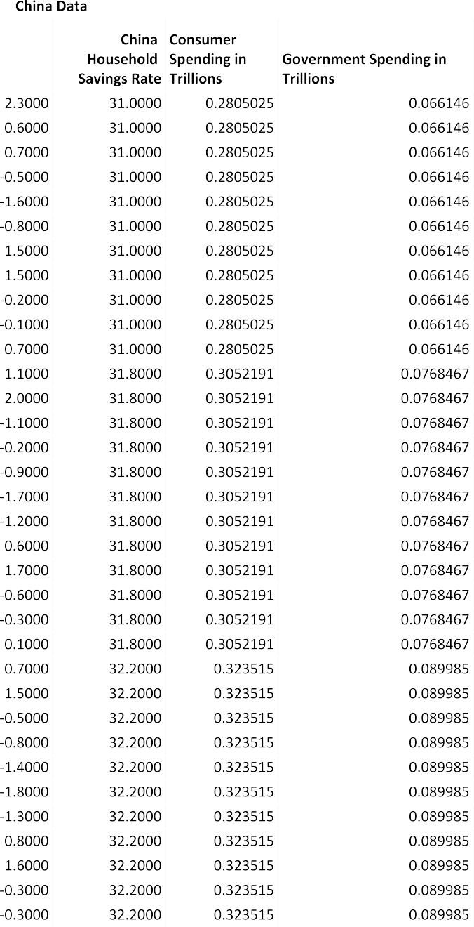

|  |  |  |
| --- | --- | --- |
|  | 2.22050 | 1.049346968 |
|  | 0.95790 | 1.205457034 |
|  | 2.15924 | 1.205457034 |
|  | 0.61237 | 1.205457034 |
|  | 0.71931 | 1.205457034 |
| 0.77185 | 1.205457034 |
| 1.18389 | 1.205457034 |
| 0.04490 | 1.205457034 |
|  | 1.26824 | 1.205457034 |
|  | 1.99598 | 1.205457034 |
|  | 0.27025 | 1.205457034 |
|  | 1.01309 | 1.205457034 |
|  | 2.86456 | 1.205457034 |
| 1.10302 | 1.311470678 |
| 0.29945 | 1.311470678 |
| 0.84173 | 1.311470678 |
|  | 1.23574 | 1.311470678 |
|  | -0.05527 | 1.311470678 |
|  | 2.05718 | 1.311470678 |
|  | -0.22227 | 1.311470678 |
| 1.16083 | 1.311470678 |
| 2.09992 | 1.311470678 |
| -0.72919 | 1.311470678 |
|  | 1.13625 | 1.311470678 |
|  | 2.76058 | 1.311470678 |
|  | 2.17911 | 1.41127373 |
|  | -0.96944 | 1.41127373 |
|  | 1.86058 | 1.41127373 |
| 0.86879 | 1.41127373 |
| -0.66745 | 1.41127373 |
| 6.32583 | 1.41127373 |
|  | 0.96002 | 1.41127373 |
|  | 0.47786 | 1.41127373 |
|  | 1.25275 | 1.41127373 |
|  | -0.21269 | 1.41127373 |
| 1.71026 | 1.41127373 |
| 2.73454 | 1.41127373 |
| 0.84484 | 1.499656622 |



|  |  |  |
| --- | --- | --- |
|  | 0.81202 | 1.499656622 |
|  | 1.94426 | 1.499656622 |
|  | 0.30842 | 1.499656622 |
|  | 0.88254 | 1.499656622 |
|  | 2.15524 | 1.499656622 |
| 0.73696 | 1.499656622 |
| 1.40461 | 1.499656622 |
| 2.15543 | 1.499656622 |
|  | 0.17459 | 1.499656622 |
|  | 1.37743 | 1.499656622 |
|  | 2.93246 | 1.499656622 |
|  | 2.99345 | 1.484680411 |
|  | -0.22918 | 1.484680411 |
| 2.30337 | 1.484680411 |
| 0.84468 | 1.484680411 |
| 1.72085 | 1.484680411 |
|  | 2.70780 | 1.484680411 |
|  | 0.62745 | 1.484680411 |
|  | 2.13334 | 1.484680411 |
|  | 1.41278 | 1.484680411 |
| 0.42249 | 1.484680411 |
| 0.87765 | 1.484680411 |
| 2.25147 | 1.484680411 |
|  | 1.75348 | 1.456869413 |
|  | 0.86574 | 1.456869413 |
|  | 2.02770 | 1.456869413 |
|  | 0.85183 | 1.456869413 |
|  | 0.51984 | 1.456869413 |
| 1.52660 | 1.456869413 |
| -0.12603 | 1.456869413 |
| 0.67283 | 1.456869413 |
|  | 1.68010 | 1.456869413 |
|  | -0.00681 | 1.456869413 |
|  | 1.39300 | 1.456869413 |
|  | 2.45699 | 1.456869413 |
| 1.77751 | 1.484284571 |
| 0.63979 | 1.484284571 |
| 2.01714 | 1.484284571 |



|  |  |  |
| --- | --- | --- |
|  | 0.90850 | 1.484284571 |
|  | 0.84190 | 1.484284571 |
|  | 2.43091 | 1.484284571 |
|  | 0.42816 | 1.484284571 |
|  | 1.56044 | 1.484284571 |
| 2.18641 | 1.484284571 |
| 0.05333 | 1.484284571 |
| 1.65471 | 1.484284571 |
|  | 2.19097 | 1.484284571 |
|  | 1.61202 | 1.46877858 |
|  | 0.31116 | 1.46877858 |
|  | 1.96193 | 1.46877858 |
|  | 1.03436 | 1.46877858 |
| 0.95871 | 1.46877858 |
| 1.90919 | 1.46877858 |
| 0.38865 | 1.46877858 |
|  | 1.19592 | 1.46877858 |
|  | 1.21375 | 1.46877858 |
|  | 0.26571 | 1.46877858 |
|  | 1.42961 | 1.46877858 |
| 2.39979 | 1.46877858 |
| 1.70577 | 1.402158665 |
| 2.03713 | 1.402158665 |
|  | 1.51520 | 1.402158665 |
|  | 0.88790 | 1.402158665 |
|  | 0.65111 | 1.402158665 |
|  | 2.19464 | 1.402158665 |
|  | 1.60195 | 1.402158665 |
| 0.86492 | 1.402158665 |
| 1.52211 | 1.402158665 |
| 0.28118 | 1.402158665 |
|  | 1.40884 | 1.402158665 |
|  | 0.92163 | 1.402158665 |
|  | 3.56346 | 1.362396006 |
|  | 0.77045 | 1.362396006 |
| 0.47898 | 1.362396006 |
| 1.47953 | 1.362396006 |
| 1.60906 | 1.362396006 |



|  |  |  |
| --- | --- | --- |
|  | 1.58621 | 1.362396006 |
|  | 0.72690 | 1.362396006 |
|  | 0.55661 | 1.362396006 |
|  | 0.90276 | 1.362396006 |
|  | 0.05180 | 1.362396006 |
| 1.21629 | 1.362396006 |
| 3.60233 | 1.362396006 |
| 4.41292 | 1.495577943 |
|  | 2.13103 | 1.495577943 |
|  | 4.72039 | 1.495577943 |
|  | 1.85714 | 1.495577943 |
|  | 1.43988 | 1.495577943 |
|  | 3.76693 | 1.495577943 |
| 0.73591 | 1.495577943 |
| 0.62748 | 1.495577943 |
| 1.50968 | 1.495577943 |
|  | 0.21148 | 1.495577943 |
|  | 1.35711 | 1.495577943 |
|  | 2.62692 | 1.495577943 |
|  | 2.52117 | 1.476455366 |
| 1.67245 | 1.476455366 |
| 2.18139 | 1.476455366 |
| 1.01757 | 1.476455366 |
|  | 1.03421 | 1.476455366 |
|  | 1.59347 | 1.476455366 |
|  | 0.01926 | 1.476455366 |
|  | 1.99620 | 1.476455366 |
|  | 1.30393 | 1.476455366 |
| 3.88078 | 1.476455366 |
| -1.81907 | 1.476455366 |
| 2.18386 | 1.476455366 |
|  | 1.10670 | 1.44670325 |
|  | 0.30606 | 1.44670325 |
|  | 2.98860 | 1.44670325 |
|  | -0.09844 | 1.44670325 |
| 0.79545 | 1.44670325 |
| 2.28078 | 1.44670325 |
| -1.01140 | 1.44670325 |



|  |  |  |
| --- | --- | --- |
|  | 1.02579 | 1.44670325 |
|  | 0.83933 | 1.44670325 |
|  | 3.73670 | 1.44670325 |
|  | 1.06077 | 1.44670325 |
|  | 3.16138 | 1.44670325 |
| 0.50588 | 1.476202118 |
| 1.31704 | 1.476202118 |
| 3.27434 | 1.476202118 |
|  | -0.66567 | 1.476202118 |
|  | 1.17410 | 1.476202118 |
|  | 2.77123 | 1.476202118 |
|  | -0.63988 | 1.476202118 |
|  | 0.63349 | 1.476202118 |
| 2.03204 | 1.476202118 |
| -0.77192 | 1.476202118 |
| 0.90005 | 1.476202118 |
|  | 3.10281 | 1.476202118 |
|  | 1.84577 | 1.465058237 |
|  | 0.65228 | 1.465058237 |
|  | 3.73098 | 1.465058237 |
| -0.31920 | 1.465058237 |
| 0.93141 | 1.465058237 |
| 1.17395 | 1.465058237 |
|  | -0.20783 | 1.465058237 |
|  | 0.85953 | 1.465058237 |
|  | 1.51922 | 1.465058237 |
|  | -0.66244 | 1.465058237 |
|  | 0.84232 | 1.465058237 |
| 2.52654 | 1.465058237 |
| 1.53600 | 1.448933149 |
| 0.73337 | 1.448933149 |
|  | 2.55589 | 1.448933149 |
|  | 0.70004 | 1.448933149 |
|  | 1.15342 | 1.448933149 |
|  | 2.30850 | 1.448933149 |
| -1.26804 | 1.448933149 |
| 0.27213 | 1.448933149 |
| 0.38015 | 1.448933149 |



|  |  |  |
| --- | --- | --- |
|  | -0.23419 | 1.448933149 |
|  | 0.78131 | 1.448933149 |
|  | 1.63567 | 1.448933149 |
|  | 1.16702 | 1.589992325 |
|  | 1.18051 | 1.589992325 |
|  | 1.42775 | 1.589992325 |
| 0.42705 | 1.589992325 |
| 2.07518 | 1.589992325 |
| 1.99011 | 1.589992325 |
|  | 1.48762 | 1.589992325 |
|  | 0.27321 | 1.589992325 |
|  | 0.21491 | 1.589992325 |
|  | 0.08800 | 1.589992325 |
| 0.95041 | 1.589992325 |
| 1.33353 | 1.589992325 |
| 1.72677 | 1.671419241 |
|  | 0.58596 | 1.671419241 |
|  | 1.51474 | 1.671419241 |
|  | -0.06834 | 1.671419241 |
|  | 1.14070 | 1.671419241 |
|  | 1.97009 | 1.671419241 |
| 0.07158 | 1.671419241 |
| 1.30228 | 1.671419241 |
| 0.35590 | 1.671419241 |
|  | 0.20608 | 1.671419241 |
|  | 0.72042 | 1.671419241 |
|  | 1.28294 | 1.671419241 |
|  |  |  |

