**Fig 1** 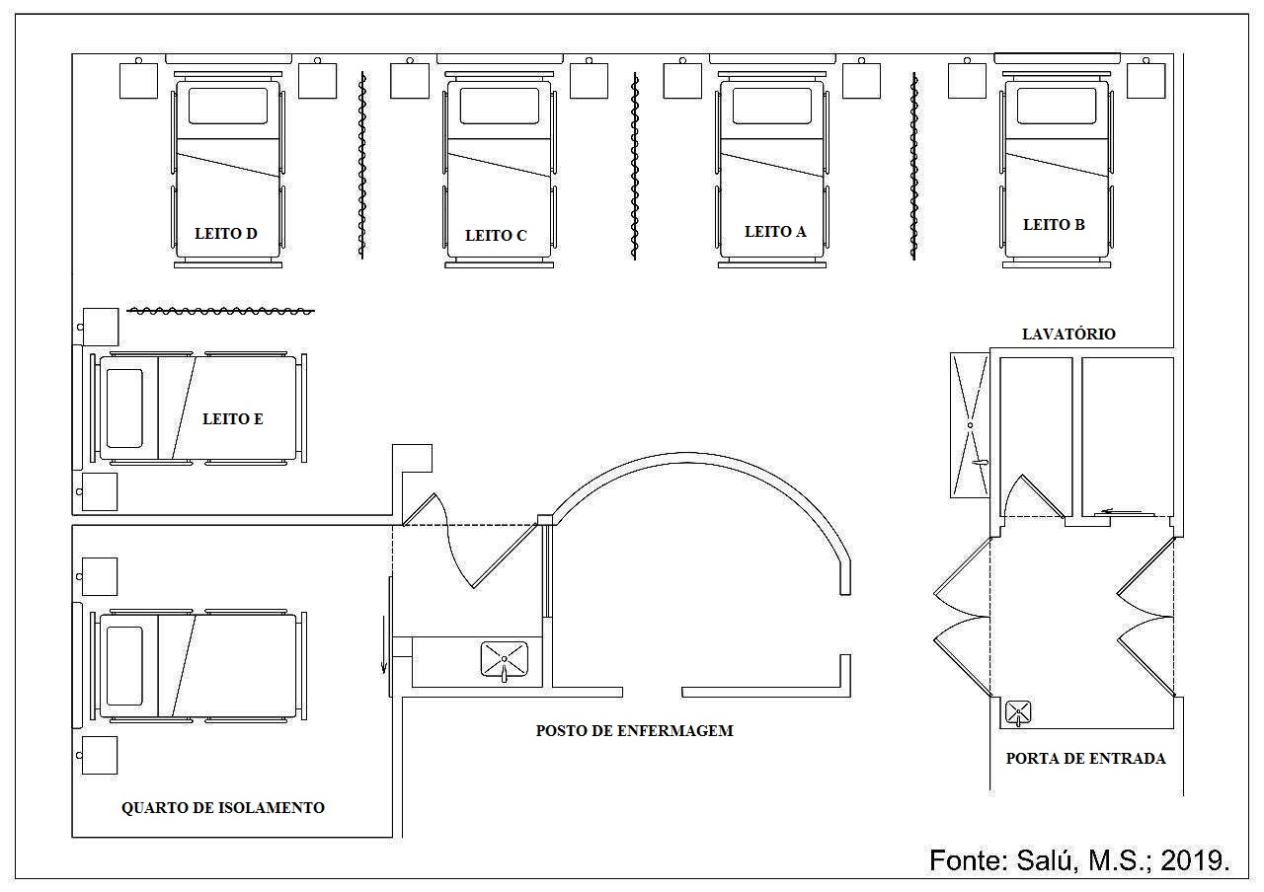

**Fig 2**

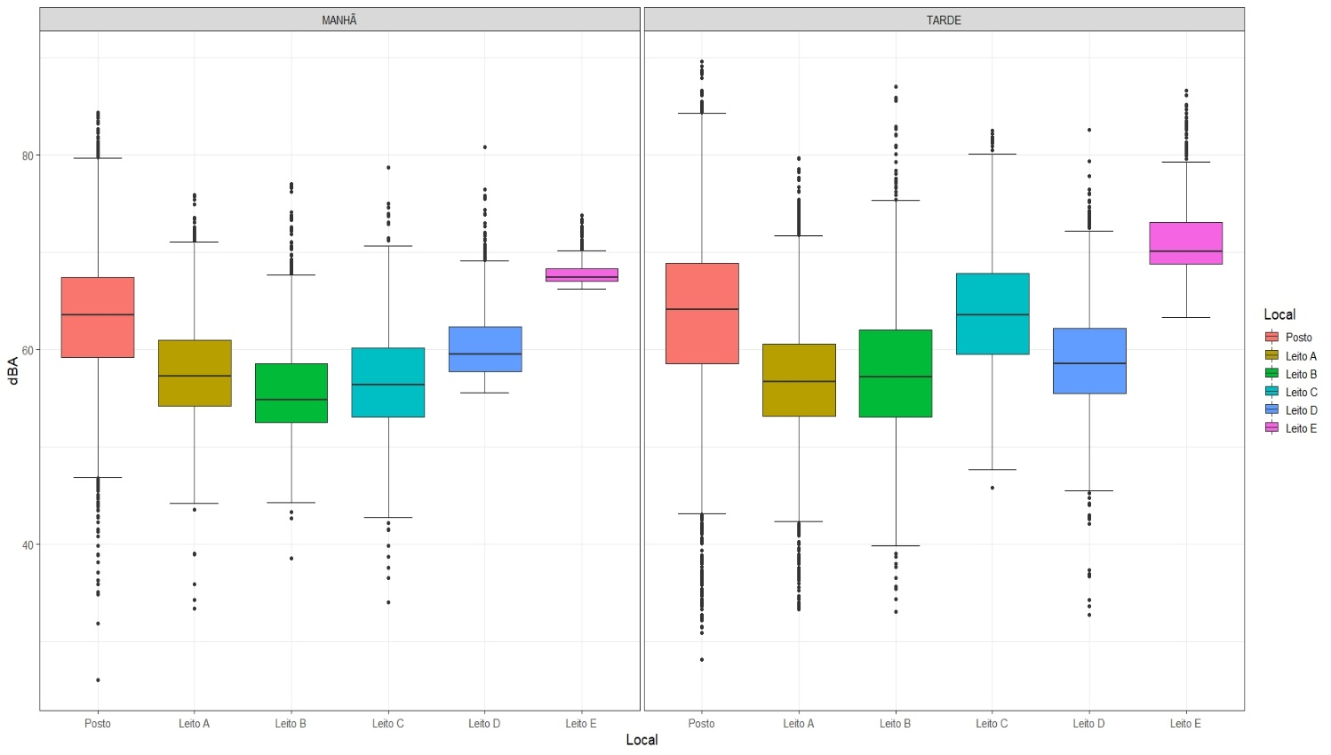

Source: The Authors, 2019

**Fig 3**

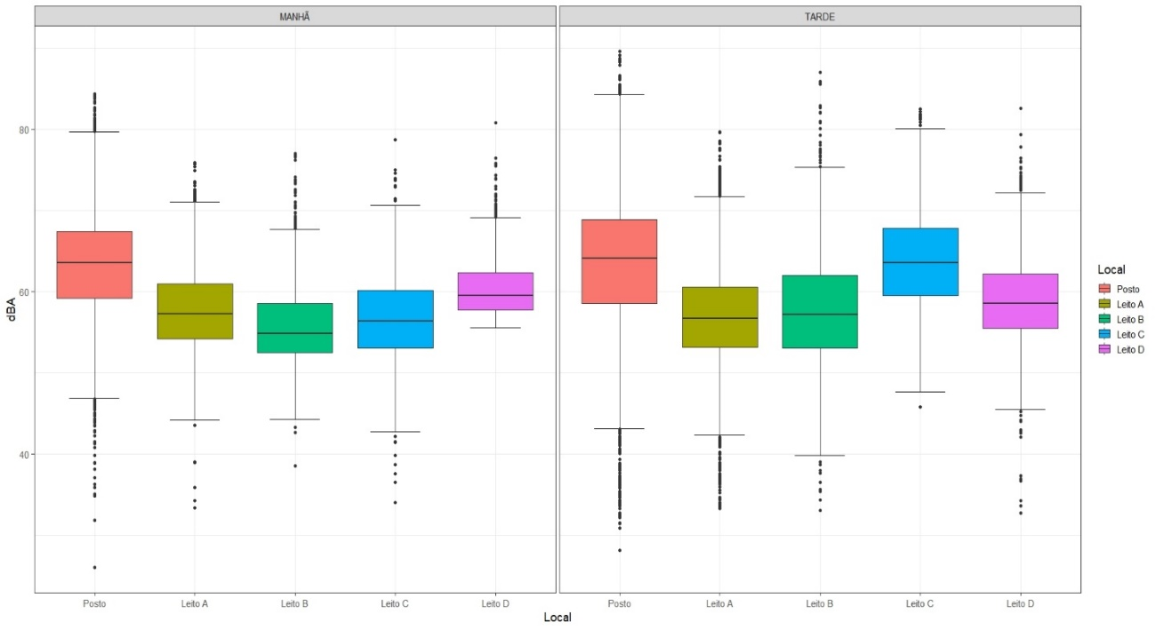

Source: The Authors, 2019

**Fig 4**

Source: The Authors, 2019.