# Data and analyses

# ≤4000g vs >4000g

|  |  |  |  |  |
| --- | --- | --- | --- | --- |
| Outcome or Subgroup | Studies | Participants | Statistical Method | Effect Estimate |

|  |  |  |  |  |
| --- | --- | --- | --- | --- |
| 1.2 New outcome | 16 | 3650728 | Odds Ratio (M-H, Fixed, 95% CI) | 0.81 [0.77, 0.85] |

# Figures

## Figure 1 (Analysis 1.2)

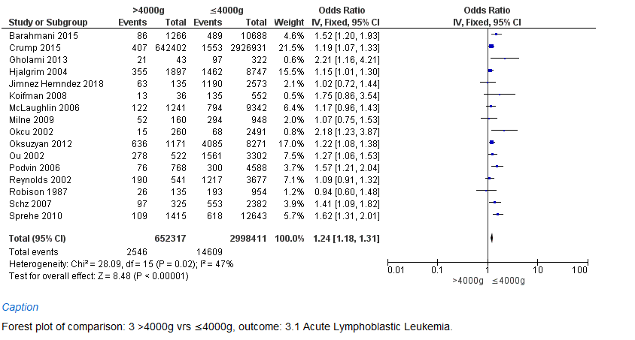

Forest plot of comparison: 1 >4000g vs ≤4000g, outcome: 1.2 New Outcome.

Figure 2- Funnel plot.

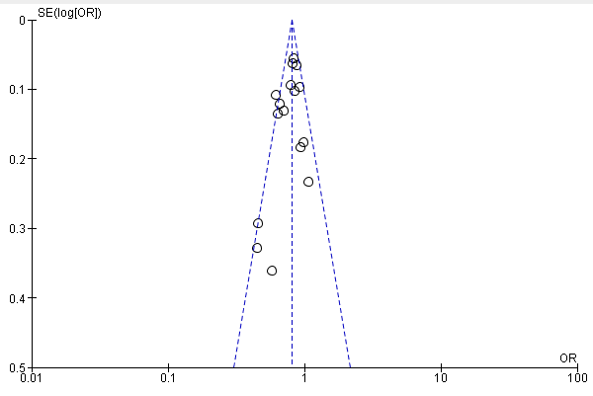

Figure 3

PRISMA TABLE

