REGRESSION RESULTS OF ATHENS ROAD SAMPLE

Variables Entered/Removedª
Model | Variables Entered | Variables Removed | Method
1 | OPDC | . | Stepwise (Criteria: Probability-of-F-to-enter <= ,050, Probability-of-F-to-remove >= ,100).
2 | OPDP | . | Stepwise (Criteria: Probability-of-F-to-enter <= ,050, Probability-of-F-to-remove >= ,100).
3 | LNLUSES | . | Stepwise (Criteria: Probability-of-F-to-enter <= ,050, Probability-of-F-to-remove >= ,100).
4 | LNOSPACE | . | Stepwise (Criteria: Probability-of-F-to-enter <= ,050, Probability-of-F-to-remove >= ,100).
a. Dependent Variable: MVALUE

Model Summary^{e}
Model | R | R Square | Adjusted R Square | Std. Error of the Estimate | Selection Criteria |  |  |  | Durbin-Watson
 |  |  |  |  | Akaike Information Criterion | Amemiya Prediction Criterion | Mallows' Prediction Criterion | Schwarz Bayesian Criterion | Durbin-Watson
1 | ,633ª | ,401 | ,393 | 6853,67685 | 1362,185 | ,631 | 256,616 | 1366,872
2 | ,901^{b} | ,811 | ,806 | 3872,37981 | 1275,230 | ,204 | 32,822 | 1282,262
3 | ,921^{c} | ,848 | ,842 | 3497,96408 | 1260,523 | ,168 | 14,571 | 1269,898
4 | ,933^{d} | ,870 | ,863 | 3261,87059 | 1250,699 | ,148 | 4,675 | 1262,418 | 1,801
a. Predictors: (Constant), OPDC
b. Predictors: (Constant), OPDC, OPDP
c. Predictors: (Constant), OPDC, OPDP, LNLUSES
d. Predictors: (Constant), OPDC, OPDP, LNLUSES, LNOSPACE
e. Dependent Variable: MVALUE

ANOVAª
Model |  | Sum of Squares | df | Mean Square | F | Sig.
1 | Regression | 2358941571,337 | 1 | 2358941571,337 | 50,219 | ,000^{b}
1 | Residual | 3522966480,611 | 75 | 46972886,408
1 | Total | 5881908051,948 | 76
2 | Regression | 4772253972,571 | 2 | 2386126986,286 | 159,125 | ,000^{c}
2 | Residual | 1109654079,377 | 74 | 14995325,397
2 | Total | 5881908051,948 | 76
3 | Regression | 4988698106,693 | 3 | 1662899368,898 | 135,905 | ,000^{d}
3 | Residual | 893209945,255 | 73 | 12235752,675
3 | Total | 5881908051,948 | 76
4 | Regression | 5115842468,141 | 4 | 1278960617,035 | 120,205 | ,000e
4 | Residual | 766065583,807 | 72 | 10639799,775
4 | Total | 5881908051,948 | 76
a. Dependent Variable: MVALUE
b. Predictors: (Constant), OPDC
c. Predictors: (Constant), OPDC, OPDP
d. Predictors: (Constant), OPDC, OPDP, LNXRHSEIS
e. Predictors: (Constant), OPDC, OPDP, LNXRHSEIS, LNOSPACE

Coefficientsª
Model |  | Unstandardized Coefficients |  | Standardized Coefficients | t | Sig. | Collinearity Statistics
 |  | B | Std. Error | Beta | t | Sig. | Tolerance | VIF
1 | (Constant) | 2463,107 | 1533,708 |  | 1,606 | ,112
1 | OPDC | 29254,656 | 4128,193 | ,633 | 7,087 | ,000 | 1,000 | 1,000
2 | (Constant) | -10278,345 | 1326,523 |  | -7,748 | ,000
2 | OPDC | 46333,954 | 2693,119 | 1,003 | 17,205 | ,000 | ,750 | 1,333
2 | OPDP | 6396,254 | 504,193 | ,740 | 12,686 | ,000 | ,750 | 1,333
3 | (Constant) | -9462,312 | 1213,869 |  | -7,795 | ,000
3 | OPDC | 47922,735 | 2461,879 | 1,037 | 19,466 | ,000 | ,732 | 1,365
3 | OPDP | 5612,636 | 492,079 | ,649 | 11,406 | ,000 | ,643 | 1,556
3 | LNXRHSEIS | -561,409 | 133,482 | -,222 | -4,206 | ,000 | ,746 | 1,340
4 | (Constant) | -18939,298 | 2965,993 |  | -6,385 | ,000
4 | OPDC | 48090,183 | 2296,226 | 1,041 | 20,943 | ,000 | ,732 | 1,366
4 | OPDP | 5228,933 | 472,100 | ,605 | 11,076 | ,000 | ,607 | 1,647
4 | LNLUSES | -456,684 | 128,106 | -,181 | -3,565 | ,001 | ,705 | 1,419
4 | LNOSPACE | 2713,326 | 784,911 | ,165 | 3,457 | ,001 | ,790 | 1,266
a. Dependent Variable: MVALUE

Residuals Statisticsª
 | Minimum | Maximum | Mean | Std. Deviation | N
Predicted Value | 97,8481 | 37818,7578 | 11816,8831 | 8204,49369 | 77
Residual | -7644,94971 | 8319,11133 | ,00000 | 3174,87170 | 77
Std. Predicted Value | -1,428 | 3,169 | ,000 | 1,000 | 77
Std. Residual | -2,344 | 2,550 | ,000 | ,973 | 77
a. Dependent Variable: MVALUE

Charts

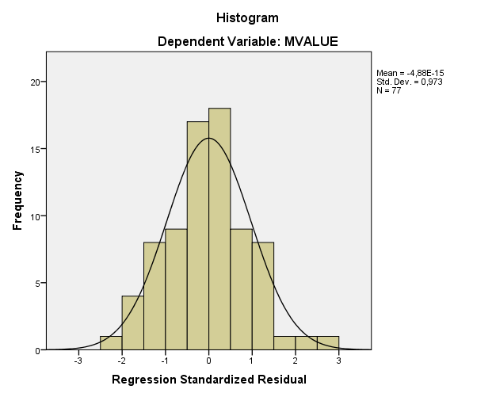

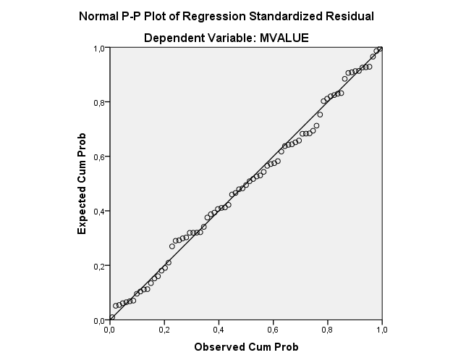

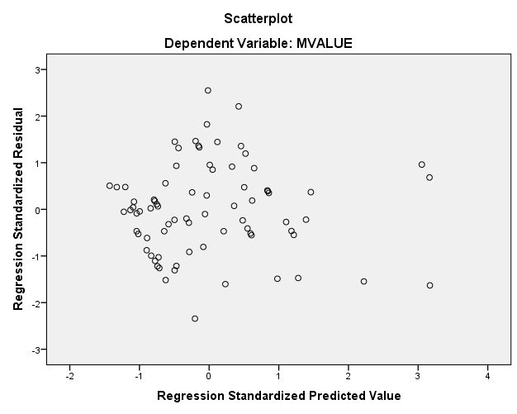

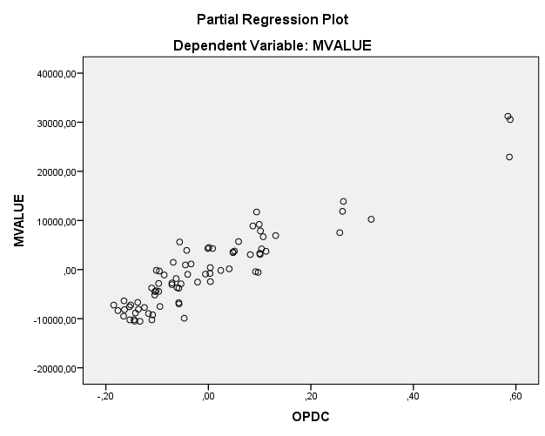

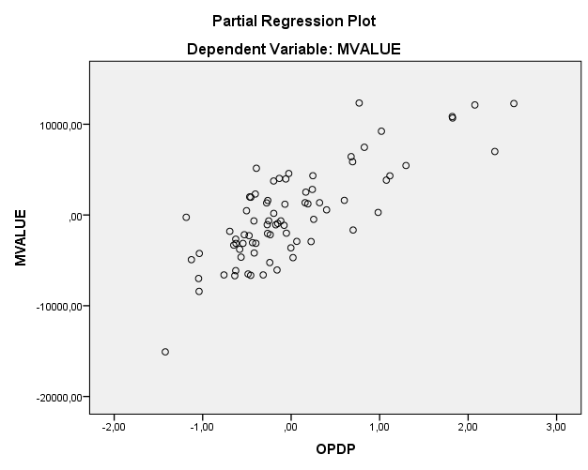

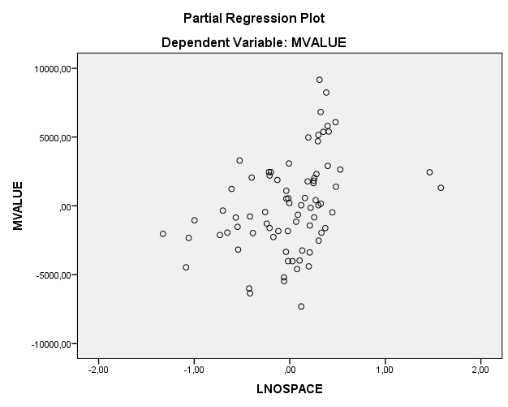

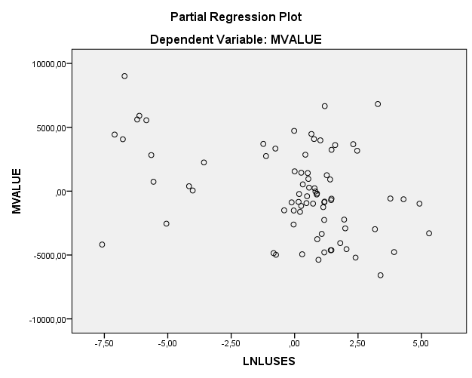

Explore

Case Processing Summary
 | Cases
 | Valid |  | Missing |  | Total
 | N | Percent | N | Percent | N | Percent
Unstandardized Residual | 77 | 63,1% | 45 | 36,9% | 122 | 100,0%

Descriptives
 |  |  | Statistic | Std. Error
Unstandardized Residual | Mean |  | ,0000000 | 361,81020915
Unstandardized Residual | 95% Confidence Interval for Mean | Lower Bound | -720,6074835
Unstandardized Residual | 95% Confidence Interval for Mean | Upper Bound | 720,6074835
Unstandardized Residual | 5% Trimmed Mean |  | -44,0490699
Unstandardized Residual | Median |  | -44,7472802
Unstandardized Residual | Variance |  | 10079810,313
Unstandardized Residual | Std. Deviation |  | 3174,87170028
Unstandardized Residual | Minimum |  | -7644,94956
Unstandardized Residual | Maximum |  | 8319,11131
Unstandardized Residual | Range |  | 15964,06086
Unstandardized Residual | Interquartile Range |  | 3535,04215
Unstandardized Residual | Skewness |  | ,150 | ,274
Unstandardized Residual | Kurtosis |  | -,097 | ,541

Tests of Normality
 | Kolmogorov-Smirnovª |  |  | Shapiro-Wilk
 | Statistic | df | Sig. | Statistic | df | Sig.
Unstandardized Residual | ,055 | 77 | ,200* | ,991 | 77 | ,860
*. This is a lower bound of the true significance.
a. Lilliefors Significance Correction

Unstandardized Residual

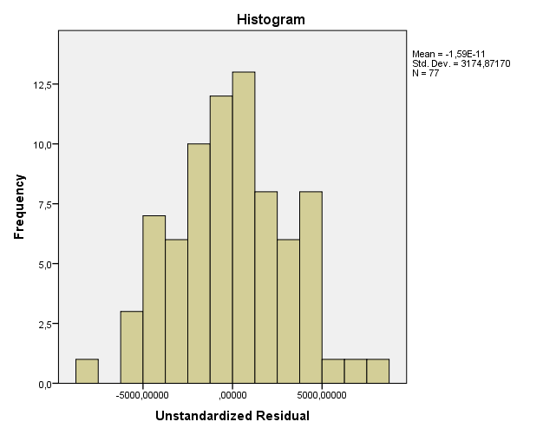

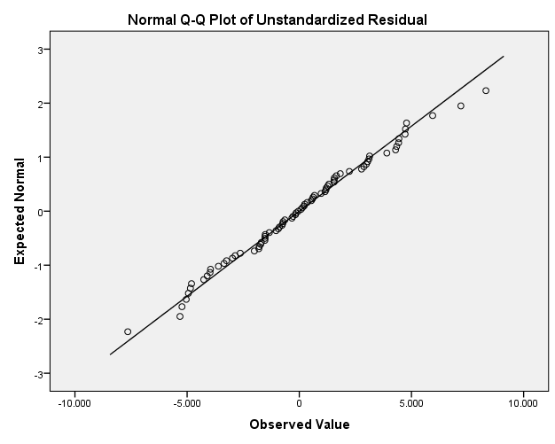

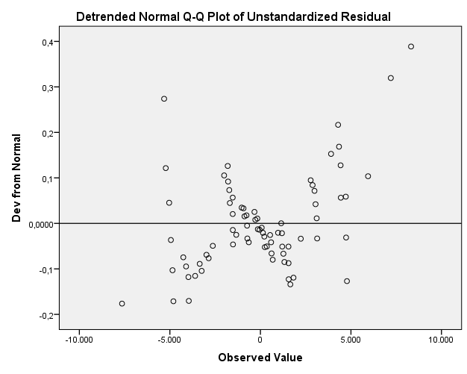

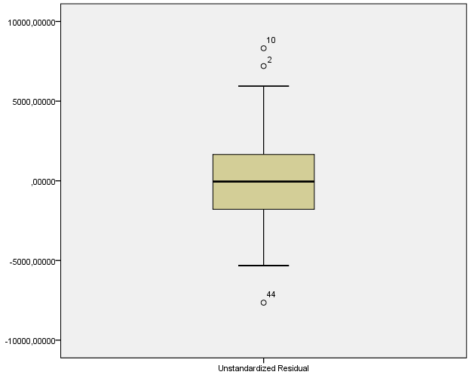

Regression OF RESIDUALS (RES_12) (heteroskedasticity TEST)

Variables Entered/Removedª
Model | Variables Entered | Variables Removed | Method
1 | LNXRHSEIS, OPDC, LNOSPACE, OPDP^{b} | . | Enter
a. Dependent Variable: RES_12
b. All requested variables entered.

Model Summary^{b}
Model | R | R Square | Adjusted R Square | Std. Error of the Estimate | Durbin-Watson
1 | ,245ª | ,060 | ,008 | 13504034,06860 | 2,170
a. Predictors: (Constant), LNLUSES, OPDC, LNOSPACE, OPDP
b. Dependent Variable: RES_12

ANOVAª
Model |  | Sum of Squares | df | Mean Square | F | Sig.
1 | Regression | 837957597754573,400 | 4 | 209489399438643,340 | 1,149 | ,341^{b}
1 | Residual | 13129843401070352,000 | 72 | 182358936125977,120
1 | Total | 13967800998824926,000 | 76
a. Dependent Variable: RES_12
b. Predictors: (Constant), LNXRHSEIS, OPDC, LNOSPACE, OPDP

Coefficientsª
Model |  | Unstandardized Coefficients |  | Standardized Coefficients | t | Sig. | Collinearity Statistics
 |  | B | Std. Error | Beta | t | Sig. | Tolerance | VIF
1 | (Constant) | -10923695,854 | 12279112,056 |  | -,890 | ,377
1 | OPDC | 11124532,532 | 9506299,153 | ,156 | 1,170 | ,246 | ,732 | 1,366
1 | OPDP | -937674,708 | 1954479,468 | -,070 | -,480 | ,633 | ,607 | 1,647
1 | LNOSPACE | 5169088,417 | 3249503,307 | ,205 | 1,591 | ,116 | ,790 | 1,266
1 | LNLUSES | -322077,878 | 530354,928 | -,083 | -,607 | ,546 | ,705 | 1,419
a. Dependent Variable: RES_12

Residuals Statisticsª
 | Minimum | Maximum | Mean | Std. Deviation | N
Predicted Value | 1288498,6250 | 16571711,0000 | 9948903,6858 | 3320505,66408 | 77
Residual | -14128027,00000 | 59922084,00000 | ,00000 | 13143861,58564 | 77
Std. Predicted Value | -2,608 | 1,995 | ,000 | 1,000 | 77
Std. Residual | -1,046 | 4,437 | ,000 | ,973 | 77
a. Dependent Variable: RES_12

Charts

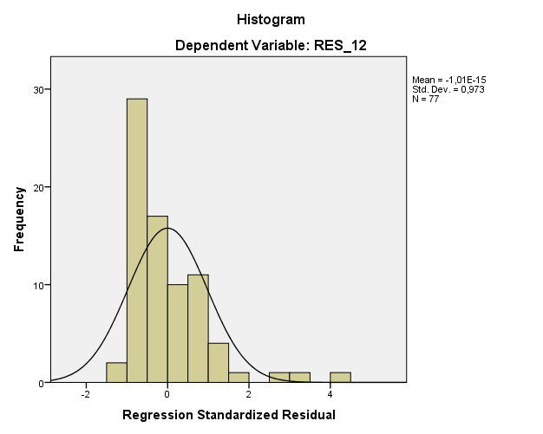

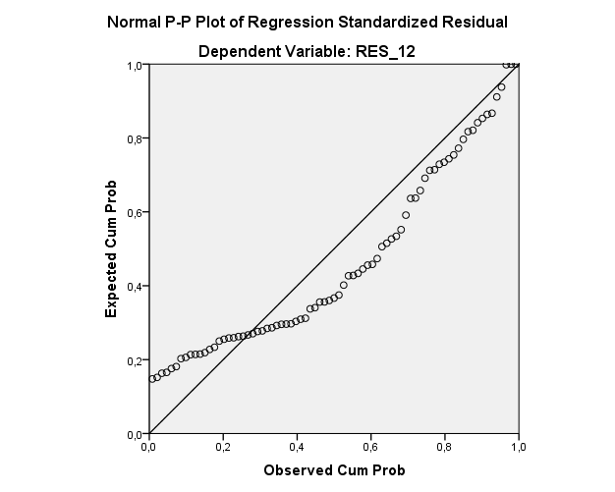

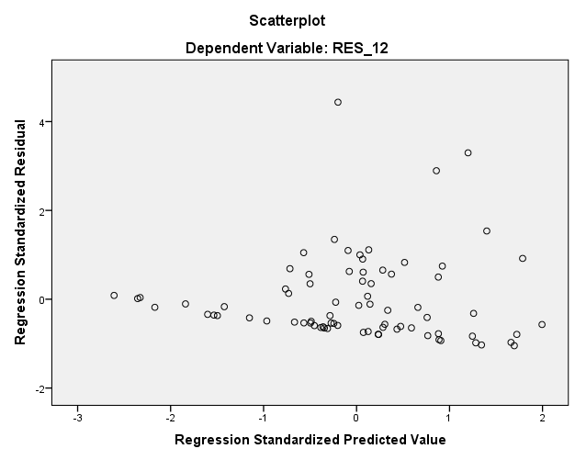

REGRESSION RESULTS OF KARDITSA AND TRIKALA ROADS SAMPLE

Regression
Variables Entered/Removedª
Model | Variables Entered | Variables Removed | Method
1 | OPDC | . | Stepwise (Criteria: Probability-of-F-to-enter <= ,050, Probability-of-F-to-remove >= ,100).
2 | OPDA | . | Stepwise (Criteria: Probability-of-F-to-enter <= ,050, Probability-of-F-to-remove >= ,100).
3 | ABR | . | Stepwise (Criteria: Probability-of-F-to-enter <= ,050, Probability-of-F-to-remove >= ,100).
4 | LNAREA | . | Stepwise (Criteria: Probability-of-F-to-enter <= ,050, Probability-of-F-to-remove >= ,100).
5 | OPDT | . | Stepwise (Criteria: Probability-of-F-to-enter <= ,050, Probability-of-F-to-remove >= ,100).
a. Dependent Variable: MVALUE

Model Summary^{f}
Model | R | R Square | Adjusted R Square | Std. Error of the Estimate | Selection Criteria |  |  |  | Durbin-Watson
 |  |  |  |  | Akaike Information Criterion | Amemiya Prediction Criterion | Mallows' Prediction Criterion | Schwarz Bayesian Criterion | Durbin-Watson
1 | ,694ª | ,481 | ,475 | 8632,38447 | 1415,845 | ,546 | 123,092 | 1420,558
2 | ,843^{b} | ,710 | ,703 | 6492,76977 | 1372,378 | ,313 | 38,031 | 1379,448
3 | ,875^{c} | ,765 | ,755 | 5889,33175 | 1358,114 | ,260 | 19,322 | 1367,541
4 | ,891^{d} | ,793 | ,782 | 5563,34678 | 1350,170 | ,235 | 10,630 | 1361,953
5 | ,900e | ,810 | ,797 | 5367,83161 | 1345,513 | ,222 | 6,198 | 1359,653 | 1,505
a. Predictors: (Constant), OPDC
b. Predictors: (Constant), OPDC, OPDA
c. Predictors: (Constant), OPDC, OPDA, ABR
d. Predictors: (Constant), OPDC, OPDA, ABR, LNAREA
e. Predictors: (Constant), OPDC, OPDA, ABR, LNAREA, OPDT
f. Dependent Variable: MVALUE

ANOVAª
Model |  | Sum of Squares | df | Mean Square | F | Sig.
1 | Regression | 5257065552,998 | 1 | 5257065552,998 | 70,548 | ,000^{b}
1 | Residual | 5663372684,182 | 76 | 74518061,634
1 | Total | 10920438237,179 | 77
2 | Regression | 7758733795,524 | 2 | 3879366897,762 | 92,024 | ,000^{c}
2 | Residual | 3161704441,656 | 75 | 42156059,222
2 | Total | 10920438237,179 | 77
3 | Regression | 8353805331,823 | 3 | 2784601777,274 | 80,284 | ,000^{d}
3 | Residual | 2566632905,357 | 74 | 34684228,451
3 | Total | 10920438237,179 | 77
4 | Regression | 8661027840,038 | 4 | 2165256960,009 | 69,958 | ,000e
4 | Residual | 2259410397,142 | 73 | 30950827,358
4 | Total | 10920438237,179 | 77
5 | Regression | 8845857874,519 | 5 | 1769171574,904 | 61,401 | ,000^{f}
5 | Residual | 2074580362,660 | 72 | 28813616,148
5 | Total | 10920438237,179 | 77
a. Dependent Variable: MVALUE
b. Predictors: (Constant), OPDC
c. Predictors: (Constant), OPDC, OPDA
d. Predictors: (Constant), OPDC, OPDA, ABR
e. Predictors: (Constant), OPDC, OPDA, ABR, LNAREA
f. Predictors: (Constant), OPDC, OPDA, ABR, LNAREA, OPDT

Coefficientsª
Model |  | Unstandardized Coefficients |  | Standardized Coefficients | t | Sig. | Collinearity Statistics
 |  | B | Std. Error | Beta | t | Sig. | Tolerance | VIF
1 | (Constant) | -7712,853 | 3000,098 |  | -2,571 | ,012
1 | OPDC | 79741,415 | 9493,864 | ,694 | 8,399 | ,000 | 1,000 | 1,000
2 | (Constant) | -21460,697 | 2876,926 |  | -7,460 | ,000
2 | OPDC | 112918,323 | 8338,954 | ,982 | 13,541 | ,000 | ,733 | 1,364
2 | OPDA | 7737,511 | 1004,422 | ,559 | 7,703 | ,000 | ,733 | 1,364
3 | (Constant) | -24570,405 | 2715,394 |  | -9,049 | ,000
3 | OPDC | 103598,648 | 7891,486 | ,901 | 13,128 | ,000 | ,674 | 1,484
3 | OPDA | 7742,342 | 911,072 | ,559 | 8,498 | ,000 | ,733 | 1,364
3 | ABR | 14405,997 | 3477,961 | ,247 | 4,142 | ,000 | ,892 | 1,121
4 | (Constant) | -21283,646 | 2769,118 |  | -7,686 | ,000
4 | OPDC | 105885,449 | 7489,931 | ,921 | 14,137 | ,000 | ,667 | 1,499
4 | OPDA | 7908,380 | 862,255 | ,571 | 9,172 | ,000 | ,731 | 1,369
4 | ABR | 16764,746 | 3369,672 | ,288 | 4,975 | ,000 | ,848 | 1,179
4 | LNAREA | -2062,249 | 654,562 | -,174 | -3,151 | ,002 | ,925 | 1,082
5 | (Constant) | -19853,413 | 2730,826 |  | -7,270 | ,000
5 | OPDC | 99848,220 | 7609,686 | ,869 | 13,121 | ,000 | ,602 | 1,662
5 | OPDA | 8083,696 | 834,827 | ,584 | 9,683 | ,000 | ,726 | 1,378
5 | ABR | 12974,750 | 3579,089 | ,223 | 3,625 | ,001 | ,700 | 1,429
5 | LNAREA | -2530,760 | 658,092 | -,214 | -3,846 | ,000 | ,852 | 1,174
5 | OPDT | 4340,467 | 1713,756 | ,176 | 2,533 | ,013 | ,548 | 1,823
a. Dependent Variable: MVALUE

Residuals Statisticsª
 | Minimum | Maximum | Mean | Std. Deviation | N
Predicted Value | -6331,6592 | 35521,1953 | 16110,8974 | 10718,26810 | 78
Residual | -10844,30957 | 13271,71289 | ,00000 | 5190,62637 | 78
Std. Predicted Value | -2,094 | 1,811 | ,000 | 1,000 | 78
Std. Residual | -2,020 | 2,472 | ,000 | ,967 | 78
a. Dependent Variable: MVALUE

Charts

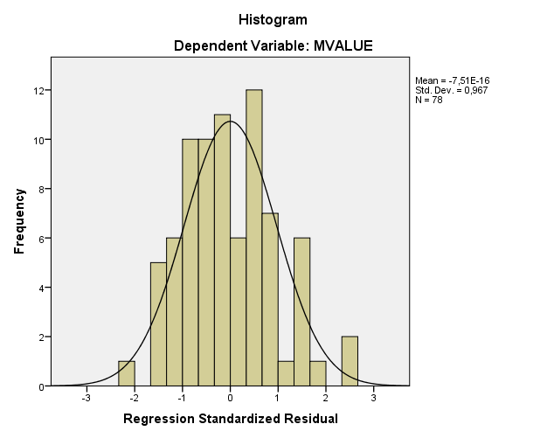

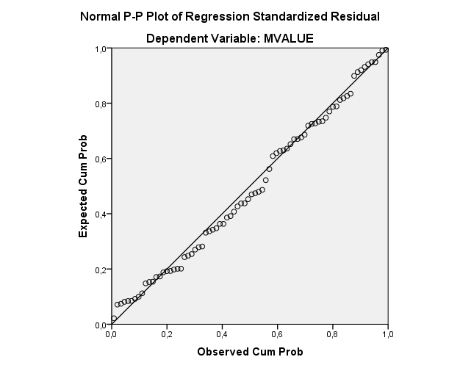

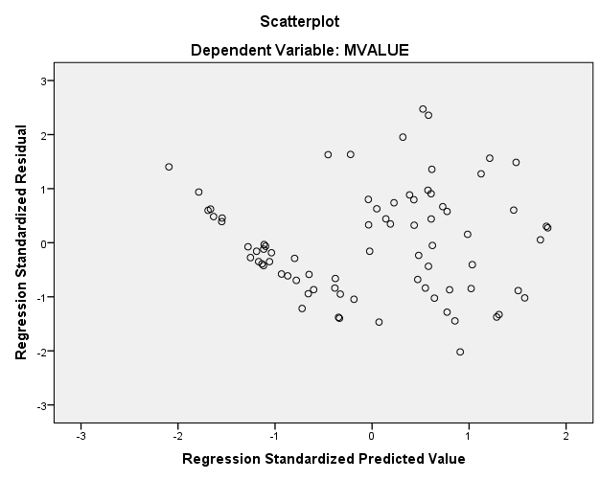

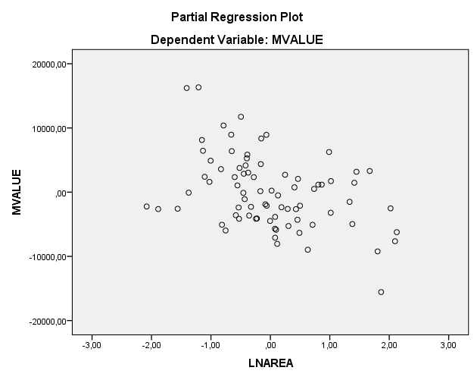

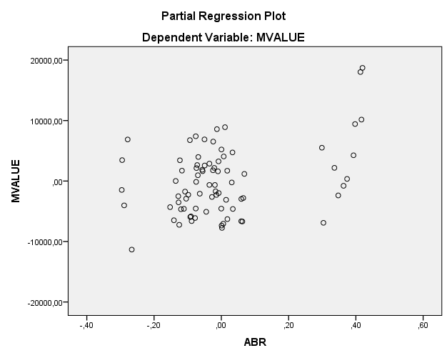

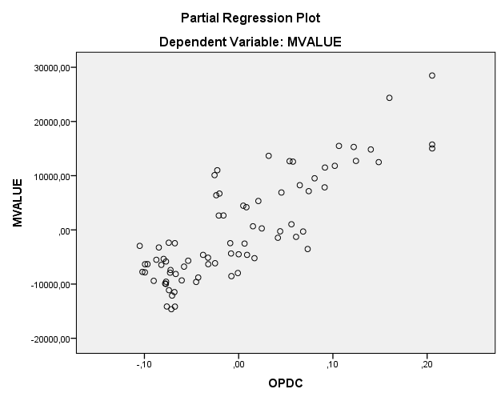

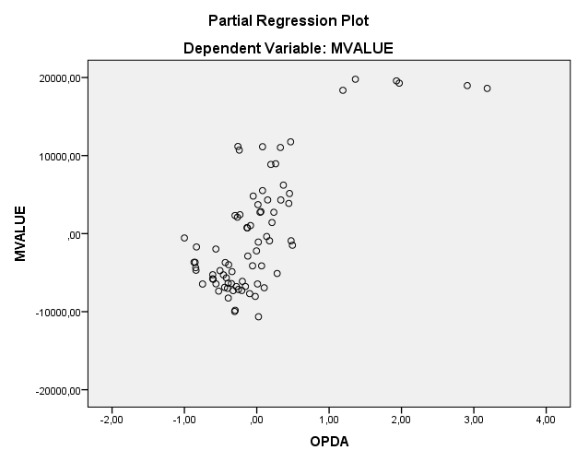

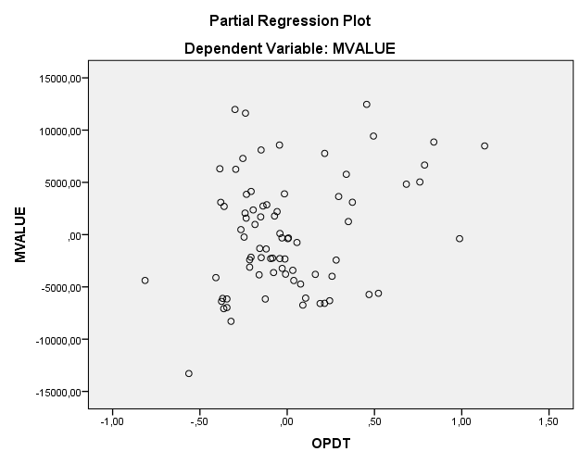

Explore

Case Processing Summary
 | Cases
 | Valid |  | Missing |  | Total
 | N | Percent | N | Percent | N | Percent
Unstandardized Residual | 78 | 100,0% | 0 | 0,0% | 78 | 100,0%

Descriptives
 |  |  | Statistic | Std. Error
Unstandardized Residual | Mean |  | ,0000000 | 587,72270315
Unstandardized Residual | 95% Confidence Interval for Mean | Lower Bound | -1170,3054159
Unstandardized Residual | 95% Confidence Interval for Mean | Upper Bound | 1170,3054159
Unstandardized Residual | 5% Trimmed Mean |  | -157,5784910
Unstandardized Residual | Median |  | -519,9631072
Unstandardized Residual | Variance |  | 26942602,112
Unstandardized Residual | Std. Deviation |  | 5190,62636995
Unstandardized Residual | Minimum |  | -10844,30914
Unstandardized Residual | Maximum |  | 13271,71301
Unstandardized Residual | Range |  | 24116,02215
Unstandardized Residual | Interquartile Range |  | 7842,57208
Unstandardized Residual | Skewness |  | ,383 | ,272
Unstandardized Residual | Kurtosis |  | -,277 | ,538

Tests of Normality
 | Kolmogorov-Smirnovª |  |  | Shapiro-Wilk
 | Statistic | df | Sig. | Statistic | df | Sig.
Unstandardized Residual | ,065 | 78 | ,200* | ,980 | 78 | ,269
*. This is a lower bound of the true significance.
a. Lilliefors Significance Correction

Unstandardized Residual

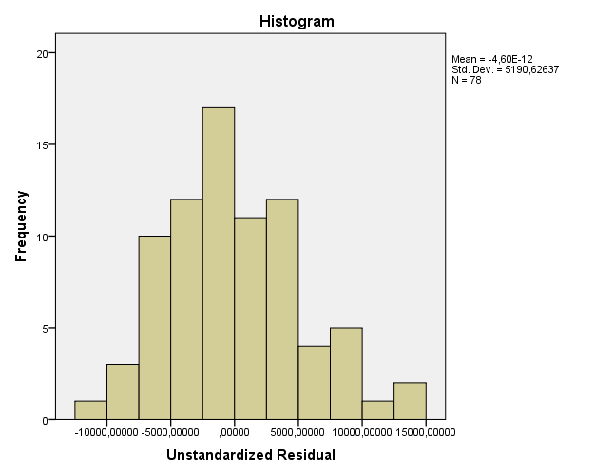

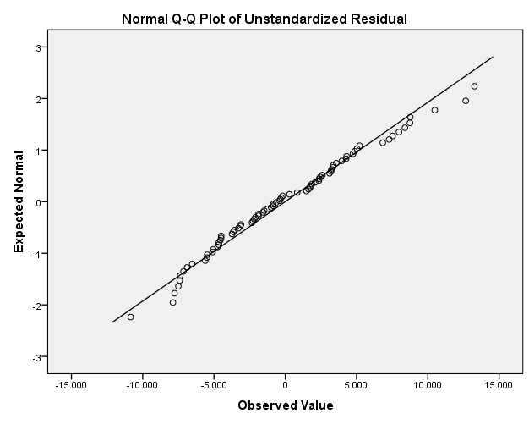

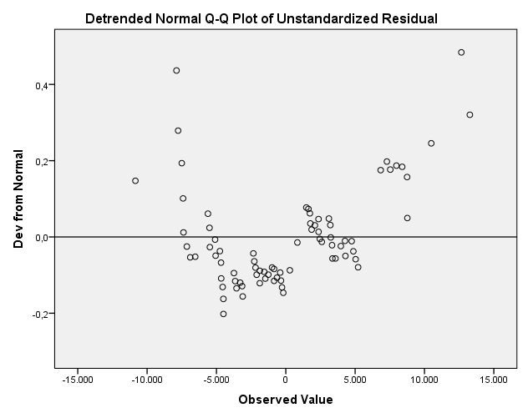

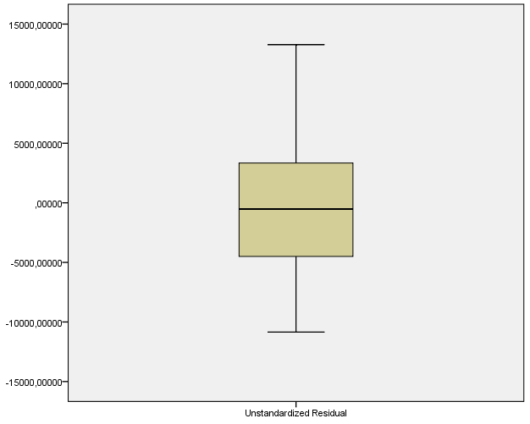

Regression OF RESIDUALS (RES_12) (heteroskedasticity TEST)

Variables Entered/Removedª
Model | Variables Entered |  | Variables Removed |  | Method
1 | LNAREA, LNOSPACE, ABR, LNLUSES, OPDT, OPDA, OPDC^{b} |  | . |  | Enter
a. Dependent Variable: RES_12
b. All requested variables entered.
Model Summary^{b}
Model | R | R Square |  | Adjusted R Square |  | Std. Error of the Estimate |  | Durbin-Watson
1 | ,412ª | ,170 |  | ,073 |  | 33244842,22269 |  | 1,844
a. Predictors: (Constant), LNAREA, LNOSPACE, ABR, LNLUSES, OPDT, OPDA, OPDC
b. Dependent Variable: RES_12

ANOVAª
Model |  | Sum of Squares | df | Mean Square | F | Sig.
1 | Regression | 15577776437621382,000 | 8 | 1947222054702672,800 | 1,762 | ,100^{b}
1 | Residual | 76260147874399264,000 | 69 | 1105219534411583,500
1 | Total | 91837924312020640,000 | 77
a. Dependent Variable: RES_12
b. Predictors: (Constant), LNAREA, LNOSPACE, ABR, LNLUSES, OPDT, OPDA, OPDC

Coefficientsª
Model |  | Unstandardized Coefficients |  | Standardized Coefficients | t | Sig. | Collinearity Statistics
 |  | B | Std. Error | Beta | t | Sig. | Tolerance | VIF
1 | (Constant) | -95039798,886 | 118434472,847 |  | -,802 | ,425
1 | LNAREA | -6490770,133 | 4244870,830 | -,189 | -1,529 | ,131 | ,785 | 1,274
1 | LNOSPACE | 4781018,793 | 24199435,810 | ,027 | ,198 | ,844 | ,631 | 1,585
1 | LNLUSES | 1769652,522 | 1751829,737 | ,167 | 1,010 | ,316 | ,443 | 2,258
1 | ABR | 68304602,893 | 23251344,809 | ,404 | 2,938 | ,004 | ,636 | 1,573
1 | OPDC | 183733183,815 | 100961322,111 | ,551 | 1,820 | ,073 | ,131 | 7,625
1 | OPDA | 6377111,768 | 7018040,894 | ,159 | ,909 | ,367 | ,394 | 2,540
1 | OPDT | -17410912,977 | 13288500,689 | -,243 | -1,310 | ,194 | ,350 | 2,858
a. Dependent Variable: RES_12

Residuals Statisticsª
 | Minimum | Maximum | Mean | Std. Deviation | N
Predicted Value | -2642762,7500 | 60520236,0000 | 26597184,1367 | 14223529,27034 | 78
Residual | -57868352,00000 | 121385104,00000 | ,00000 | 31470486,66348 | 78
Std. Predicted Value | -2,056 | 2,385 | ,000 | 1,000 | 78
Std. Residual | -1,741 | 3,651 | ,000 | ,947 | 78
a. Dependent Variable: RES_12

Charts

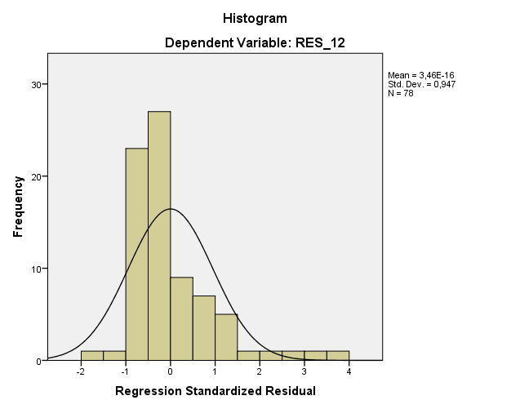

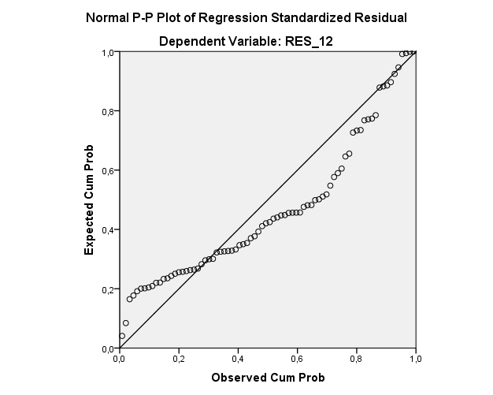

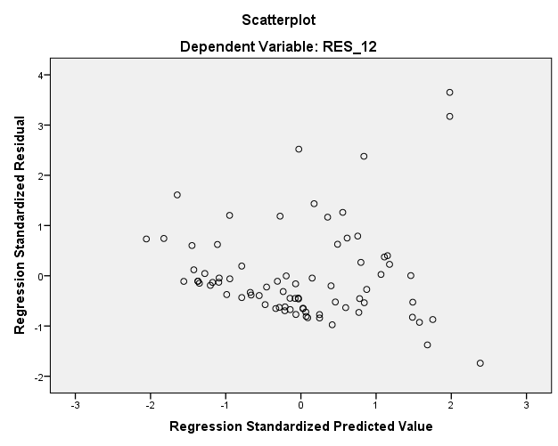

REGRESSION RESULTS OF THESSALONIKI ROAD SAMPLE

Variables Entered/Removedª
Model | Variables Entered | Variables Removed | Method
1 | LNDC | . | Stepwise (Criteria: Probability-of-F-to-enter <= ,050, Probability-of-F-to-remove >= ,100).
2 | LNABR | . | Stepwise (Criteria: Probability-of-F-to-enter <= ,050, Probability-of-F-to-remove >= ,100).
3 | LNAREA | . | Stepwise (Criteria: Probability-of-F-to-enter <= ,050, Probability-of-F-to-remove >= ,100).
4 | LNOSPACE | . | Stepwise (Criteria: Probability-of-F-to-enter <= ,050, Probability-of-F-to-remove >= ,100).
a. Dependent Variable: LNMVALUE

Model Summary^{e}
Model | R | R Square | Adjusted R Square | Std. Error of the Estimate | Selection Criteria |  |  |  | Durbin-Watson
 |  |  |  |  | Akaike Information Criterion | Amemiya Prediction Criterion | Mallows' Prediction Criterion | Schwarz Bayesian Criterion | Durbin-Watson
1 | ,921ª | ,849 | ,845 | ,49279 | -58,908 | ,166 | 181,758 | -55,386
2 | ,970^{b} | ,941 | ,938 | ,31265 | -97,099 | ,068 | 49,694 | -91,816
3 | ,985^{c} | ,971 | ,969 | ,22138 | -125,875 | ,035 | 7,380 | -118,830
4 | ,987^{d} | ,975 | ,972 | ,20999 | -129,537 | ,032 | 4,152 | -120,731 | 1,899
a. Predictors: (Constant), LNDC
b. Predictors: (Constant), LNDC, LNABR
c. Predictors: (Constant), LNDC, LNABR, LNAREA
d. Predictors: (Constant), LNDC, LNABR, LNAREA, LNOSPACE
e. Dependent Variable: LNMVALUE

ANOVAª
Model |  | Sum of Squares | df | Mean Square | F | Sig.
1 | Regression | 55,945 | 1 | 55,945 | 230,376 | ,000^{b}
1 | Residual | 9,956 | 41 | ,243
1 | Total | 65,901 | 42
2 | Regression | 61,991 | 2 | 30,996 | 317,089 | ,000^{c}
2 | Residual | 3,910 | 40 | ,098
2 | Total | 65,901 | 42
3 | Regression | 63,990 | 3 | 21,330 | 435,216 | ,000^{d}
3 | Residual | 1,911 | 39 | ,049
3 | Total | 65,901 | 42
4 | Regression | 64,226 | 4 | 16,056 | 364,137 | ,000e
4 | Residual | 1,676 | 38 | ,044
4 | Total | 65,901 | 42
a. Dependent Variable: LNMVALUE
b. Predictors: (Constant), LNDC
c. Predictors: (Constant), LNDC, LNABR
d. Predictors: (Constant), LNDC, LNABR, LNAREA
e. Predictors: (Constant), LNDC, LNABR, LNAREA, LNOSPACE

Coefficientsª
Model |  | Unstandardized Coefficients |  | Standardized Coefficients | t | Sig. | Collinearity Statistics
 |  | B | Std. Error | Beta | t | Sig. | Tolerance | VIF
1 | (Constant) | 11,838 | ,256 |  | 46,225 | ,000
1 | LNDC | -2,192 | ,144 | -,921 | -15,178 | ,000 | 1,000 | 1,000
2 | (Constant) | 12,258 | ,171 |  | 71,665 | ,000
2 | LNDC | -1,691 | ,112 | -,711 | -15,153 | ,000 | ,674 | 1,483
2 | LNABR | 1,863 | ,237 | ,369 | 7,865 | ,000 | ,674 | 1,483
3 | (Constant) | 12,545 | ,129 |  | 97,109 | ,000
3 | LNDC | -1,491 | ,085 | -,627 | -17,539 | ,000 | ,583 | 1,717
3 | LNABR | 2,047 | ,170 | ,405 | 12,026 | ,000 | ,655 | 1,527
3 | LNAREA | -,209 | ,033 | -,188 | -6,386 | ,000 | ,861 | 1,162
4 | (Constant) | 10,868 | ,735 |  | 14,777 | ,000
4 | LNDC | -1,544 | ,084 | -,649 | -18,419 | ,000 | ,539 | 1,855
4 | LNABR | 1,921 | ,170 | ,380 | 11,273 | ,000 | ,588 | 1,701
4 | LNAREA | -,248 | ,035 | -,223 | -7,019 | ,000 | ,664 | 1,506
4 | LNOSPACE | ,439 | ,190 | ,076 | 2,312 | ,026 | ,626 | 1,596
a. Dependent Variable: LNMVALUE

Residuals Statisticsª
 | Minimum | Maximum | Mean | Std. Deviation | N
Predicted Value | 6,8891 | 10,4624 | 8,1218 | 1,23660 | 43
Residual | -,61653 | ,36397 | ,00000 | ,19974 | 43
Std. Predicted Value | -,997 | 1,893 | ,000 | 1,000 | 43
Std. Residual | -2,936 | 1,733 | ,000 | ,951 | 43
a. Dependent Variable: LNMVALUE

Charts

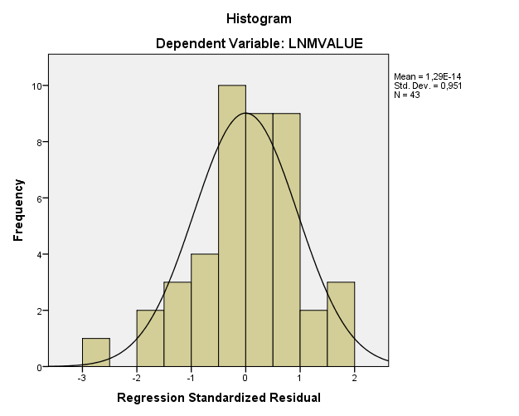

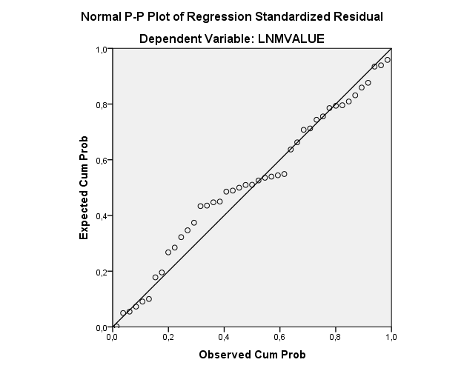

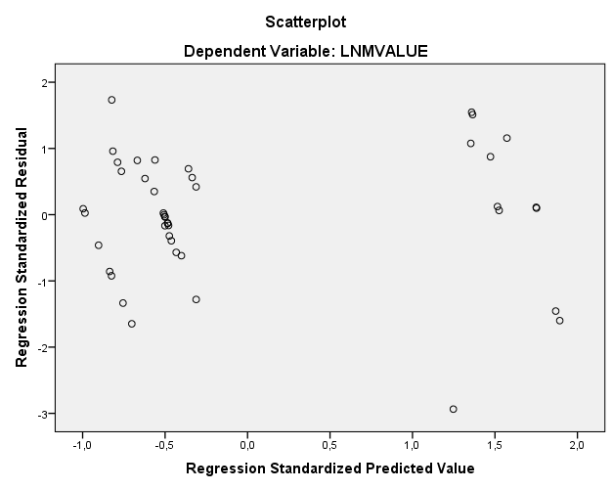

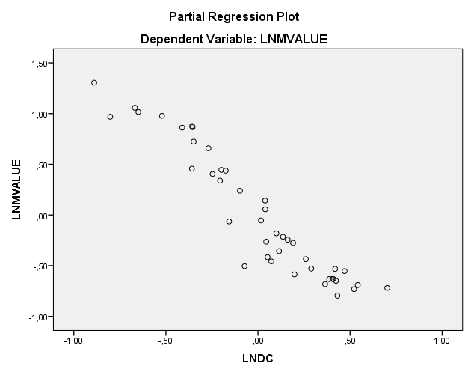

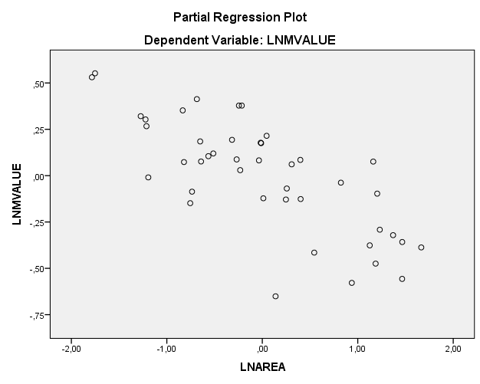

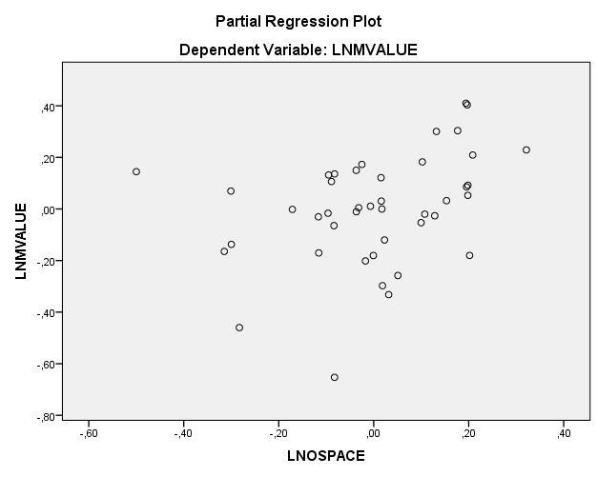

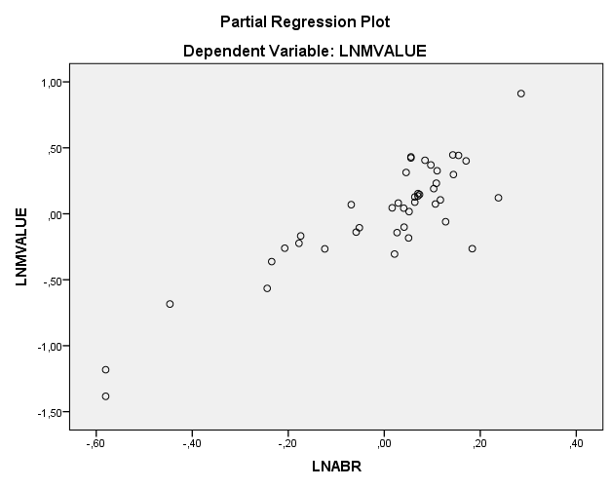

Explore

Case Processing Summary
 | Cases
 | Valid |  | Missing |  | Total
 | N | Percent | N | Percent | N | Percent
Unstandardized Residual | 43 | 100,0% | 0 | 0,0% | 43 | 100,0%

Descriptives
 |  |  | Statistic | Std. Error
Unstandardized Residual | Mean |  | 0E-7 | ,03045965
Unstandardized Residual | 95% Confidence Interval for Mean | Lower Bound | -,0614701
Unstandardized Residual | 95% Confidence Interval for Mean | Upper Bound | ,0614701
Unstandardized Residual | 5% Trimmed Mean |  | ,0071448
Unstandardized Residual | Median |  | ,0053643
Unstandardized Residual | Variance |  | ,040
Unstandardized Residual | Std. Deviation |  | ,19973726
Unstandardized Residual | Minimum |  | -,61653
Unstandardized Residual | Maximum |  | ,36397
Unstandardized Residual | Range |  | ,98050
Unstandardized Residual | Interquartile Range |  | ,24235
Unstandardized Residual | Skewness |  | -,699 | ,361
Unstandardized Residual | Kurtosis |  | 1,023 | ,709

Tests of Normality
 | Kolmogorov-Smirnovª |  |  | Shapiro-Wilk
 | Statistic | df | Sig. | Statistic | df | Sig.
Unstandardized Residual | ,128 | 43 | ,074 | ,963 | 43 | ,173
a. Lilliefors Significance Correction

Unstandardized Residual

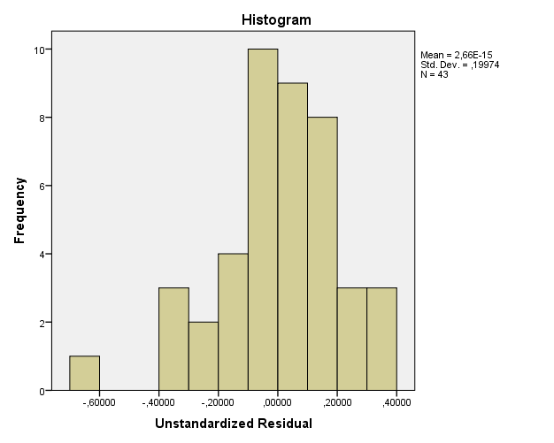

Unstandardized Residual Stem-and-Leaf Plot

Frequency Stem & Leaf

1,00 Extremes (=<-,62)
3,00 -3 . 034
2,00 -2 . 68
4,00 -1 . 1389
10,00 -0 . 0002233689
9,00 0 . 001122278
8,00 1 . 11346778
3,00 2 . 024
3,00 3 . 126

Stem width: ,10000
Each leaf: 1 case(s)

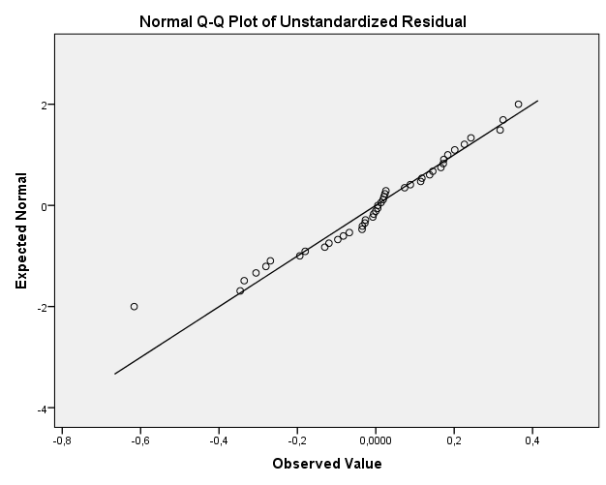

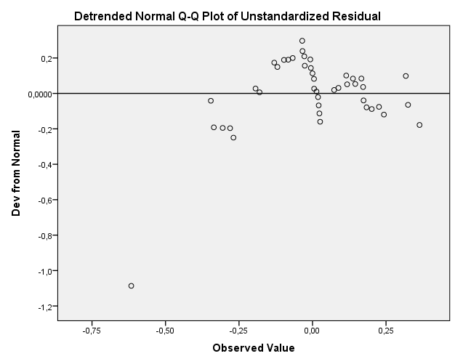

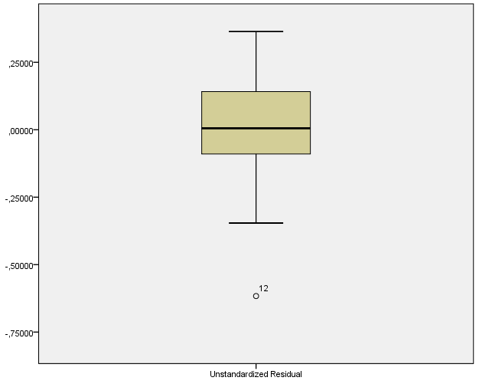

Regression OF RESIDUALS (RES_12) (heteroskedasticity TEST)

Variables Entered/Removedª
Model | Variables Entered | Variables Removed | Method
1 | LNABR, LNAREA, LNLUSES, LNDC, LNOSPACE^{b} | . | Enter
a. Dependent Variable: RES_12
b. All requested variables entered.

Model Summary^{b}
Model | R | R Square | Adjusted R Square | Std. Error of the Estimate | Durbin-Watson
1 | ,376ª | ,141 | ,025 | ,06481 | 1,747
a. Predictors: (Constant), LNABR, LNAREA, LNLUSES, LNDC, LNOSPACE
b. Dependent Variable: RES_12

ANOVAª
Model |  | Sum of Squares | df | Mean Square | F | Sig.
1 | Regression | ,026 | 5 | ,005 | 1,217 | ,320^{b}
1 | Residual | ,155 | 37 | ,004
1 | Total | ,181 | 42
a. Dependent Variable: RES_12
b. Predictors: (Constant), LNABR, LNAREA, LNLUSES, LNDC, LNOSPACE

Coefficientsª
Model |  | Unstandardized Coefficients |  | Standardized Coefficients | t | Sig. | Collinearity Statistics
 |  | B | Std. Error | Beta | t | Sig. | Tolerance | VIF
1 | (Constant) | ,416 | ,283 |  | 1,470 | ,150
1 | LNDC | -,016 | ,026 | -,127 | -,595 | ,555 | ,514 | 1,947
1 | LNAREA | ,003 | ,011 | ,044 | ,232 | ,818 | ,636 | 1,571
1 | LNOSPACE | -,077 | ,071 | -,253 | -1,082 | ,286 | ,423 | 2,363
1 | LNLUSES | -,002 | ,003 | -,152 | -,638 | ,527 | ,411 | 2,434
1 | LNABR | ,066 | ,054 | ,251 | 1,220 | ,230 | ,547 | 1,827
a. Dependent Variable: RES_12

Residuals Statisticsª
 | Minimum | Maximum | Mean | Std. Deviation | N
Predicted Value | -,0037 | ,0991 | ,0390 | ,02467 | 43
Residual | -,08157 | ,31144 | ,00000 | ,06083 | 43
Std. Predicted Value | -1,728 | 2,438 | ,000 | 1,000 | 43
Std. Residual | -1,259 | 4,806 | ,000 | ,939 | 43
a. Dependent Variable: RES_12

Charts

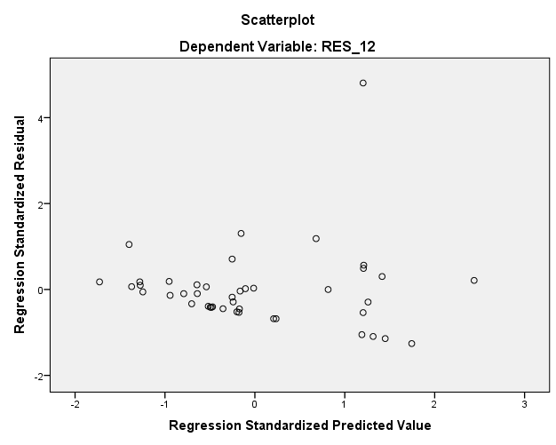

REGRESSION RESULTS OF VOLOS ROAD SAMPLE

Variables Entered/Removedª
Model | Variables Entered | Variables Removed | Method
1 | DH | . | Stepwise (Criteria: Probability-of-F-to-enter <= ,050, Probability-of-F-to-remove >= ,100).
2 | AREA | . | Stepwise (Criteria: Probability-of-F-to-enter <= ,050, Probability-of-F-to-remove >= ,100).
3 | ABR | . | Stepwise (Criteria: Probability-of-F-to-enter <= ,050, Probability-of-F-to-remove >= ,100).
a. Dependent Variable: LNMVALUE

Model Summary^{e}
Model | R | R Square | Adjusted R Square | Std. Error of the Estimate | Selection Criteria |  |  |  | Durbin-Watson
 |  |  |  |  | Akaike Information Criterion | Amemiya Prediction Criterion | Mallows' Prediction Criterion | Schwarz Bayesian Criterion | Durbin-Watson
1 | ,981ª | ,962 | ,961 | ,25900 | -95,324 | ,043 | 25,115^{b} | -92,157
2 | ,987^{c} | ,974 | ,973 | ,21601 | -107,469 | ,031 | 8,558^{b} | -102,718
3 | ,990^{d} | ,980 | ,978 | ,19365 | -114,445 | ,025 | 2,049^{b} | -108,111 | 1,627
a. Predictors: (Constant), DH
b. Multicollinearity is present. The following variables were not included in the full model used for calculation of the Mallows' Prediction Criterion: LUSES
c. Predictors: (Constant), DH, AREA
d. Predictors: (Constant), DH, AREA, ABR
e. Dependent Variable: LNMVALUE

ANOVAª
Model |  | Sum of Squares | df | Mean Square | F | Sig.
1 | Regression | 57,311 | 1 | 57,311 | 854,355 | ,000^{b}
1 | Residual | 2,281 | 34 | ,067
1 | Total | 59,592 | 35
2 | Regression | 58,052 | 2 | 29,026 | 622,098 | ,000^{c}
2 | Residual | 1,540 | 33 | ,047
2 | Total | 59,592 | 35
3 | Regression | 58,392 | 3 | 19,464 | 519,063 | ,000^{d}
3 | Residual | 1,200 | 32 | ,037
3 | Total | 59,592 | 35
a. Dependent Variable: LNMVALUE
b. Predictors: (Constant), DH
c. Predictors: (Constant), DH, AREA
d. Predictors: (Constant), DH, AREA, ABR

Coefficientsª
Model |  | Unstandardized Coefficients |  | Standardized Coefficients | t | Sig. | Collinearity Statistics
 |  | B | Std. Error | Beta | t | Sig. | Tolerance | VIF
1 | (Constant) | 10,353 | ,073 |  | 142,739 | ,000
1 | DH | -1,018 | ,035 | -,981 | -29,229 | ,000 | 1,000 | 1,000
2 | (Constant) | 10,495 | ,070 |  | 149,436 | ,000
2 | DH | -,925 | ,037 | -,891 | -24,751 | ,000 | ,605 | 1,653
2 | AREA | -,035 | ,009 | -,143 | -3,985 | ,000 | ,605 | 1,653
3 | (Constant) | 9,727 | ,263 |  | 37,014 | ,000
3 | DH | -,849 | ,042 | -,817 | -20,231 | ,000 | ,386 | 2,594
3 | AREA | -,033 | ,008 | -,136 | -4,210 | ,000 | ,601 | 1,663
3 | ABR | 1,058 | ,351 | ,109 | 3,010 | ,005 | ,484 | 2,066
a. Dependent Variable: LNMVALUE

Residuals Statisticsª
 | Minimum | Maximum | Mean | Std. Deviation | N
Predicted Value | 6,7022 | 10,4631 | 8,6494 | 1,29165 | 36
Residual | -,36647 | ,53650 | ,00000 | ,18516 | 36
Std. Predicted Value | -1,507 | 1,404 | ,000 | 1,000 | 36
Std. Residual | -1,892 | 2,771 | ,000 | ,956 | 36
a. Dependent Variable: LNMVALUE

Charts

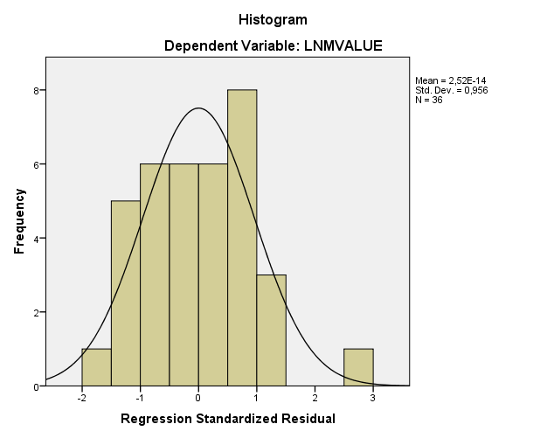

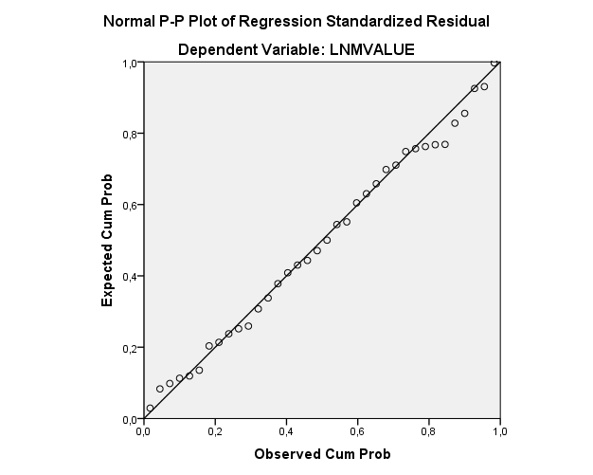

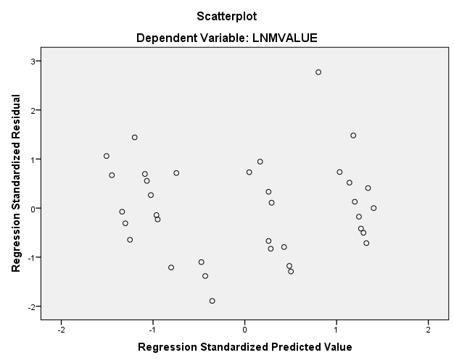

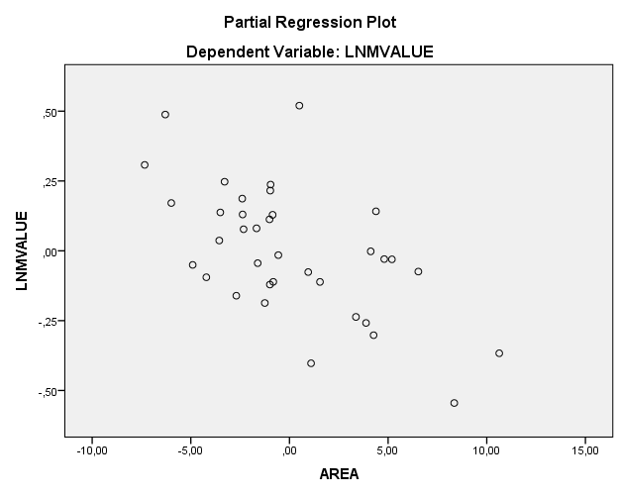

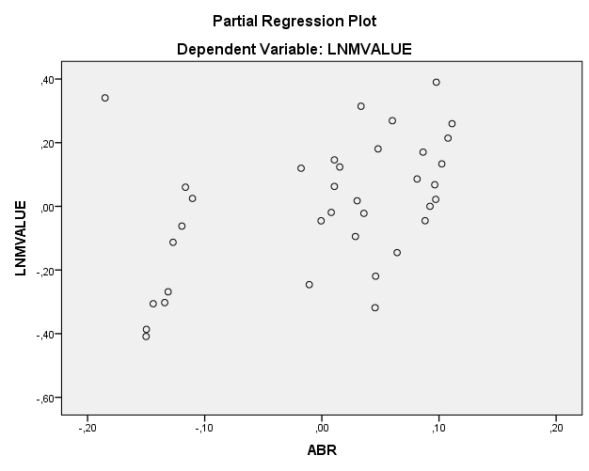

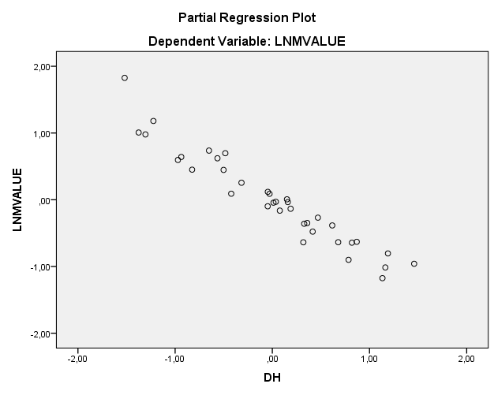

Explore

Case Processing Summary
 | Cases
 | Valid |  | Missing |  | Total
 | N | Percent | N | Percent | N | Percent
Unstandardized Residual | 36 | 41,9% | 50 | 58,1% | 86 | 100,0%

Descriptives
 |  |  | Statistic | Std. Error
Unstandardized Residual | Mean |  | 0E-7 | ,03086004
Unstandardized Residual | 95% Confidence Interval for Mean | Lower Bound | -,0626492
Unstandardized Residual | 95% Confidence Interval for Mean | Upper Bound | ,0626492
Unstandardized Residual | 5% Trimmed Mean |  | -,0057069
Unstandardized Residual | Median |  | -,0071177
Unstandardized Residual | Variance |  | ,034
Unstandardized Residual | Std. Deviation |  | ,18516024
Unstandardized Residual | Minimum |  | -,36647
Unstandardized Residual | Maximum |  | ,53650
Unstandardized Residual | Range |  | ,90298
Unstandardized Residual | Interquartile Range |  | ,26956
Unstandardized Residual | Skewness |  | ,457 | ,393
Unstandardized Residual | Kurtosis |  | ,703 | ,768

Tests of Normality
 | Kolmogorov-Smirnovª |  |  | Shapiro-Wilk
 | Statistic | df | Sig. | Statistic | df | Sig.
Unstandardized Residual | ,082 | 36 | ,200* | ,978 | 36 | ,682
*. This is a lower bound of the true significance.
a. Lilliefors Significance Correction

Unstandardized Residual

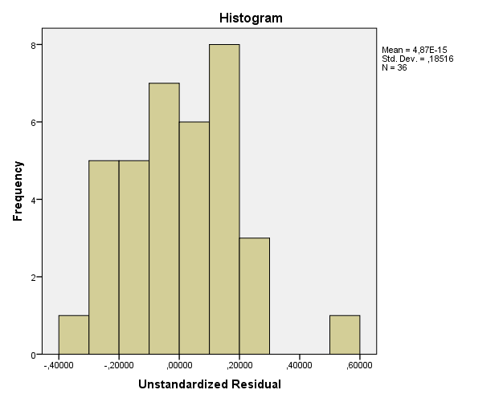

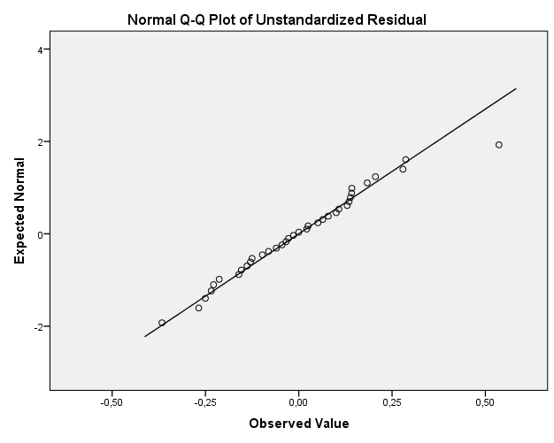

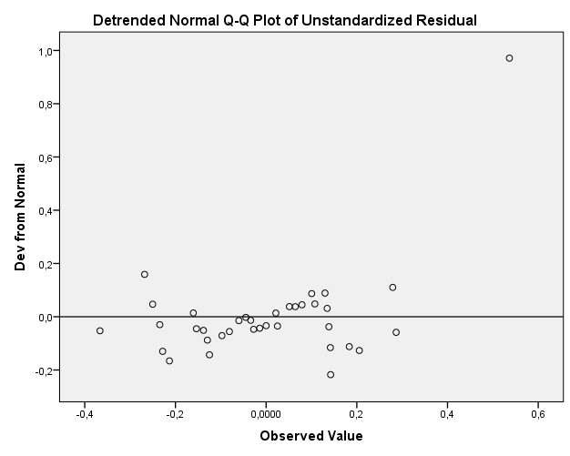

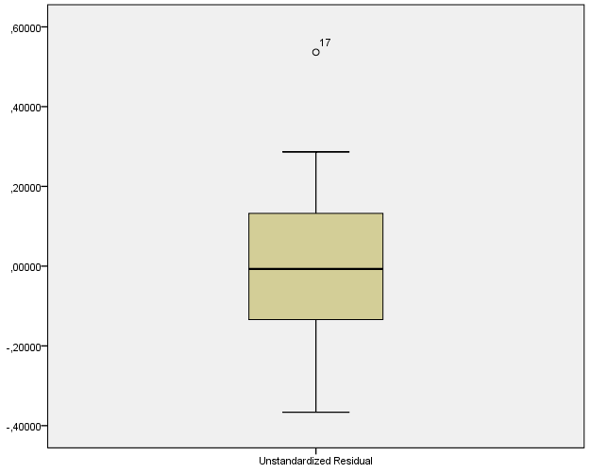

Regression OF RESIDUALS (RES_12) (heteroskedasticity TEST)

Variables Entered/Removedª
Model | Variables Entered | Variables Removed | Method
1 | OSPACE,  ABR, AREA,  DH^{b} | . | Enter
a. Dependent Variable: RES_12
b. Tolerance = ,000 limits reached.

Model Summary^{b}
Model | R | R Square | Adjusted R Square | Std. Error of the Estimate | Durbin-Watson
1 | ,330ª | ,109 | -,006 | ,05304 | 1, 359
a. Predictors: (Constant), DH, OSPACE, AREA, ABR, DC
b. Dependent Variable: RES_12

ANOVAª
Model |  | Sum of Squares | df | Mean Square | F | Sig.
1 | Regression | ,011 | 4 | ,003 | ,947 | ,450^{b}
1 | Residual | ,087 | 31 | ,003
1 | Total | ,098 | 35
a. Dependent Variable: RES_12
b. Predictors: (Constant), DH, OSPACE, AREA, ABR

Coefficientsª
Model |  | Unstandardized Coefficients |  | Standardized Coefficients | t | Sig. | Collinearity Statistics
 |  | B | Std. Error | Beta | t | Sig. | Tolerance | VIF
1 | (Constant) | ,143 | ,093 |  | 1,541 | ,133
1 | DH | ,019 | ,012 | -,453 | -1,647 | ,110 | ,381 | 2,628
1 | AREA | ,000 | ,002 | ,045 | ,196 | ,846 | ,542 | 1,844
1 | ABR | -,169 | ,097 | -,427 | -1,734 | ,093 | ,473 | 2,113
1 | OSPACE | ,000 | ,001 | ,063 | ,304 | ,763 | ,662 | 1,511
a. Dependent Variable: RES_12

Residuals Statisticsª
 | Minimum | Maximum | Mean | Std. Deviation | N
Predicted Value | ,0079 | ,0707 | ,0333 | ,01745 | 36
Residual | -,05232 | ,21712 | ,00000 | ,04992 | 36
Std. Predicted Value | -1,456 | 2,142 | ,000 | 1,000 | 36
Std. Residual | -,986 | 4,094 | ,000 | ,941 | 36
a. Dependent Variable: RES_12

Charts

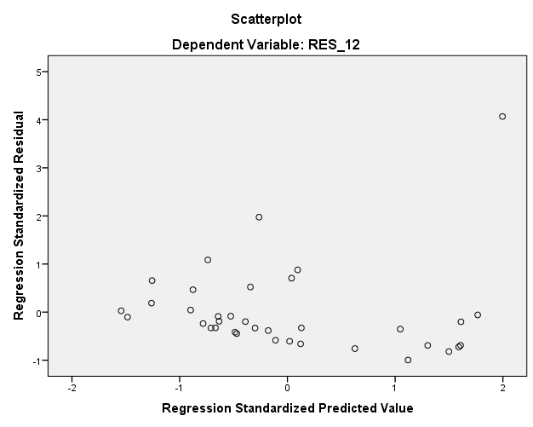

REGRESSION RESULTS OF VOLOS ROAD SAMPLE (2)

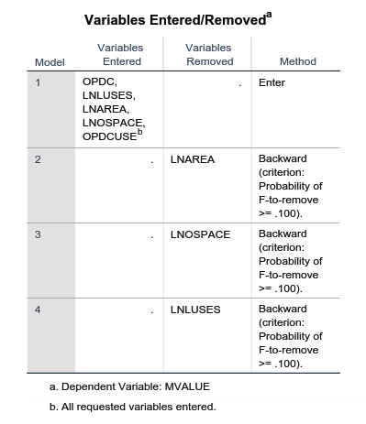

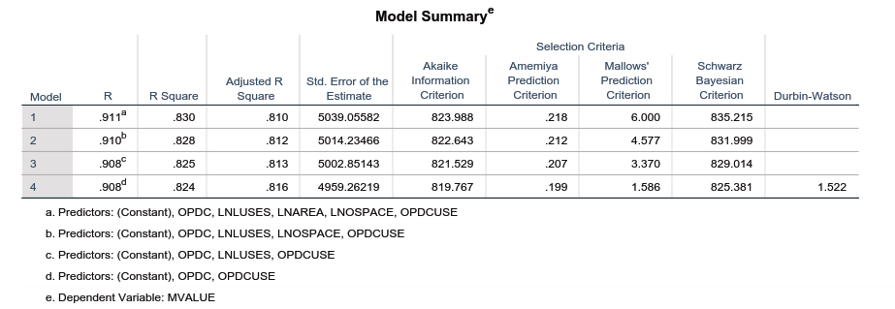

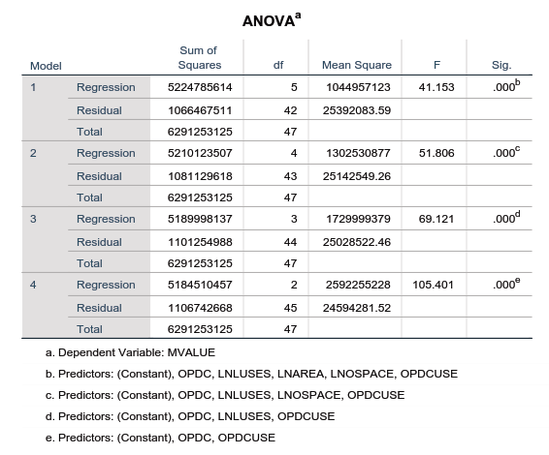

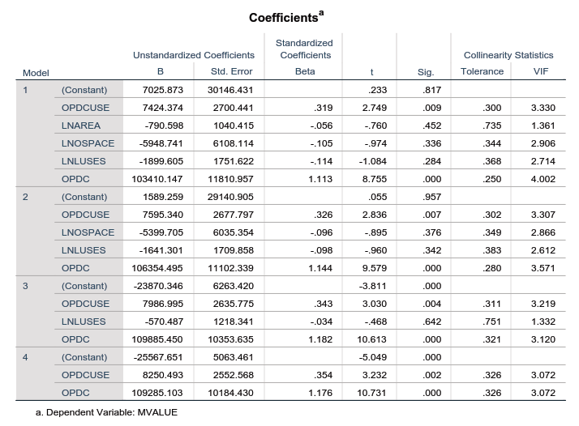

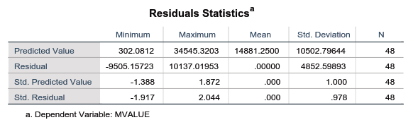

Charts

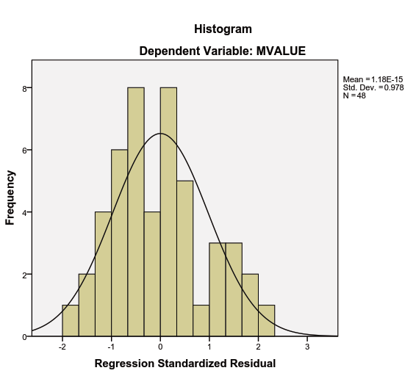

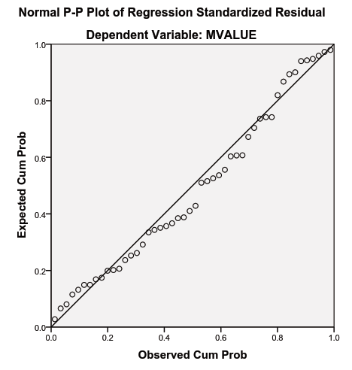

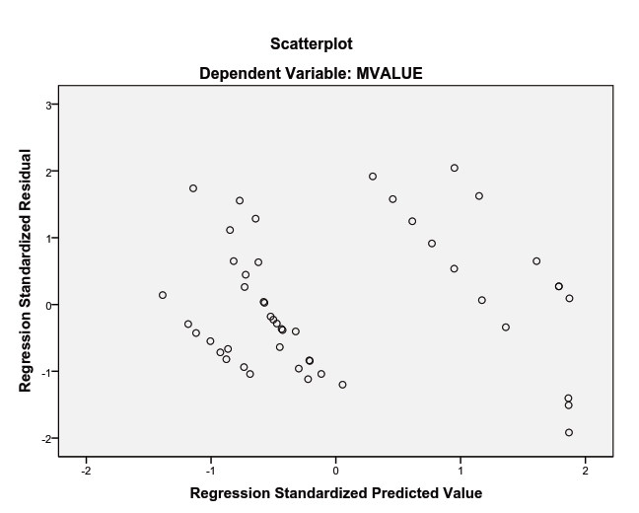

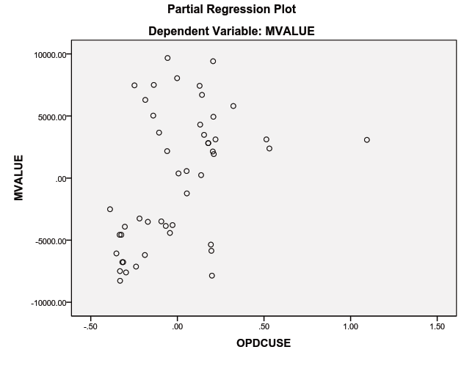

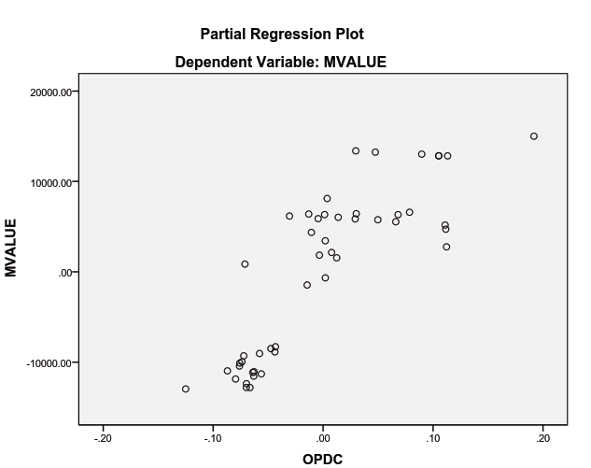

Explore
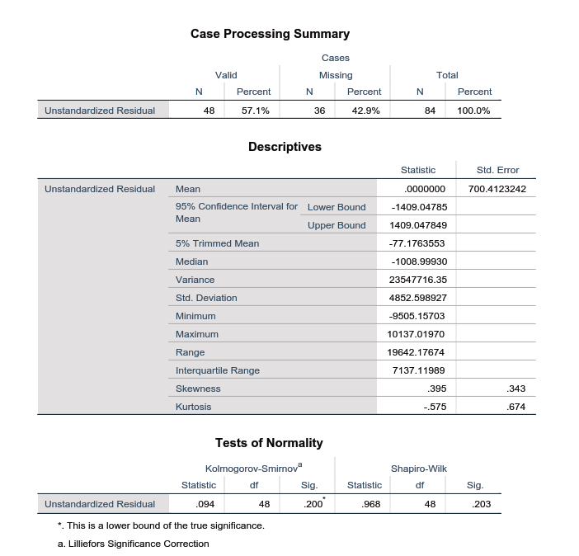

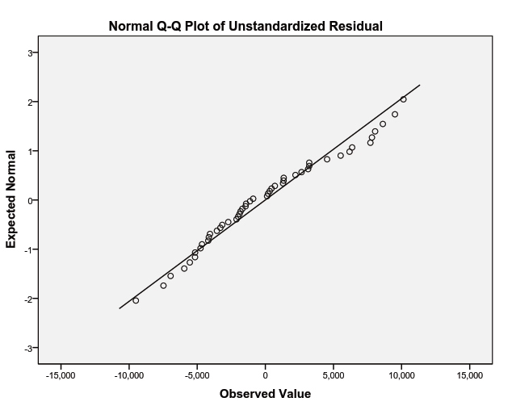

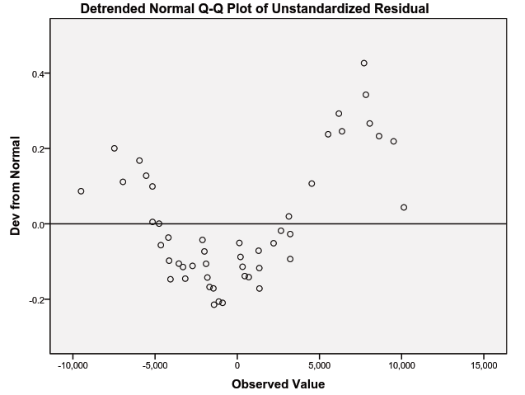

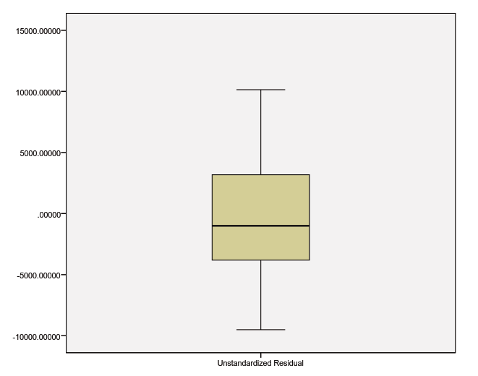

Regression OF RESIDUALS (RES_12) (heteroskedasticity TEST)

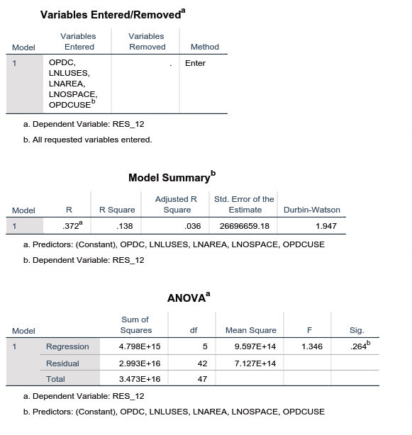

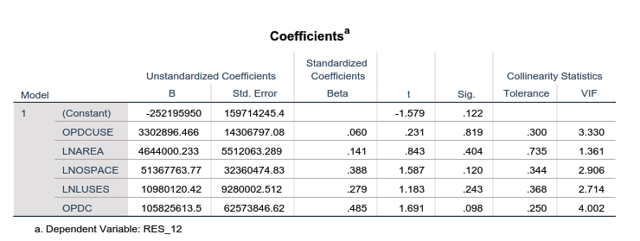

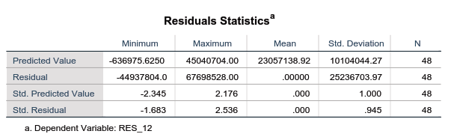

Charts

