**Ecological Indices of the Heavy Metals in the Soil of Shewasoor Sub-Basin, Kirkuk/ NE Iraq**

**Omer S. Al-Tamimi**1 **and Mustafa J. A. Ali** 2

*1Head of Environmental Research Unit, College of Science, University of Kirkuk, Kirkuk/ Iraq*

*2Master Student at Department of Applied Geology, College of Science, University of Kirkuk, Kirkuk/ Iraq*

[omeribrahiem@gmail.com](mailto:omeribrahiem@gmail.com)

[mustafa.jamalakbar77@gmail.com](mailto:mustafa.jamalakbar77@gmail.com)

***Abstract:***

The current research aimed to assess contamination levels of soil by heavy metals. Eight sites were selected for the collection of soil samples. The eight heavy metals namely As, Pb, Cd, Cr, Co, Cu, Ni, and Zn were analyzed in each soil samples by using ICP-MS technology. The measured concentrations of heavy metals were compared with Geochemical Background values, EPA Sediment Quality Guidelines, EPA Ecological Screening values, and WHO Guidelines. The spatial distribution maps of ecological indices were performed using ArcGIS software (version 10.2), which provides an idea of the geographical distribution of heavy metals contamination levels in the soil of Shewasoor sub-basin. The soil contamination by heavy metals assessed using Potential Ecological Risk Index ($RI$), Nemerow Pollution Index ($P_{N}$), Hazard Index (*HI*), and Cancer Risk. The $RI$ showed there are high risk of heavy metals in soil and according to $P_{N}$ the soil has been moderate to severely contaminated by heavy metals. The hazard index of all soil samples was within acceptable range for adults and showed unacceptable risk for children. While the total cancer risk values of As and Cr was in acceptable limits, whereas Pb, Cd, Co, and Ni was lower than acceptable risk range at all sites for adults and children.

***Keywords:*** Ecological, Assessment, Heavy Metals, Soil, Shewasoor Sub-basin.

***1.Introduction:***

The soil is an important component of terrestrial ecosystems, it’s very sensitive to environmental change. the soil can contaminate by introducing of pollutants from different pathways (Van der Perk, 2006; Bullock and Gregory, 1991). The contribution of heavy metals from anthropogenic sources in soil is higher than the contribution from natural sources (Nriagu and Pacyna, 1988). The soil contamination with heavy metals is of one the most ecological problems because it's related directly to the human health. (Li et al., 2014; Li et al., 2012; Zhao et al., 2012). The heavy metals are dangerous pollutants unlike other pollutants because they are non-degradable for that accumulate in the soil, the effects of these metals may be reflected in the plant behavior, microbiological processes and transfer of toxic levels of the elements to man and animals, these elements have negative effects on human health and on the environment especially on the children (Nouri et al., 2006; Pekey, 2006; Abdelhafez et al., 2012; Harikumar et al., 2010; Campbell et al., 2001; Nickolson et al., 2003). Some heavy metals play an essential role in biochemical processes, most organisms required these metals in a small amount for normally healthy growth (e.g. Zn, Cu, and Cr) (Van der Perk, 2006), but become toxic at higher concentration (Lane and Morel, 2009). Other heavy metals are not essential and do not cause deficiency disorders if absent (e.g. Cd, Pb, and As) (Van der Perk, 2006), these metals toxic at low levels of exposure (Van der Perk, 2006; Kabata-Pendias, 2011). Absorption of heavy metals by the body for a period of time (years or decades) lead to accumulation these metals in vital organs like brain, liver, bones, and kidneys, then causing serious health consequences (Kabata-Pendias, 2011). Hence, the study of heavy metals pollution in soil and assess its environmental risks to the agricultural products and human health very important and necessary (Wang et al., 2014). The current research aimed to 1) Determine the concentration of heavy metals in the soil of Shewasoor sub-basin. 2) Ecological assessment of the soil of Shewasoor sub-basin using Potential ecological risk index, Nemerow pollution index. 3) Assessment of the potential health risks of heavy metals on the population in the study area by an estimate carcinogenic risk and non-carcinogenic hazard.

***2. Study Area:***

The study area is located to the northeastern part of Iraq, between longitudes (44° 30' 0.1"- 44° 40' 41.06") and latitudes (35° 41' 25"- 35° 51' 40.2"), apart about 39 km to the north east of Kirkuk city, covers about 160 ${Km}^{2}$. The study area is bounded by Taqtaq Anticline from north and northeast sides, by Northern ChamChamal Anticline from west and southwest sides, and by topographic elevated area from south and southeast sides. Also, the topographic elevations of the study area ranges between (311-1186) m (Figure 1). The climate of Iraq is generally continental type, its cold rainy in the winter and hot and dry in the summer (Jaradat, 2002).

C:\Users\MUSTAFA\Desktop\kozal oglan\geology\MS\MAMaMA\Maps and Images\Study area maps\soil sampling-location.tif

**Figure 1.** The Location of Study Area and Soil Sampling Sites.

***2.1 Tectonic and Geological Setting:***

The study area lies in the Unstable shelf within Foothill zone in Chamchamal-Arbil subzone according to (Al-Kadhimi et al., 1996) tectonic division of Iraq. The exposed formations in the study area extending from oldest (Upper Miocene) up to youngest (Quaternary deposits) (Sissakian, 1992), (Figure 2) are:

***Injana Formation:*** (Upper Miocene), it consists of gray, brown sandstone, brown claystone and siltstone of the same colour (Sissakian, 1992). The thickness of this formation is 2000m in the center of depositional basin within Foothill zone (Al-Naqib, 1960).

***Mukdadiya Formation:*** (Uppermost Miocene-Pliocene), it consists of brown claystone with gray coarse-grained sandstone, brown and gray siltstone, and pebbly sandstone (Sissakian, 1992). Its thickness is more than 2500m in the center of the depositional basin within Foothill zone (Al-Naqib, 1960).

***Bai-Hassan Formation:*** (Pliocene), it consists of thick and coarse conglomerates, thick brown claystone and thin sandstone (Sissakian, 1992). Its thickness is more than 2000m in the center of depositional basin within Foothill zone (Al-Naqib, 1960).

***Quaternary Deposition:*** (Pliocene-Holocene), Six types of quaternary deposits are developed in the study area, are River terraces, Polygenetic deposits, Slope deposits, Residual gravels, Floodplain, and Valley-fill deposits (Sissakian, 1992).

***2.2 Soil of the Study Area:***

The study area represents deep valley contain ephemeral stream coming down from the high areas. The soil of the study area formed as a result of intensive erosion processes of rock formations that are exposed at the surface mainly Bai-Hassan and Mukdadiya Formations. Two soil types were recognized in the area are (Buringh, 1960):

***Reddish-Brown Soil:*** This type of soil represents the hill slopes soils, which is characterized by reddish-brown surface soil which at little depth turns up from brown colour into red colour, lime accumulation begins at depth 15 cm, also its soft soil easily eroded, the biological activity and chemical weathering are rather low, and its highly permeable soil causing infiltration of water into subsurface.

***Brown Soil:*** This soil has a brown surface layer of about (25-30) cm, grading into a brownish-gray to the whitish horizon of lime accumulation, which consists of silt loam mixed with some gravels, grading into brown silt loam at 14 cm, with lime accumulation beginning at a depth of 30 cm. The topsoil is alkaline and may have (1 or 2) % of organic matter. The process of chemical weathering becomes more important in this type of soil.

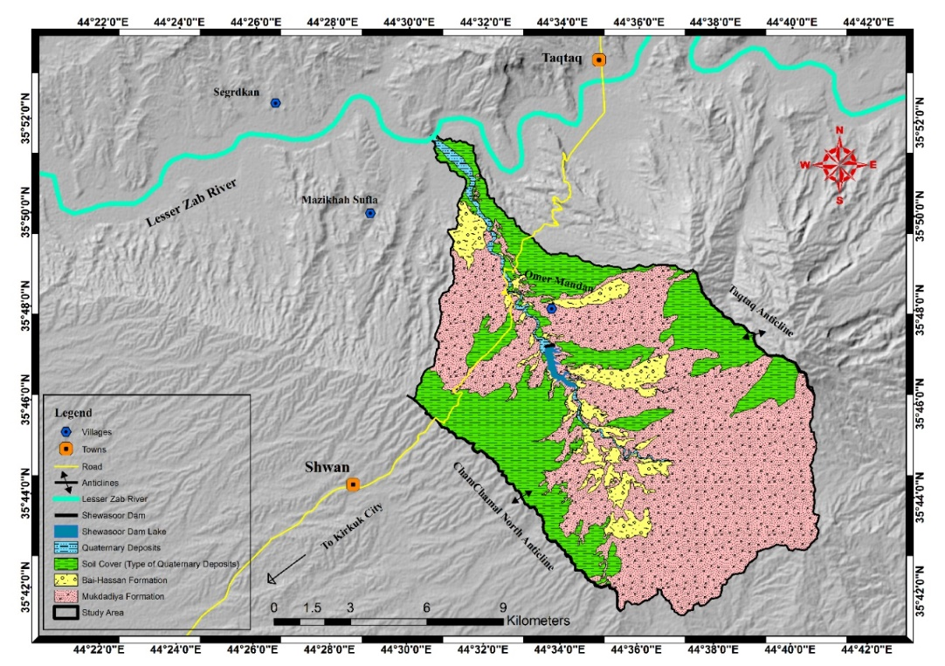

**Figure 2.** Geological Map of the Study Area.

***3. Materials and Methods:***

***3.1 Sampling and Analysis:***

***3.1.1 Collection of Samples:*** Soil samples were collected from eight sites within the study area as shown in (Figure 1) at Oct 2016. Before the sampling (Fieldwork) start, the stratified random sampling method was selected, where the study area is divided into a grid of egalitarian squares and soil samples were taken randomly from each square from (0-20) cm depth, the samples were placed in clean and new polythene bags. The large empty area in the sampling map represent the geological outcrops.

***3.1.2* *Preparation of Samples:*** Soil samples were air-dried at room temperature and sieved by (200 mesh) sieve in order to separate and remove all course materials. The weighted 2 gm of samples and placed in small polythene bags, then they were transferred to the laboratory.

***3.1.3 Analysis of Samples:***Theeight heavy metals As, Pb, Cd, Cr, Co, Cu, Ni, and Zn, were analyzed in all samples. The concentrations of heavy metals were determined using Inductively Coupled Plasma-Mass Spectrometry (ICP-MS) at Acme labs/ Vancouver, BC Canada V6P 6E5. The detection limits for metals mentioned above are 0.1, 0.01, 0.01, 0.5, 0.1, 0.01, 0.1, 0.1 ppm, respectively. The physicochemical characteristics of soil samples were analyzed in the Environmental Research Unit Laboratory/ College of Science/ University of Kirkuk.

***3.2 Statistical Analysis:*** The calculated of descriptive statistical parameters (median, average, max, and min) and Pearson’s correlation coefficients analysis were performed between heavy metals using the SPSS software, version 22.

***3.3 Spatial Distribution Analysis:*** The spatial distribution maps of ecological indices were mapped (scale 1:88000) carried through Inverse Distance Weighted (IDW) method by using ArcGIS software (version 10.2).

***3.4 Ecological Assessment Methods:*** The ecological assessment of the soil of Shewasoor sub-basin was performed by using the following ecological indices:

***3.4.1 Nemerow Pollution Index ($P_{N}$):***

The Nemerow pollution index ($P_{N}$) was used to assess the total contamination level of heavy metals in the soil of study area and evaluate environment quality. The Nemerow pollution index was calculated by using the following equation (Chen et al., 2015), see (Table 1):

$PI= \frac{C_{n}}{S_{n}}$ (1)

$P_{N}=\sqrt[2]{{{({PI}_{max})}^{2}+{({PI}_{average})}^{2}}/2}$ (2)

Where: $PI$ is Pollution Index of heavy metal (n), $C_{n}$ is Measured concentration of heavy metal (n), $S_{n}$ is Background concentration of heavy metal (n), according to (Wedephol, 1995), $P_{N}$ is Nemerow pollution index, ${PI}_{max}$ is Maximum pollution index value for all of the pollutant, ${PI}_{average}$ is Average pollution index value for all of the pollutant.

**Table 1** Nemerow Pollution Index ($P_{N}$) and Contamination Level (Chen et al., 2015).

|  |  |
| --- | --- |
| $P_{N}$ value | Contamination Level |
| $P_{N}$ ≤ 1 | Soil has not been contaminated |
| 1 < $P_{N}$ ≤ 2 | Soil has been slightly contaminated |
| 2 < $P_{N}$ ≤ 3 | Soil has been moderately contaminated |
| $P_{N}$ > 3 | Soil has been severely contaminated |

***3.4.2 Potential Ecological Risk Index (RI):***

The contaminated soil with heavy metal can enter the human body through several pathways and various exposure approaches (Bade et al., 2013). Elevated levels of toxic heavy metals in agricultural soil can influence food chain, hence lead to increase the exposure of severing dangerous diseases, such as cancer, leukemia, and kidney or liver damage (Khan et al., 2011). Therefore, the assessment of potential ecological risks (RI) is necessary, which developed by (Hakanson, 1980), represent the toxicity of heavy metals and their risks level to the environment, (RI) value is calculated by the following (Hakanson, 1980), see (Table 2):

$RI=\sum_{i=1}^{n}{\frac{(T_{i}*C_{i})}{B_{i}}}$ (3)

Where: $T_{i}$ is Toxicity factor of heavy metals are (Cd= 30, As = 10, Pb = 5, Cu = 5, Cr = 2, Zn = 1, Ni = 5), ( $\frac{C_{i}}{B_{i}}$) is Contamination factor.

**Table 2** Potential Ecological Risk Index ($RI$) and Level of Risk (Hakanson, 1980).

|  |  |
| --- | --- |
| $RI$ value | Risk Level |
| $RI$ ≤ 50 | Low risk |
| 50 < $RI$ ≤ 100 | Moderate risk |
| 100 < $RI$ ≤ 150 | High risk |
| 150 < $RI$ ≤ 200 | Very high risk |
| 200 < $RI$ | Extreme risk |

***3.4.3 Health Risk Assessment:***

Health risk assessment was employed to estimate the adverse health effects of exposure to the carcinogenic and non-carcinogenic heavy metals on the human health (U.S. EPA, 2001). The risk assessment consisted of four basic steps (U.S. EPA, 2001; NRC., 1983): hazard identification, exposure assessment, toxicity (dose-response) assessment, and risk characterization.

***3.4.3.1 Chronic Daily Intake (CDI):***

The human can expose to heavy metals in soil through three pathways are (U.S. EPA, 1989): 1) Ingestion of soil 2) Dermal absorption of heavy metals 3) Inhalation of heavy metals that emitted with soil particles. The Chronic Daily Intake (*CDI*) of heavy metals in the soil of study area by three pathways was calculated by using the following equations (U.S. EPA, 1989), see (Table 3):

For non-carcinogenic:

${CDI}_{ing-nc}=\frac{C_{soil}*IngR*EF*ED*CF}{BW*{AT}_{nc}}$ (4)

${CDI}_{dermal-nc}=\frac{C_{soil}*SA*AF*ABS*EF*ED*CF}{BW*{AT}_{nc}}$ (5)

${CDI}_{inh-nc}=\frac{C_{soil}*InhR*EF*ED}{PEF*BW*{AT}_{nc}}$ (6)

For carcinogenic:

${CDI}_{ing-c}=\frac{C_{soil}*IngR*EF*ED*CF}{BW*{AT}_{c}}$ (7)

${CDI}_{dermal-c}=\frac{C_{soil}*SA*AF*ABS*EF*ED*CF}{BW*{AT}_{c}}$ (8)

${CDI}_{inh-c}=\frac{C_{soil}*InhR*EF*ED}{PEF*BW*{AT}_{c}}$ (9)

Where: ${CDI}_{ing}$, ${CDI}_{dermal}$, and ${CDI}_{inh}$ were the chronic daily intake through ingestion of soil (mg/kg-day), dermal contact with soil particles (mg/kg-day), and inhalation of heavy metals via soil particles (mg/m3 for non-carcinogenic and µg/m3 for carcinogenic), and other parameters are clarified in (Table 3).

**Table 3** Parameters Used for the Health Risk Assessment of Study Area Soil . for Adult and Children (U.S. EPA, 2016 and U.S. EPA, 2017).

|  |  |  |  |
| --- | --- | --- | --- |
| Parameter | Unit | Adult | Child |
| Concentration of metals (Csoil) | ppm | - | - |
| Exposure Duration (ED) | year | 30 | 6 |
| Exposure Frequency (EF) | days/ year | 350 | 350 |
| Ingestion Rate (IngR) | mg/ day | 100 | 200 |
| Inhalation Rate (InhR) | m3/ day | 20 | 10 |
| Body Weight (BW) | kg | 70 | 15 |
| Average Time (AT):  For Non-carcinogenic  For Carcinogenic | days | ED * 365  70 * 365 | ED * 365  70 * 365 |
| Conversion Factor (CF) | kg/mg | 10-6 | 10-6 |
| Skin Surface Area (SA) | cm2 | 5700 | 2800 |
| Soil Adherence Factor (AF) | mg/cm2.day | 0.07 | 0.2 |
| Particle Emission Factor (PEF) | m3/kg | 1.4*109 | 1.4*109 |
| Dermal Absorption Factor (ABS) | - | 0.03 for As and 0.001 for other elements | |

***3.4.3.2 Non-carcinogenic Risk Assessment:***

The non-carcinogenic risk evaluated by using the hazard quotient (*HQ*). *HQ* value indicates the degree of exposure (*CDI*) greater or less than the (*RfD*). The *HQ* value represents the ratio of *ADI* to *RfD* of the toxic metals in soil samples were calculated by using the following equation (U.S. EPA, 1989), see (Table 4):

$THQ={HQ}_{ing}+{HQ}_{drmal}+{HQ}_{inh}=\frac{{CDI}_{ing-nc}}{{RfD}_{ing}}+\frac{{CDI}_{dermal-nc}}{{RfD}_{dermal}}+\frac{{CDI}_{inh-nc}}{{RfC}_{inh}}$ (10)

Where: $THQ$ is Total Hazard Quotient, ${HQ}_{ing}$ is Ingestion Hazard Quotient, ${HQ}_{drmal}$ is Dermal Hazard Quotient, ${HQ}_{inh}$ is Inhalation Hazard Quotient ${CDI}_{ing-nc}$, ${CDI}_{dermal-nc}$, and ${CDI}_{inh-nc}$ were non-carcinogenic chronic daily intake through three pathways ingestion (mg/kg-day), dermal (mg/kg-day), and inhalation (mg/m3), respectively, ${RfD}_{ing}$, ${RfD}_{dermal}$, and ${RfC}_{inh}$ were Ingestion Reference Dose (mg/ kg-day), Dermal Reference Dose (${RfD}_{ing}$/ Fraction of contaminant absorbed in the skin $({ABS}_{GI}$)) (mg/ kg-day), and Inhalation Reference Concentration (mg/m3), respectively.

The hazard index (*HI*) estimated the risk of a mixture of contaminant (e.g. Heavy metal), which represents the sum of more than one HQ for heavy metals, the *HI* calculated by using the following equation (U.S. EPA, 1989):

$HI=\sum{THQ}$ (11)

Where, $THQ$ and $HI$ are total hazard quotient and hazard index, respectively. If the *HI* value is less than one (*HI* < 1) mean there is no non-carcinogenic adverse effects, if the *HI* value exceeds one (*HI* > 1) mean there is non-carcinogenic effects risk (U.S. EPA, 1989).

***3.4.3.3 Carcinogenic Risk Assessment:***

Cancer risk estimates the probability of an individual lifetime health risk as a result of exposure to the carcinogens. The cancer risk calculated by using the following equation (U.S. EPA, 1989), see (Table 4):

$Total Cancer Risk={Risk}_{ing}+{Risk}_{dermal}+{Risk}_{inh}$. = ${CDI}_{ing-c}*{CSF}_{ing}+{CDI}_{dermal-c}*{CSF}_{dermal}+{CDI}_{inh-c}*IUR$ (12

Where: ${Risk}_{ing}$, ${Risk}_{dermal}$, and ${Risk}_{inh}$ are cancer risks through ingestion, dermal, and inhalation pathways, ${CSF}_{ing}$, ${CSF}_{dermal}$, and $IUR$ are ingestion chronic slope factor (mg/kg-day)-1, dermal chronic slope factor (${CSF}_{ing}$ ${ABS}_{GI}$*) (mg/kg-day)-1, and inhalation unit risk (g/m3)-1, respectively. The acceptable or tolerable total risk for regulatory purposes is in the range of (10-6 – 10-4), (U.S. EPA, 2004; MOE, 2009).

**Table 4** Parameters Used for the Non-carcinogenic Hazard and Carcinogenic Risk . . Assessment of Study Area Soil for Adult and Children. (U.S. EPA, 2017).

|  |  |  |  |  |  |  |  |
| --- | --- | --- | --- | --- | --- | --- | --- |
| Metal |  |  |  |  |  |  |  |
| As | 3*10-4 | 3*10-4 | 1.5*10-5 | 1.5 | 1.5 | 4.3*10-3 | 1 |
| Pb | 3.5*10-3 | 3.5*10-3 | - | 8.5*10-3 | 8.5*10-3 | 1.2*10-5 | 1 |
| Cd | 5*10-4 | 2.5*10-5 | 1*10-5 | - | - | 1.8*10-3 | 0.05 |
| Cr | 3*10-3 | 7.5*10-5 | 1*10-4 | 5*10-1 | 20 | 8.4*10-2 | 0.025 |
| Co | 3*10-4 | 3*10-4 | 6*10-6 | - | - | 9*10-3 | 1 |
| Cu | 4*10-2 | 4*10-2 | - | - | - | - | 1 |
| Ni | 2*10-2 | 8*10-4 | 9*10-5 | - | - | 2.6*10-4 | 0.04 |
| Zn | 3*10-1 | 3*10-1 | - | - | - | - | 1 |

**4. Results and Discussion:**

***4.1 Concentrations of Heavy Metals in Soil Samples:***

(Table 5) shows the concentration of heavy metals in the Shewasoor’s sub-basin soil. The abundance trend of median concentrations of heavy metals in the soil samples in order of Ni> Cr> Zn> Cu> Co> Pb> As> Cd, the concentrations of As, Cd, and Ni in the all samples highest than geochemical background values, while the concentrations of Pb, Cr, Co, and Zn in all samples lower than geochemical background values, except Zn at site (S7), higher than same value. The concentration of Cu at (S1, S2, and S4) lower than geochemical background value, but its concentration higher than the compared value at other sites.

**Table 5** Concentrations of Heavy Metals in Soil Samples of Study Area, Geochemical Background values of Heavy Metals, and Maximum Allowable Limit of Concentrations of Heavy Metals in Soil for Several Guidelines. (ppm)

|  |  |  |  |  |  |  |  |  |  |
| --- | --- | --- | --- | --- | --- | --- | --- | --- | --- |
| Site Name | As | Pb | Cd | Cr | Co | Cu | Ni | Zn | pH |
| S1 | 6.7 | 10.07 | 0.25 | 79.8 | 17.6 | 23.15 | 118 | 49.2 | 7.5 |
| S2 | 5.3 | 8.08 | 0.17 | 61.6 | 20.2 | 25.56 | 94.5 | 36.1 | 7.7 |
| S3 | 8.7 | 13.56 | 0.15 | 78.4 | 19.1 | 29.98 | 129.7 | 56.7 | 8 |
| S4 | 9.7 | 10.92 | 0.16 | 64.6 | 14.4 | 19.55 | 82 | 39.4 | 8 |
| S5 | 7.3 | 11.53 | 0.15 | 69.5 | 16.3 | 25.08 | 108.9 | 52.5 | 8.1 |
| S6 | 6.9 | 12.59 | 0.27 | 80.1 | 17.1 | 27.77 | 132 | 57 | 7.8 |
| S7 | 7.1 | 14.66 | 0.27 | 99.1 | 21.8 | 33.72 | 143.2 | 76 | 7.9 |
| S8 | 6.1 | 11.29 | 0.27 | 79.1 | 17.5 | 27.39 | 128.9 | 51.2 | 8.2 |
| Median | 7.0 | 11.41 | 0.21 | 78.75 | 17.55 | 26.475 | 123.45 | 51.85 | 7.95 |
| Average | 7.225 | 11.587 | 0.211 | 76.525 | 18 | 26.525 | 117.15 | 52.263 | 7.9 |
| Min | 5.3 | 8.08 | 0.15 | 61.6 | 14.4 | 19.55 | 82 | 36.1 | 7.5 |
| Max | 9.7 | 14.66 | 0.27 | 99.1 | 21.8 | 33.72 | 143.2 | 76 | 8.2 |
| Geochemical Background  Value a | 1.7 | 14.8 | 0.1 | 136 | 24 | 25 | 56 | 65 | - |
| EPA b | 10 | 16 | 0.38 | 0.4 | 9 | 36 | 30 | 50 | - |
| WHO Guidelines c | 20 | 100 | 3 | 100 | 50 | 100 | 50 | 300 | - |

a Wedephol, (1995); b EPA Ecological Screening Values, (2005); c Chiroma et al., (2014).

The heavy metals concentrations in the soil of study area were assessed by comparing with the EPA Sediment Quality Guidelines (SQGs) (U.S. EPA, 1977) shown in (Table 6). The results showed all sites are non-polluted with Pb, Cd, and Zn, but polluted heavily by Ni, the soil at S6, S7, and S8 is polluted moderately with As and Cu, whereas polluted heavily by Cr. also the S5 and S2 considered as polluted moderately by As, Cr, and Cu, while S3 showed heavy pollute by As and Cr and moderate pollute for Cu. The moderate pollution observed at S1 for As, and heavy pollution for Cr, but it non-polluted with Cu, as well as S4 heavily polluted by As, and exhibit moderate pollute with Cr, also it non-polluted by Cu.

**Table 6** EPA Sediment Quality Guidelines (SQGs) (U.S. EPA, 1977).

|  |  |  |  |  |
| --- | --- | --- | --- | --- |
| Metal | Non-polluted | Moderately Polluted | Heavily Polluted | Present Study |
| As (ppm) | < 3 | 3 – 8 | >8 | 5.3 – 9.7 |
| Pb (ppm) | < 40 | 40 – 60 | >60 | 8.08 – 14.66 |
| Cd (ppm) | * | * | >6 | 0.15 – 0.27 |
| Cr (ppm) | < 25 | 25 – 75 | >75 | 61.6 – 99.1 |
| Cu (ppm) | < 25 | 25 – 50 | >50 | 19.55 – 33.72 |
| Ni (ppm) | < 20 | 20 – 50 | >50 | 82 – 143.2 |
| Zn (ppm) | < 90 | 90 – 200 | >200 | * 1. – 76 |

*Lower limits not established.

According to EPA Ecological Screening values (EPA, 2005) (Table 5), the concentrations of As, Pb, Cd, and Cu are lower than EPA Ecological Screening values, while the concentrations of Cr, Co, and Ni are higher than the EPA Ecological Screening values at all soil sampling sites. But Zn at sites (S1, S2, and S4) is lower than EPA Ecological Screening value and at other sites its concentration higher than the same value. The concentrations of As, Pb, Cd, Cr, Co, Cu, and Zn at all sites did not exceed the WHO Guidelines, except the Ni, exceeded the same guidelines (Table 5).

***4.3 Correlation Coefficient of Heavy Metals in Soil of the Study Area:***

The Pearson’s correlation coefficient is a statistical method which describe the strength and direction of the relationship between two variables (Table 7), (Zou et al., 2003), were employed to evaluate the relations among heavy metals (Table 8), showed strong positive relation between heavy metals pairs of Pb-Zn (r = 0.894), Cr-Ni (r = 0.891), Cr-Zn (r = 0.942), Cu-Ni (r = 0.859), Cu-Zn (r = 0.835), Ni-Zn (r = 0.872), and Co-Cu (r = 0.810). While, the moderate positive relations observed between heavy metals pairs of Pb-Cr (r = 0.783), Pb-Ni (r = 0.733), Cr-Cu (r = 0.774), Pb-Cu (r = 0.7), Cd-Cr (r = 0.705), Cd-Ni (r = 0.663), Cd-Zn (r = 0.509), Cr-Co (r = 0.549), Co-Ni (r = 0.547), Co-Zn (r = 0.520). The high positive relations among heavy metals indicate to the heavy metals are originated from the same pollution source, whereas the weak relations denoted to differences in geochemical behavior and source of metals (Manta, et al., 2002; Yang, et al., 2011). While the correlations coefficient of pH with other heavy metals showed no association between them in the soil of the study area, this attributed to the alkaline soil of Shewasoor sub-basin (Van der Perk, 2006).

**Table 7** Interpretation of Pearson’s Correlation Coefficient (Zou et al., 2003).

|  |  |
| --- | --- |
| Correlation value | Strength and Direction of Correlation |
| (-0.8) – (-1.0) | Strongly negative |
| (-0.5) – (-0.8) | Moderately negative |
| (-0.2) – (-0.5) | Weakly negative |
| (+0.2) – (-0.2) | No association |
| (+0.2) – (+0.5) | Weakly positive |
| (+0.5) – (+0.8) | Moderately positive |
| (+0.8) – (+1.0) | Strongly positive |

**Table 8** Pearson’sCorrelation Matrix Among Heavy Metals in Soil of Study Area.

|  |  |  |  |  |  |  |  |  |  |
| --- | --- | --- | --- | --- | --- | --- | --- | --- | --- |
| Metal | As | Pb | Cd | Cr | Co | Cu | Ni | Zn | pH |
| As | 1 |  | | | | | | | |
| Pb | 0.420 | 1 |  | | | | | | |
| Cd | -0.448 | 0.269 | 1 |  | | | | | |
| Cr | -0.062 | 0.783 | 0.705 | 1 |  | | | | |
| Co | -0.488 | 0.255 | 0.271 | 0.549 | 1 |  | | | |
| Cu | -0.260 | 0.700 | 0.395 | 0.774 | 0.810 | 1 |  | | |
| Ni | -0.233 | 0.733 | 0.663 | 0.891 | 0.547 | 0.859 | 1 |  | |
| Zn | 0.035 | 0.894 | 0.509 | 0.942 | 0.520 | 0.835 | 0.872 | 1 |  |
| pH | 0.315 | 0.380 | -0.206 | -0.017 | -0.253 | 0.152 | 0.070 | 0.148 | 1 |

***4.8 Potential Ecological Risk Index (RI):***

The potential ecological risk index (*RI*) was used to evaluate the level of ecological risk in the study area. The results of *RI* showed in (Table 9), and spatial distribution of *RI* shown in (Figure 3). According to (Hakanson, 1980), the high level of ecological risk was observed at all sites, except site (S2) which show moderate ecological risk.

***4.9 Nemerow Pollution Index ($P_{N}$):***

Degree of heavy metals contamination was evaluated by using Nemerow pollution index ($P_{N}$). The results of Nemerow pollution index listed in (Table 9), and spatial distribution of $P_{N}$ shown in (Figure 3). According to (Chen et al., 2015) the, soil has been moderately contaminated at sites (S1, S2, and S8), whereas the soil has been severely contaminated at all other sites.

**Table 9** Ecological Risk Index and Nemerow Pollution Index of Heavy Metals in the Soil of Study Area.

|  |  |  |  |  |
| --- | --- | --- | --- | --- |
| Site Name | Ecological Risk Index (RI) | | Nemerow pollution index ($P_{N}$) | |
| RI value | Risk Level | $P_{N}$ value | Contamination Level |
| S1 | 134.91 | High Risk | 2.99 | Soil has been Moderately Contamination |
| S2 | 98.92 | Moderate Risk | 2.36 | Soil has been Moderately Contamination |
| S3 | 120.36 | High Risk | 3.80 | Soil has been Severely Contamination |
| S4 | 121.54 | High Risk | 4.17 | Soil has been Severely Contamination |
| S5 | 108.41 | High Risk | 3.20 | Soil has been Severely Contamination |
| S6 | 145.24 | High Risk | 3.10 | Soil has been Severely Contamination |
| S7 | 149.87 | High Risk | 3.22 | Soil has been Severely Contamination |
| S8 | 139.63 | High Risk | 2.77 | Soil has been Moderately Contamination |
| *50 < RI <100 Moderate Risk, *100 < RI < 150 High Risk | | | | |
| *2 < $P_{N}$ < 3 Soil has been Moderately Contamination $P_{N}$ * > 3 Soil has been Moderately Contamination | | | | |

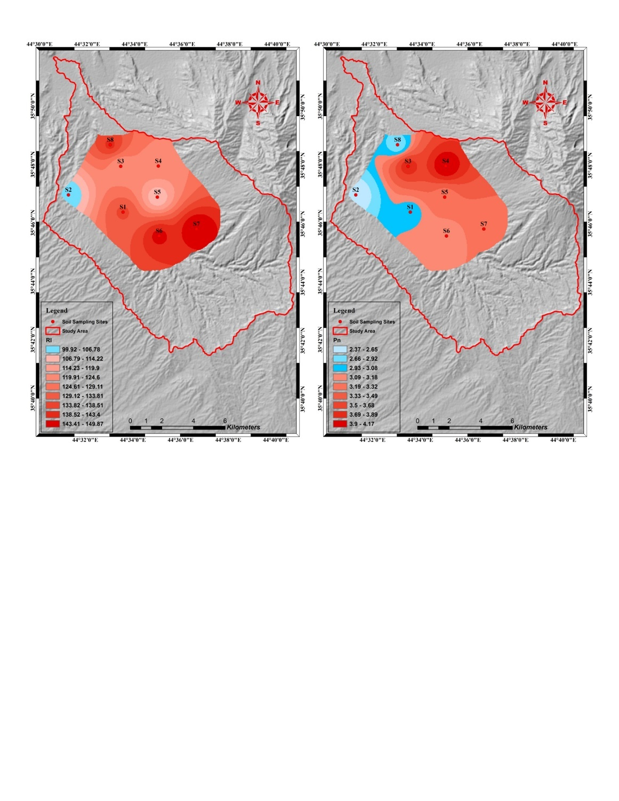

**Figure 3** Spatial Distribution of RI, and $P_{N}$ in Soil of Study Area.

***4.10 Non-carcinogenic Risk Assessment of heavy metals for Adults and children:***

The Total Hazard Quotient (*HQ*) results of heavy metals present in (Table 10). The non-carcinogenic risk was assessed according to calculated values of Hazard Index (*HI*) of soil samples for adults and children through different pathways. The results of *HI* listed in (Table 11), and spatial distribution of *HI* for adults and children shown in (Figure 4). The *HI* values for adults at all sites were observed lower than one (*HI*< 1), this means there is no non-carcinogenic risk for adults, and the adults population were unlikely to experience adverse effects. Whereas the *HI* values for children higher than one (*HI*> 1) at all sampling sites, this mean the children that reside in the study area were at risk of non-carcinogenic effects of heavy metals.

***4.11 Carcinogenic Risk Assessment of Heavy Metals for Adults and Children:***

The cancer risk for heavy metals As, Pb, Cd, Cr, Co, and Ni were calculated, these metals are most contributors to the cancer risk, the results were shown in (Table 11). The total cancer risk values of As and Cr for adults and children were in acceptable risk range at all sampling sites, while the total cancer risk of Pb, Cd, Co, and Ni was lower than tolerable risk range at all sites. These values mean there is no cancer risk for adults and children, which they residing in the study area.

**Table 10** TotalHazard Quotient of Heavy Metals for Adults and Children in Soil of Study Area.

|  |  |  |  |  |  |  |  |  |  |
| --- | --- | --- | --- | --- | --- | --- | --- | --- | --- |
|  | Site Name | Total Hazard Quotient (THQ) | | | | | | | |
| As | Pb | Cd | Cr | Co | Cu | Ni | Zn |
| Adults | S1 | 3.8E-02 | 4.0E-03 | 9.0E-04 | 4.2E-02 | 8.1E-02 | 8.0E-04 | 9.1E-03 | 2.3E-04 |
| S2 | 3.0E-02 | 3.2E-03 | 6.2E-04 | 3.3E-02 | 9.3E-02 | 8.8E-04 | 7.3E-03 | 1.7E-04 |
| S3 | 4.9E-02 | 5.3E-03 | 6.0E-04 | 4.2E-02 | 8.8E-02 | 1.0E-03 | 1.0E-02 | 2.6E-04 |
| S4 | 5.5E-02 | 4.3E-03 | 6.0E-04 | 3.4E-02 | 6.6E-02 | 6.7E-04 | 6.4E-03 | 1.8E-04 |
| S5 | 4.1E-02 | 4.5E-03 | 5.8E-04 | 3.7E-02 | 7.5E-02 | 8.6E-04 | 8.4E-03 | 2.4E-04 |
| S6 | 3.9E-02 | 4.9E-03 | 9.6E-04 | 4.3E-02 | 7.9E-02 | 9.5E-04 | 1.0E-02 | 2.6E-04 |
| S7 | 4.0E-02 | 5.8E-03 | 9.9E-04 | 5.3E-02 | 1.0E-01 | 1.2E-03 | 1.1E-02 | 3.5E-04 |
| S8 | 3.5E-02 | 4.4E-03 | 9.5E-04 | 4.2E-02 | 8.1E-02 | 9.4E-04 | 1.0E-02 | 2.3E-04 |
| Children | S1 | 3.1E-01 | 3.7E-02 | 6.8E-03 | 3.8E-01 | 7.5E-01 | 7.4E-03 | 8.1E-02 | 2.1E-03 |
| S2 | 2.5E-01 | 3.0E-02 | 4.6E-03 | 2.9E-01 | 8.6E-01 | 8.2E-03 | 6.5E-02 | 1.5E-03 |
| S3 | 4.0E-01 | 5.0E-02 | 4.1E-03 | 3.7E-01 | 8.2E-01 | 9.6E-03 | 8.9E-02 | 2.4E-03 |
| S4 | 4.5E-01 | 4.0E-02 | 4.3E-03 | 3.1E-01 | 6.2E-01 | 6.3E-03 | 5.7E-02 | 1.7E-03 |
| S5 | 3.4E-01 | 4.2E-02 | 4.1E-03 | 3.3E-01 | 7.0E-01 | 8.0E-03 | 7.5E-02 | 2.2E-03 |
| S6 | 3.2E-01 | 4.6E-02 | 7.3E-03 | 3.8E-01 | 7.3E-01 | 8.9E-03 | 9.1E-02 | 2.4E-03 |
| S7 | 3.3E-01 | 5.4E-02 | 7.3E-03 | 4.7E-01 | 9.3E-01 | 1.1E-02 | 9.9E-02 | 3.2E-03 |
| S8 | 2.8E-01 | 4.1E-02 | 7.3E-03 | 3.8E-01 | 7.5E-01 | 8.8E-03 | 8.9E-02 | 2.2E-03 |

**Table 11** Hazard Index and Total Cancer Risk of Heavy Metals in Soil of Study Area.

|  |  |  |  |  |  |  |  |  |  |  |
| --- | --- | --- | --- | --- | --- | --- | --- | --- | --- | --- |
|  | Site Name | Total Cancer Risk | | | | | | | | Hazard Index (HI) |
| As | Pb | Cd | Cr | Co | Cu | Ni | Zn |
| Adults | S1 | 6.6E-06 | 5.0E-08 | 3.8E-14 | 2.7E-05 | 1.3E-11 | - | 2.6E-12 | - | 0.177 |
| S2 | 5.2E-06 | 4.0E-08 | 2.6E-14 | 2.1E-05 | 1.5E-11 | - | 2.1E-12 | - | 0.168 |
| S3 | 8.6E-06 | 6.8E-08 | 2.3E-14 | 2.7E-05 | 1.4E-11 | - | 2.8E-12 | - | 0.196 |
| S4 | 9.6E-06 | 5.5E-08 | 2.4E-14 | 2.2E-05 | 1.1E-11 | - | 1.8E-12 | - | 0.168 |
| S5 | 7.2E-06 | 5.8E-08 | 2.3E-14 | 2.4E-05 | 1.2E-11 | - | 2.4E-12 | - | 0.168 |
| S6 | 6.8E-06 | 6.3E-08 | 4.1E-14 | 2.7E-05 | 1.3E-11 | - | 2.9E-12 | - | 0.178 |
| S7 | 7.0E-06 | 7.3E-08 | 4.1E-14 | 3.4E-05 | 1.6E-11 | - | 3.1E-12 | - | 0.213 |
| S8 | 6.0E-06 | 5.7E-08 | 4.1E-14 | 2.7E-05 | 1.3E-11 | - | 2.8E-12 | - | 0.174 |
| Children | S1 | 1.2E-05 | 9.4E-08 | 1.8E-14 | 4.9E-05 | 6.2E-12 | - | 1.2E-12 | - | 1.576 |
| S2 | 9.4E-06 | 7.5E-08 | 1.2E-14 | 3.8E-05 | 7.1E-12 | - | 9.6E-13 | - | 1.511 |
| S3 | 1.6E-05 | 1.3E-07 | 1.1E-14 | 4.8E-05 | 6.7E-12 | - | 1.3E-12 | - | 1.747 |
| S4 | 1.7E-05 | 1.0E-07 | 1.1E-14 | 3.9E-05 | 5.1E-12 | - | 8.3E-13 | - | 1.480 |
| S5 | 1.3E-05 | 1.1E-07 | 1.1E-14 | 4.2E-05 | 5.7E-12 | - | 1.1E-12 | - | 1.497 |
| S6 | 1.2E-05 | 1.2E-07 | 1.9E-14 | 4.9E-05 | 6.0E-12 | - | 1.3E-12 | - | 1.587 |
| S7 | 1.3E-05 | 1.4E-07 | 1.9E-14 | 6.0E-05 | 7.7E-12 | - | 1.5E-12 | - | 1.905 |
| S8 | 1.1E-05 | 1.1E-07 | 1.9E-14 | 4.8E-05 | 6.2E-12 | - | 1.3E-12 | - | 1.555 |
| \**HI* <1 means there is no non-carcinogenic effects risk.  \**HI* > 1 means there is non-carcinogenic adverse effects risk. | | | | | | | | | | |

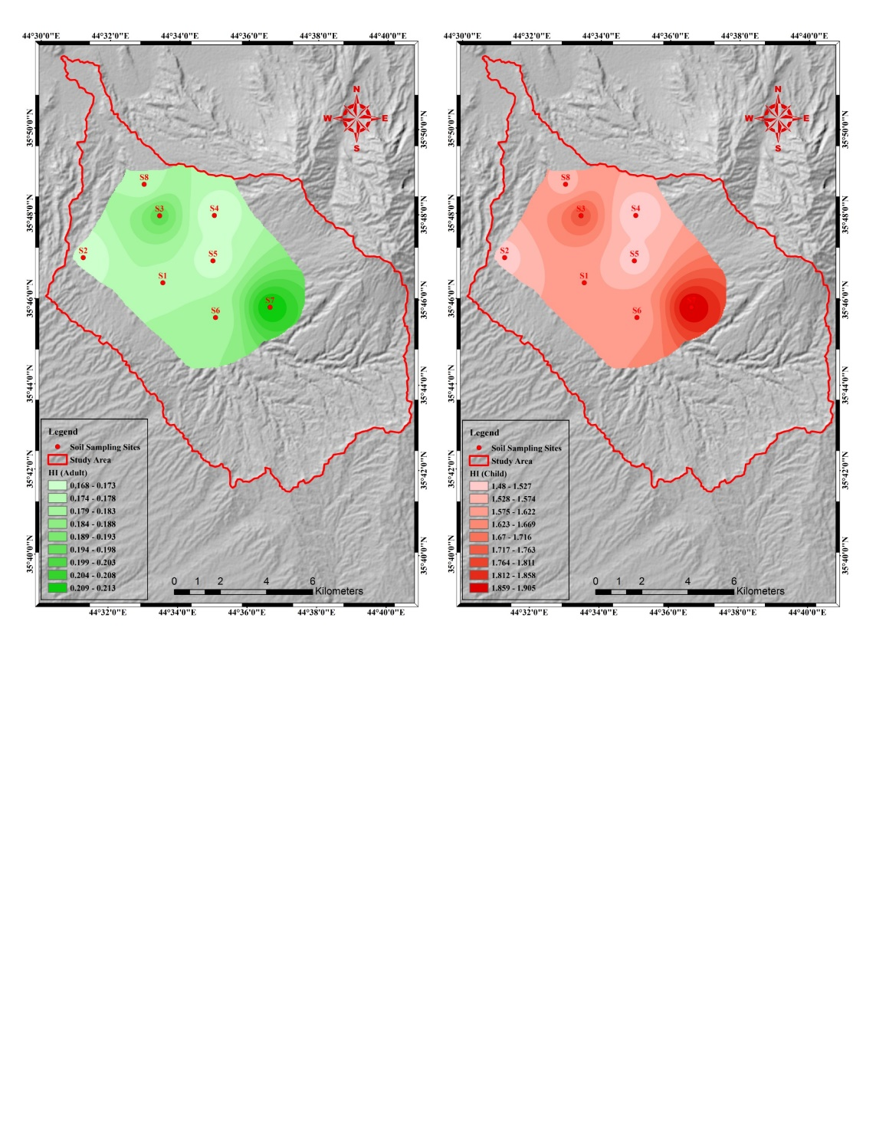

**Figure 4** Spatial Distribution of HI for Adults and Children in Soil of Study Area.

**5. Conclusion:**

In a current study several environmental indices were used to the assessment of heavy metals contaminations and determine the environmental quality is soil of study area, the results of this study summarized as follows:

1) The abundance trend of median concentrations of heavy metals increasing in order of Ni> Cr> Zn> Cu> Co> Pb> As> Cd. The concentrations of As, Cd, and Ni highest than geochemical background values at all sites, whereas concentrations of Pb, Cr, Co, and Zn are lower than the geochemical background values, except Zn at S7 exceeded the same background value. The comparison of heavy metals concentration with U.S. SQGs, where all sites non-polluted with Pb, Cd, and Zn, and polluted heavily by Ni, whereas S6, S7, and S8 are polluted moderately with As and Cu, but polluted heavily by Cr. The Concentrations of As, Pb, Cd, and Cu are lower than EPA Ecological Screening values, and concentrations of Cr, Co, Ni, and Zn are higher than EPA Ecological Screening values at all sites, except Zn at S1, S2, and S4 is lower than the same value. The concentrations of As, Pb, Cd, Cr, Co, Cu, and Zn at all sites lower than WHO guidelines, except Ni its concentrations higher than the same guidelines.

2) the Pearson’s correlation coefficient analysis showed there are strong positive relations among Pb, Co, Cu, Zn, Cr, and Ni indicates these metals have similar origins mostly anthropogenic, while the weak positive relation was observed among (As-Pb), (Cd-Cu), (Pb-Cd), (Cd-Co), and (Pb-Co) which indicate these metals come from different origins, also the weak negative relationship found between As with Cd, Co, Cu, and Ni.

3) The RI showed high risk at all sites, except site (S2), while according to $P_{N}$ the soil has been moderately contaminated at sites (S1, S2, and S8), and severely contaminated at other sites.

4) The HI showed there are no noncarcinogenic adverse effects for adults, but the children are at risk of non-carcinogenic effects. While the total cancer risk of As and Cr in the acceptable range for adults and children, while for Pb, Cd, Co, and Ni were lower than tolerable risk range at all sites.

This study reveals that the soil of the study area moderately to heavily contaminated by heavy metals. These metals originated from anthropogenic and natural sources, but the anthropogenic sources contribute to soil contamination more than natural sources. Human health risk assessment showed there is high non-carcinogenic for children this means the residing of children in this area unhealthy.

**Reference:**

1. Abdelhafez, A. A.; Abbas, H. H.; Abd-El-Aal, R. S.; Kandil, N. F.; Li, J.; and Mahmoud, W. (2012). Environmental and health impacts of successive mineral fertilization in Egypt. *Clean Soil Air Water*, 40 (4), pp. 356-363.
2. Al-Kadhimi, J. A.; Sissakian, V. K.; Deikran, D. B.; Fattah, A.S. (1996). Tectonic Map of Iraq, Scale 1:1000000, 2nd edition. *GEOSURV, Baghdad, Iraq*.
3. Al-Naqib, K. M. (1960). Southern Region Geology Summary for the brigade Kirkuk-Iraq, Iraq Oil Company Limited. *Second Arab Petroleum conference*, pp. 62.
4. Bade, R.; Oh, S.; Shin, W. S.; and Hwang, I. (2013). Human health risk assessment of soils contaminated with metal(loid)s by using DGT uptake: A case study of a former Korean metal refinery site. *Hum. Ecol. Risk Assessment*, 19, pp. 767-777.
5. Bullock, P. and Gregory, P. J. (1991). Soils in the urban environment. *UK: Blackwell Scientific Publications.*
6. Buringh, P. (1960). Soils and Soil Conditions in Iraq. *The Ministry of Agriculture, Baghdad, Iraq*, p. 332.
7. Campbell, L.M. (2001). Mercury in Lake Victoria (East Africa): Another emerging issue for a Beleaguered Lake? Ph.D. *dissertation, Waterloo, Ontario, Canada*.
8. Chen, H.; An, J.; Wei, S.; and Gu, J. (2015). Spatial Patterns and Risk Assessment of Heavy Metals in Soil in Resources-Exhausted City, Northeast China. *PLoS ONE* 10 (9), pp. 12.
9. Chiroma, T. M.; Ebewele, R. O.; and Hymore, K. (2014). Comparative assessment of heavy metal levels in soil, vegetables and urban grey wastewater used for irrigation in Yola and Kano. *Int. Ref. J. Eng. Sci.*, 3, pp. 1-9.
10. Environmental Protection Agency (2005). Ecological Screening values for Surface Water, Sediment, and Soil. *WSRC-TR-2004-00227, Savanah River National Laboratory, Aiken, South Carolina 29803*.
11. Hakanson, L. (1980). An Ecological Risk Index for Aquatic Pollution Control. *A Sedimentological Approach. Water Research,* Vol. 14, pp. 975-1001.
12. Harikumar, P. S.; Prajitha, K.; and Silpa, S. (2010). Assessment of Heavy Metal Contamination in the Sediments of a River Draining into a Ramsar site in the India Sub Continent. *Journal of Advanced Laboratory Research in Biology*, Vol. I, pp. 120-129.
13. Jaradat, A. A. (2002). Agriculture in Iraq: Resources, Potentials, Constraints, and Research Needs and Priorities. *NCSC Research Lab, ARS-USDA 803 Iowa Avenue, Morris, MN 56267*, 83 p.
14. Kabata-Pendias, A. (2011). Trace Elements in Soil and Plants, 4th ed., *Taylor & Francis: Boca Raton, FL, USA*.
15. Khan, M. N.; Wasim, A. A.; Sarwar, A.; and Rasheed, M. F. (2011). Assessment of heavy metal toxicants in the roadside soil along the N-5, national highway, Pakistan. Environ. *Monit. Assess. 182*, pp. 587-595.
16. Lane, T. W. and Morel, F. M. (2009). A biological function for cadmium in marine diatoms. *Proc. Natl. Acad. Sci. USA*.
17. Li, Q; Chen, Y.; Fu, H.; Cui, Z.; Shi, L.; and Wang, L., et al. (2012). Health risk of heavy metals in food crops grown on reclaimed tidal flat soil in the Pearl River Estuary, China. *J. Hazard Mater*. 227-228: pp. 148-154.
18. Li, Z.; Ma, Z.; van der Kuijp, T. J.; Yuan, Z.; and Huang, L. (2014). A review of soil heavy metal pollution from mines in China: Pollution and health risk assessment. *Sci. Total Environ*. 468-469: pp. 843-853.
19. Manta, D. S.; Angelone, M.; Bellanca, A.; Neri, R.; and Sprovieri, M. (2002). Heavy metals in urban soils: A case study from the city of Palermo (Sicily), Italy. Science of the Total Environment, 300, pp. 229–243.
20. MOE (2009). Soil contamination risk assessment guidelines. *Korean Ministry of Environment, Gwachun, Kyunggi in South Korea*.
21. Nicholson, F. A.; Smith, S. R.; Alloway, B. J.; Carlton-Smith, C.; and Chambers, B. J. (2003). An Inventory of heavy metals inputs to agricultural soils in England and Wales. *The Science of the Total Environment*, 311, pp. 205-219.
22. Nouri, J.; Mahvi, A. H., Babaei, A.; and Ahmed Pour, E. (2006). Regional pattern distribution of groundwater fluoride in the Shush aquifer of Khuzestan County Iran. *Fluoride* 39 (4), pp. 321-325.
23. NRC. (1983). Risk assessment in the Federal Government: Managing the process*, National Academy Press*, Washington, D.C. USA.
24. Nriagu, J. O., and Pacyna, J. M. (1988). Quantitative assessment of worldwide contamination of air, water, and soils by trace metals; Nature, 333, pp. 1139-1341.
25. Pekey, H. (2006). Heavy metal pollution assessment in sediments of Izmit Bay, Turkey. *Environ. Monit. Assess*. 123 (1-3), pp. 219-231.
26. Sissakian, V. K. (1992). The Geology of Kirkuk Quadrangle Sheet NI-38-2, Scale 1:250000. *GEOSURV, Baghdad*, 48 p.
27. U. S. Environmental Protection Agency (U.S. EPA), (2017). Regional Screening Level (RSL) Summary Table, <<https://www.epa.gov/risk/regional-screening-levels-rsls-generic-tables-june-2017>>.
28. U. S. Environmental Protection Agency (U.S. EPA), (2016). Regional Screening Levels prepared by Oak Ridge National Laboratories, <<http://epaprgs.ornl.gov/chemicals/index.shtml>>.
29. U. S. Environmental Protection Agency (U.S. EPA), (2004). Risk Assessment Guidance for Superfund Volume I: Human Health Evaluation Manual (Part E, Supplemental Guidance for Dermal Risk Assessment); USEPA: Washington, D.C., USA.
30. U. S. Environmental Protection Agency (U.S. EPA), (2001). Toxics Release Inventory: Public Data Release Report. <[www.epa.gov/tri/tridata/tri01](http://www.epa.gov/tri/tridata/tri01)>. (accessed 24 February 2015).
31. U. S. Environmental Protection Agency (U.S. EPA), (1989). Risk Assessment Guidance for Superfund Volume 1: Human Health Evaluation Manual (Part A). *Office of Emergency and Remedial Response*: *Washington, D.C.*, USA.
32. U. S. Environmental Protection Agency (U.S. EPA), (1977). Guidance for the Pollutional Classification of Great Lakes Harbor Sediments, Region V, Chicago, Illinois.
33. Van der Perk, M. (2006). Soil and Water Contamination. *Taylor & Francis/Balkema Group plc, London*, UK, 389 p.
34. Wang, J.; Cui, L.; Gao, W.; Shi, T.; Chen, Y.; and Gao, y. (2014). Prediction of low heavy metal concentrations in agricultural soils using visible and near-infrared reflectance spectroscopy. *Geoderma.* 216: pp. 1-9.
35. Wedephol, K. H. (1995). The Composition of the Continental Crust. *Geochimica et Cosmochimica Acta (Elsevier)*, 59, pp. 1217-1232.
36. Yang, Z.; Lu,W.; Long, Y.; Bao, X.; Yang, Q. (2011) Assessment of heavy metals contamination in urban topsoil from Changchun City, China. Journal of Geochemical Exploration, 108, pp. 27–38.
37. Zhao, H.; Xia, B.; Fan, C.; Zhao, P.; and Shen, S. (2012). Human health risk from soil heavy metal contamination under different land use near Dabaoshan Mine, Southern China. *Sci Total Environ*. 417-418: pp. 45-54.
38. Zou, K. H.; Tuncali, K.; Silverman, S. G. (2003). Correlation and Simple Linear Regression. *Radiology*, 227, pp. 617-628.